**727721EUIT145**

**SHANKARESHWARA P**

**CLOUD COMPUTING – CC1**

**QUESTION 1:**

**INSTANCE NAME:**

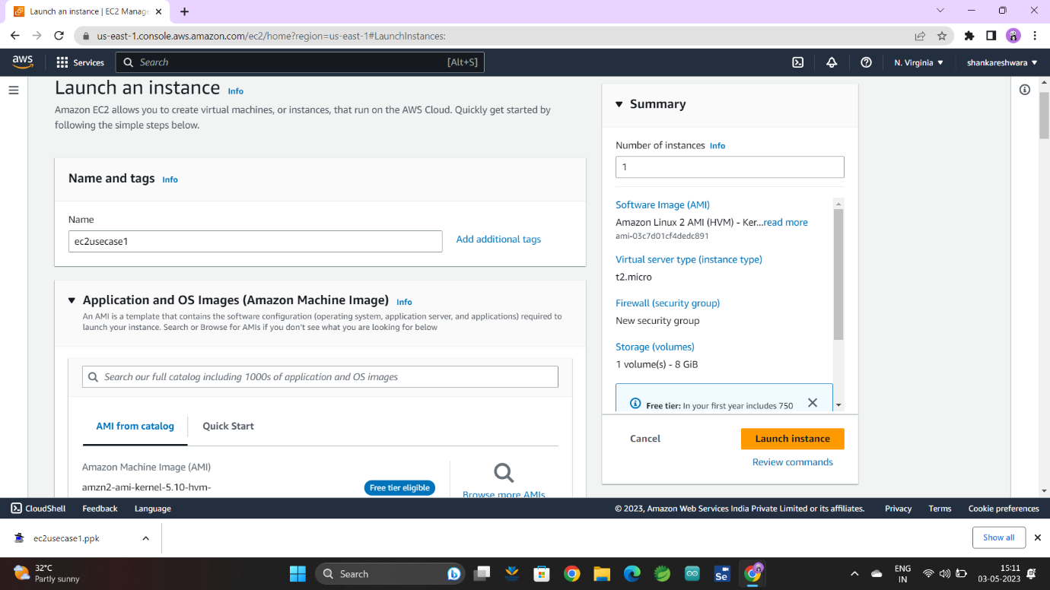

**KEYPAIR NAME:**

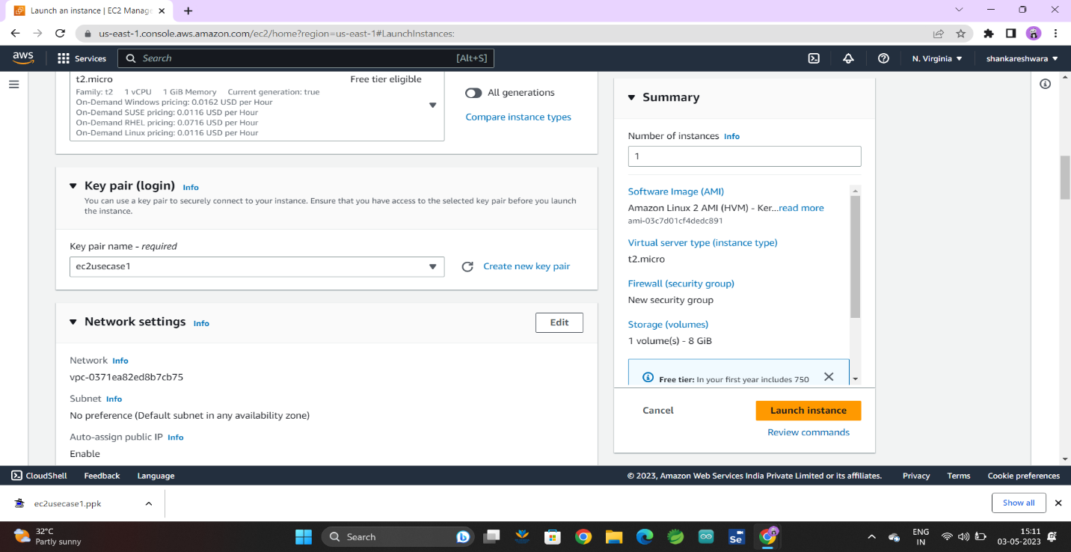

**AMAZON2 LINUX INSTANCE:**

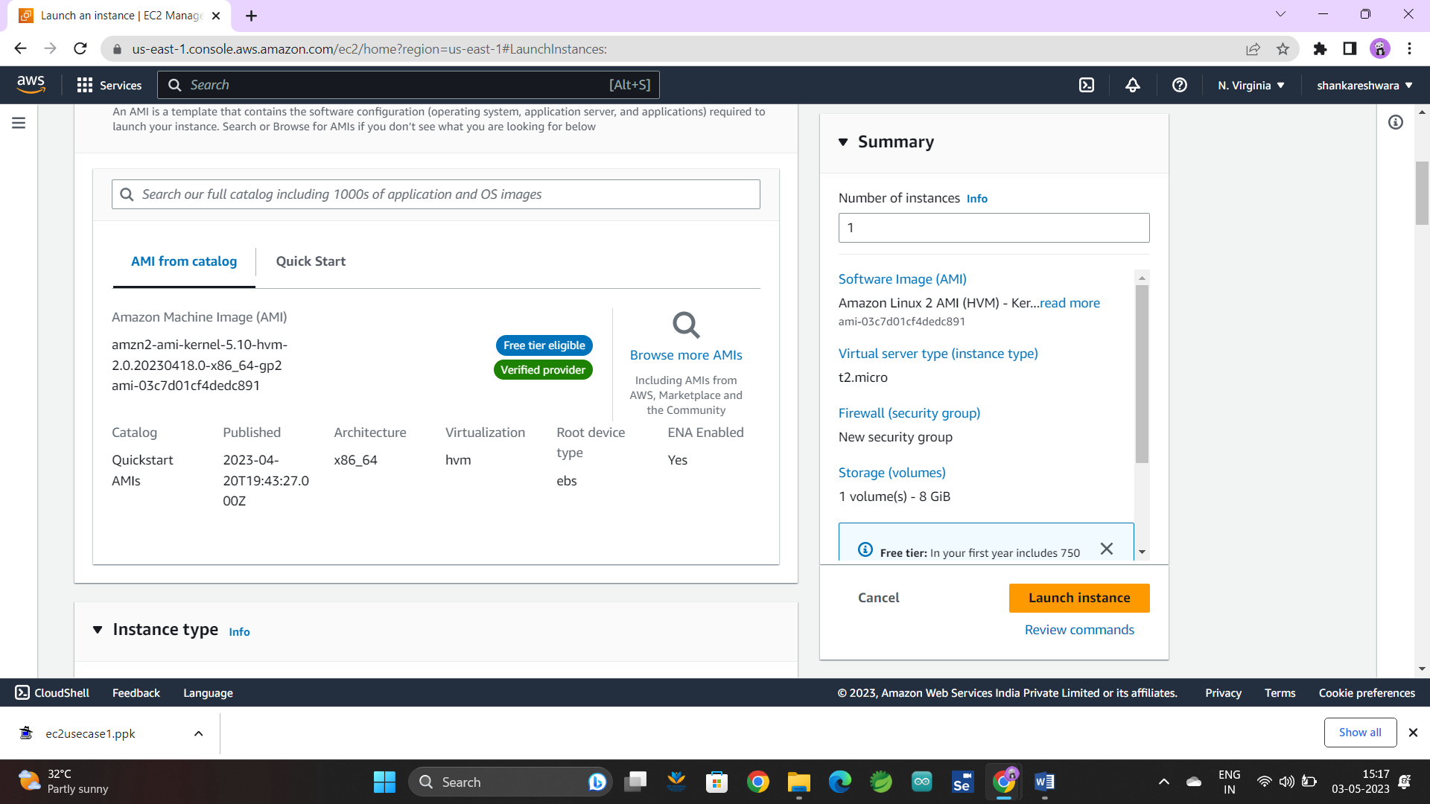

**SSH TRAFFIC AND HTTP TRAFFIC:**

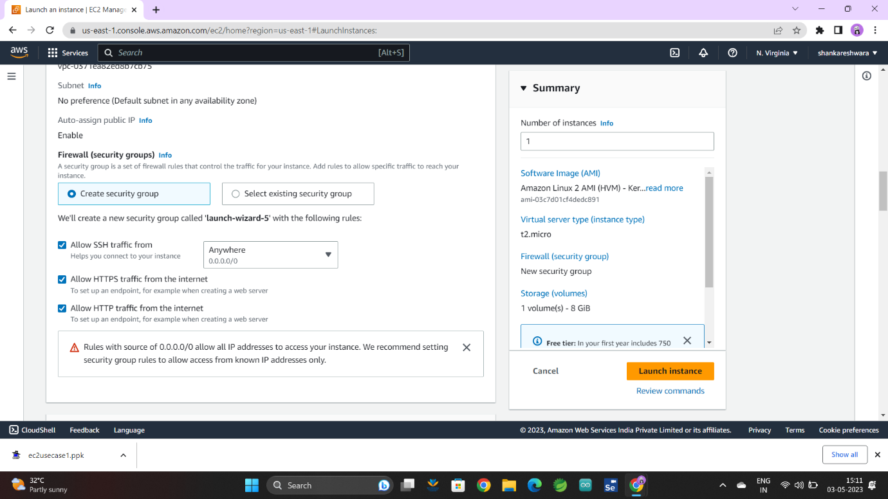

**REGION US-EAST-1 :**

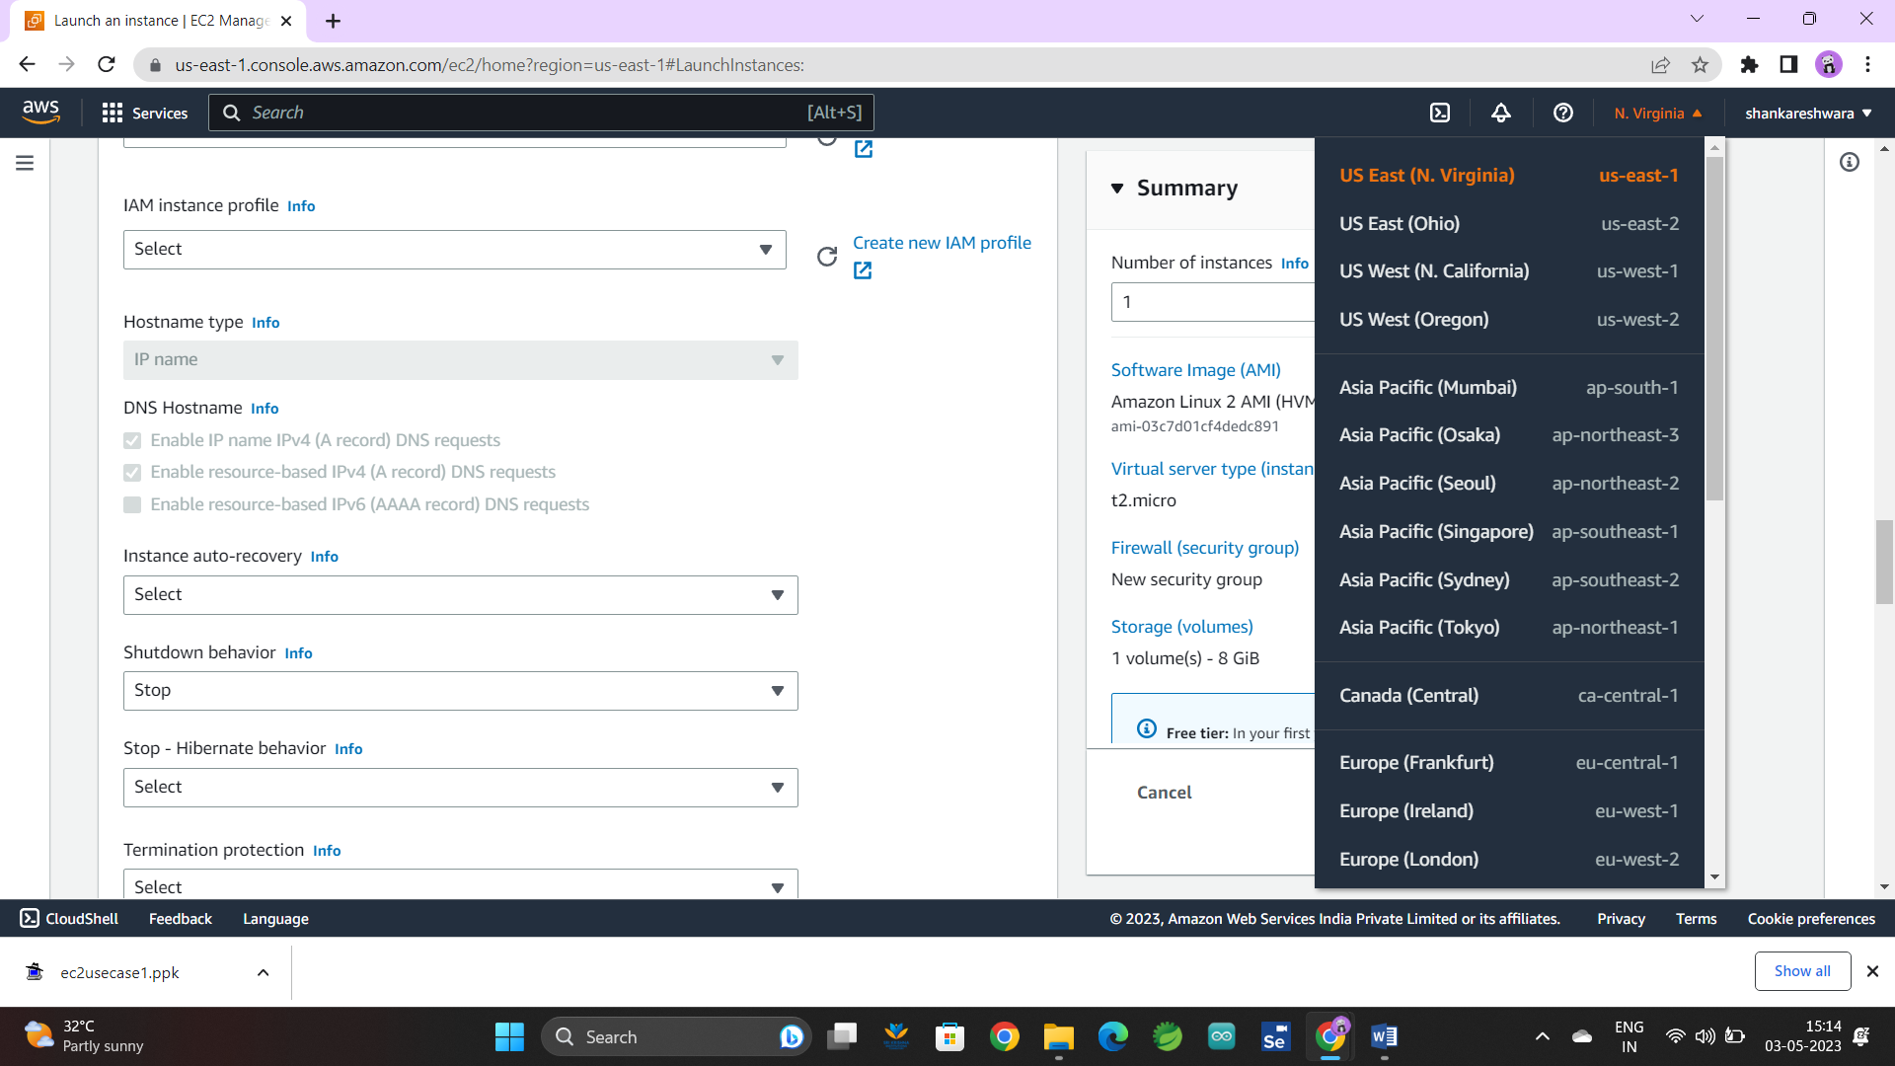

**PUTTY:**

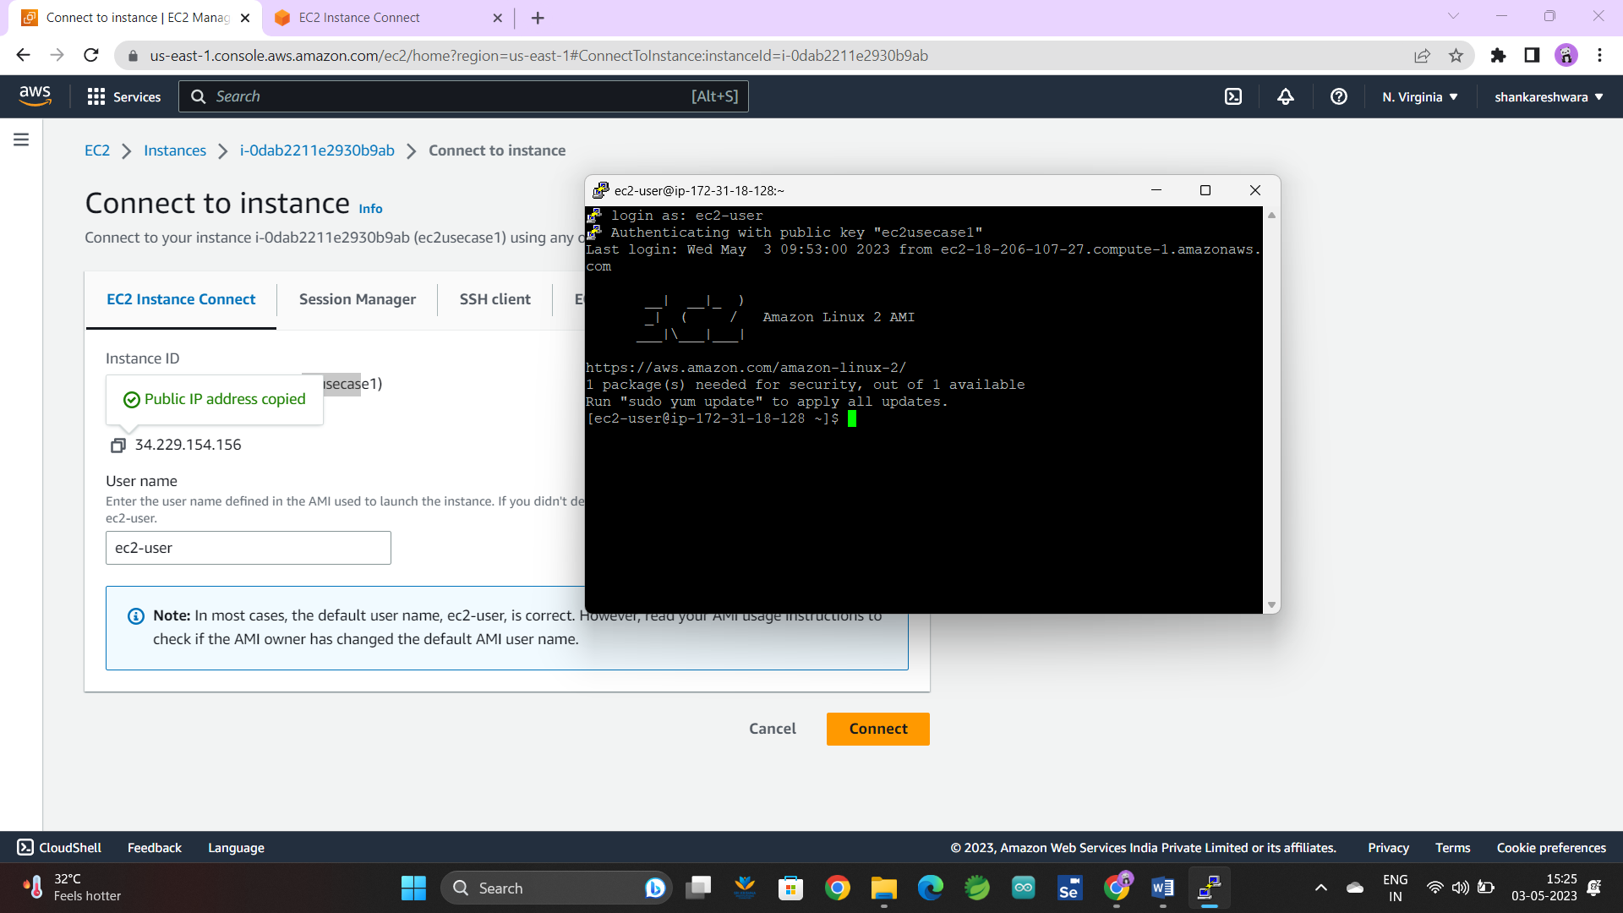

**INSTANCE RUNNING**

