**727721EUIT145**

**SHANKARESHWARA P**

**CLOUD COMPUTING CC1**

**QUESTION 3:**

**MY BUCKET:**

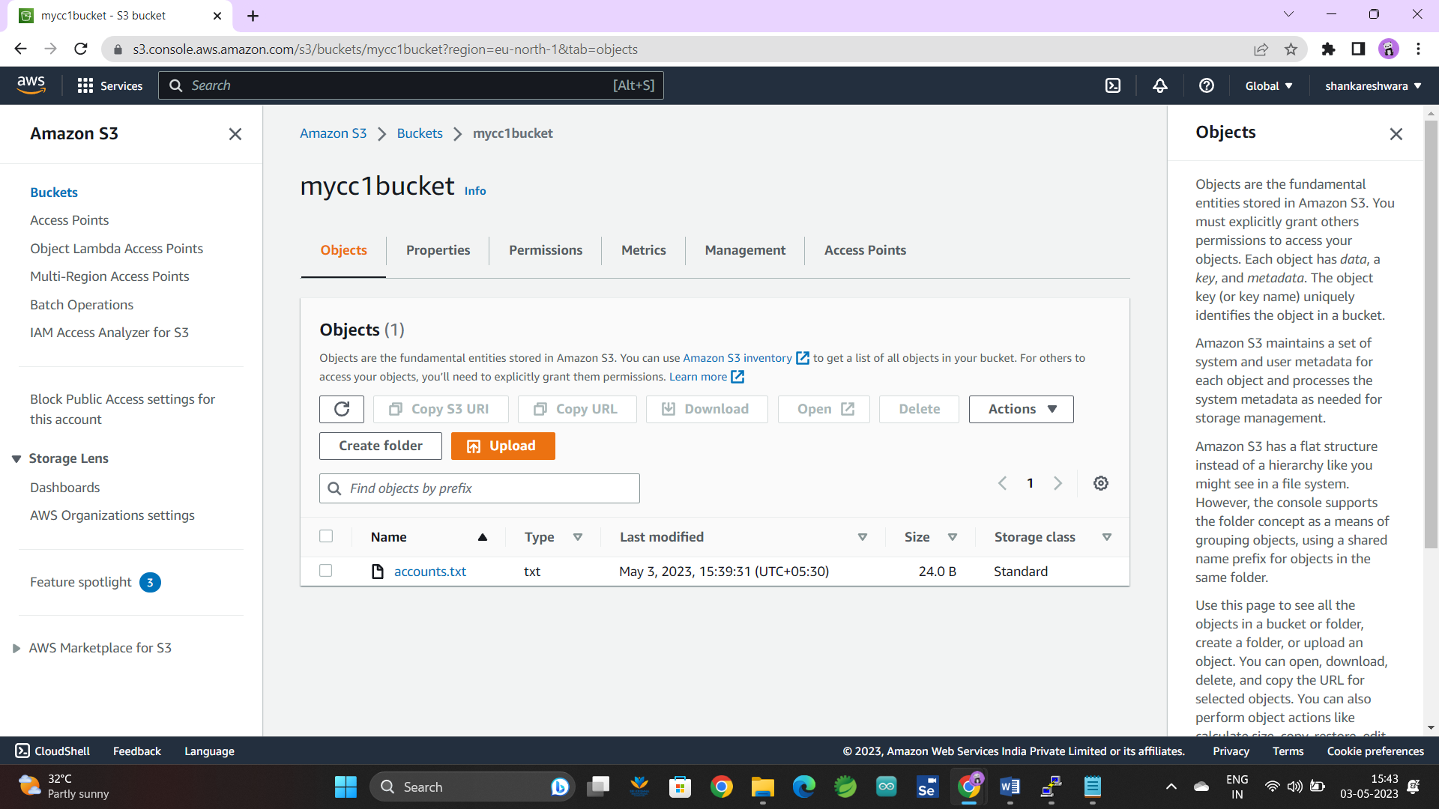

**REGION:**

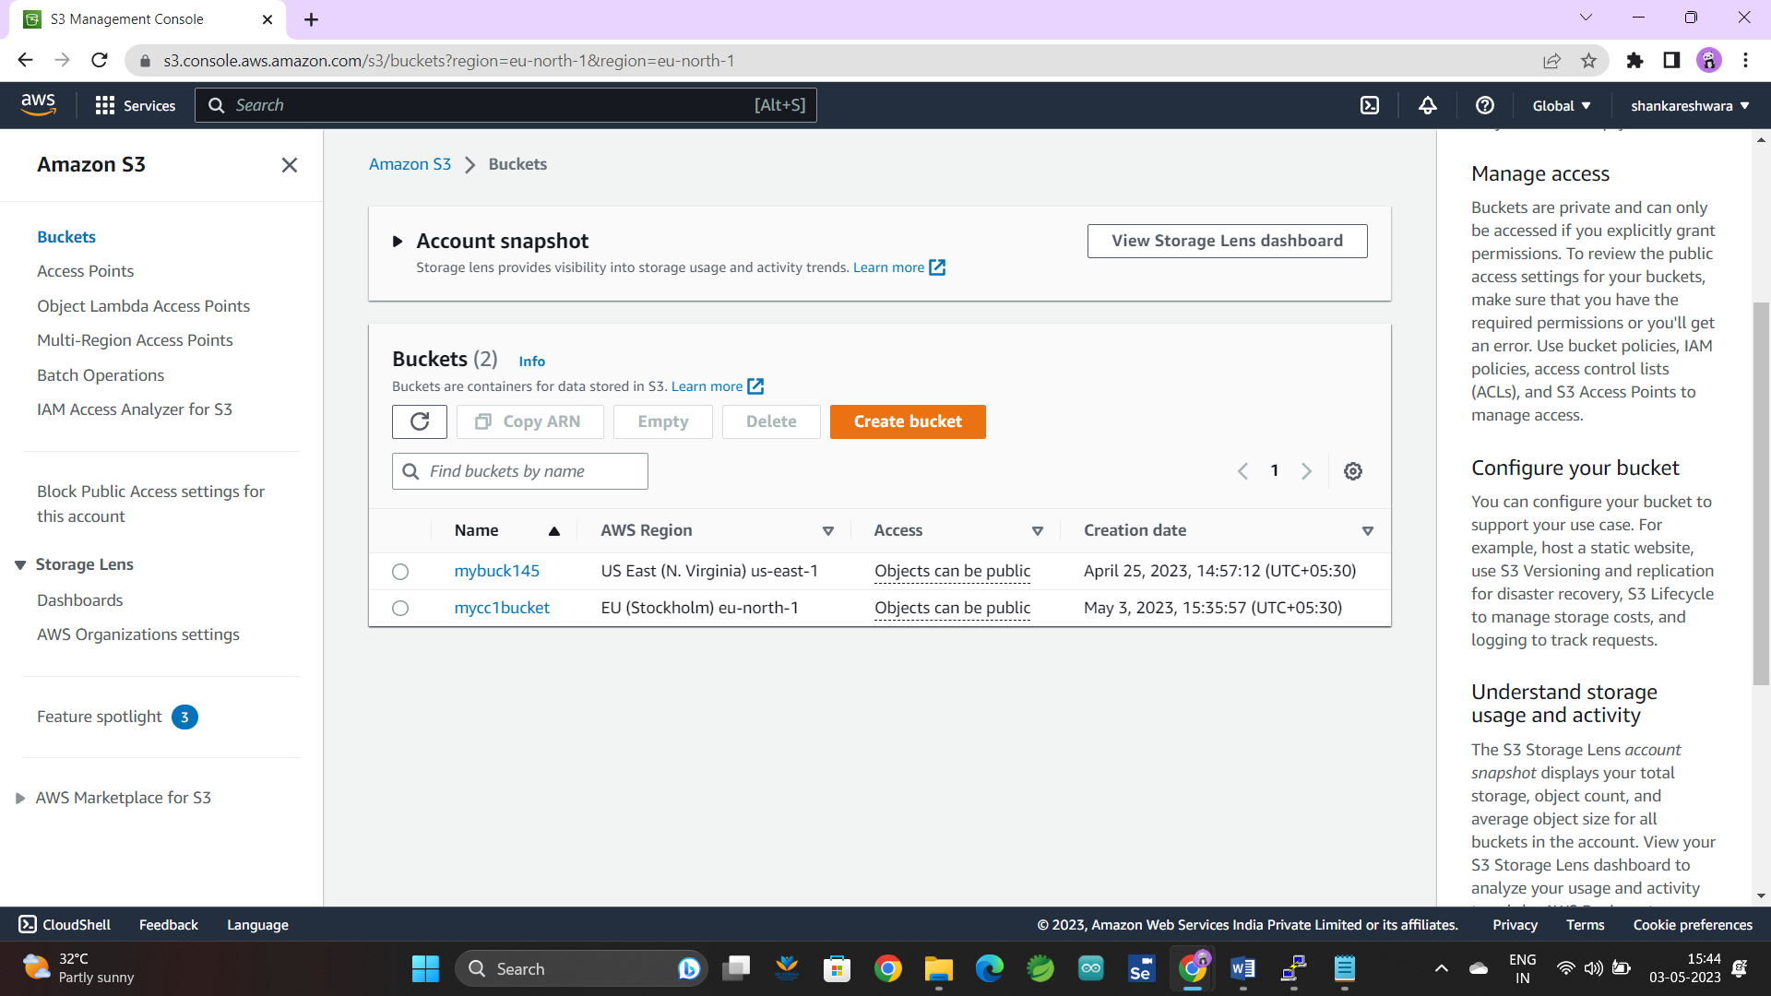

**PUBLIC ACCESSABLE:**

