Basics – 101-OOD With Java

Prepared by

Shankar Karthik & Anita

Object Oriented Programming
There are many opinions of what it means for a development system or language to be "object oriented". However, it is widely agreed that any language that claims to be object oriented must at least support Encapsulation, Inheritance, Polymorphism and Dynamic binding.
Remember (PIED)
Polymorphism
Inheritance
Encapsulation
Dynamic Binding
http://www.eschertech.com/tutorial/tutorial1/oo_principles.htm

Encapsulation [= Security and Integrity]
Encapsulation means that the detailed implementation of a component is hidden from the rest of the system. Specifically, the data held by a component is normally not accessible from the outside of the component. Instead, a number of interface functions and procedures (collectively called methods) are provided for use by those parts of the software system that are clients (i.e. users) of the component.

The way most object oriented language support encapsulation is to allow the user to declare classes. A Class is a collection of data variables (sometimes called attributes), private methods and public (or interface) methods, together with one or more special methods called constructors. A constructor for a class creates a new instance of the class (i.e. a new object with its own copies of the data variables). Instances can be stored in variables, passed as parameters, etc. but the data within an instance cannot be directly accessed. Instead, the interface methods of the class can be invoked on the particular instance to modify the values of the data variables and/or return information about them.

public class MyMarks {
private int marks = 0;
public void setMarks( int mark){
if ( marks < 0 ) {
throw new IllegalArgumentException(“No Negative Values Allowed”);
}
marks = mark;
}
}

The code above illustrates how encapsulation protects MyMarks object from having negative values.

Inheritence [= Reuse]

- Inheritance is a facility to declare new classes by extending old ones.
- Inheritence is a way to relate 2 objects.

Polymorphism [= Reuse]
Polymorphism ("many structures") is a facility by which one type can be substituted for another.

Dynamic Binding
Dynamic binding means that where you are using polymorphism and you call a method, the "version" of the method that actually gets called depends on the actual type(s) of the instance(s) involved. For example, suppose you declared BankAccount and then SavingsAccount, but in declaring SavingsAccount you redefined the inherited method withdraw. This gives you two versions of withdraw. Then, each time a call is made to myAccount.withdraw(someMoney), the version of withdraw that is called will depend on whether myAccount holds a plain BankAccount, or a SavingsAccount.

What do we gain by encapsulation?
http://www.brpreiss.com/books/opus4/html/page14.html
Conceptual Independence – User of an Object can do anything he wants without depending on the object or changes to the object. Common in Procedural Language defining a module.
Physical Independence – The behavior of the Object is defined entirely by it and cannot be changed by external entity.

How is it different from C or Procedural Language
Procedural Programming separates the data of the program from the operations that manipulate the data. For example, if you want to send information across a network, only the relevant data is sent, with the expectation that the program at the other end of the network pipe knows what to do with it. In other words, some sort of handshaking agreement must be in place between the client and server to transmit the data. In this model, no code is actually sent over the wire.
Eg: Data transmitted over a wire
OO programming - The fundamental advantage of OO programming is that the data and the operations that manipulate the data (the code) are both encapsulated in the object. For example, when an object is transported across a network, the entire object, including the data and behavior, goes with it. Eg: An Employee object is sent over the network.
A good example of this concept is a Web object, such as a Java applet. The browser has no idea of what the Web object will do. When the object is loaded, the browser executes the code within the object and uses the data contained within the object.

Java vs C++

Why one favors Interface over Inheritence? Why multiple inheritances are not allowed in Java? Why Implementation Inheritence over Interface Inheritence.
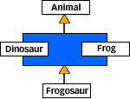

- Reason1: Diamond class problem: Interfaces promote more polymorphism, enables composition, flexibility, use it for unrelated objects.
- Reason 2: Inheritance breaks Encapsulation If super class changes all subclasses have to be recompiled.

Static vs Dynamic Binding
The underlying mechanism that makes polymorphism possible is dynamic binding. Except for three special cases, all instance methods in Java programs are dynamically bound. The instance method that is invoked at run-time will be determined by the actual class of the object, not by the type of the reference. This differs from C++, in which you must declare an instance method virtual to get polymorphism and dynamic binding. If you don't declare an instance method virtual in a C++ class, you get static binding, in which the method called is determined by the type of the reference, not the class of the object referred to by the reference. Polymorphism plays no role in static binding. In C++, therefore, a programmer can, wielding the power of the virtual keyword, create instance methods that are either statically or dynamically bound. In Java, however, "virtual" is not a keyword, and all instance methods, except for the three special cases, are dynamically bound. The three special cases are private methods, instance method invocations with the super keyword, and invocation of instance initialization methods.

Static binding also plays a role in class methods (those declared with the static modifier), which are always statically bound. You can redefine a class method in a subclass, just like an instance method; however, a redefined class method will not participate in the rewards of polymorphism and dynamic binding. Because class methods do not operate on specific objects, you don't even need an object to call them. Class methods can be invoked even when no instances of the class exist. Polymorphism requires an object, because it enables a method to be dynamically selected based on the actual class of the object. Thus, polymorphism does not apply to class methods. If you invoke a class method on an object, the implementation of the class method is chosen based not on the class of the object at run-time, but on the type of the object reference at compile-time.

The three special cases, mentioned above, in which Java performs static binding on instance methods are:
- private methods
- methods invoked with the super keyword
- instance initialization methods

When you invoke a private method from another method, both methods must be defined in the same class. Although a method of the same signature as a private method can be declared in a subclass, a private method can't be overridden by a subclass. When you invoke a private method, the Java compiler knows precisely which class contains the method to invoke, because it must by definition be in the same class. Static binding is used so that the private method is invoked independent of the actual class of the object at run-time.

The super keyword, which will be described in detail later in this chapter, allows you to access a superclass's methods and fields from a subclass, even if they are overridden or hidden in the subclass. In the case of instance methods, static binding must be used. If a method is overridden in a subclass, dynamic binding would cause the subclass's version of the method to be invoked rather than the superclass's version. As with invocation of a private method, the compiler knows precisely which class contains the method to invoke when it is invoked with the super keyword. Static binding allows a superclass's version of an instance method to be invoked independent of the actual class of the object at run-time.

The Java compiler creates one instance initialization method for each constructor in the source for a class. This special kind of instance method is invoked only when an object is created. Like private methods and methods invoked with super, instance initialization methods are invoked using static binding.

Abstract Class vs Interface
- Abstract Class cannot be instantiated.
- Abstract class may or may not contain an abstract method and may contain concrete methods.
- If you want to provide a blue print of a type as well as serve as a base class – use Abstract Class.

Advantages of Interface over Abstract Class.
- Capture similarities among unrelated classes without artificially forcing a class relationship.
- Declare methods that one or more classes are expected to implement.
- Reveal an object’s programming interface without revealing its actual implementation.
- Model multiple inheritances in Java, which provides some of the benefits of full on multiple inheritances, a feature that some OOP languages support that allow a class to have more than one superclass.

Polymorphism in Java?
http://www.javaworld.com/javaworld/jw-04-2001/jw-0413-polymorph.html?page=1

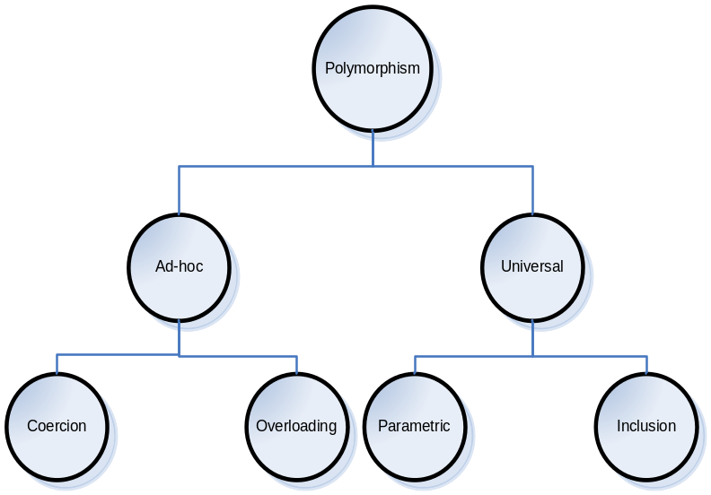
Coercion | - Represents implicit parameter type conversion to the type expected by a method or an operator, thereby avoiding type errors.  Eg 1:  2.0 + 2.0  2.0 + 2  2.0 + “2”  Eg 2:  Another example is from Expression Language [EL] used in JSP Tags  ${musicList[2]} is same as ${musicList[“2”]}  here “2” String is co-erced to int 2
Overloading | - Permits the use of same operator or method name to denote multiple distinct program meanings.  Eg:  + operator used above  Overloading of method names.
Parametric | - Parametric polymorphism allows the use of a single abstraction across many types. For example, a List abstraction, representing a list of homogeneous objects, could be provided as a generic module.  - You would reuse the abstraction by specifying the types of objects contained in the list. Since the parameterized type can be any user-defined data type, there are a potentially infinite number of uses for the generic abstraction, making this arguably the most powerful type of polymorphism.  Eg:  Generics in 1.5
Inclusion | - Inclusion polymorphism achieves polymorphic behavior through an inclusion relation between types or sets of values. For many object-oriented languages, including Java, the inclusion relation is a subtype relation. So in Java, inclusion polymorphism is subtype polymorphism.  - When Java developers generically refer to polymorphism, they invariably mean subtype polymorphism. Gaining a solid appreciation of subtype polymorphism's power requires viewing the mechanisms yielding polymorphic behavior from a type-oriented perspective. The rest of this article examines that perspective closely. For brevity and clarity, I use the term polymorphism to mean subtype polymorphism.

http://www.javaworld.com/javaworld/jw-04-2001/jw-0413-polymorph.html?
http://research.microsoft.com/Users/luca/Papers/OnUnderstanding.pdf

Interface VS Class in Java - Thoughts
Types [Interfaces] determine what methods the object may perform
Implementation [Classes] determines how the object actually responds to each method.

That is, types declare responsibilities, and classes implement those responsibilities. By cleanly separating type and implementation, we find the two governing a grand object dance: types determine permissible partners and the names of the dances, while implementations choreograph the actual steps.

The concept of type best captures the spirit of freeing object interactions from the details of object implementation. Rather than refer to the interface of an object, a type-oriented perspective encourages referring to the reference type attached to an object. The reference type dictates the permissible interaction with the object. Think type when you want to know what an object can do, as opposed to how the object implements its responsibilities.

http://www.javaworld.com/javaworld/jw-04-2001/jw-0413-polymorph.html?page=6

Class inheritance through the Java extends clause further facilitates modularization. Module, or implementation, inheritance offers a way to create subclasses that automatically utilize implementation code from the super class module. Subclasses build on super class implementation and thus provide a means for module extension. This implementation-centric view of inheritance emphasizes code reuse.

Java classes also play an additional significant role. As well as providing implementation code, every class also defines a type. We often speak of this type as the public interface to the class. That terminology is somewhat confusing in light of the Java language interface keyword. Regardless, the set of public methods declared by the class defines a new type. This new type enjoys all the privileges and benefits of the Java type system in a manner that is completely independent of implementation code. Whether concrete or abstract, a class always defines a single new type.

Inheritance via the extends clause also plays another important role that mirrors a class's ability to define a type. Type, or interface, inheritance provides a mechanism for creating subtypes that build on a super-type's public interface. Since a type B declared as a subtype of A also has type A, the type-checker permits any variable or program expression of type B when expecting a variable or program expression of type A.

Curiously, Java interfaces offer perhaps the clearest distinction between type and class. An interface, quite simply, declares a type, deferring partial or full implementation to abstract or concrete classes. At first glance, that may seem to be the same as a class with no implementation. In fact, Java interfaces are often compared to C++ pure abstract classes. That misguided comparison, however, clouds an important Java language contribution. An interface not only separates type declaration from module implementation, it also facilitates the separation of type inheritance and implementation inheritance.

http://www.javaworld.com/javaworld/jw-01-2001/jw-0119-type.html

Differentiate Overloading and Overriding?
Abstract methods must be overridden by the first concrete (non-abstract) subclass. With respect to the method it overrides, the overriding method.
{public} {void} overrideMe({args_list}) throws {Exception}
- Must have the same argument list
- Must have the same return type
- Must not have a more restrictive access modifier
- May have a less restrictive access modifier
- Must not throw new or broader checked exceptions
- May throw fewer or narrower checked exceptions, or any unchecked exception
- Final methods cannot be overridden.
- Only inherited methods may be overridden.
- A subclass uses superClass.overriddenMethodName() to call the superClass version of an overridden method.
Overloading means reusing the same method name, but with different arguments. Overloaded methods
- Must have different argument lists.
- May have different return types, as long as the argument lists are also different
- May have different access modifiers
- May throw different exceptions.
- Methods from a super-class can be overloaded in a subclass.

Polymorphism applies to overriding, not to overloading - Nope
Object type determines which overridden method is used at runtime.
Reference type determines which overloaded method will be used at compile time.

Explain Runtime and Compile time polymorphism
Compile time polymorphism is functions and operators overloading. Runtime time polymorphism is done using inheritance [Class and Interface]

