Basics : JavaSE - JVM & Garbage Collection

Prepared by

Shankar Karthik & Anita

Explain JVM
http://www.artima.com/insidejvm/ed2/jvm2.html
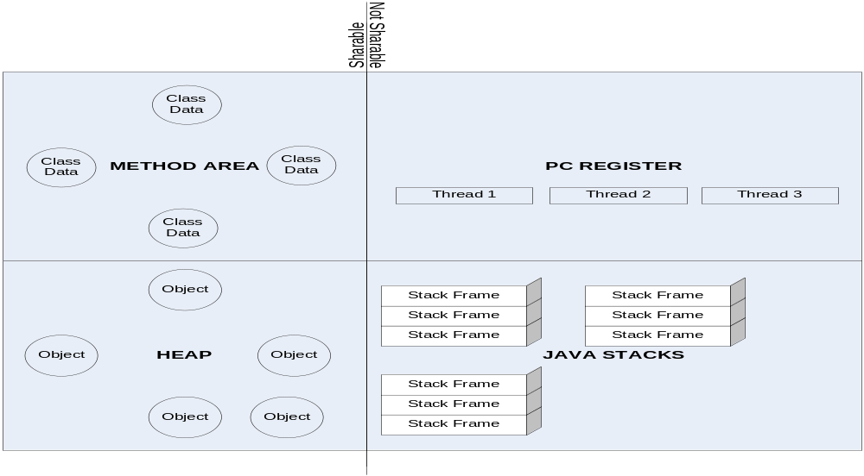
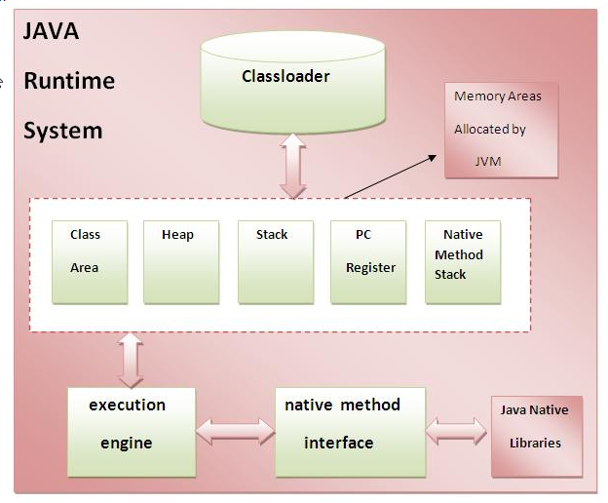
JVM (Java Virtual Machine) is an abstract machine. It is a specification that provides runtime environment in which java bytecode can be executed. JVMs are available for many hardware and software platforms (i.e. JVM is platform independent). The JVM performs four main tasks:
- Loads code
- Verifies code
- Executes code
- Provides runtime environment

Components of JVM

Class Loader:
Class loader is a subsystem of JVM responsible for loading class files. Different types of class loaders exist
- Bootstrap class loaders( load classes from jars in <JAVA_HOME>/lib/*.jar
- Extensible class loaders(load classes from jars in <JAVA_HOME>/lib/ext/*.jar
- System class loaders: (loads all classes from jars in system CLASSPATH).

Memory Areas in JVM:
- Class / Method Area:
  - Static variables
  - Global Instance variables
  - Code for methods

- Heap:
All objects irrespective of the scope they are defined in.
- Stack:
- All local variables e.g. all variables defined inside a method i.e. these local variables are not passed to another method or are not used anywhere else in the program and their scope is only until the scope of the current method.
- Java stack stores frames.
- A frame is each memory location in a stack.
- Frame holds local variables and partial results and plays a part in method invocation and return.
- A new frame is created each time a method is invoked. The frame is destroyed when its method invocation is complete.
- Each thread has a private JVM stack created at the same time as thread.

- PC Register: Program Counter (PC) register contains the address of the JVM currently executing instruction.
- Native Method Stack: It contains all the native methods used in the application.
- Execution Engine: It contains the following:-
  - Virtual Processor
  - Interpreter: Reads the bytecode stream and process the instructions.
  - JIT (Just in time compiler): The JIT compiler helps improve the performance of Java programs by compiling bytecode into native machine code at run time. JIT compiles part of the byte code into native language that has similar functionality at the same time and hence reduces the amount of time needed for compilation.

4) Native Method Interface

5) Java Native Libraries

The Just-In-Time (JIT) compiler is a component of the Java™ Runtime Environment that improves the performance of Java applications at run time.

Java programs consist of classes, which contain platform-neutral bytecode that can be interpreted by a JVM on many different computer architectures. At run time, the JVM loads the class files and performs the appropriate computation. The additional processor and memory usage during interpretation means that a Java application performs more slowly than a native application (A native application is one where in the code is meant to be run on the same machine it is compiled on. It is not meant to be run on other machines unlike .class (bytecode) in java. The JIT compiler helps improve the performance of Java programs by compiling bytecode into native machine code at run time. JIT compiles part of the byte code into native language that has similar functionality at the same time and hence reduces the amount of time needed for compilation.

The JIT compiler is enabled by default, and is activated when a Java method is called. The JIT compiler compiles the bytecode of that method into native machine code, compiling it "just in time" to run. When a method has been compiled, the JVM calls the compiled code of that method directly instead of interpreting it.

JIT compilation does require processor time and memory usage. When the JVM first starts up, thousands of methods are called. Compiling all of these methods can significantly affect startup time, even if the program eventually achieves very good peak performance.

In practice, methods are not compiled the first time they are called. For each method, the JVM maintains a call count, which is incremented every time the method is called. The JVM interprets a method until its call count exceeds a JIT compilation threshold. Therefore, often-used methods are compiled soon after the JVM has started, and less-used methods are compiled much later, or not at all. The JIT compilation threshold helps the JVM start quickly and still have improved performance.

After a method is compiled, its call count is reset to zero and subsequent calls to the method continue to increment its count. When the call count of a method reaches a JIT recompilation threshold, the JIT compiler compiles it a second time, applying a larger selection of optimizations than on the previous compilation. This process is repeated until the maximum optimization level is reached. The busiest methods of a Java program are always optimized most aggressively, maximizing the performance benefits of using the JIT compiler. The JIT compiler can also measure operational data at run time, and use that data to improve the quality of further recompilations.

The JIT compiler can be disabled, in which case the entire Java program will be interpreted. Disabling the JIT compiler is not recommended except to diagnose or work around JIT compilation problems.

Garbage Collection

What is the use of Reference API in Java? Explain Reach ability of Objects in Java?
http://weblogs.java.net/blog/enicholas/archive/2006/05/understanding_w.html
http://www.pawlan.com/Monica/refobjs/
http://java.sun.com/developer/technicalArticles/ALT/RefObj/index.html
http://mindprod.com/jgloss/weak.html
http://www.kdgregory.com/index.php?page=java.refobj

Soft – According to the Java API specification, the JVM implementations are encouraged not to clear out a soft reference if the JVM has enough memory (heap space). So a soft reference will survive a GC. However before throwing an OutOfMemoryError, JVM will attempt to reclaim memory by releasing instances that are softly reachable. This makes them ideal for implementing memory sensitive caches.

public class TestSoftRef {
public static void main(String[] args) {
// Initial Strong Ref
Object obj = new Object();
System.out.println("Instance : " + obj);
// Make a Soft Reference on obj
SoftReference<Object> softReference =
new SoftReference<Object>;
// Make obj eligible for GC !
obj = null;
System.gc(); // Run GC
// should be null if GC collected
System.out.println("Instance : " + softReference.get());
}
}

Weak – Unlike Soft References, Weak References can be reclaimed by the JVM during a GC cycle, even though there’s enough free memory available.

public class TestWeakRef {

public static void main(String[] args) {
// Initial Strong Ref
Object obj = new Object();
System.out.println("Instance : " + obj);
// Create a Weak Ref on obj
WeakReference<Object> weakRef
= new WeakReference<Object>(obj);

// Make obj eligible for GC !
obj = null;

// Get a strong reference again. Now its not eligible for GC
Object strongRef = weakRef.get();

System.out.println("Instance : " + strongRef);

// Make the instance eligible for GC again
strongRef = null;

// Keep your fingers crossed
System.gc();

// should be null if GC collected
System.out.println("Instance : " + weakRef.get());
}
}

The only real difference between a soft reference and a weak reference is that the garbage collector uses algorithms to decide whether or not to reclaim a softly reachable object, but always reclaims a weakly reachable object. So SoftReferences are good candidates for Caching solution.

Phantom – Phantom references are the weakest form of referencing. Instances that are referred via a phantom reference cannot be accessed directly using a get() method (it always returns null), as in case of Soft / Weak references. Instead, we need to rely on ReferenceQueues to make use of Phantom References. One use case of Phantom references is to keep track of active references with in an application, and to know when those instances will be garbage collected. If we use strong references, then the instance will not be eligible for GC due to the strong reference we maintain. Instead, we could rely on a phantom reference with the support of a reference queue to handle the situation.

Phantomly reachable objects are objects that have been finalized, but not reclaimed.

public class TestPhantomRefQueue {

public static void main(String[] args)
throws InterruptedException {

Object obj = new Object();
final ReferenceQueue queue = new ReferenceQueue();

PhantomReference pRef =
new PhantomReference(obj,queue);

obj = null;

new Thread(new Runnable() {
public void run() {
try {
System.out.println("Awaiting for GC");

// This will block till it is GCd
PhantomReference pRef =
(PhantomReference) queue.remove();

System.out.println("Referenced GC'd");

} catch (InterruptedException e) {
e.printStackTrace();
}
}
}).start();

// Wait for 2nd thread to start
Thread.sleep(2000);

System.out.println("Invoking GC");
System.gc();
}
}

Reference Queue – If the Referent Object is not available the Reference Object will be automatically inserted to the Reference Queue and available for GC.

Difference between Weak and Phantom Reference – Difference is when Enqueuing happens. WeakReferences are enqueued as soon as the object [Referent] becomes weakly reachable. This happens before finalization or Garbage Collection. Therefore there is possibility by an unorthodox call to finalize() it could be resurrected. But PhantomReferences are placed into the ReferenceQueue only when the object is physically removed from the HEAP.

Why Phantom References
- They allow user to determine when an Object was removed from Memory. They are in fact the only way to determine that. This isn't generally that useful, but might come in handy in certain very specific circumstances like manipulating large images: if you know for sure that an image should be garbage collected, you can wait until it actually is before attempting to load the next image, and therefore make the dreaded OutOfMemoryError less likely.
- Assume the Referent is marked for Garbage. When finalize() is called on the Referent it can try to resurrect. So GC has to run again before the Object can be finally removed. As GC is Arbitrary this can occur after several GC Cycles. This can lead to OutofMemoryError. This can never happen in PhantomReference as once it is enqueued there is no way to get a pointer to now-dead object.
 | Soft | Weak | Phantom
ReferenceQueue | N/A |  | The only use for such a reference is keeping track of when it gets enqueued into a ReferenceQueue, as at that point you know the object to which it pointed is dead.
get() | Returns softly referenced object | Returns weakly referenced object | It always returns null, even if the referent is still strongly referenced.
Use | Softly reachable objects are generally retained as long as memory is in plentiful supply. This makes them an excellent foundation for a cache. To keep objects alive even after clients have removed their references (memory-sensitive caches), in case clients start asking for them again by key. | Containers that automatically delete objects no longer in use.  A weak reference is, as its name suggests, a reference that doesn't even try to put up a fight to prevent its referent from being collected. If there are no strong or soft references to the referent, it's pretty much guaranteed to be collected. | Phantom references differ from soft and weak references in that they're not used to access their referents. Instead, their sole purpose is to tell you when their referent has already been collected. While this seems rather pointless, it actually allows you to perform resource cleanup with more flexibility than you get from finalizers.  Phantomly reachable objects are objects that have been finalized, but not reclaimed. The garbage collector will never clear a phantom reference. All phantom references must be explicitly cleared by the program.  They allow you to determine exactly when an object was removed from memory. They are in fact the only way to determine that. This isn't generally that useful, but might come in handy in certain very specific circumstances like manipulating large images: if you know for sure that an image should be garbage collected, you can wait until it actually is before attempting to load the next image, and therefore make the dreaded OutOfMemoryError less likely.
GC | The garbage collector might or might not reclaim a softly reachable object depending on how recently the object was created or accessed, but is required to clear all soft references before throwing an OutOfMemoryError. | Weakly reachable objects are finalized some time after their weak references have been cleared. The only real difference between a soft reference and a weak reference is that the garbage collector uses algorithms to decide whether or not to reclaim a softly reachable object, but always reclaims a weakly reachable object. | The garbage collector will never clear a phantom reference. All phantom references must be explicitly cleared by the program.

WeakHashMap

java.util.WeakHashMap is a special version of the HashMap, which uses weak references as the key. Therefore, when a particular key is not in use anymore, and it is garbage collected, the corresponding entry in the WeakHashMap will magically disappear from the map. And the magic relies on ReferenceQueue mechanism explained before to identify when a particular weak reference is to be garbage collected. This is useful when you want to build a cache based on weak references. In more sophisticated requirements, it is better to write your own cache implementation.

Explain various ways to call GC
System.gc();
Runtime.getRuntime().gc()

When does an object become eligible for GC
An Object becomes eligible for Garbage collection or GC if its not reachable from any live threads or any static references in other words you can say that an object becomes eligible for garbage collection if all of its references are null. Cyclic dependencies are not counted as reference so if Object A has reference of object B and object B has reference of Object A and they don't have any other live reference then both Objects A and B will be eligible for Garbage collection.

Generally an object becomes eligible for garbage collection in Java on following cases:-
- All references are null: All references of that object explicitly set to null e.g. object = null
- Local variable out of scope in method: Object is created inside a block and reference goes out scope once control exit that block. i.e. a variable created inside a method and the method has not exited.
- Parent object null, child eligible for GC: Parent object set to null, if an object holds reference of another object and when you set container object's reference null, child or contained object automatically becomes eligible for garbage collection i.e.
Class A{
B b;
}
If A == null (all references of ‘A’ are null), then B will be eligible for garbage collection.

- Weak Hashmap unused references: If an object has only live references via WeakHashMap it will be eligible for garbage collection.

Types of GC algorithms
Serial Garbage Collector
- The serial collector is the default for client style machines in Java SE 5 and 6. Here client machine means that the machine is executing some java program but he/she is not the developer of the program, may be some downloaded program from the internet or inside a browser.
- With the serial collector, both minor and major garbage collections are done serially (using a single virtual CPU).
- It uses a mark-compact collection method. This method moves older memory to the beginning of the heap so that new memory allocations are made into a single continuous chunk of memory at the end of the heap. This compacting of memory makes it faster to allocate new chunks of memory to the heap.

Sample command line to execute Serial Garbage Collector on a program
java -Xmx12m -Xms3m -Xmn1m -XX:PermSize=20m -XX:MaxPermSize=20m -XX:+UseSerialGC -jar c:\javademos\demo\jfc\Java2D\Java2demo.jar

Parallel Garbage Collector / Throughput Garbage Collector
- The parallel garbage collector uses multiple threads to perform the young generation garbage collection. By default on a host with N CPUs, the parallel garbage collector uses N garbage collector threads in the collection. The number of garbage collector threads can be controlled with command-line options:
-XX:ParallelGCThreads=<desired number>
- On a host with a single CPU the default garbage collector is used even if the parallel garbage collector has been requested. On a host with two CPUs the parallel garbage collector generally performs as well. What is the default garbage collector?
- Parallel Garbage Collector is of 2 Types:-
  - -XX:+UseParallelGC
With this command line option you get a multi-thread young generation collector with a single-threaded old generation collector. The option also does single-threaded compaction of old generation.
  - -XX:+UseParallelOldGC
GC is both a multithreaded young generation collector and multithreaded old generation collector. It is also a multithreaded compacting collector. HotSpot does compaction only in the old generation.

Sample command line to execute Parallel Garbage Collector on a program
java -Xmx12m -Xms3m -Xmn1m -XX:PermSize=20m -XX:MaxPermSize=20m -XX:+UseParallelGC -jar c:\javademos\demo\jfc\Java2D\Java2demo.jar

Concurrent Mark Sweep Collector (CMS) / Concurrent Low Pause Collector
- The Concurrent Mark Sweep (CMS) collector (also referred to as the concurrent low pause collector) collects the tenured generation.
- Concurrent garbage collector in java uses a single garbage collector thread that runs concurrently with the application threads with the goal of completing the collection of the tenured generation before it becomes full. In normal operation, the concurrent garbage collector is able to do most of its work with the application threads still running, so only brief pauses are seen by the application threads. As a fall back, if the concurrent garbage collections unable to finish before the tenured generation fill up, the application is paused and the collection is completed with all the application threads stopped. Such collections with the application stopped are referred as full garbage collections or full GC and are a sign that some adjustments need to be made to the concurrent collection parameters. Always try to avoid or minimize full garbage collection or Full GC because it affects performance of Java application.
- CMS collector on young generation uses the same algorithm as that of the parallel collector
G1 Garbage Collector
- The Garbage First or G1 garbage collector is available in Java 7 and is designed to be the long term replacement for the CMS collector.
- The G1 collector is a parallel, concurrent, and incrementally compacting low-pause garbage collector that has quite a different layout from the other garbage collectors

Sample command line to execute G1 Garbage Collector on a program
java -Xmx12m -Xms3m -XX:+UseG1GC -jar c:\javademos\demo\jfc\Java2D\Java2demo.jar

Types of GC algorithms
Garbage collection tuning mostly depends on the application in question.
For example if an application has too many short lived object then making Eden space wide enough or larger will reduces number of minor collections. you can also control size of both young and Tenured generation using JVM parameters for example setting -XX:NewRatio=3 means that the ratio among the young and tenured generation is 1:3 , you got to be careful on sizing these generation. As making young generation larger will reduce size of tenured generation which will force Major collection to occur more frequently which pauses application thread during that duration results in degraded or reduced throughput.

