Basics : JavaEE - Servlets & JSP

Prepared by

Shankar Karthik & Anita

Servlet Technology

Web Application
- From a programmer's point of view, a Web application corresponds to one ServletContext object. All Servlets’ inside a Web application share the same ServletContext instance.
- All Web servers have at least one context, called the default context. It handles requests whose URI paths match no other context prefix. (So, for example, it would handle requests for /index.html or /images/tile.gif)
http://java.sun.com/developer/technicalArticles/Servlets/servletapi/

Difference between "Get" and "Post"?
GET | POST
Allows up to 2K | More than GET
GET can be cached and used in any system as Bookmarks
Idem-potent | POST is NOT idem-potent.
<HTML>
<BODY>
<FORM METHOD="post" ACTION="/cgi-bin/script.pl">
<INPUT TYPE="text" NAME="in" SIZE="20"
MAXLENGTH="40" VALUE="hello there">
<INPUT TYPE="submit" NAME="button" VALUE="Send">
</FORM>
</BODY>
</HTML>

Now, when the web browser sends the form data, the URL will be unchanged. Instead, the
HTTP request received by the web browser from the POST method will look like this:

POST /cgi-bin/script.pl HTTP/1.0
Content-type: application/x-www-form-urlencoded
Content-length: 26

in=hello+there&button=Send

In contrast, the HTTP request for the GET method is simpler:

GET /cgi-bin/script.pl?in=hello+there&button=Send HTTP/1.0

What is the default HTTP Method used in a HTML Form
GET

CGI vs Servlets
CGI starts a heavy-weight process per request.
In Servlets though the JVM is a heavy weight process, Servlets as such stay loaded and client requests for Servlet Resources are handled as separate threads of a single running servlet. So not that for every request a JVM is loaded.

Though many Web Servers now able to keep a single Perl program running, Servlet is a J2EE application. Servlets can provide security and all other stuffs.

Various HTTP Methods – Optional Read for better understanding
http://www.w3.org/Protocols/rfc2616/rfc2616-sec9.html

Methods can also have the property of "idempotence" in that (aside from error or expiration issues) the side-effects of N > 0 identical requests is the same as for a single request.
Method | Description | Idempotent
OPTIONS | The OPTIONS method represents a request for information about the communication options available on the request/response chain identified by the Request-URI. This method allows the client to determine the options and/or requirements associated with a resource, or the capabilities of a server, without implying a resource action or initiating resource retrieval. | Yes
GET | Retrieve whatever information (in the form of an entity) is identified by the Request-URI. | YES
HEAD | The HEAD method is identical to GET except that the server MUST NOT return a message-body in the response. The meta-information contained in the HTTP headers in response to a HEAD request SHOULD be identical to the information sent in response to a GET request. This method can be used for obtaining meta-information about the entity implied by the request without transferring the entity-body itself. This method is often used for testing hypertext links for validity, accessibility and recent modification. | YES
POST | The POST method is used to request that the origin server accept the entity enclosed in the request as a new subordinate of the resource identified by the Request-URI in the Request-Line. POST is designed to allow a uniform method to cover the following functions:  - Annotation of existing resources;  - Posting a message to a bulletin board, newsgroup, mailing list, or similar group of articles;  - Providing a block of data, such as the result of submitting a form, to a data-handling process;  - Extending a database through an append operation. | NO
PUT | The PUT method requests that the enclosed entity be stored under the supplied Request-URI.  - If the Request-URI refers to an already existing resource, the enclosed entity SHOULD be considered as a modified version of the one residing on the origin server.  - If the Request-URI does not point to an existing resource, and that URI is capable of being defined as a new resource by the requesting user agent, the origin server can create the resource with that URI.  - If a new resource is created, the origin server MUST inform the user agent via the 201 (Created) response.  - If an existing resource is modified, either the 200 (OK) or 204 (No Content) response codes SHOULD be sent to indicate successful completion of the request.  - If the resource could not be created or modified with the Request-URI, an appropriate error response SHOULD be given that reflects the nature of the problem. The recipient of the entity MUST NOT ignore any Content-* (e.g. Content-Range) headers that it does not understand or implement and MUST return a 501 (Not Implemented) response in such cases.  The fundamental difference between the POST and PUT requests is reflected in the different meaning of the Request-URI. The URI in a POST request identifies the resource that will handle the enclosed entity. That resource might be a data-accepting process, a gateway to some other protocol, or a separate entity that accepts annotations. In contrast, the URI in a PUT request identifies the entity enclosed with the request -- the user agent knows what URI is intended and the server MUST NOT attempt to apply the request to some other resource. If the server desires that the request be applied to a different URI, it MUST send a 301 (Moved Permanently) response; the user agent MAY then make its own decision regarding whether or not to redirect the request. | YES
DELETE | The DELETE method requests that the origin server delete the resource identified by the Request-URI. This method MAY be overridden by human intervention (or other means) on the origin server. The client cannot be guaranteed that the operation has been carried out, even if the status code returned from the origin server indicates that the action has been completed successfully. However, the server SHOULD NOT indicate success unless, at the time the response is given, it intends to delete the resource or move it to an inaccessible location. | YES
TRACE | The TRACE method is used to invoke a remote, application-layer loop- back of the request message. The final recipient of the request SHOULD reflect the message received back to the client as the entity-body of a 200 (OK) response. The final recipient is either the origin server or the first proxy or gateway to receive a Max-Forwards value of zero (0) in the request. A TRACE request MUST NOT include an entity. | YES
CONNECT | This specification reserves the method name CONNECT for use with a proxy that can dynamically switch to being a tunnel

What is a Servlet?
A servlet is a Java technology-based Web component, managed by a container, that generates dynamic content. They are run by a Java technology-enabled Web server. Containers, sometimes called servlet engines, are Web server extensions that provide servlet functionality. Servlets interact with Web clients via a request/response paradigm implemented by the servlet container.

What is a servlet container?
The servlet container is part of a Web server or application server that provides the network services over which requests and responses are sent, decodes MIME-based requests, and formats MIME-based responses. A servlet container also contains and manages servlets through their lifecycle. A servlet container can be built into a host Web server, or installed as an add-on component to a Web Server via that server’s native extension API. Servlet containers can also be built into or possibly installed into Web-enabled application servers.
All servlet containers must support HTTP as a protocol for requests and responses, but additional request/response-based protocols such as HTTPS (HTTP over SSL) may be supported.

Lifecycle of a Servlet and what is the effect of an application calling destroy?
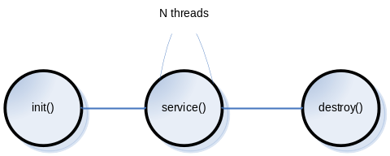
Typically, a servlet class is instantiated the first time it is invoked. This is called lazy instantiation. The same instance will be used over several client requests, so all members that are declared in that Servlet are shared across clients. That is what is meant by multi threaded model, multiple clients that access the same instance.
Web Container (Servlet Container)
- Instantiates each event listener
- For all Listener's that instantiated on step 1, and that implements ServletContextListener the container calls its contextInitialized() method.
- Instantiate each instance of Filter configured in web-app, for that particular servlet.
- Instantiate each instance of servlet with load-on-startup configured as 1
call Servlet.init() method.

What is Pre-Initialization of a Servlet?
On contrast to Lazy Initialization we can specify the order in which the servlet should be loaded and have the instance ready. This is achieved by using the following element in web.xml

<servlet>
<servlet-name>NameOfTheServlet</servlet-name>
<display-name>DisplayNameOfTheServlet</display-name>
<servlet-class>FullyQualifiedServletClassName</servlet-class>
<load-on-startup>2</load-on-startup>
</servlet>

What is SingleThreadModel?
Single Thread Model is a tag interface that a servlet can implement to transfer its re-entrancy problem to the servlet engine. javax.servlet.SingleThreadModel is part of the J2EE specification. If a Servlet implements this interface, you are guaranteed that no two threads will execute concurrently in the Servlet's service method. The Servlet container can make this guarantee by synchronizing access or serializing the requests to a single instance of the Servlet, or by maintaining a pool of Servlet instances and dispatching each new request to a free Servlet.

Evils
Its almost similar to synchronizing service() method. Implies another servlet can still access the shared attributes.

Difference between "ServletConfig" and "ServletContext"?
ServletConfig | ServletContext
Servlets have access to some servlet-specific configuration data at initialization time. This allows different instances of the same Servlet class to be initialized with different data, and be managed as differently named Servlets. The data provided at initialization time would include an area where each instance would keep its persistent instance-specific state. | Defines a set of methods that a Servlet uses to communicate with its Servlet container, for example, to get the MIME type of a file, dispatch requests, or write to a log file.
One per Servlet | One per WebApp
Use it to Pass deploy-time info to Servlet like init params - | Use it to access deploy-time info like web app params
Use to access ServletContext | Use it as a bulletin board so that any Servlet in the web-app can access it - Bulletin Board.
 | Use it to get Server Info
<servlet>  <servlet-name></servlet-name>  <servlet-class></servlet-class>  <init-param>  <param-name>userName</param-name>  <param-value>cooluser</param-value>  </init-param>  </servlet> | <web-app>  <context-param>  <param-name>email</param-name>  <param-value>email</param-value>  </context-param>  </web-app>

Note 1: Initparams are deploying time constants. They cannot be changed at runtime. No setInitParameter()method available.
Note 2: In the case of a web application marked "distributed" in its deployment descriptor, there will be one context instance for each virtual machine. In this situation, the context cannot be used as a location to share global information (because the information won't be truly global). Use an external resource like a database instead.
Note 3: The ServletContext object is contained within the ServletConfig object, which the Web server provides the Servlet when it is initialized.

How to read Parameters from the following objects?
ServletConfig | public void init(ServletConfig config) throws ServletException {  String userName = config.getInitParameter("userName");  Enumeration params = config.getInitParameterNames();  }  or from doXXX() methods  public void doGet( HttpServletRequest request,  HttpServletResponse response )  throws ServletException, IOException {  String dbuser = getServletConfig().getInitParameter("userName");  }
ServletContext | public void init(ServletConfig config) throws ServletException {  ServletContext sc = config.getServletContext();  String emailHost = sc.getInitParameter("email");  }  or from doXXX() methods  public void doGet( HttpServletRequest request,  HttpServletResponse response )  throws ServletException, IOException {  ServletContext sc1 = getServletConfig.getServletContext();  String emailHost = sc.getInitParameter("email");  ServletContext sc2 = getServletContext().getInitParameter( "email" );  }
HttpServletRequest | http://www.anitaonnuvel.com/anitaApp?firstname=anita&lastname=onnuvel  from doXXX() methods  public void doGet( HttpServletRequest request,  HttpServletResponse response )  throws ServletException, IOException {  String lastName = request.getParameter(“lastname”);  }
Note: All parameters are returned as Strings. No Casting to String is required.

Redirect vs RequestDispatcher?

Redirect
- Makes the browser do the work
- Redirect can use relative URL
- HTTP code is 3xx ( mostly 301)
http://en.wikipedia.org/wiki/URL_redirection

RequestDispatch
- Does the work on the server side.
- by calling forward / include

Request.getRequestDispatcher() takes relative path. ( Request for Relative )
ServletContext.getRequestDispatcher() takes absolute path.

What is the defference between getNamedDispatcher() and getRequestDispatcher()?
There are three ways to obtain RequestDispatcher object

- RequestDispatcher rd = request.getRequestDispatcher(arg); where arg(a string) can be a relative path or not to a particular resource. (i.e. jsp, servlet, etc.) It may be both a relative (not starting with '/') or relative (to this request) URL.
- RequestDispatcher rd = getServletContext().getRequestDispatcher(arg); where arg (a string) must be an absolute URL (starting with a '/') targeting a valid servlet or JSP file. This URL being associated to the servlet with a <servlet-mapping> element in the DD "/string" must NOT be a relative path. It must start with a forward slash "/".
- RequestDispatcher rd = getServletContext.getNamedDispatcher(arg); This method must take the servlet name as parameter. The servlet name is defined in web.xml as <servlet-name>. The request is dispatched to that corresponding servlet. arg must be the name of a servlet, as given by the <servlet-name> sub-element of the <servlet> element of the DD.
The main difference between these methods is that the "getNamedDispatcher()" method from (ServletContext interface) does not add some request "attributes" to the request operation. It means that the included or forwarded pages are not able to get some attributes from the request sent.
The getRequestDispatcher() methods sets the following request attributes while transferring the request in case of include:
javax.servlet.include.request_uri | /examples/jsp/include.jsp
javax.servlet.include.servlet_path | /jsp/include.jsp
javax.servlet.include.context_path | /examples
and it sets the following request attributes while transferring the request in case of forward:
javax.servlet.include.request_uri | /examples/jsp/include.jsp
javax.servlet.include.servlet_path | /jsp/include.jsp
javax.servlet.include.context_path | /examples
javax.servlet.forward.query_string | Shankar=Karthik

NamedDispatcher
Returns a RequestDispatcher object that acts as a wrapper for the named servlet.
getNamedDispatcher(String) method takes the name of the Servlet as parameter which is declared via Deployment descriptor. Example: Deployment Descriptor
<servlet>
<servlet-name>FirstServlet</servlet-name>
<servlet-class>com.example.ServletExample</servlet-class>
</servlet>
RequestDispatcher dispatch = getServletContext.getNamedDispatcher(“FirstServlet”);
dispatch.forward(request, response);
Note: A Servlet instance can determine its name using servletConfig.getServletName(); This method returns the name of the class that implements the Servlet interface or extends the HttpServlet class.
RequestDispatcher
Returns a RequestDispatcher object that acts as a wrapper for the resource located at the given path.
RequestDispatcher dispatch = request.getRequestDispatcher("/test");
Here "/test" represents the url-pattern element value of the servlet class.
<servlet-mapping>
<servlet-name>Test</servlet-name>
<url-pattern>/test</url-pattern>
</servlet-mapping>
It represents the path of the servlet class. Since both the base as well as target servlet are in the same package structure by just specifying the url-pattern element value we will be able to access the target servlet.
We shouldn't specify the entire path like
String str = "/WEB-INF/classes/com/example/posr/Test"
RequestDispatcher dispatch = request.getRequestDispatcher(str);
To forward a request to a JSP page we use
RequestDispatcher dispatch = request.getRequestDispatcher("/TestJspOne.jsp");
Here "/TestJspOne.jsp" the slash denotes the Jsp page is at the root of the application.

Difference between RequestDispatcher.include() and RequestDispatcher.forward()?
http://www.ibm.com/developerworks/java/library/j-pj2ee7.html

Flow Control Techniques
 | RequestDispatcher.forward() | RequestDispatcher.include()
Processing  Control | In J2EE Web development, a forward transfers control for processing the user's request to another Web component. | Rather than transferring control, as you do with a forward, the component performing the “include” maintains control of the request and simply requests that the output of another component be included at a particular point within the page.
Response  Content | Source cannot set response - partially processes a request and then transfers to another component depending on the nature of the request. | Yes. Target can write to the response and commit a response.
Response  Headers | Source cannot set | Target cannot set headers or call any method (for example, setCookie) that affects the headers of the response.
Uses | This can be useful if you need one component to set up some JavaBeans, open or close resources, authenticate the user, or otherwise perform some prep work prior to passing control to the next component. | This is an excellent way to handle common design elements such as headers, footers, and navigation panes.
The execution control returns to the resource that has called the forward() method after the callee resource finishes processing. RequestDispatcher.forward() is also a normal method call, so the control does return to the calling resource.

What is a SSI?
http://en.wikipedia.org/wiki/Server_Side_Includes

Servlet Mapping?
It is a way to control they way of accessing the Servlets. Control is done by specifying the URL pattern.

A Servlet can have 3 names
- Actual *.java name
- Deployment Name
- Given by Servlet Mapping

By mapping the name instead of coding in the real file and path name, we have
- Flexibility to move things around a while without any maintenance nightmare of tracking down and changing the client code.
- Security - No one comes to knows of the server structure.

What are the various Session Tracking methods in Servlets?
http://publib.boulder.ibm.com/infocenter/iseries/v5r3/index.jsp?topic=/rzatz/51/program/sesdeci.htm

Session Tracking  Methods | Advantages |  | Disadvantages
User Authentication | Easy to implement.  The user may access the site from different machine. Sessions may last indefinitely. |  | User needs to create an account on the server.  Requires a login process the first access.  Not easy to support anonymous users.
URL Rewriting  Description:  With URL rewriting, links returned to the browser or redirect have the session ID appended to them. For example, the following link in a Web page:  <a href="/store/catalog">  is rewritten as:  <a href="store/catalog;jsessionid=DA32242SSGE2">  When the user clicks the link, the rewritten form of the URL is sent to the server as part of the client's request. The Web container recognizes; jsessionid=DA32242SSGE2 as the session ID and saves it for obtaining the proper HttpSession object for this user.  response.encodeURL | Let user remain anonymous.  They are universally supported (most styles). |  | Tedious to rewrite all URLs.  Only works for dynamically created  documents.  An application that uses URL rewriting to track sessions must adhere to certain programming guidelines. The application developer needs to:  - Program session Servlets to encode URLs  - Supply a Servlet or JSP file as an entry point to the application  - Avoid using plain HTML files in the application
Hidden Forms | Universally supported.  Allow anonymous users |  | Only works for a sequence of dynamically generated forms.  Relies on POST  Breaks down with static documents, emailed documents, bookmarked documents.  No browser shutdowns.
Cookies | Very easy to implement.  Highly customizable.  Persist across browser shut-downs |  | Often: users turn off cookies for privacy or security reason.  Not quite universal browser support.
SERVER SIDE
SSL Sessions  Description:  Secure Sockets Layer, the encryption technology used in the HTTPS protocol, has a built-in mechanism allowing multiple requests from a client to be unambiguously identified as being part of a session. A Servlet container can easily use this data to define a session. |  |  |  | Can be used only with HTTPS  Easy to Manage
Session
Use SSB
Use a DB

What technique does HttpSession uses to maintain a session.
HttpSession API is written on Cookies with fallback on URL- Re Writing.

- First request to request.getSession(), the container will use both Cookies and URL Re-Writing
- On second request, if the client sends cookies, it will use cookies to maintain session else will use URL Re-Writing technique.
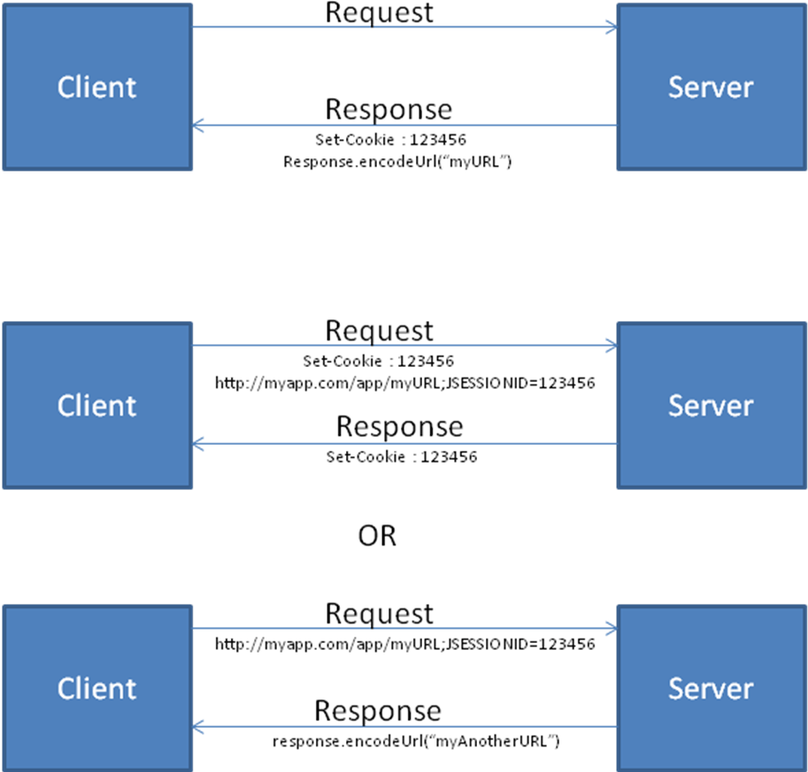

HttpSession Events
Milestone | Methods | Event | Listener
Lifecycle | new / invalidate() | HttpSessionEvent | HttpSessionListener
Attributes | setAttribute()/add  removeAttribute()  setAttribute()/replace | HttpSessionBindingEvent | HttpSessionAttributeListener
Migration |  | HttpSessionEvent | HttpSessionActivationListener

Listener API
ServletContext | ServletContextListener | contextInitialized( ServletContextEvent )  contextDestroyed( ServletContextEvent )
ServletContext | ServlerContextAttributeListener | attributeAdded(ServletContextAttributeEvent)  attributeRemoved(ServletContextAttributeEvent)  attributeReplaced(ServletContextAttributeEvent)
ServlerRequest | ServlerRequestListener | requestInitialized(ServletRequestEvent)  requestDestroyed(ServletRequestEvent )
ServlerRequest | ServlerRequestAttributeListener | attributeAdded(ServletRequestAttributeEvent)  attributeRemoved(ServletRequestAttributeEvent)  attributeReplaced(ServletRequestAttributeEvent)
HttpSession | HttpSessionListener | sessionCreated(HttpSessionEvent)  sessionDestroyed(HttpSessionEvent)
HttpSession | HttpSessionAttributeListener | attributeAdded(HttpSessionBindingEvent)  attributeRemoved(HttpSessionBindingEvent)  attributeReplaced(HttpSessionBindingEvent)
HttpSession | HttpSessionBindingListener | valueBound(HttpSessionBindingEvent)  valueUnbound(HttpSessionBindingEvent)

Difference between HttpSessionBindingListener and HttpSessionAttributeListener

Attribute API
All below classes provide attribute API to set and get Attributes. Attributes are always String, Object pair i.e., String literals are used to hold any objects

Scopes
- Context → ServletContext
- Session → HttpSession
- Request → ServletRequest

- Context scope attributes are not thread safe.
Synchronizing the service method can save only Servlet A but doesn’t stop another Servlet B to access the attributes in context scope
Solution:
synchronized ( getServletContext () ) { }
But the problem is all servlets in a web application Servlets A, B,...Z should do this to ensure safety

- Session scope attributes are not thread safe.
Reason: If client opens another tab/browser then it is not thread safe. So synchronize HttpSession too

So Only
- Request scope attributes and local variables are thread-safe.

Techniques to create Sessions
- request.getSession( false ) ==> always returns current HttpSession, and if the request has no valid HttpSession, this method returns null.
- request.getSession( true ) ==> Returns the current HttpSession associated with this request or, returns a new HttpSession.
- request.getSession() ==> Returns the current HttpSession associated with this request, or if the request does not have a session, creates one.

How to specify a session timeout?
<get|set>MaxInactiveInterval() in Session.

Cookies getting and setting values
Reading Cookies:
Cookie[] lCookies = request.getCookies();
for( Cookie lCookie : lCookies ) {
System.out.println( lCookie.getName());
System.out.println( lCookie.getValue());
}
Writing Cookies:
Cookie userCookie = new Cookie("user", "uid1234");
response.addCookie(userCookie);
Attributes of a Cookie | Description
Name
Value
Domain | Gets/sets the domain to which cookie applies. Normally, cookies are returned only to the exact hostname that sent them. You can use this method to instruct the browser to return them to other hosts within the same domain. Note that the domain should start with a dot (e.g. .prenhall.com), and must contain two dots for non-country domains like .com, .edu, and .gov, and three dots for country domains like .co.uk and .edu.es.
MaxAge
Path | If you don't specify a path, the cookie is returned for all URLs in the same directory as the current page as well as all subdirectories. This method can be used to specify something more general. For example, someCookie.setPath("/") specifies that all pages on the server should receive the cookie. Note that the path specified must include the current directory.
Secure | The boolean value indicating whether the cookie should only be sent over encrypted (i.e. SSL) connections.
Version
Comment

What are filters?
Filters introduced in Servlet spec version 2.3 are objects that dynamically intercept request and response to transform or use the information contained in the requests or responses.
They provide the ability to encapsulate recurring tasks in reusable units. Organized developers are constantly on the lookout for ways to modularize their code. Modular code is more manageable and document able, easier to debug, and if done well, can be reused in another setting.

Filter API
The filter API is defined by the Filter, FilterChain, and FilterConfig interfaces in the javax.servlet package. You define a filter by implementing the Filter interface. A filter chain, passed to a filter by the container, provides a mechanism for invoking a series of filters. A filter config contains initialization data.
- init
- doFilter( Request, Response, FilterChain )
- destroy()
public final class HitCounterFilter implements Filter {
private FilterConfig filterConfig = null;

public void init(FilterConfig filterConfig)
throws ServletException {
this.filterConfig = filterConfig;
}

public void destroy() {
this.filterConfig = null;
}

public void doFilter(ServletRequest request,
ServletResponse response, FilterChain chain)
throws IOException, ServletException {
if (filterConfig == null)
return;
StringWriter sw = new StringWriter();
PrintWriter writer = new PrintWriter(sw);
Counter counter = (Counter)filterConfig.
getServletContext().
getAttribute("hitCounter");
writer.println();
writer.println("===============");
writer.println("The number of hits is: " +
counter.incCounter());
writer.println("===============");
// Log the resulting string
writer.flush();
filterConfig.getServletContext().
log(sw.getBuffer().toString());
...
chain.doFilter(request, wrapper);
...
// filter post-processing code
}
}
A filter can block the request in which case it populates the response using the Wrappers.
Uses:
- Authentication-Blocking requests based on user identity.
- Logging and auditing-Tracking users of a web application.
- Image conversion-Scaling maps, and so on.
- Data compression-Making downloads smaller.
- Localization-Targeting the request and response to a particular locale.
- XSL/T transformations of XML content-Targeting web application responses to more that one type of client.

What is Servlet Caching?

Structure of a WEB APP
WEBAPP
|
|__WEB-INF
| |
| |__lib
| |__classes
| |__web.xml
|
|__{Unprotected_Public_Data such as html_and_jsp_files_and_sub_directories }

What is a JSP? Lifecycle of a JSP? Explain translation of a JSP page?

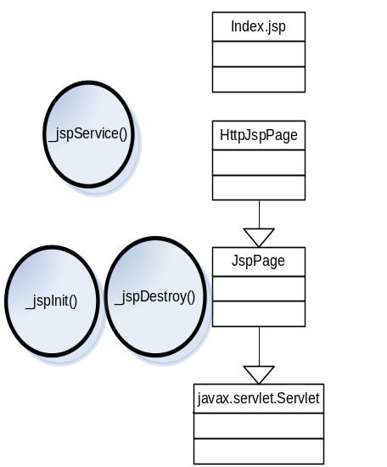Note: At runtime, index.jsp will get converted as a index.java file which will be extending container specific class which implements HttpJspPage. For eg. in Tomcat the pages will extend org.apache.jasper.runtime.HttpJspBase. The container will then know how to convert this class to a servlet at runtime. That’s the reason there is a disconnect in extensions between index.jsp and HttpJspPage interface. Also note both HttpJspPage and JspPage are interfaces.
A JSP is a text document that contains two types of text
- Static data – which can be expressed in any text-based format – HTML, SVG, WML and XML
- JSP elements – which construct dynamic contents based on Servlet technology.

When a request hits the servlet container, the container checks if the JSP’s servlet is older than the JSP page. If so it translates the JSP page to a servlet and process the request.

The page is translated and compiled once and happens during first request. To save time you can append ?jsp_precompile and compile it to save time.

What implicit objects are available in a JSP page?
Implicit objects let developers access container-provided services and resources. These objects are defined as implicit because you do not have to explicitly declare them. They are defined in every JSP page and used behind the scenes by the container whether you declare them or not -- although you cannot redeclare them. Because implicit objects are declared automatically, we need only use the reference variable associated with a given object to begin calling methods on it.
http://www.ibm.com/developerworks/java/library/j-pj2ee7.html

Implicit Object | Class or Interface | Description
page | javax.servlet.jsp.HttpJspPage | Page's Servlet instance processing the current request.
config | javax.servlet.ServletConfig | Servlet Config
pageContext | javax.servlet.jsp.pageContext | Encapsulates other implicit objects, so if you give some helper object a reference of the pageContext, the helper class can use it to get references of the other implicit objects and attributes from all scopes.
request | javax.servlet.http.HttpServletRequest | Data included with the HTTP Request
response | javax.servlet.http.HttpServletResponse | HTTP Response data, e.g. cookies
out | javax.servlet.jsp.JspWriter | Provides access to Servlet’s Output stream.
session | javax.servlet.http.HttpSession | User specific session data. Only if the page participates in a session
application | javax.servlet.ServletContext | Data shared by all application pages
exception | java.lang.Exception | If a Page is configured as Error Page

How to do doGet() doPost() in a JSP page?

