Basics : JavaEE -JMS

Prepared by

Shankar Karthik & Anita

Difference between "Topic" and "Queue"?
Queue | Topic
Point to Point –intended for one recipient | Publish Subsribe
One Producer and One consumer per Message | Producers publish to ACTIVE Consumers
Store and Forward | Broadcast
There can be more than one Producer and one consumer | The topic messages can be stored and made available for inactive consumers

What is DurableSubsriber?
Nondurable subscriptions last for the lifetime of their subscriber object. This means that a client will only see the messages published on a topic while its subscriber is active. If the subscriber is not active, it is missing messages published on its topic. At the cost of higher overhead, a subscriber can be made durable.

A durable subscriber registers a durable subscription with a unique identity that is retained by JMS. Subsequent subscriber objects with the same identity resume the subscription in the state it was left in by the prior subscriber. If there is no active subscriber for a durable subscription, JMS retains the subscription’s messages until they are received by the subscription or until they expire. All JMS providers must be able to run JMS applications that dynamically create and delete durable subscriptions. Some JMS providers may, in addition, provide facilities to administratively configure durable subscriptions. If a durable subscription has been administratively configured, it is valid for it to silently override the subscription specified by the client. An inactive durable subscription is one that exists but does not currently have a message consumer subscribed to it.

What is the use of setClientId()?
The purpose of client identifier is to associate a connection and its objects with a state maintained on behalf of the client by a provider. The only such state identified by JMS is that required to support durable subscriptions.

Use of Sessions
- It is a factory for its message producers and consumers.
- It supplies provider-optimized message factories.
- It supports a single series of transactions that combine work spanning its producers and consumers into atomic units.
- It defines a serial order for the messages it consumes and the messages it produces.
- It retains messages it consumes until they have been acknowledged.
- It serializes execution of message listeners registered with its message consumers.

Is there durability in Queue?
A "durable message" is a message where the JMS server will hold on to a message if the subscriber is temporarily unavailable. So the durability is defined by the relationship between a "Topic Subscriber" and the "JMS Server". Durability is applicable only to publish/Subscribe paradigm. For this to happen subscribers need to register themselves with a unique "client id ".
A "persistent message" is a message that defines the relationship between a "Message Producer" and the "JMS Server". This can be established for both
point-to-point and publish/subscribe. This has to do with the guaranteed once only delivery of the message by persisting the message after it has been received from the message producer.

The bean identified as commandManager will call its own method createCommand() whenever it needs a new instance of the command bean. It is important to note that the person deploying the beans must be careful to deploy the command bean as a prototype (if that is actually what is needed). If it is deployed as a singleton, the same instance of the command bean will be returned each time!Describe ACK modes in JMS?
If a session is not transacted, there are three acknowledgment options, and recovery is handled manually:

DUPS_OK_ACKNOWLEDGE | This option instructs the session to lazily acknowledge the delivery of messages. This is likely to result in the delivery of some duplicate messages if JMS fails, so only consumers that are tolerant of duplicate messages should use it.  Benefits: Reduction of session overhead achieved by minimizing the work the session does to prevent duplicates.
AUTO_ACKNOWLEDGE | With this option, the session automatically acknowledges a client’s receipt of a message when it has either successfully returned from a call to receive or the MessageListener it has called to process the message successfully returns.
CLIENT_ACKNOWLEDGE | With this option, a client acknowledges a message by calling the message’s acknowledge method. Acknowledging a consumed message automatically acknowledges the receipt of all messages that have been delivered by its session [ie. Any other Consumers].

When CLIENT_ACKNOWLEDGE mode is used, a client may build up a large number of unacknowledged messages while attempting to process them. A JMS provider should provide administrators with a way to limit client over-run so that clients are not driven to resource exhaustion and ensuing failure when some resource they are using is temporarily blocked.

A session’s recover method is used to stop a session and restart it with its first unacknowledged message. In effect, the session’s series of delivered messages is reset to the point after its last acknowledged message. The messages it now delivers may be different from those that were originally delivered due to message expiration and the arrival of higher-priority messages. A session must set the redelivered flag of messages it redelivers due to a recovery.

What are the delivery modes in JMS?

MESSAGE  DELIVERY  MODES | Description
NON_PERSISTENT | The lowest-overhead delivery mode because it does not require that the message be logged to stable storage. A JMS  Provider failure can cause a NON_PERSISTENT message to be lost.
PERSISTENT | This mode instructs the JMS provider to take extra care to insure the message is not lost in transit due to a JMS provider failure.

A JMS provider must deliver a NON_PERSISTENT message at-most-once. This means that it may lose the message, but it must not deliver it twice.
A JMS provider must deliver a PERSISTENT message once-and-only-once. This means a JMS provider failure must not cause it to be lost, and it must not deliver it twice.
Session maintains the Ordering only within the Delivery Mode. If a PERSISTENT and a NON_PERSISTENT are sent to the same destination ordering will be preserved PERSISTENT among and NON_PERSISTENT messages individually.

What is PreserveUndelivered?
Provider specific message property which is set by the application if this message should be placed into special system queue in case it could not be delivered. - JMS_TIBCO_PRESERVE_UNDELIVERED

What is the advantage of using a MOM and Asynchrony?
www.theserverside.com/tt/articles/content/JMSArchitecture/JMSApplicationArchitemmctures.pdf

Loose-Coupling
- Process Level – Producer process can be up and send messages to the destination and not worry about the consumer process of the message being up and running.
- Application Level – While RPC used in EJBs, CORBA, DCOM, RMI etc are interface centric. Any change can affect the consumers. Messaging dictates data centric development.

Describe how will you get a Session?
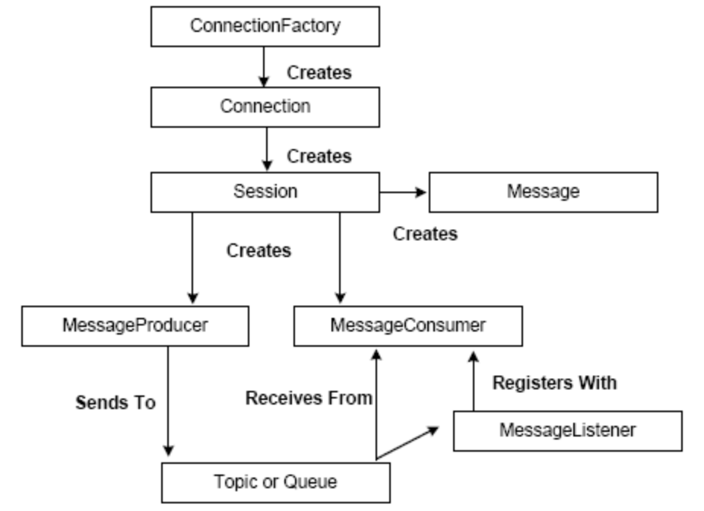

InitialDirContext lInitialDirContext = new InitialDirContext( lEnvMap );
//Send all the configuration to it
//String lContextFactory;
//String lUserName;
//String lPassword;

ConnectionFactory lConnectionFactory = ( ConnectionFactory )
lInitialDirContext.lookup( “ConnectionFactoryClassName” );
lConnection = lConnectionFactory.createConnection( lUserName, lPassword );
Session lSession = lConnection.createSession( lTransacted, lAckModeInt );
// Set Exception Listener on Connection Object
lConnection.setExceptionListener( MyExceptionListener );
// Set Message Listener on Session Object
lSession.setMessageListener( new MessageListener() );

// Producer
MessageProducer lMessageProducer = lSession.createProducer( lDestination );
TextMessage lTextMessage = lSession.createTextMessage();
lTextMessage.clearBody();
lTextMessage.clearProperties();
// specific for TIBCO EMS
lTextMessage.setBooleanProperty( “PRESERVE_UNDELIVERED”,
true );
lTextMessage.setText( getMessageString( pMessage ) );
lProducer.send( lTextMessage, lDeliveryMode, lPriority, lTimeToLive );
lReturnMessageId = lTextMessage.getJMSMessageID();

// Consumer(can be QueueReceiver or TopicReceiver
MessageConsumer lMessageConsumer = lSession.createConsumer( lDestination );
lMessageConsumer.setMessageListener( new MessageListener() );
lConnection.start();
Message lMessage1 = lMessageConsumer.receive();
lMessage1.acknowledge();

//
Message lMessage2 = lMessageConsumer.receive();
Message lMessage3 = lMessageConsumer.receive();
lMessage3.acknowledge();

Setting MessageListener with Session vs Consumer

TODO-TODO-TODO-TODO-TODO

Message Types in JMS?

Message type | Description
Message | The base class. This message type is used for event notification and does not have a payload.
BytesMessage | The payload is stored as an array of bytes. This message type is useful for exchanging data in an application’s native format and when JMS is used as a transport between two systems, where the JMS client does not know the message payload type.
TextMessage | Data is stored as a string. This message type is useful for exchanging simple text messages and for more complex character data, such as XML documents.
StreamMessage | A Stream message is a sequence of primitive Java types. The message object keeps track of the order and the types of these primitives within the stream. Formal conversion rules apply; for example, an exception is thrown if a JMS application tries to read a double value as a short value. If the data structure is unknown, the generic method readObject() can be used to return the next object in the stream. If the structure of the data is known, the JMS client can be specific about the type of object being accessed.
MapMessage | The payload of a MapMessage is stored as a set of name-value pairs. The name is defined as a string and the value is typed. The MapMessage is useful for delivering keyed data that can change from one message to the next. Data can be accessed by using getMapNames(), which returns a Java Enumeration object. It is possible to iterate through the MapMessage by using hasMoreElements() to retrieve the mapped name-value pairs.
ObjectMessage | The ObjectMessage carries a Serializable Java Object as its payload. It is useful for exchanging Java objects.

Design Patterns in JMS
  - Inversion of Control
  - Observer Pattern when I use Publish-Subscribe model
  - Factory Pattern

