Basics : JavaEE -EJB 2.x & 3.0

Prepared by

Shankar Karthik & Anita

Java EE

http://www.devx.com/Java/Article/20843/0/page/3

Enterprise Java Beans 2.x

EJB 2.1 Architecture
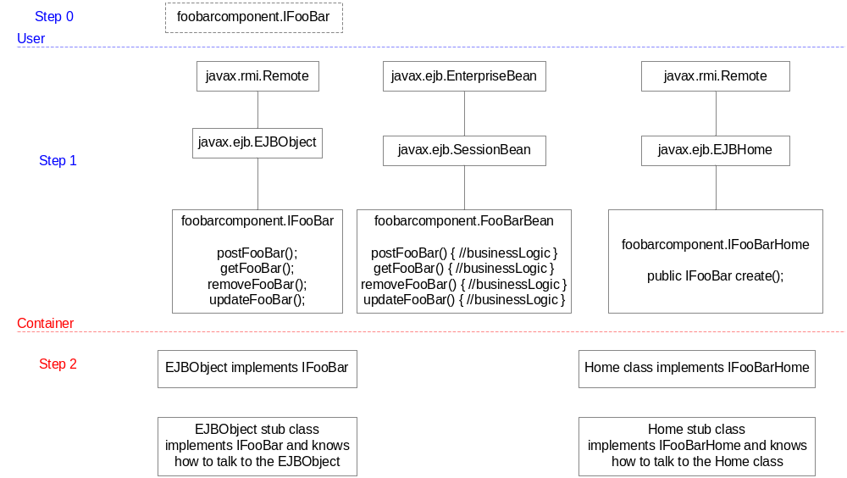

Enterprise Java Beans 3.0

Lifecycle Callback Methods

Define your own methods and assign the callback annotations

SSLB | SFSB | EB | MDB
postConstruct()  preDestroy() | postConstruct()  preDestroy()  prePassivate()  postActivate() |  | postConstruct()  preDestroy()

