Basics : JavaEE JAX-P & JAX-B

Prepared by

Shankar Karthik & Anita

XML

XML InfoSet
The XML Information Set (Infoset) defines a data model for XML. This data model is a set of abstractions that detail the properties of XML trees. These abstractions provide a common viewpoint from which to think about XML APIs and higher-level specifications such as XPath, XSLT and XML Schema. http://msdn.microsoft.com/en-us/library/aa468561.aspx
The root of an Infoset is always a document information item. The most important property of the document information item is the [children] property, which is a list of information items, in document order (a depth-first traversal of the tree), that are immediate descendants of the document information item. Exactly one of those information items is an element information item. This element is known as the document element and is also present in the [document element] property of the document information item. Comment and processing instruction information items may also appear in the [children] property. In the case where the only child of the document information item is the document element, the [children] and [document element] properties essentially have the same value.  It is worth noting that without the document information item, XML would be a forest rather than a tree, due to the possibility of comments and processing instructions appearing before and after the document element. It is the document information item, which is pretty much entirely abstract, that makes XML a tree. All other information items in the tree are descendants of the document information item. |  |  | 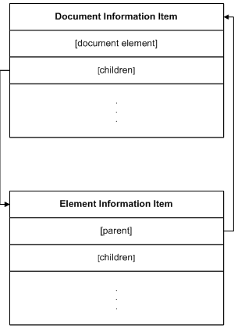
XML Information Sets are predominantly made up of element information items and attribute information items. The former can be used to model structured or simple values while the latter can only be used to model simple values. Both types of information item have several important properties. For element information items, the [parent] property contains the information item that is the parent of the element information item. In the case of the document element, this will be the document information item, while for all other elements it will be another element information item. In both cases the [children] property of the parent information item will contain the element information item.  Element information items also have a [children] property that, like the [children] property of the document information item, contains all the immediate descendants of the element information item. These descendants may be other element information items, comment or processing instruction information items, or character information items.  Element information items have two name-related properties: [local name] and [namespace name]. The value of the latter is either the URI of the namespace the element belongs to or, if the element is not associated with a namespace, it is empty. The value of the [local name] property is the local part of the name of the element, scoped by the [namespace name] property. Together these two properties make up the name of the element information item. Two element information items with the same value for [local name] but different values for [namespace name] are assumed to be semantically distinct.  The list of attribute information items associated with an element information item is modeled by the [attributes] property. This property is an unordered list of attribute information items. Such information items are not considered to be part of the tree directly, so doing a depth-first traversal of the [children] properties of all information items starting with the document information item will not encounter any attribute information items. |  |  |  | 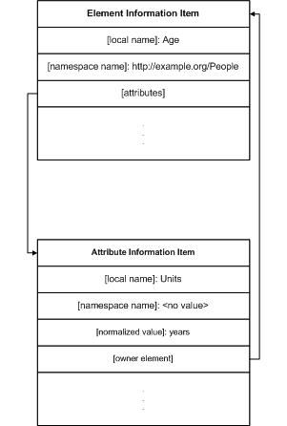  Attribute information items share some properties with element information items. For instance, the [namespace name] and [local name] properties of an attribute information item are interpreted the same way as those of an element information item. However, other aspects of attribute information items are modeled differently. There is no [children] property; rather, attribute information items have a [normalized value] property that contains the simple value of the attribute. Similarly there is no [parent] property; instead, there is an [owner element] property whose value is the element information item whose [attributes] property has the attribute information item in its list.
Textual content of element information items is modeled using character information items. There is a [parent] property that contains the element information item whose [children] property contains the character information item. The other important property is the [character code] property, the value of which is the ISO 10646 character code that represents the character. |  | 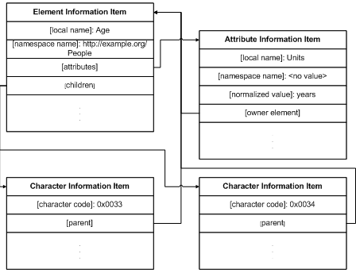
Namespaces are used to disambiguate the names of element and attribute information items. As discussed earlier, every element and attribute information item has a two-part name. Where the [namespace name] part of that name is not empty, the name is said to be a qualified name, the local part is qualified by the namespace part. The Infoset models namespaces using a combination of namespace information items and attribute information items.  Each element has an [in-scope namespaces] property that contains a set of namespace information items. These information items have two properties: a [namespace name] property whose value is a URI and a [prefix] property whose value is the prefix to which the namespace URI is bound. This prefix to namespace name mapping can be used to determine the namespace affiliation of values in the tree. Such values may appear as the character information item children of element information items, or as the value of attribute information items. | 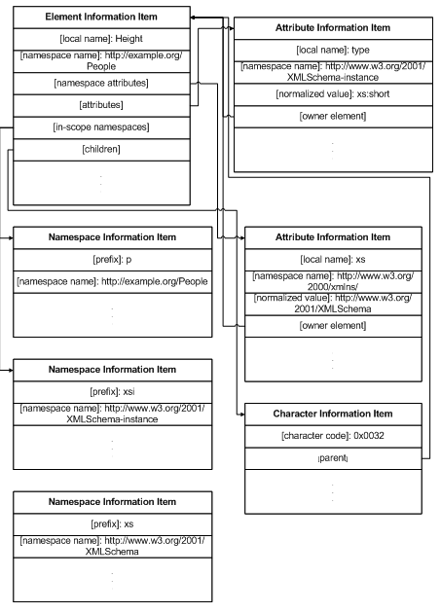Each element information item also has a [namespace attributes] property. This property is a set of attribute information items. For each attribute information item in the set, the [namespace name] property is always http://www.w3.org/2000/xmlns/. The [local name] part is the prefix used when referring to things in that namespace. These attribute information items are important when it comes to serializing and deserializing an Infoset.

XML Parsing APIs in JAX-P
Generally speaking, there are two programming models for working with XML infosets: streaming and the document object model (DOM).

DOM
The DOM model involves creating in-memory objects representing an entire document tree and the complete infoset state for an XML document.
Once in memory, DOM trees can be navigated freely and parsed arbitrarily, and as such provide maximum flexibility for developers.
Drawbacks:
The cost of this flexibility is a potentially large memory footprint and significant processor requirements, because the entire representation of the document must be held in memory as objects for the duration of the document processing. This may not be an issue when working with small documents, but memory and processor requirements can escalate quickly with document size.

SAX
Streaming refers to a programming model in which XML infosets are transmitted and parsed serially at application runtime, often in real time, and often from dynamic sources whose contents are not precisely known beforehand. SAX is a push Streaming API – the parser with push events to the application( DefaultHandler)
Advantages:
Stream-based parsers can start generating output immediately, and infoset elements can be discarded and garbage collected immediately after they are used.
Streaming models for XML processing are particularly useful when your application has strict memory limitations, as with a cell phone running J2ME, or when your application needs to simultaneously process several requests, as with an application server.
Drawbacks:
While providing a smaller memory footprint, reduced processor requirements, and higher performance in certain situations, the primary trade-off with stream processing is that you can only see the infoset state at one location at a time in the document. You are essentially limited to the “cardboard tube” view of a document, the implication being that you need to know what processing you want to do before reading the XML document.

XPath
XPath is an expression language designed for extracting specific bits of data from an XML document.

TrAX (XSLT)
TrAX is an API for transforming source documents into result documents using XSLT (XML Stylesheet Language for Transformations), a declarative, rule-based language. XPath is a foundational part of XSLT and is used to query nodes from the source document and apply styling templates to them to create a result document. A TrAX source document may be created via SAX or DOM. TrAX requires both Java and XSLT skills.

JAXP- StAX:
StAX (Streaming API for XML) is a Java specific API from JAX-P family that provides a standard, bidirectional pull parser interface for streaming XML processing, offering a simpler programming model than SAX and more efficient memory management than DOM. StAX enables developers to parse and modify XML streams as events, and to extend XML information models to allow application-specific additions.

Pull Parsing versus Push Parsing
Streaming pull parsing refers to a programming model in which a client application calls methods on an XML parsing library when it needs to interact with an XML infoset; that is, the client only gets (pulls) XML data when it explicitly asks for it.

Streaming push parsing refers to a programming model in which an XML parser sends (pushes) XML data to the client as the parser encounters elements in an XML infoset; that is, the parser sends the data whether or not the client is ready to use it at that time.

Pull parsing provides several advantages over push parsing when working with XML streams:

- With pull parsing, the client controls the application thread, and can call methods on the parser when needed. By contrast, with push processing, the parser controls the application thread, and the client can only accept invocations from the parser.

- Pull parsing libraries can be much smaller and the client codes to interact with those libraries much simpler than with push libraries, even for more complex documents.
- Pull clients can read multiple documents at one time with a single thread.

StAX vs SAX

- StAX-enabled clients are generally easier to code than SAX clients. While it can be argued that SAX parsers are marginally easier to write, StAX parser code can be smaller and the code necessary for the client to interact with the parser simpler.
- StAX is a bidirectional API, meaning that it can both read and write XML documents. SAX is read only, so another API is needed if you want to write XML documents.
- SAX is a push API, whereas StAX is pull. The trade-offs between push and pull APIs outlined above apply here.

Features  from  JAXP-API | StAX | SAX | DOM | TrAX
API Style | Pull, Streaming | Push, Streaming | In Memory Tree | XSLT Rule
Ease of Use | High | Medium | High | Medium
XPath Capability | Not Supported | Not Supported | Supported | Supported
CPU and Memory Efficiency | Good | Good | Varies | Varies
Forward Only | Supported | Supported | Not Supported | Not Supported
Read XML | Supported | Supported | Supported | Supported
Write XML | Supported | Not Supported | Supported | Supported
CRUD Operations | Not Supported | Not Supported | Supported | Not Supported

XQuery
XQuery extends XPath (is Turing-complete) and can be considered a general-purpose language; it easily overcomes many of the limitations of XPath, at the expense of introducing a little complexity.
XPath has limitations that it cannot transform the result. For ex.

/persons/person[age lt 12]/firstname/text()
on the below XML Will return
archanaa2
archanaa

<?xml version="1.0"?>
<persons>
<person>
<firstname>archanaa2</firstname>
<lastname>shankar karthik</lastname>
<age>1</age>
<sex>female</sex>
</person>
<person>
<firstname>archanaa</firstname>
<lastname>shankar karthik</lastname>
<age>1</age>
<sex>female</sex>
</person>
</persons>

XQuery can sort this data and give back.

What is the need for a Schema?
Though Schema is good, it does only syntactic validation. It doesn’t do semantic validation.

How DTD does differ from a Schema?
http://www-128.ibm.com/developerworks/xml/library/x-matters7.html

Features | DTD | XML Schema
Rich Typing | Either #CDATA or #PCDATA | Built in data types  Allows building new dataypes.
Occurrence Constraints | Contains only ? * +  Have to repeat the data for ranges n-m | minoccurs and maxoccurs
Enumeration | Only attributes | Both attributes and elements using simpleType. This allows the enum to be used anywhere unlike DTD.

PCDATA vs CDATA
PCDATA means parsed character data. Think of character data as the text found between the start tag and the end tag of an XML element. PCDATA is text that WILL be parsed by a parser. The text will be examined by the parser for entities and markup.
Tags inside the text will be treated as markup and entities will be expanded.
However, parsed character data should not contain any &, <, or > characters; these need to be represented by the &amp; &lt; and &gt; entities, respectively.
CDATA means character data. CDATA is text that will NOT be parsed by a parser. Tags inside the text will NOT be treated as markup and entities will not be expanded.

What is the need for a namespace in XML Schema?
The XML namespaces recommendation defines a way to distinguish between duplicate element type and attribute names. http://www.rpbourret.com/xml/NamespacesFAQ.htm

Xpath vs Xquery
XQuery is similar to SQL and provides JOINS between multiple documents with where clause and stuffs.

When to declare An Element vs An Attribute
http://www.ibm.com/developerworks/xml/library/x-eleatt/index.html

Principle of core content
If you consider the information in question to be part of the essential material that is being expressed or communicated in the XML, put it in an element. For human-readable documents this generally means the core content that is being communicated to the reader. For machine-oriented records formats this generally means the data that comes directly from the problem domain. If you consider the information to be peripheral or incidental to the main communication, or purely intended to help applications process the main communication, use attributes. This avoids cluttering up the core content with auxiliary material. For machine-oriented records formats, this generally means application-specific notations on the main data from the problem-domain.
As an example, many XML formats, usually home-grown in businesses, where document titles were placed in an attribute. A title is such a fundamental part of the communication of a document that it should always be in element content. On the other hand, in many cases internal product identifiers are thrown as elements into descriptive records of the product. In some of these cases, attributes were more appropriate because the specific internal product code would not be of primary interest to most readers or processors of the document, especially when the ID was of a very long or inscrutable format.

You might have heard the principle data goes in elements, metadata in attributes. The above two paragraphs really express the same principle, but in more deliberate and less fuzzy language.

Principle of structured information
If the information is expressed in a structured form, especially if the structure may be extensible, use elements. On the other hand: If the information is expressed as an atomic token, use attributes. Elements are the extensible engine for expressing structure in XML. Attributes are designed for expressing simple properties of the information represented in an element.

For example: A date has fixed structure and generally acts as a single token, so it makes sense as an attribute (preferably expressed in ISO-8601). Representing personal names, on the other hand, is a case where one should use Elements. A personal name has surprisingly variable structure (in some cultures you can cause confusion or offense by omitting honorifics or assuming an order of parts of names). A personal name is also rarely an atomic token. As an example, sometimes you may want to search or sort by a forename and sometimes by a surname. Thus:
<customer>
<name>Gabriel Okara</name>
<occupation>Poet</occupation>
</customer>

<customer name="Gabriel Okara">
<occupation>Poet</occupation>
</customer>

Principle of readability
If the information is intended to be read and understood by a person, use elements. In general this guideline places prose in element content. If the information is most readily understood and digested by a machine, use attributes. In general this guideline means that information tokens that are not natural language go in attributes.

URLs are a great example: People have learned to read URLs through exposure in Web browsers and e-mail messages, but a URL is usually not much use without the computer to retrieve the referenced resource. Some database identifiers are also quite readable (although established database management best practice discourages using IDs that could have business meaning), but such IDs are usually props for machine processing.

Principle of element/attribute binding
Use an element if you need its value to be modified by another attribute. XML establishes a very strong conceptual bond between an attribute and the element in which it appears. An attribute provides some property or modification of that particular element. Processing tools for XML tend to follow this concept and it is almost always a terrible idea to have one attribute modify another. For example, if you are designing a format for a restaurant menu and you include the portion sizes of items on the menu, you may decide that this is not really important to the typical reader of the menu format so you apply the Principle of core content and make it an attribute. The first attempt is:

<menu>
<menu-item portion="250 mL">
<name>Small soft drink</name>
</menu-item>
<menu-item portion="500 g">
<name>Sirloin steak</name>
</menu-item>
</menu>

Following the Principle of structured information you decide not to shoehorn the portion measurement and units into a single attribute, but instead of using an element, you opt for:
<menu>
<menu-item portion-size="250" portion-unit="mL">
<name>Small soft drink</name>
</menu-item>
<menu-item portion-size="500" portion-unit="g">
<name>Sirloin steak</name>
</menu-item>
</menu>

The attribute portion-unit now modifies portion-size, which is a bad idea. An attribute on the element menu-item should modify that element, and nothing else. The solution is to give in and use an element:
<menu>
<menu-item>
<portion unit="mL">250</portion>
<name>Small soft drink</name>
</menu-item>
<menu-item>
<portion unit="g">500</portion>
<name>Sirloin steak</name>
</menu-item>
</menu>

In this case we applied a mix of the Principle of core content and the Principle of readability to the decision to put the value in content and the units in an attribute. The solution also involves contradicting the original decision to put the portion size into an attribute based on the Principle of core content. This illustrates that sometimes the principles will lead to conflicting conclusions where you'll have to use your own judgment to decide on each specific matter.

