Basics : Database & SQL

Prepared by

Shankar Karthik & Anita

SQL Syntax:
CREATE | TABLE simpletable  ( column1 varchar(15),  column2 varchar(15),  column3 varchar(15)  );
DROP
SELECT | $Column_Name FROM $Table_Name WHERE $Column_Name >= ‘XX’;
UPDATE | $Table_Name SET $Column_Name = ‘value’ WHERE $Column_Name = ‘XX’;
INSERT | INTO $Table_Name ($Field_Names) VALUES($Field_Values);
DELETE | FROM $Table_Name WHERE $Column_Name = 'XX' AND $Column_Name = ’XX’;
USE

What are the different types of Joins?
http://en.wikipedia.org/wiki/Join_(SQL)
CREATE TABLE a_table(a_id INTEGER,a_value VARCHAR(255));

CREATE TABLE b_table(b_id INTEGER,b_value VARCHAR(255));

INSERT INTO a_table (a_id, a_value) VALUES (1,'A');
INSERT INTO a_table (a_id, a_value) VALUES (2,'B');
INSERT INTO a_table (a_id, a_value) VALUES (3,'C');

INSERT INTO b_table (b_id, b_value) VALUES (1,'A');
INSERT INTO b_table (b_id, b_value) VALUES (3,'C');
INSERT INTO b_table (b_id, b_value) VALUES (4,'D');
INSERT INTO b_table (b_id, b_value) VALUES (5,'E');

  A_ID | A_VAL
  1 | a
  2 | b
  3 | c
  B_ID | B_VAL
  1 | A
  3 | C
  4 | D
  5 | E

- CROSS JOIN (Cartesian product) is the simplest join n X m

select * from a_table CROSS JOIN b_table;
A_ID | A_VAL | B_ID | B_VAL
1 | A | 1 | A
1 | A | 3 | C
1 | A | 4 | D
1 | A | 5 | E
2 | B | 1 | A
2 | B | 3 | C
2 | B | 4 | D
2 | B | 5 | E
3 | C | 1 | A
3 | C | 3 | C
3 | C | 4 | D
3 | c | 5 | E

- INNER JOIN (sometimes called the "EQUI-JOIN") where tables are combined based on a common column

select * from a_table, b_table where a_id = b_id;
select * from a_table INNER JOIN b_table on A_id = B_id;
A_ID | A_VAL | B_ID | B_VAL
3 | C | 3 | C
1 | A | 1 | A

- OUTER JOIN, which involves combining all rows of one table with only matching, rows from the other table
IN ORACLE OUTER JOIN behaves same like INNER JOIN so specify the left and right

select * from a_table LEFT OUTER JOIN b_table on a_id = b_id;
A_ID | A_VAL | B_ID | B_VAL
3 | C | 3 | C
1 | A | 1 | A
2 | B | (null) | (null)

select * from a_table RIGHT OUTER JOIN b_table on a_id = b_id;
A_ID | A_VAL | B_ID | B_VAL
3 | C | 3 | C
1 | A | 1 | A
(null) | (null) | 4 | D
(null) | (null) | 5 | E

select * from a_table FULL OUTER JOIN b_table on a_id = b_id;
A_ID | A_VAL | B_ID | B_VAL
3 | C | 3 | C
1 | A | 1 | A
2 | B | (null) | (null)
(null) | (null) | 4 | D
(null) | (null) | 5 | E

- SELF JOIN that is a table joined to itself.
http://www.onlamp.com/pub/a/onlamp/2001/07/12/aboutSQL.html
CREATE TABLE emp(emp_id INTEGER,emp_name VARCHAR(255), mgr_id INTEGER);

INSERT INTO emp (emp_id,emp_name) VALUES (61,'Sue Smith');
INSERT INTO emp (emp_id,emp_name, mgr_id) VALUES (62, 'David Jones', 61);
INSERT INTO emp (emp_id,emp_name, mgr_id) VALUES (63, 'Troy Parker', 61);
INSERT INTO emp (emp_id,emp_name, mgr_id) VALUES (64, 'Claire Smith-Jones', 63);
INSERT INTO emp (emp_id,emp_name, mgr_id) VALUES (65, 'Grover Rivers', 63);

SELECT E1.emp_name AS employee,
E2.emp_name AS manager
FROM
emp AS E1
INNER JOIN
emp AS E2
ON E1.mgr_id = E2.emp_id
  emp_id | emp_name | mgr_id
  61 | Sue Smith | (null)
  62 | David Jones | 61
  63 | Troy Parker | 61
  64 | Claire Smith-Jones | 63
  65 | Grover Rivers | 63
  employee | manager
  David Jones | Sue Smith
  Troy Parker | Sue Smith
  Claire Smith-Jones | Troy Parker
  Grover Rivers | Troy Parker

Explain advantage of using Outer-Joins and Self-Joins

How to write a sub query?
SELECT column_name AS temp_name FROM table_name
WHERE column_name IN
( SELECT DISTINCT column_name FROM table_name )

SubQueries vs Joins?
Though written as subquery it will get transformed to inline query but again it depends on the version of the oracle which allows this transformation. The performance will be good only in the inline query. And more over the use of DISTINCT clause which is used to eliminate unintended duplicate rows is provided in inline queries

Explain Normalization with examples?
Database normalization is the process of organizing the fields and tables of a relational database to minimize redundancy and dependency. Normalization usually involves dividing large tables into smaller (and less redundant) tables and defining relationships between them. The objective is to isolate data so that additions, deletions, and modifications of a field can be made in just one table and then propagated through the rest of the database using the defined relationships.

Chef Number
Chef Name
Restaurant Code
Restaurant Name
Restaurant Location
Food Item ID
Food Item Name
Food Item Learned
Food Item Skill Level
Tappan Style Cooking – 4th Normal Form
Cuisine Category { Asian|African}
Cuisine Sub Category {Japanese|Indian|Chinese|SriLankan}{SouthAfrican|CentralAfrican}

http://www.marcrettig.com/poster/rettigNormalizationPoster.pdf

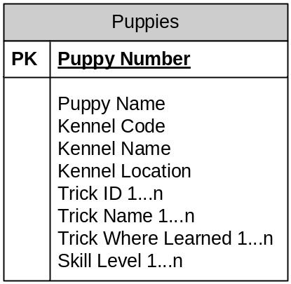

NORMAL FORM | DESCRIPTION | APPLICATION
Eliminate  Repeating  Groups | Make a separate table for set of related attributes and give a primary key for each table. | 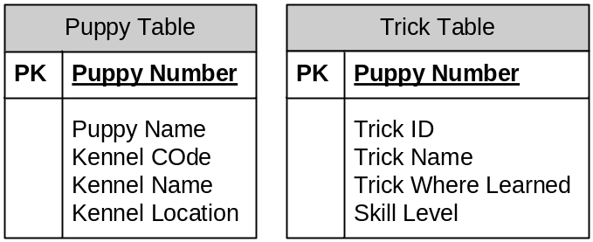
Eliminate  Redundant  Data | If an attribute depends only on part of a multi-valued Key remove it to a new table | 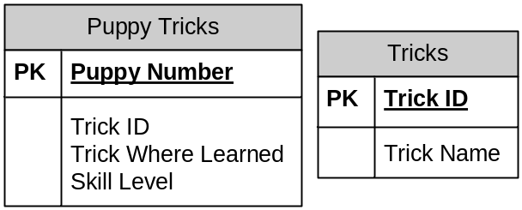  Updates Anomaly: Updates are Hard – Changing Trick ID for a given Trick Name will involve update in all the columns  Delete Anomaly [if the last known puppy with a new trick dies - the trick is lost]
Eliminate Columns  Not Dependent on KEY | If attributes do not contribute to a description of the key, remove them to a separate table | 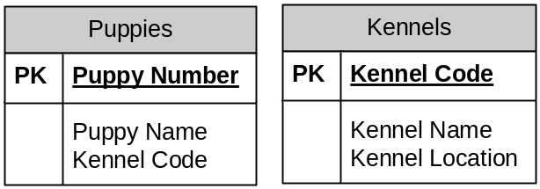  Same motivation like 2nd Normal form to avoid Update and Delete Anomalies.  Eg: If there are no puppies currently available from Daisy Puppy Farm, then with the current design Daisy Puppy Farm kennel will be lost.
Isolate Independent Multiple  Relationships | No table may contain two or more 1 to n or n to m relationships that are no longer directly related | 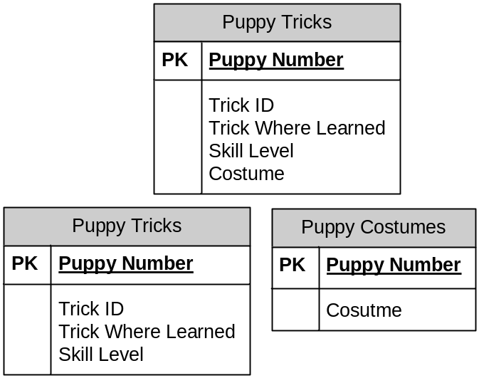
Isolate  Semantically Related Multiple Relationships |  | 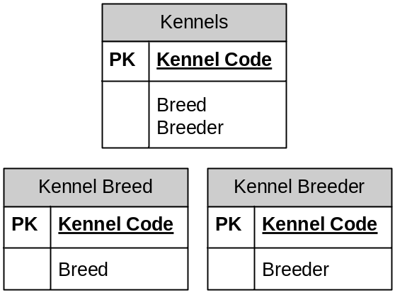  Suppose you want to add Breeds 1, 2 and 3 to for every Breeder A, B and C.  Previous design will involve 9 inserts while later will involve only 6 inserts.  Inserts and Updates are Reduced.

Explain De-Normalization with examples?

- De-Normalization is the process of attempting to optimize the read performance of a database by adding redundant data or by grouping data
- De-Normalization may solve one part of dealing with performance, but it creates possible performance problems in several other areas. Total performance impact must be evaluated. Furthermore, data integrity is at (high) risk.
- If you have a much higher demand on reporting functions, consider denormalization of your database into a separate data warehouse, which is periodically updated with summary information, preferably during night time, and leave your running database normalized for flexibility and data integrity. A clean, normalized database should always deliver good performance, as well as preserve data integrity.
http://publib.boulder.ibm.com/infocenter/dzichelp/v2r2/index.jsp?topic=/com.ibm.db29.doc.admin/db2z_denormalization.htm

Data Integrity
Required  Data | Some columns are specified as NULL and NOT NULL
Validity  Checking | Every column in a database has a domain, a set of data values that are legal for that column. E.g.: Some columns can have values in a range 101-999
Entity  Integrity | The primary key of a table must contain a unique value in each row.
Referential  Integrity | A foreign key in a relational database links each row in the child table containing the foreign key to the row of the parent table containing matching primary key.  Unlike Primary Key Foreign Keys are allowed to have null values. Eg: A newly joined Employee may not have been assigned a Manager.
Other  Data  Relationships | Real world can have additional constraints. E.g.: A discount should not exceed a maximum limit.
Business  Rules | Updates to a business rule may be constrained.
Consistency | An INSERT in one table can cause an UPDATE in another table.  Eg: Adding an Order can increase a column value in Sales table.

What are the different types of constraints?
Constraints are rules that can be imposed to maintain the data integrity of any data store.
PRIMARY KEY | CONSTRAINT $Constraint_Name PRIMARY KEY ( $Column_Name )
REFERENCES (Oracle)/  FOREIGN KEY | CONSTRAINT $Constraint_Name FOREIGN KEY ($Column_Name) REFERENCES $Table_Name ( $Column_name )
NOT NULL | CONSTRAINT $Constraint_Name NOT NULL ($Column_Name )
UNIQUE | CONSTRAINT $Constraint_Name UNIQUE ($Column_Name
CHECK (Oracle) | CONSTRAINT $Constraint_Name  CHECK ( $Column_Name BETWEEN 100 and 9999 )

What are Views?
A virtual table defined in the database, whose contents are defined by a query. Unlike tables it doesn’t exist in database. The rows and columns are visible only due to the Query Result.

CREATE | CREATE VIEW $View_Name AS $Select_Statement>;
ALTER | ALTER VIEW $View_Name [($column_list)] AS $Select_Statement;
DROP | DROP VIEW [IF EXISTS] $View_Name [,$View_Name]

Simple View - Rows and Columns are created on the fly.
Complex Views – Materialized views: a temporary table is created by the DBMS and all query operations are carried out on this temporary table. It is then discarded after use.

Advantages:
- Security – Users can be given access to the database only through views.
- Query Simplicity - A View can draw data from multiple tables and present it as a single table turning multi-table queries to a single table query.
- Structural Simplicity – Gives a personalized view of the database structure, presenting the database as a set of virtual tables that makes sense for the user.
- Insulation from Change – A view can present a consistent, unchanged image of the structure of the database, even if the underlying source tables are split, restructured or renamed.
- Data Integrity – If data is accessed through a view DBMS provides auto check for integrity constraints.
Disadvantages:
- Performance – Views create the appearance of a table, but the DBMS still translates the queries against the view into queries against the underlying source tables. If the view is defined by a complex multi-table query even a single query against the view becomes a complicated join and takes long time to complete.
- Update Restrictions – When a user tries to update rows of a view, the DBMS must translate the request to an update on rows of the source tales. This is possible for simple views but for more complex views updates are not possible. They are read only.
Horizontal Views – All columns participate in the view but only some rows are visible through the view.
Vertical Views – Restriction is placed on certain columns of a table.
Both of the above are only concepts. There is no notion of horizontal or vertical in SQL syntax.

Transactions and Locking
Database Level Locking | Allows only one Transaction to happen at any time.
Table Level Locking | Database locks the tables involved in Transaction.
Page Level Locking | Database locks individual blocks of data (pages) from the disk as they are accessed by a transaction.
Row Level Locking | For certain applications, the overhead of row level locking – maintenance and keeping track of locks on variable-length pieces of the database (rows) rather than fixed sized pages is greater than the performance gains.  So most databases address this problem by promoting many individual row level locks to page or table level when the number of row levels reaches a certain limit.
Item Level Locking | Theoretically possible. But no commercial database avails this feature.

Locking Schemes
Shared Lock – Used by DBMS when a transaction wants to read data from the database. Another concurrent transaction can also acquire a shared lock on the same data, allowing the other transaction to also read the data.
Exclusive Lock – Used by DBMS when a transaction wants to update data in the database. No other transaction can acquire any type of lock on the data while another transaction is executing.
 |  | Transaction B
 |  | Unlocked | Shared Lock | Exclusive Lock
Transaction A | Unlocked | OK | OK | OK
Transaction A | Shared Lock | OK | OK | NO
Transaction A | Exclusive Lock | OK | NO | NO

Transaction Isolation Levels
Isolation Levels | Description
Read Uncommitted | Transaction can read uncommitted data | Dirty Reads  Non-Repeatable Reads  Phantom Reads
Read Committed | Transaction cannot read uncommitted data | Non-Repeatable Reads  Phantom Reads
Repeatable Read | Transaction cannot change data that is being read by a different transaction | Phantom Reads
Serializable | Transaction has exclusive read and update privileges.

STORED PROCEDURES/ FUNCTIONS
 | Stored Procedures | Functions
Return | Multiple OUT Parameters | Single Return Value
Usage | PL/SQL using Execute or  begin <> end; | In SQL Queries
 | Compiled once and called each time | Compile each time they are called

SPL – Stored Procedure Language
As SQL was not envisioned as a Computer programming language it needed the following capabilities.
- Conditional Execution
- Looping
- Block Structure
- Named Variables
- Named Procedures
Stored Procedures were first introduced by Sybase.
Advantages:
- Runtime Performance – Most SPs are compiled into an internal representation that can be executed very efficiently by the DBMS.
- Reusability – Can be called by many different applications
- Reduced Network Traffic - If a logical transaction requires 6 SQL operations, 6 network roundtrips are required. With a Stored Procedures the sequence of 6 SQL operations could be programmed into a procedure and stored in a Database.
- Security – With SP you can give permissions to a user who doesn’t have permission for the underlying tables. So by giving an execute SP only permission more tighter security is gained.
- Encapsulation –
- Simplicity – A call to a SP is easier to understand than a bunch of SQL statements.
- Business Rules Enforcement – Good candidates for enforcing business level integrity
- Can handle Exceptions

CREATE PROCEDURE $MY_PROCEDURE
…
END PROCEDURE
DROP PROCEDURE $MY_PROCEDURE
EXECUTE MY_PROCEDURE( ‘$MY_PARAMETER1’, ‘$MY_PARAMETER2’, ‘$MY_PARAMETER3’ )
FUNCTIONS
CREATE OR REPLACE FUNCTION delete_emps(dept in number) return number as
BEING
delete emp where emp.deptno = dept;
return sql%rowcount;
END;
SQL> var rowsdel number
SQL> exec :rowsdel := delete_emps(30);
PL/SQL procedure successfully completed.
SQL> print rowsdel
ROWSDEL

TRIGGERS
For any event that causes a change in the contents of a table, a user can specify an associated action that the DBMS should carry out. The three events that can trigger an action are attempts to INSERT, DELETE or UPDATE.

CREATE TRIGGER NEWORDER
ON ORDERS
FOR INSERT
AS UPDATE SALESREPS
…
The above trigger will be invoked whenever an INSERT is attempted on the Order tables. The remainder of the definition (after AS) defines the action of the Trigger.

Uses: An alternative way to implement Referential Integrity constraints provided by the Foreign and Primary Keys.

CURSORS

Need For Cursors
It is necessary because many programming languages suffer from impedance mismatch. Programming languages are often procedural and do not offer any mechanism for manipulating whole result sets at once. Therefore, the rows in a result set must be processed sequentially by the application. In this way, a cursor can be thought of as an iterator over the collection of rows in the result set.

- For every SQL statement execution certain area in memory is allocated. PL/SQL allow you to name this area. This private SQL area is called context area or cursor. A cursor acts as a handle or pointer into the context area. A PL/SQL program controls the context area using the cursor. Cursor represents a structure in memory and is different from cursor variable.
- When you declare a cursor, you get a pointer variable, which does not point any thing. When the cursor is opened, memory is allocated and the cursor structure is created. The cursor variable now points the cursor. When the cursor is closed the memory allocated for the cursor is released.
- Cursors allow the programmer to retrieve data from a table and perform actions on that data one row at a time. There are two types of cursors implicit cursors and explicit cursors.
IMPLICIT CURSORS
Implicit cursors are simple SELECT statements and are written in the BEGIN block (executable section) of the PL/SQL. Implicit cursors are easy to code, and they retrieve exactly one row. PL/SQL implicitly declares cursors for all DML statements. The most commonly raised exceptions here are NO_DATA_FOUND or TOO_MANY_ROWS.

SELECT ename, sal INTO ena, esa FROM EMP WHERE EMPNO = 7844;

EXPLICIT CURSORS
Explicit cursors are used in queries that return multiple rows. The set of rows fetched by a query is called active set. The size of the active set meets the search criteria in the select statement. Explicit cursor is declared in the DECLARE section of PL/SQL program.
CURSOR <cursor-name> IS <select statement>

DECLARE
CURSOR emp_cur IS SELECT ename FROM EMP;
BEGIN
----
---
END;

http://www.exforsys.com/tutorials/oracle-9i/oracle-cursors.html

Note: SQL1 Cursors support only Sequential Motion.

Scroll Cursors: Cursors may be declared as being scrollable or not. The scrollability indicates the direction in which a cursor can move. A non-scrollable cursor is also known as forward-only. Each row can be fetched at most once, and the cursor automatically moves to the immediately following row. A fetch operation after the last row has been retrieved positions the cursor after the last row and returns SQLSTATE 02000 (SQLCODE +100).

A scrollable cursor can be positioned anywhere in the result set using the FETCH SQL statement. The keyword SCROLL must be specified when declaring the cursor. The default is NO SCROLL, although different language bindings like JDBC may apply different default.

DECLARE $Cursor_Name sensitivity SCROLL CURSOR FOR SELECT ... FROM ...

The target position for a scrollable cursor can be specified relative to the current cursor position or absolute from the beginning of the result set.

FETCH [ NEXT | PRIOR | FIRST | LAST ] FROM $Cursor_Name

FETCH ABSOLUTE n FROM $Cursor_Name

FETCH RELATIVE n FROM $Cursor_Name

Disadvantages:
- Fetching a row from the cursor may result in a network round trip each time. This uses much more network bandwidth than would ordinarily be needed for the execution of a single SQL statement like DELETE.
- Cursors allocate resources at the server, for instance locks, packages, processes, temporary storage, etc. If a cursor is not properly closed (deallocated), the resources will not be freed until the SQL session (connection) itself is closed.

What cursor type do you use to retrieve multiple recordsets?

What are HINTS?
Oracle Hints is an Oracle Database feature through which a developer makes decisions usually reserved for the optimizer. Developers use hints to specify things such as join order for a join statement, or the optimization approach of an SQL call.

What are sequences?
- To build calendar-type applications and leave-day/business-day calculations (tables with ranges of dates)
- Sales fact tables (tables with ranges of numbers or dates)
- Creating volume data for volume testing of applications (tables with ranges of numbers, dates or alpha-numeric values)
- Motivation - Use the MAX function to determine the currently used maximum value and then increment that value for the new row - Tedious

Tradeoffs with having indexes?
http://www.odetocode.com/Articles/70.aspx
CREATE INDEX [IDX_UnitPrice] ON Products (UnitPrice)
- The database takes the columns specified in a CREATE INDEX command and sorts the values into a special data structure known as a B-tree. A B-tree structure supports fast searches with a minimum amount of disk reads, allowing the database engine to quickly find the starting and stopping points for the query we are using.

Modeling m-n relationship in Database
http://www.alachisoft.com/articles/m-n_relationships.html

Difference between "drop", "truncate" and "delete" ➔DeTD
OPERATION | DESCRIPTION | COMMIT & ROLLBACK | TRIGGER
DELETE  [DML] | The DELETE command is used to remove rows from a table. A WHERE clause can be used to only remove some rows. If no WHERE condition is specified, all rows will be removed. After performing a DELETE operation you need to COMMIT or ROLLBACK the transaction to make the change permanent or to undo it. Note that this operation will cause all DELETE triggers on the table to fire. | Y | Y
TRUNCATE  [DDL] | TRUNCATE removes all rows from a table. The operation cannot be rolled back and no triggers will be fired. As such, TRUNCATE is faster and doesn't use as much undo space as a DELETE. | N | N
DROP  [DDL] | The DROP command removes a table from the database. All the tables' rows, indexes and privileges will also be removed. No DML triggers will be fired. The operation cannot be rolled back. | N | N
DROP and TRUNCATE are DDL commands, whereas DELETE is a DML command. Therefore DELETE operations can be rolled back (undone), while DROP and TRUNCATE operations cannot be rolled back.

DECODE in ORACLE
if ( 1 == 1 )
show sysdate
else
show sysdate-1

select decode( 1, 1, sysdate, sysdate-1) from dual;

Why can a “groupby” and “orderby” clauses can be expensive to compute?
GroupBy – used to combine database records with identical values in a specified field into a single record, usually for the purposes of calculating some sort of aggregate function.
http://www.linuxdevcenter.com/pub/a/linux/2001/02/23/aboutSQL.html

EmployeeID | SalesAmount | SalesDate |  | EmployeeID | SUM(SalesAmount)
1 | 150 | 1/1/01 |  | 1 | 200
1 | 50 | 1/1/01 |  | 2 | 100
2 | 100 | 1/1/01 |  | 3 | 300
3 | 300 | 1/1/01
3 | 0 | 1/1/01
SELECT EmployeeID, SUM(SalesAmount) GROUP BY EmployeeID

OrderBy - for display purpose
http://www.linuxdevcenter.com/pub/a/linux/2001/02/13/aboutSQL.html
SELECT * from employee ORDER BY EmployeeID

Difference between "Primarykey" and "Aggregatekey"?
primary key : the column which is used for thr unique identification of a record from a table is called the primary key
alternate/aggregate key : a column which is used for unique identification but not a primary key is called the alternate key

Difference between "where" and "having"?
- HAVING clause is usually used with Group By clause although it can be used without it too.
- HAVING is just an additional filter to WHERE clause.
- WHERE clause applies to the individual rows whereas HAVING clause is used to test some condition on the group (usually with aggregate methods) rather than on individual rows.
- HAVING can be used only with the SELECT statement. HAVING is typically used in a GROUP BY clause. When GROUP BY is not used, HAVING behaves like a WHERE clause.

SELECT max(state) from States HAVING count(State) > 60

Difference between UNION and UNION ALL
UNION selects distinct
UNION ALL selects all values

Difference between "varchar" and "varchar2"?

 | Char | varchar | varchar2
Column Creation | Fixed Length | Variable Length | Variable Length
Length | 0-255 | 0-65,535
Padding | Right Padded with spaces
Bytes |  | Values are stored as a one-byte or two-byte length prefix plus data.

Value | CHAR(4) | Storage Required | VARCHAR(4) | Storage Required
‘’ | ‘ ‘ | 4 bytes | ‘’ | 1 byte
‘ab’ | ‘ab ‘ | 4 bytes | ‘ab’ | 3 bytes
‘abcd’ | ‘abcd’ | 4 bytes | ‘abcd’ | 5 bytes
‘abcdefgh’ | ‘abcd’ | 4 bytes | ‘abcd’ | 5 bytes

Difference between "translate" and "replace"?

How to remove duplicate rows from a table?
http://www.orafaq.com/faq/how_does_one_eliminate_duplicates_rows_from_a_table

What are the large objects supported by Oracle?

Storing XML
http://www.xml.com/pub/a/2001/06/20/databases.html

Oracle | oracle.xml.sql.query.OracleXMLQuery.getXMLString();  oracle.xml.sql.query.OracleXMLQuery.getXMLDOM();
XML:DB API (XAPI)

BLOB vs CLOB for XML

How to find the database name from SQL*PLUS command prompt?
Select * from mySchema.tables

Query to display all table names from a database?

How to copy structure of a table without copying its data?

How to convert RAW datatype to Text?

What is OCI?

What is “index covering” of a Query?

What is PL/SQL?

What is the use of ANALYZing the table?

Difference between "NULL" in C and "NULL” in Oracle ?

What is Pro*C?

