Basics : Testing

Prepared by

Shankar Karthik & Anita

Testing

Uncle Bob’s TDD 3 Laws
- A TDD developer does not write a line of production code until he writes a failing unit test.
- Don’t write more of a unit test than it is sufficient to fail or compilation failure. So a TDD developer cannot write more of a unit test before writing a production code.
- You only write production code sufficient to pass the unit test.

These 3 laws lock a TDD developer into a cycle that is probably 30 secs long.

- It keeps the beast under control ( application code) with the suite of tests that we develop. Otherwise the code rots.
- Unit Testing is the only way we TDD is the only way for It helps us to safely refactor without any consequences on the functionality. If refactoring fails we know what we broke.
- The sole purpose of having a suite of tests is for refactoring, it is not for QA. It makes us not afraid of our code. We are not afraid of touching a messy code to become a clean code.

Code without testing is like operating a mars rover from earth. If it doesn’t have an onboard guidance, then we would be operating it from earth and it takes 14 minutes to send a signal to mars. Imagine how ridiculously inefficient it is.

Coding without Unit testing is similar to the above example. We make some changes, start a build and then find out what happened later.

Thoughts on Test Driven Development?
http://en.wikipedia.org/wiki/Test-driven_development
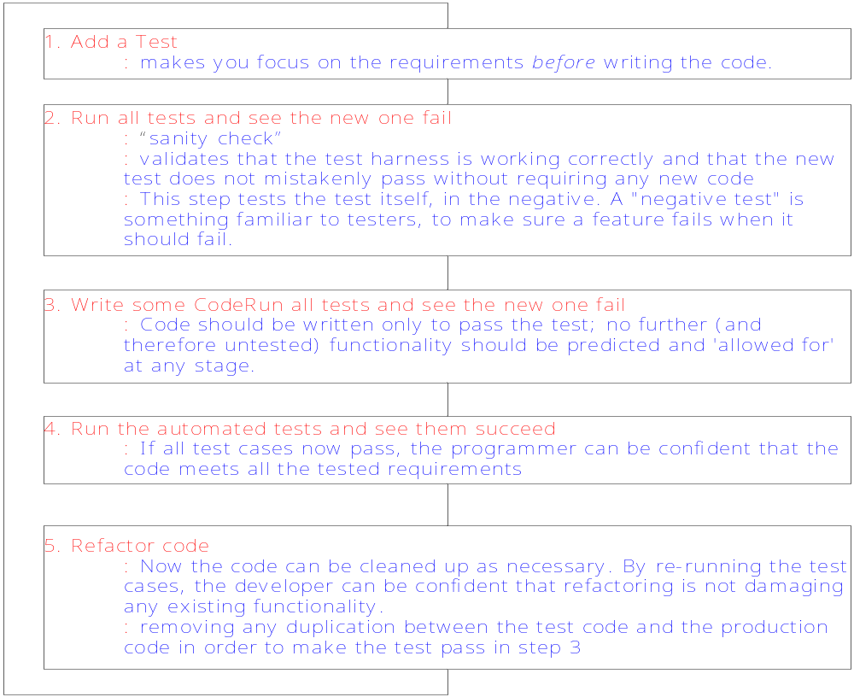

Benefits
- “Test-Driven Development Mantra”, known as red/green/refactor
- Drives design and development towards Interface
- Promotes Code Coverage
- Write tests to achieve a design pattern

Principles of Unit Testing
Fast – Should run fast. A Unit test that takes 1/10 of a second is slow. – To run fast we have to write production code in decoupled fashion. This promotes de-coupling.
Independent – Should run independently without any dependencies
Repeatable – Should be self contained and should leave the test harness in a sane state.
Self-validating – Should assert by itself. One should not have to read through a log file to know if the test passed through
Timely- Should be written just before the production code.
Error Localization – Should help localize an error and mitigate risks.

Unit Testing?
Testing a class in isolation

Load Testing?
TODO-TODO-TODO-TODO-TODO

Functional Testing?
Black Box vs White Box Testing

