BASICS: Performance, Profiling & Capacity Planning

Prepared by

Shankar Karthik & Anita

Detecting Memory Leaks in Java?
  - OutOfMemoryError indicates memory leak - Obvious
  - Runtime.getRuntime().totalMemory() – Runtime.getRuntime().freeMemory()
  - Use operating system process monitors
  - Use Profiling tools

Improving performance at code level and as a programming practice
ftp://ftp.glenmccl.com/pub/free/jperf.pdf
Classes:
- Try to provide empty constructors. Cost of JRE creating default constructors for a class hierarchy and invoking them is much more.
- Use static variables when needed (esp. Arrays) in place of using instance variable. Eg: If a class ABC is in need of a array initialized with values in String[] str = {“a”,”b”,”c”}, instantiating ABC 100 times in a for loop will create 100 str object. If the same is defined as static, it will get instantiated only once.
Methods:
- Method Inlining – Inline methods when possible for smaller functions like finding max or min to avoid call to method stacks.
- Making methods final.
public final void function(){…}
public <final> class A {..}
A aref = new A();
aref.function();
The above is like calling A’s method function(), and not some function() in a subclass of A if A is made final.
String:
- Use StringBuffer where possible
- Use char[] or byte[] when you know the length of the String that you will be creating in ahead.
- Use == || str1.equals(str2) short circuit operations during equals check. ➔ Always perform cheap performance test before performing expensive test
- String Interning
public class StringInterning{
public static void main(String[] pArgs) {
String str = new String(“testing”);
if ( str == “testing” )
System.out.println(“equal”);
else
System.out.println(“unequal”);
str = str.intern();
if ( str == “testing” )
System.out.println(“equal”);
else
System.out.println(“unequal”);
}
}
- Never invoke String.length() method in a for loop for computing the loop index.
- Use toCharArray and iterate over the array instead of using chatAt() method.
- new Double(“12.34”) is expensive than new Double(12.34)
Input/Output:
- Buffering – Always use buffering while doing I/O operations
- String formatting – Using java.text.MessageFormat based templates to format strings (these templates are precomiled) is expensive than printing strings as such.
- Avoid calling File.length() redundantly in a program unless you suspect any file changes while processing.
Libraries:
- System.arraycopy() performs better than Object.clone() which performs better than looping through the array and copying items.
- Vector vs ArrayList
- Vector’s methods are synchronized, ArrayListS are not. This means that Vector is threadsafe, at some extra cost.
- The collection framework provides an alternative to ArrayList called LinkedList , which offers different performance tradeoffs.
- When Vector needs to grow its internal data structure to hold more elements, the size of the structure is doubled, whereas for ArrayList, the size is increased by 50%. So ArrayList is more conservative in its use of space.
- It’s worth using the collection framework in your applications if you possibly can, because it’s now the "standard" way to handle collections. If you are concerned about thread safety, one way to handle this issue is to use wrappers around objects like ArrayList , for example: List list = Collections.synchronizedList(new ArrayList());
- ArrayList.ensureCapacity() → setting this to a predefined value stops ArrayList to grow dynamically every time during an ArrayList.add()operation
- ArrayList vs LinkedList – Adding elements in ArrayList is expensive compared to LinkedList. Whereas retrieving elements from an ArrayList is very cheap when compared to LinkedList.
- Programming to interface like List or Map improves efficiency of your application.
Size:
- .class file size
javac Code, SourceFile, LineNumberTable
javac –g Code, SourceFile, LineNumberTable, LocalVariableTable
javac -g:none Code
If you strip out information such as line numbers from .class files, you may have problems with debugging and exception reporting.
- Using Wrapper variables a lot in place of primitive types as instance variables will increase the size of your bytecode.
- Clear references of large unused objects by explicitly setting their references to null
- Use SoftReference when possible for caching mechanisms
- Use BitSet when you want to store Boolean arrays.
- Sparse Arrays

GC Tuning
http://www.petefreitag.com/articles/gctuning/
Garbage collection normally consumes from 5% to 20% of total execution time of a properly functioning application. The initial heap size is a threshold that triggers new garbage collection cycles. If the initial heap size is 10 MB, for example, then a new collection cycle is triggered as soon as the JVM detects that 10 MB have been allocated since the last collection cycle. Smaller heap sizes result in more frequent garbage collections than larger heap sizes.

JMeter experience?

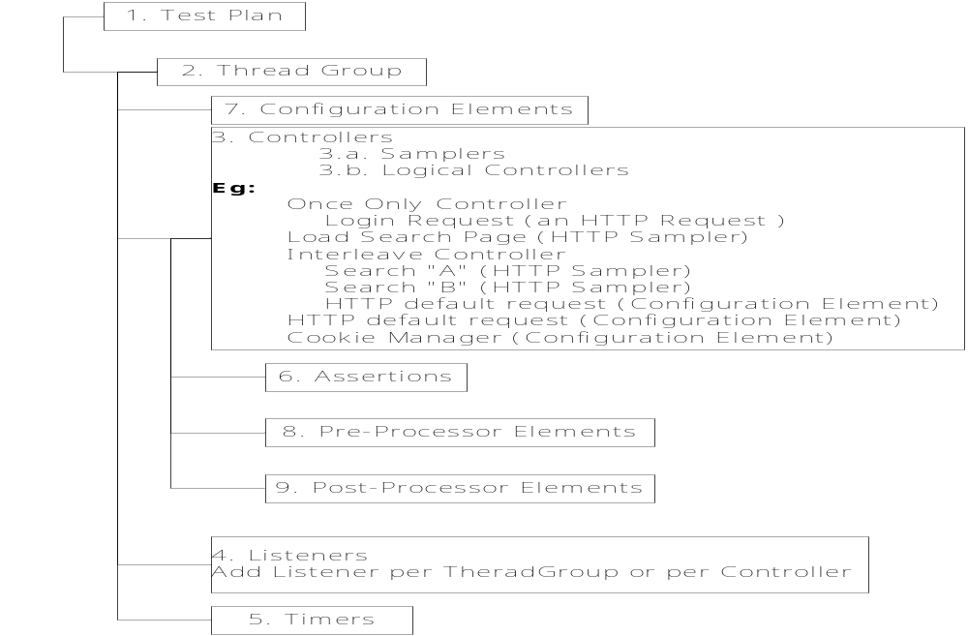
Distributed Testing: Multiple JMeters can be configured to test a web server

Memory Leaks
http://java.dzone.com/news/how-fix-memory-leaks-java
When is a memory eligible for GC

{
SomeClass sc = new SomeClass();
someClass.doSomething();
// If we set sc to null, it will be eligible for GC
// sc = null;

// Or if we point sc to some other object, the old object it was pointing will become
// eligible for GC
// sc = someOtherObject;
}
// sc is eligible for GC here;
Why do we call as “eligible” for GC? Because objects are not collected immediately. GC is not instantaneous and comes with some performance impacts. Consequently, Java doesn’t immediately collect every object that is eligible for collection; it typically postpones collection until a more convenient time later on. The way to think about GC in Java is that it’s a “lazy bachelor” that hates taking out the trash and typically postpones the process for some period of time. However, if the trash can begins to overflow, Java immediately takes it out. In other words, if memory becomes scarce, Java immediately runs GC to free memory.
Memory Leaks - Watch List:

Step 1: First Watch for memory usage via Windows Task Manager or top/prstat for Java Process.

Step 2: Enable GC Logs for the JVM
-Xloggc:gc.log -verbose:gc -XX:-PrintGCDetails -XX:+PrintGCTimeStamps
Other Options
-XX:+HeapDumpOnCtrlBreak
+XX:+HeapDumpOnOutOfMemoryError

Step 3: Use various JDK 1.5+ Monitoring Tools
Start using the monitoring tools that comes with JDK1.5
jps -> lists all java process running in the system. Remember ps command in unix lists all processes in the operating system.
jinfo -> lists all information about a running jvm
jinfo <pid>
jstat ->JVM statistics monitoring tool
http://docs.oracle.com/javase/1.5.0/docs/tooldocs/share/jstat.html
jstat -gcutil <pid> 250 7
jmap -> Java Memory Map
jmap -histo <pid>
jmap -dump:live,format=b,file=c:/work/basics/heap.bin <pid>
jhat --> java heap analyzer tool
jhat -port 8080 c:/work/basics/heap.bin
Open your browser and access http://localhost:8080

Step4:
Repeat step 3 as per the below flowchart.
http://java.dzone.com/news/how-fix-memory-leaks-java

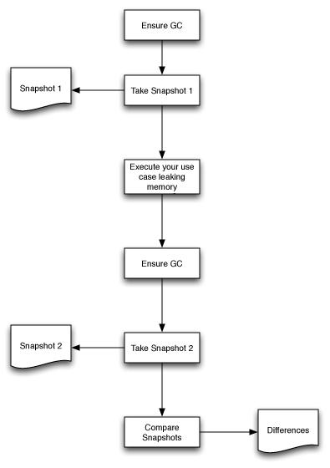
Step5: Analyze Heap Snapshot
Use tools like Visual VM or Eclipse MAT to analyze your heap snap shots. Find the Delta.

Monitoring and Management in JDK
http://java.sun.com/developer/technicalArticles/J2SE/monitoring/
Problems | Description |  | Tools
Insufficient Memory | Heap  Memory Error | java.lang.OutOfMemoryError: Java heap space | jconsole
Insufficient Memory | Non-heap Memory Error | java.lang.OutOfMemoryError: PermGen space | jconsole
Insufficient Memory | Native  Memory Error | java.lang.OutOfMemoryError: request <size> bytes for <reason>.  Out of swap space? | jconsole
Memory Leaks | Unintentional object retention |  | jconsole  jstat  jmap  jinfo  jhat
finalizerS | An object that has a finalizer will not be garbage collected until its finalizer is run. Thus, objects that are pending for finalization will retain memory even though the objects are no longer referenced by the application, and this could lead to a problem similar to a memory leak. |  | jconsole  jmap
Deadlocks |  |  | jconsole  jstack
Looping Threads | When loop = Infinity |  | jtop + jconsole
High Lock Contention

JVM Monitoring Tools
jconsole | - Memory usage and garbage collection activities  - Thread state, thread stack trace, and locks  - Number of objects pending for finalization  - Runtime information such as uptime and the CPU time that the process consumes  - VM information such as the input arguments to the JVM and the application class path
jstat | Command to monitor the memory usage and garbage collection statistics
jmap | When you suspect a memory leak in an application, the command will help you get a heap histogram that shows the per-class statistics, including the total number of instances and the total number of bytes occupied by the instances of each class.
jmap | Tips  - Its instances occupy unexpectedly large amounts of memory.  - The number of instances of the class is growing over time at a high rate.  - Class instances that you would expect to be garbage collected are not.
jmap | -histo  -dump  -finalizerinfo
jinfo | jinfo -flag +HeapDumpOnOutMemoryError <pid>  java -XX:+HeapDumpOnOutOfMemoryError
jhat | Analyzes the heap dump and starts a HTTP Server on port 7000 with Query interface

Solaris Monitoring Tools
prstat
sar 2 100 (run sar for 100 times every 2 secs)

Non-Functional Aspects while writing a software

Fail-over VS Fault-tolerant?
HA | High availability refers to systems with redundant components that provide consistent, uninterrupted service, even during failures. In most high availability configurations, nodes are isolated from each other so that a failure on one node does not affect the entire system.  There are two factors that determine system availability:  1. The first factor is the reliability of the individual components that comprise the system. These components include server hardware, server operating system and the application itself. Other components may include data storage devices, network access devices, databases, file systems and the data center infrastructure.  2. The second factor is the time it takes for the application to be restored once a failure has occurred. The amount of time it takes to bring an application online again is dependent on the component that failed. If the application itself has failed, all that may be required for recovery is to simply restart the application.  High availability must encompass all components required to provide a service. Certain components of a service may be highly available, however, other system components may not support the same level of high availability, therefore, overall availability is reduced.
FT | Now that we have a clear understanding of high availability, we can contrast this concept with fault tolerance. Fault tolerance differs from high availability by providing additional resources that allow an application to continue functioning after a component failure without interruption. Many of the high-availability solutions on the market today actually provide fault tolerance for a particular application component. Disk mirroring, where there are two disk drives with identical copies of the data, is an example of a fault-tolerant component. If one of the disk drives fail, there is another copy of the data that is instantly available so the application can continue execution.  A fully fault-tolerant solution requires that all the resources the application is dependent on, be replicated including the application process itself. This requires an independent processor (not part of the same computer) and a copy of the memory that the application uses. In the worst case failure scenario, one in which the processor or memory fails, the replicated version of the application continues to execute. Other failures simply require the application to use the alternate resources (disks, communications devices). As a result of this complete hardware and process replication, fault-tolerant systems are significantly more expensive than highly available systems.
Failover | Failover is a backup operational mode in which the functions of a system component (such as a processor, server, network, or database, for example) are assumed by secondary system components when the primary component becomes unavailable through either failure or scheduled down time. Used to make systems more fault-tolerant, failover is typically an integral part of mission-critical systems that must be constantly available.
LB

Fault tolerance
Simply defined, fault tolerance is the ability of a compute system to provide uninterrupted compute functions with no loss of process or data. In more complete terms, fault tolerance is the ability of two or more compute nodes to provide uninterrupted and expected services despite faults that occur internally or externally to the control of a system or application. Faults that occur internally to the control of a system might be compute node component failures (e.g., memory, CPU), disk drive errors, or operating system/application crashes. Faults that occur externally to the control of a system might be the building-wide loss of electricity, the physical severing of network connections, or the destruction of the system or data center by fire or natural disaster. While the external faults are typically aggregated and defined within the context of disaster recovery, a fault-tolerant environment must comprehend and, to some degree, support the requirements of disaster recovery.

