**Institute Of Science and Technology**

**Tribhuwan University**



**Lab Report**

**On**

**Artificial Intelligence (CSC 261)**

**Submitted to:**

**\*\*\*\*\*\*\*\*\*\*\*\*\*\*\*\*\*\*\*\***

**Department Of Computer Science And Information Teachnology**

**Prithivi Narayan Campus , Pokhara**

**Submitted by :**

**\*\*\*\*\*\*\*\*\*\*\*\*\*\*\*\*\*\*\*\*\*\***

**Roll No: *\*\****

**Third Batch**

**RECOMMENDATION SYSTEM IN AI**

**INTRODUCTION:**

**A**rtificial Intelligence is a wide-ranging branch of computer science concerned with building smart machines capable of performing tasks that typically require human intelligence. The explosive growth in information on the world wide web and rapid increase in e-services has presented users with a huge number of choices, which often lead to more complex decision-making. Recommendation system is a system that suggests products, services, information to users based on analysis of data. The recommendation can derive from a variety of factors such as the history of the user and the behavior of similar users.

Recommendation systems are quickly becoming the primary way for users to expose to the whole digital world through the lens of their experiences, behaviors, preferences and interests. And in a world of information density and product overload, a recommendation system provides an efficient way for companies to provide consumers with personalized information and solutions. The recommendation systems were first applied in e-commerce to solve the information overload caused by Web 2.0, and they were quickly expanded to the personalization of e-government, e-business, e-learning, and e-tourism. Nowadays, recommendation systems are a crucial feature of internet websites such as Amazon.com, YouTube.com, Netflix, Facebook etc. The core element of recommendation system is:

**F : U × I → D**

This is a function to define the utility of a specific itemi ∈ I to a user

u ∈ U. D is the final recommendation list containing a set of items ranked according to the utility of all the items the user has not consumed. The utility of an item is presented in terms of user ratings. Recommendation system find an item for the user by maximizing the utility function, formulated as follows:

∀ u ∈ U, arg max f (u, i)

i ∈ I

Predicting the utility of items for a particular user according to the recommendation algorithm selected. The information collected by the system is the critical aspect of the process. This can be information relating to explicit interactions, for example information about my past activity, my ratings, reviews, and other information about my profile, such as gender, age or investment objectives. These can combine with implicit interactions such as the device you use for access, clicks on a link, location and dates.

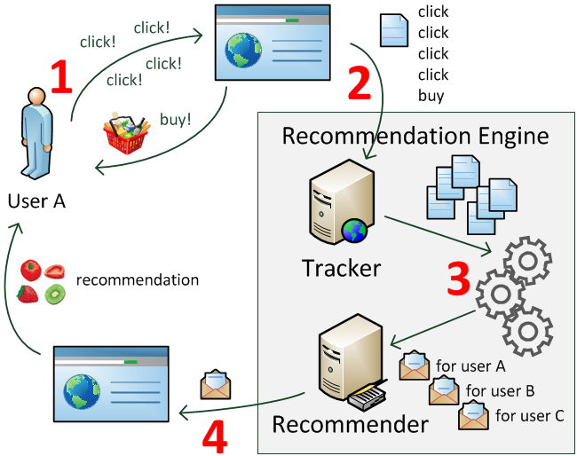

**TYPES:**

There are three main types of techniques for Recommendation systems:

* Content Based Filtering
* Collaborative Filtering
* Knowledge Based System

**Content Based Filtering:**

**C**ontent-based filtering is based on a single user’s interactions and preference. Recommendations are based on the metadata collected from user’s history and interactions. For example, recommendations will be based on looking at established patterns in a user’s choice or behaviors. Returning information such as products or services will relate to your likes or views. With an approach like this the more information that the user provides, the higher the accuracy.

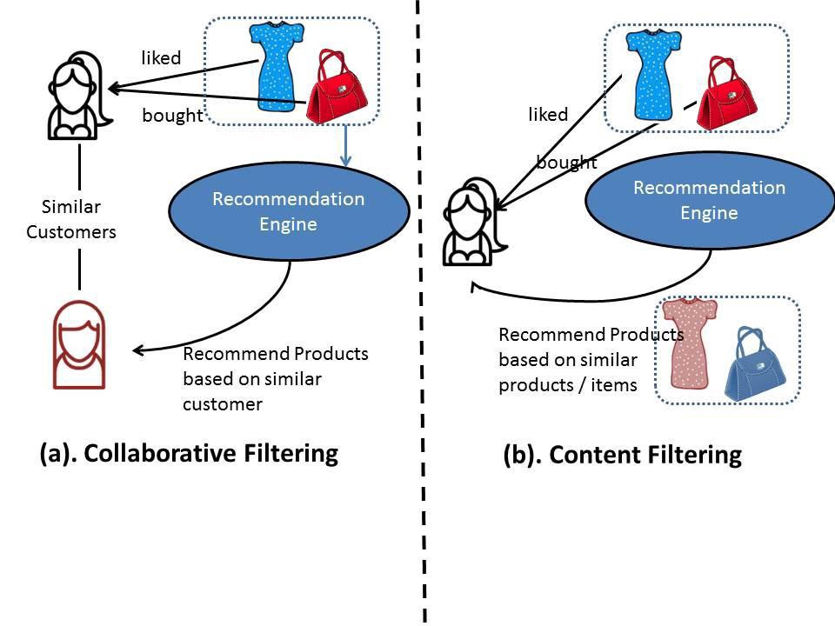

**Collaborative Filtering:**

**C**ollaborative filtering is the most famous application suggestions system and is based on the calculated guesses, the people who liked the product will like the product will enjoy the same product in the future. This type of algorithm is known as product-based collaborative shift. Most collaborative filtering systems apply the so-called similarity index-based technique. In the neighborhood- based approach, a number of users are selected based on their similarity to the active user. Inference for the active user is made by calculating a weighted average of the ratings of the selected users. Collaborative-filtering systems focus on the relationship between users and items. The similarity of items is determined by the similarity of the ratings of those items by the user who have rated both items.

There are two classes of collaborative filtering:

1. User based, which measures the similarity between target users and other users.
2. Item-based, which measures the similarity between the items that target users’ rate or interact with and other items.

**Knowledge Based System:**

**K**nowledge based systems are the systems where suggestions are based on an influence about a user’s need and based on a degree of domain expertise and knowledge. Rules are defined that set context for each recommendation.

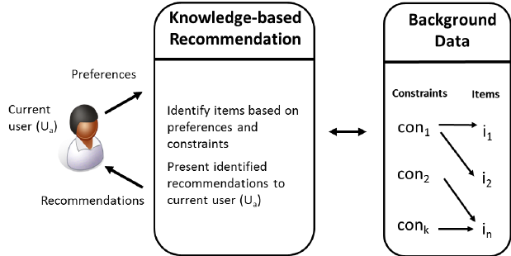

**Common Challenges a Recommendation System face:**

* **Sparsity of data:**

Data sets filled with rows and rows of values that contain blank or zero values. So, finding ways to use denser parts of the data set and those with information is critical.

* **Latent Association:**

Labelling is imperfect. Same products with different labelling can be ignored or incorrectly consumed, meaning that the information does not get incorporated correctly.

* **Scalability:**

The traditional approach has become overwhelmed by the multiplicity of products and clients. This becomes a challenge as data sets widen and can lead to performance reduction.

In general, recommendation engines improve with more information. Recommendation engines that display smart, intuitive, visualization techniques for their results, are much likelier to ensure repeat visits. As such, recommendation engines that continue with you, along with your quest for more and more information and products, will be to gather more and more of the underlying information for usage later. Creating a self-sustaining ever-improving environment for the recommendation engine relies on much more than preparing the engine itself.

**/\*\*\*\*\*\*\*\*\*\*\*\*\*\*\*\*\*\*\*\*** **The End **********************/**