Delhi University

B.Sc. (Computer Science)

Computer Graphics

Practical File

(19020570018)

Submitted By:- K A Shankar Narayan(20191417)

Submitted To:- Ms. Sheetal

# Write a program to implement Bresenhams line drawing algorithm.

#include<stdio.h> #include<graphics.h>

void midpointline(int x0,int y0,int x1,int y1,int value)

{

double dy=y1-y0; double dx=x1-x0; int d=2*dy-dx; int incrE=2*dy;

int increNE=2*(dy-dx); int x=x0;

int y=y0; putpixel(x,y,value); while(x<x1)

{ //choose E

if(d<0)

{

d+=incrE; x++;

}

else

{

d+=increNE; x++;

y++;

}

putpixel(x,y,value);

}

}

main()

{

int gd=DETECT,gm; int i,j,k;

initgraph(&gd,&gm,"c:\\turboc3\\bgi"); midpointline(100,100,200,200,3); getch();

closegraph(); return 0;

}

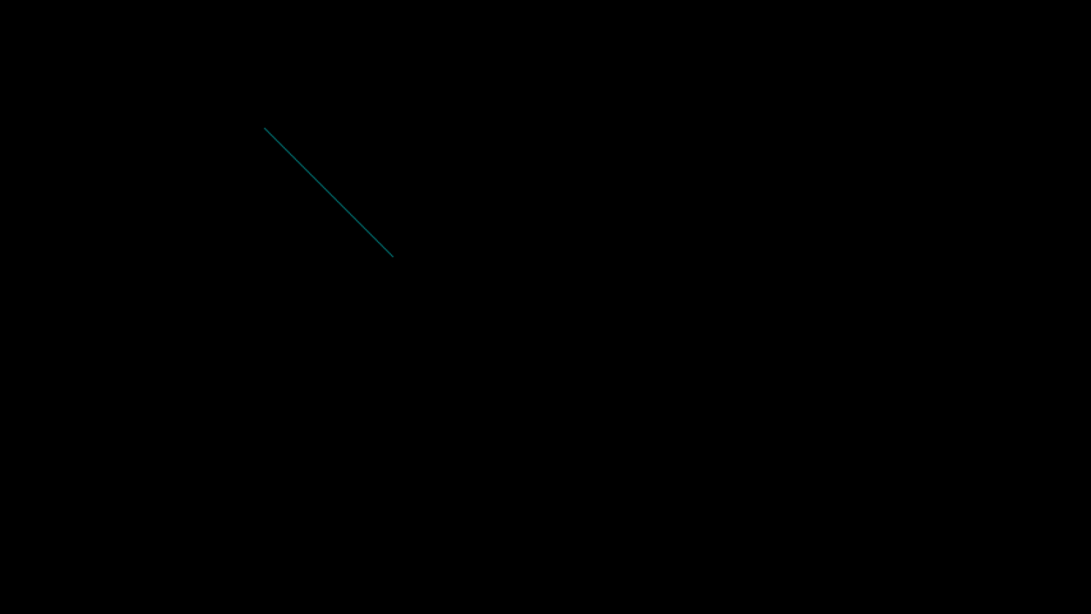

# Write a program to implement mid-point circle drawing algorithm.

#include<graphics.h> #include<conio.h> #include<dos.h>

void circlepoints(int x1,int y1,int x, int y,int val)

{

putpixel(x1+x,y1+y,val); putpixel(x1+y,y1+x,val); putpixel(x1+y,y1-x,val); putpixel(x1+x,y1-y,val); putpixel(x1-x,y1-y,val); putpixel(x1-y,y1-x,val); putpixel(x1-x,y1+y,val); putpixel(x1-y,y1+x,val);

}

void midpointcircle(int x1,int y1,int r,int value)

{

int x=0,y=r,p; p=1-r;

circlepoints(x1,y1,x,y,value); while(x<y)

{

if(p<0)

{

p=p+2.0*x+3.0;

}

else

{

p=p+2.0*(x-y)+5.0;

y=y-1;

}

x=x+1; circlepoints(x1,y1,x,y,value);

}

}

void main()

{

int gd =DETECT,a,gm; initgraph(&gd,&gm,"C:\\TURBOC3\\BGI"); printf("enter radius");

scanf("%d",&a); midpointcircle(100,100,a,5); getch();

closegraph();

}

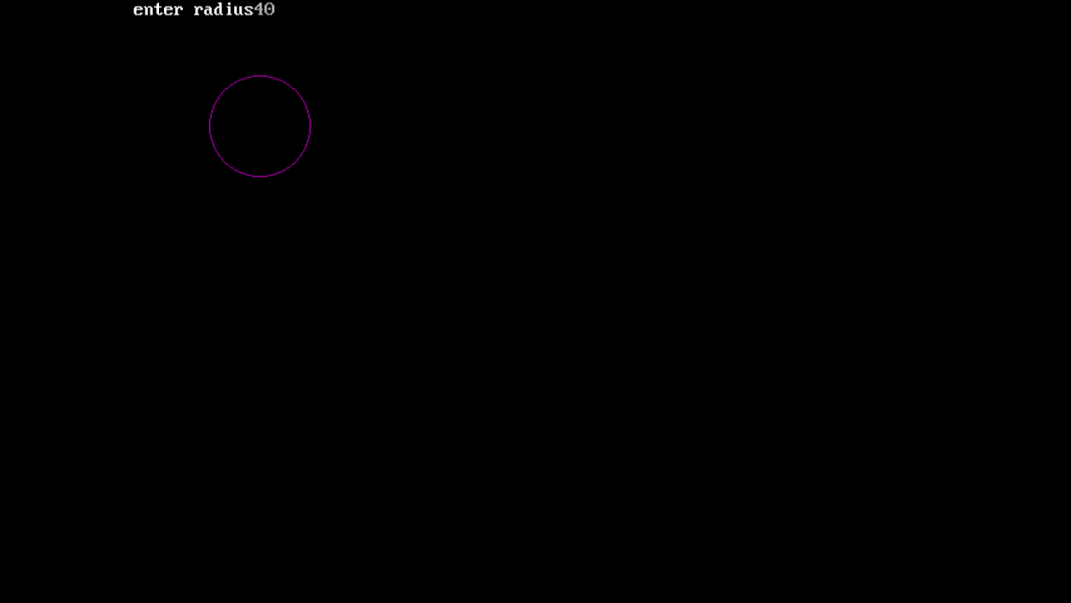

# Write a program to clip a line using Cohen and Sutherland line Clipping algorithm.

#include<graphics.h> #include<conio.h> #include<stdio.h> #include<math.h> void main()

{

int rcode_begin[4]={0,0,0,0},rcode_end[4]={0,0,0,0},region_code[4]; int W_xmax,W_ymax,W_xmin,W_ymin,flag=0;

float slope; int x,y,x1,y1,i;

int gm=DETECT,gd; initgraph(&gm,&gd,"c:\\turboc3\\bgi");

printf("\n****** Cohen Sutherlsnd Line Clipping algorithm ***********"); printf("\n Now, enter XMin, YMin =");

scanf("%d %d",&W_xmin,&W_ymin); printf("\n First enter XMax, YMax ="); scanf("%d %d",&W_xmax,&W_ymax); printf("\n Please enter intial point x and y= "); scanf("%d %d",&x,&y);

printf("\n Now, enter final point x1 and y1= "); scanf("%d %d",&x1,&y1);cleardevice(); rectangle(W_xmin,W_ymin,W_xmax,W_ymax); line(x,y,x1,y1);

if(y>W_ymax) { rcode_begin[0]=1; // Top flag=1 ;

}

if(y<W_ymin) {

rcode_begin[1]=1; // Bottom

flag=1;

}

if(x>W_xmax) { rcode_begin[2]=1; // Right flag=1;

}

if(x<W_xmin) { rcode_begin[3]=1; //Left flag=1;

}

//end point of Line if(y1>W_ymax){ rcode_end[0]=1; // Top flag=1;

}

if(y1<W_ymin) { rcode_end[1]=1; // Bottom flag=1;

}

if(x1>W_xmax){ rcode_end[2]=1; // Right flag=1;

}

if(x1<W_xmin){ rcode_end[3]=1; //Left flag=1;

}

if(flag==0)

{

printf("No need of clipping as it is already in window");

}

flag=1; for(i=0;i<4;i++){

region_code[i]= rcode_begin[i] && rcode_end[i] ; if(region_code[i]==1)

flag=0;

}

if(flag==0)

{

printf("\n Line is completely outside the window");

}

else{

slope=(float)(y1-y)/(x1-x);

if(rcode_begin[2]==0 && rcode_begin[3]==1) //left

{

y=y+(float) (W_xmin-x)*slope ; x=W_xmin;

}

if(rcode_begin[2]==1 && rcode_begin[3]==0) // right

{

y=y+(float) (W_xmax-x)*slope ; x=W_xmax;

}

if(rcode_begin[0]==1 && rcode_begin[1]==0) // top

{

x=x+(float) (W_ymax-y)/slope ; y=W_ymax;

}

if(rcode_begin[0]==0 && rcode_begin[1]==1) // bottom

{

x=x+(float) (W_ymin-y)/slope ; y=W_ymin;

}

// end points

if(rcode_end[2]==0 && rcode_end[3]==1) //left

{

y1=y1+(float) (W_xmin-x1)*slope ; x1=W_xmin;

}

if(rcode_end[2]==1 && rcode_end[3]==0) // right

{

y1=y1+(float) (W_xmax-x1)*slope ; x1=W_xmax;

}

if(rcode_end[0]==1 && rcode_end[1]==0) // top

{

x1=x1+(float) (W_ymax-y1)/slope ; y1=W_ymax;

}

if(rcode_end[0]==0 && rcode_end[1]==1) // bottom

{

x1=x1+(float) (W_ymin-y1)/slope ; y1=W_ymin;

}

}

setcolor(BLUE); rectangle(W_xmin,W_ymin,W_xmax,W_ymax);line(x,y,x1,y1); getch();

closegraph();

}

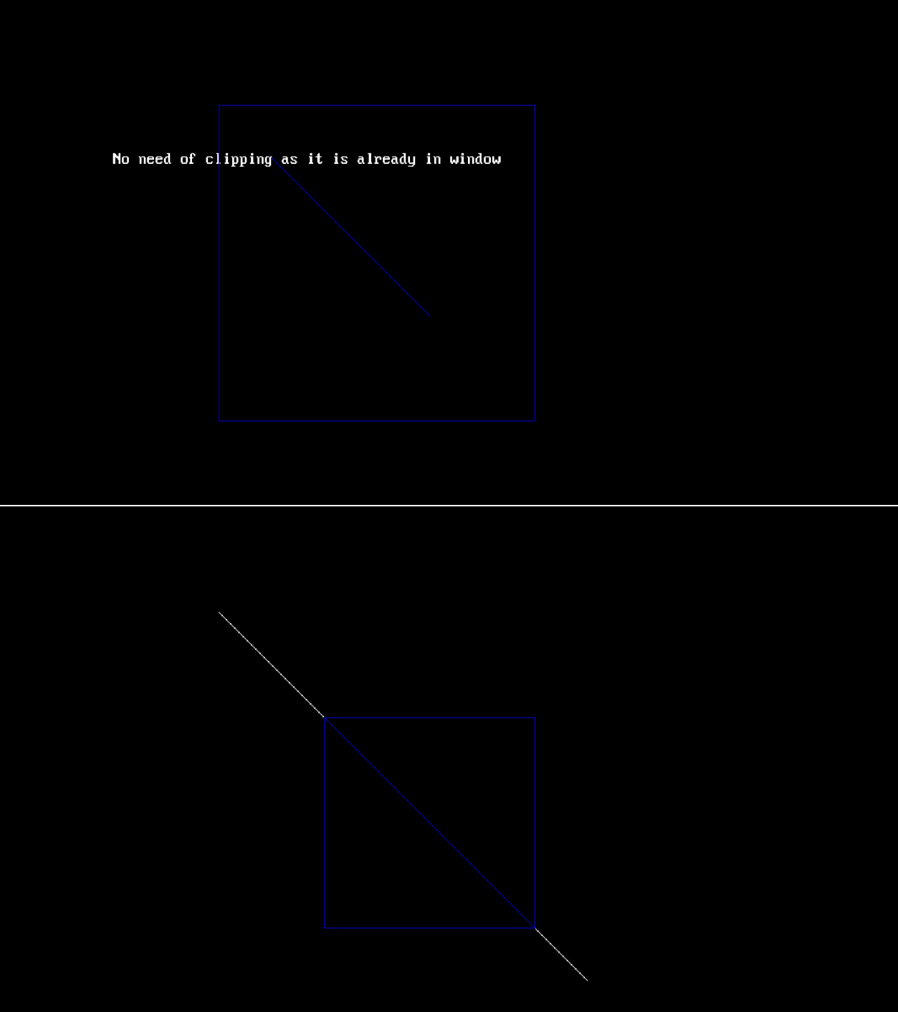

# Write a program to clip a Polygon using Sutherland Hodgeman algorithm.

#include<graphics.h> #include<stdlib.h> #include<conio.h> #include<math.h>

int *x1,*y1,*x2,*y2,*x,*y,*ymax,*ymin,i,j,nin,nout,*pintersect; float *dx,*xa;

int sign(long int a)

{

if (a<0) return(-1);

else if (a==0) return(0); else return(1);

}

void clip_polygon(void)

{

int s1,s2,f1,f2,spcross,svisible;

int visible(int a,int b,int c,int d,int e,int f); void output(int a,int b,int *c,int *d,int *e);

int cross(int a,int b,int c,int d,int e,int f,int g,int h);

int *intersect(int a,int b,int c,int d,int e,int f,int g,int h); pintersect=(int *)malloc(sizeof(int)*2);

for (i=1;i<=4;i++)

{

nout=0;

for (j=0;j<nin;j++)

*(x2+j)=*(y2+j)=0; for (j=1;j<=nin;j++)

{

if (j!=1) {} else

{

f1=*(x1+j-1);

f2=*(y1+j-1);

s1=*(x1+j-1);

s2=*(y1+j-1);

svisible=visible(s1,s2,*(x+i-1),*(y+i-1),*(x+i),*(y+i)); if (svisible>=0) output(s1,s2,&nout,x2,y2);

continue;

}

spcross=cross(s1,s2,*(x1+j-1),*(y1+j-1),*(x+i-1),*(y+i-1),*(x+i),*(y+i)); if (!spcross) {}

else

{

pintersect=intersect(s1,s2,*(x1+j-1),*(y1+j-1),*(x+i-1),*(y+i-

1),*(x+i),*(y+i));

output(*pintersect,*(pintersect+1),&nout,x2,y2);

}

s1=*(x1+j-1);

s2=*(y1+j-1);

svisible=visible(s1,s2,*(x+i-1),*(y+i-1),*(x+i),*(y+i)); if (svisible>=0) output(s1,s2,&nout,x2,y2);

}

if (!nout) continue;

spcross=cross(s1,s2,f1,f2,*(x+i-1),*(y+i-1),*(x+i),*(y+i));

if (!spcross) {} else

{

pintersect=intersect(s1,s2,f1,f2,*(x+i-1),*(y+i-1),*(x+i),*(y+i)); output(*pintersect,*(pintersect+1),&nout,x2,y2);

}

for (j=0;j<nout;j++)

{

*(x1+j)=*(x2+j);

*(y1+j)=*(y2+j);

}

nin=nout;

}

*(x2+nout)=*x2;

*(y2+nout)=*y2;

}

int cross(int s1,int s2,int p1,int p2,int wx1,int wy1,int wx2,int wy2)

{

int pvisible1,pvisible2;

int visible(int a,int b,int c,int d,int e,int f); pvisible1=visible(s1,s2,wx1,wy1,wx2,wy2); pvisible2=visible(p1,p2,wx1,wy1,wx2,wy2); if (pvisible1==-pvisible2)

return 1;

else return 0;

}

int visible(int sx1,int sx2,int px1,int py1,int px2,int py2)

{

long int temp1,temp2,temp3;

int pvisible;

temp1=(long)(sx1-px1)*(long)(py2-py1); temp2=(long)(sx2-py1)*(long)(px2-px1); temp3=temp2-temp1; pvisible=sign(temp3);

return (pvisible);

}

int *intersect(int px1,int py1,int px2,int py2,int wx1,int wy1,int wx2,int wy2)

{

float parameter[2][1],coeff[2][2],temp1,temp2; int right[2][1];

coeff[0][0]=px2-px1; coeff[0][1]=wx1-wx2; coeff[1][0]=py2-py1; coeff[1][1]=wy1-wy2; right[0][0]=wx1-px1; right[1][0]=wy1-py1;

temp1=(coeff[0][0]*coeff[1][1])-(coeff[0][1]*coeff[1][0]); temp2=coeff[0][0];

coeff[0][0]=(coeff[1][1])/temp1; coeff[1][1]=temp2/temp1; coeff[0][1]=-(coeff[0][1])/temp1;

coeff[1][0]=-(coeff[1][0])/temp1; parameter[0][0]=(coeff[0][0]*right[0][0])+(coeff[0][1]*right[1][0]);

parameter[1][0]=(coeff[1][0]*right[0][0])+(coeff[1][1]*right[1][0]);

*pintersect=px1+(px2-px1)*parameter[0][0];

*(pintersect+1)=py1+(py2-py1)*parameter[0][0]; return(pintersect);

}

void output(int vertex1,int vertex2,int *n,int *x2,int *y2)

{

(*n)++;

*(x2+(*n)-1)=vertex1;

*(y2+(*n)-1)=vertex2;

}

void include(int *end_edge,int final_edge,int scan)

{

while((*end_edge<=final_edge)&&(*(ymax+*end_edge)>=scan)) (*end_edge)++;

}

void fillscan(int end_edge,int start_edge,int scan)

{

int nx,j,k;

nx=(end_edge-start_edge)/2; j=start_edge;

for (k=1;k<=nx;k++)

{

line(*(xa+j),scan,*(xa+j+1),scan); j+=2;

}

}

void update_xvalues(int last_edge,int *start_edge,int scan)

{

int k1,k2; k2=last_edge;

for (k1=last_edge;k1>=*start_edge;k1--)

{

if (*(ymin+k1)<scan)

{

*(xa+k2)=*(xa+k1)+*(dx+k1); if (k1!=k2)

{

*(ymin+k2)=*(ymin+k1);

*(dx+k2)=*(dx+k1);

}

k2--;

}

}

*start_edge=k2+1;

}

void xsort(int start_edge,int last_edge)

{

int k,l; float t;

for (k=start_edge;k<=last_edge;k++)

{

l=k;

while((l>start_edge)&&(*(xa+l)<*(xa+l-1)))

{

t=*(ymin+l);

*(ymin+l)=*(ymin+l-1);

*(ymin+l-1)=t; t=*(xa+l);

*(xa+l)=*(xa+l-1);

*(xa+l-1)=t; t=*(dx+l);

*(dx+l)=*(dx+l-1);

*(dx+l-1)=t;

l--;

}

}

}

void poly_insert(int j,int xc1,int yc1,int xc2,int yc2)

{

int j1,ym; j1=j;

if (yc1>yc2) ym=yc1; else ym=yc2;

while((j1!=0)&&(*(ymax+j1-1)<ym))

{

*(ymax+j1)=*(ymax+j1-1);

*(ymin+j1)=*(ymin+j1-1);

*(xa+j1)=*(xa+j1-1);

*(dx+j1)=*(dx+j1-1); j1--;

}

*(ymax+j1)=ym;

*(dx+j1)=-(float)(xc2-xc1)/(yc2-yc1); if (yc1>yc2)

{

*(ymin+j1)=yc2;

*(xa+j1)=xc1;

}

else

{

*(ymin+j1)=yc1;

*(xa+j1)=xc2;

}

}

void getpoint(int i,int *xtemp,int *ytemp)

{

*xtemp=*(x2+i);

*ytemp=*(y2+i);

}

void loadpolygon(int i,int *edges)

{

int xc1,xc2,yc1,yc2,i1,k; getpoint(i,&xc1,&yc1); i1=i+1;

*edges=0; for(k=1;k<=nin;k++)

{

getpoint(i1,&xc2,&yc2); if (yc1==yc2)

xc1=xc2; else

{

poly_insert(*edges,xc1,yc1,xc2,yc2); (*edges)++;

yc1=yc2; xc1=xc2;

} i1++;

}

(*edges)--;

}

void fillpolygon(int index)

{

int edges,scan,start_edge,end_edge; loadpolygon(index,&edges);

if (edges<1) return; scan=*ymax; start_edge=0; end_edge=0;

include(&end_edge,edges,scan); while(end_edge!=start_edge)

{

xsort(start_edge,end_edge-1); fillscan(end_edge,start_edge,scan); scan--;

update_xvalues(end_edge-1,&start_edge,scan); include(&end_edge,edges,scan);

}

}

void main()

{

int gd=DETECT,gm;

int gdriver = DETECT,gmode,errorcode; clrscr();

/* //Request autodetection

int gdriver = DETECT,gmode,errorcode;

//int xmax,ymax,x1,y1,x2,y2,l;

//Initialize graphics and local variables initgraph(&gdriver,&gmode,"C:\\TURBOC3\\BGI");

//Read result of initialization

errorcode=graphresult(); if(errorcode!=grOk) //Error occured

{

printf("Graphics error : %s\n",grapherrormsg(errorcode)); printf("Press any key to halt.");

getch();

exit(1);

}*/

x=(int *)malloc(sizeof(int)*5); y=(int *)malloc(sizeof(int)*5);

printf("Enter number of sides in polygon : "); scanf("%d",&nin);

x1=(int *)malloc(sizeof(int)*2*nin); y1=(int *)malloc(sizeof(int)*2*nin); x2=(int *)malloc(sizeof(int)*2*nin); y2=(int *)malloc(sizeof(int)*2*nin); ymax=(int *)malloc(sizeof(int)*2*nin); ymin=(int *)malloc(sizeof(int)*2*nin); xa=(float *)malloc(sizeof(float)*2*nin); dx=(float *)malloc(sizeof(float)*2*nin);

printf("Enter the coordinates of the polygon vertices (x y) :\n"); for (i=0;i<nin;i++)

{

printf("%d",(i+1));

printf(":"); scanf("%d%d",&*(x1+i),&*(y1+i));

}

*(x1+nin)=*x1;

*(y1+nin)=*y1;

printf("\n\nEnter the coordinates of the window vertices :\n");

for (i=0;i<4;i++)

{

printf("%d",(i+1));

printf(":"); scanf("%d%d",&*(x+i),&*(y+i));

}

*(x+4)=*x;

*(y+4)=*y;

// registerbgidriver(EGAVGA_driver); initgraph(&gdriver,&gmode,"C:\\TURBOC3\\BGI"); errorcode = graphresult();

// initgraph(&gd,&gm,""); printf("Before clipping"); outtextxy(*x1+10,*y1-10,"Polygon");

outtextxy(*(x+1)+10,*(y+1)-10,"Clipping Window"); for (i=0;i<4;i++)

line(*(x+i),*(y+i),*(x+i+1),*(y+i+1)); for (i=0;i<nin;i++)

line(*(x1+i),*(y1+i),*(x1+i+1),*(y1+i+1));

getch(); clearviewport(); printf("After clipping");

//rectangle(200,200,400,400); for (i=0;i<4;i++)

line(*(x+i),*(y+i),*(x+i+1),*(y+i+1)); clip_polygon();

for (i=0;i<nin;i++)

{

if(*(y2+i)<*(y2+i+1))

{

*(ymax+i)=*(y2+i+1);

*(ymin+i)=*(y2+i);

*(xa+i)=*(x2+i+1);

}

else

{

*(ymax+i)=*(y2+i);

*(ymin+i)=*(y2+i+1);

*(xa+i)=*(x2+i);

}

*(dx+i)=*(y2+i)-*(y2+i+1); if (*(dx+i))

*(dx+i)=(float)(*(x2+i)-*(x2+i+1))/(*(dx+i));

line(*(x2+i),*(y2+i),*(x2+i+1),*(y2+i+1));

}

fillpolygon(0); getch(); closegraph();

}



# Write a program to fill a polygon using Scan line fill algorithm.

#include <stdio.h> #include <conio.h> #include <graphics.h>

main()

{

int n,i,j,k,gd,gm,dy,dx; int x,y,temp;

int a[20][2],xi[20]; float slope[20];

clrscr();

printf("\n\n\tEnter the no. of edges of polygon : "); scanf("%d",&n);

printf("\n\n\tEnter the cordinates of polygon :\n\n\n ");

for(i=0;i<n;i++)

{

printf("\tX%d Y%d : ",i,i); scanf("%d %d",&a[i][0],&a[i][1]);

}

a[n][0]=a[0][0];

a[n][1]=a[0][1];

detectgraph(&gd,&gm); initgraph(&gd,&gm,"c:\\turboc3\\bgi");

/*- draw polygon -*/

for(i=0;i<n;i++)

{ line(a[i][0],a[i][1],a[i+1][0],a[i+1][1]);

}

getch();

for(i=0;i<n;i++)

{

dy=a[i+1][1]-a[i][1];

dx=a[i+1][0]-a[i][0];

if(dy==0) slope[i]=1.0; if(dx==0) slope[i]=0.0;

if((dy!=0)&&(dx!=0)) /*- calculate inverse slope -*/

{

slope[i]=(float) dx/dy;

}

}

for(y=0;y< 480;y++)

{ k=0;

for(i=0;i<n;i++)

{

if( ((a[i][1]<=y)&&(a[i+1][1]>y))||

((a[i][1]>y)&&(a[i+1][1]<=y)))

{

xi[k]=(int)(a[i][0]+slope[i]*(y-a[i][1])); k++;

}

}

for(j=0;j<k-1;j++) /*- Arrange x-intersections in order -*/ for(i=0;i<k-1;i++)

{

if(xi[i]>xi[i+1])

{

temp=xi[i]; xi[i]=xi[i+1]; xi[i+1]=temp;

}

}

setcolor(35); for(i=0;i<k;i+=2)

{

line(xi[i],y,xi[i+1]+1,y); getch();

}

}

}

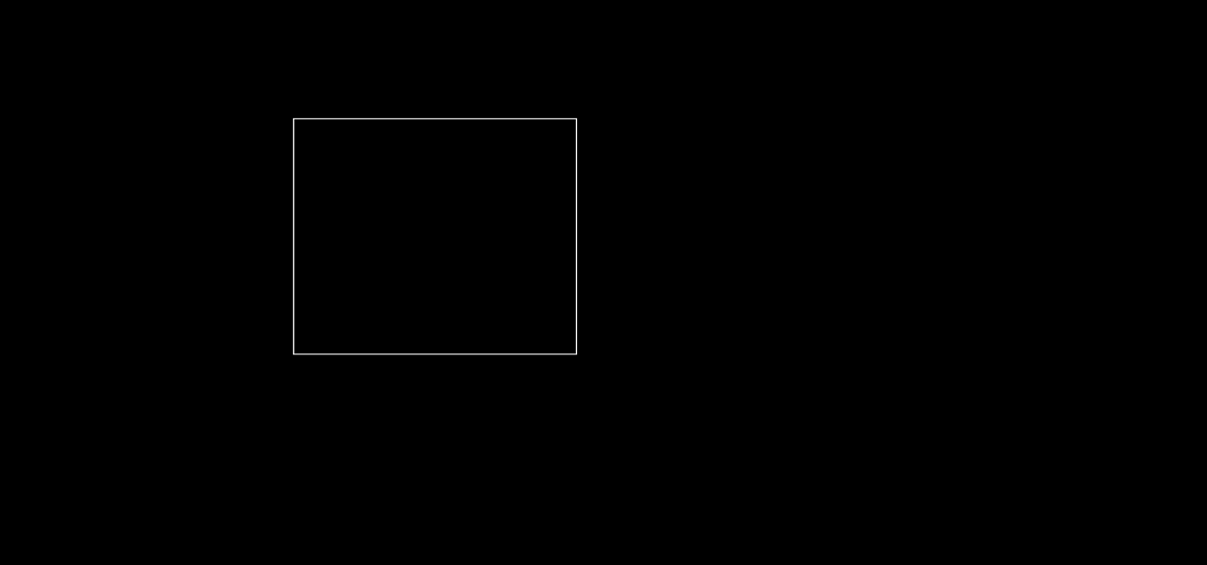



# Write a program to apply various 2D transformations on a 2D object(use homogeneous coordinates).

#include<stdio.h> #include<graphics.h> #include<math.h> #define pi (22/7) #define sz 3

double x[3][3],res[3][3],tm[3][3]; int t2[3][2];

void prod(double a[sz][sz],double b[sz][sz],double c[sz][sz],int r1,int c1,int c2)

{ int i,j,k; for(i=0;i<r1;i++)

{

for(j=0;j<c2;j++)

{

for(k=0;k<c1;k++)

{

c[i][j] += a[i][k]*b[k][j];

}

}

}

}

void drawtriangle(int t[3][2])

{ int i;

for(i=0;i<3;i++)

{

line(t[i][0]+100,100-t[i][1],t[(i+1)%3][0]+100,100-t[(i+1)%3][1]);

} line(0,100,400,100); line(100,0,100,400);

}

void translation(int t1[3][2])

{

int i,j,val; for(i=0;i<3;i++)

{

for(j=0;j<2;j++)

{

x[i][j] = t1[i][j]; t2[i][j] = 0;

res[i][j] = 0; if(i == j)

tm[i][j] = 1;

else

tm[i][j] = 0;

}

x[i][j] = 1;

res[i][j] = 0; if(i == j)

tm[i][j] = 1;

else

tm[i][j] = 0;

}

printf("\n Shift in x-axis : "); scanf("%d",&val);

tm[2][0] = val;

printf("\n Shift in y-axis : "); scanf("%d",&val);

tm[2][1] = val; prod(x,tm,res,3,3,3); for(i=0;i<3;i++)

{

for(j=0;j<2;j++)

{

t2[i][j] = (int)res[i][j];

}

}

settextstyle(2,0,5);

outtextxy(10,405,"Press any key to continue..."); getch();

clrscr();

outtextxy(10,10,"\n Triangle after transformation "); drawtriangle(t2);

outtextxy(10,405,"Press any key to continue..."); getch();

}

void rotation(int t1[3][2])

{

int i,j,ang;

double sinx[] = {0,0.5,0.7,0.8,1,0,-1,0};

double cosx[] = {1,0.8,0.7,0.5,0,-1,0,1};

for(i=0;i<3;i++)

{

for(j=0;j<2;j++)

{

x[i][j] = t1[i][j]; t2[i][j] = 0;

res[i][j] = 0; if(i == j)

tm[i][j] = 1;

else

tm[i][j] = 0;

}

x[i][j] = 1;

res[i][j] = 0; if(i == j)

tm[i][j] = 1;

else

tm[i][j] = 0;

}

printf("\n Choose the angle of rotation : ");

printf("\n\t 1. 0 degree\n\t 2. 30 degree\n\t 3. 45 degree\n\t 4. 60 degree\n\t 5. 90 degree");

printf("\n\t 6. 180 degree\n\t 7. 270 degree\n\t 8. 360 degree\n Enter your choice : "); scanf("%d",&ang);

if(ang > 0 && ang < 9)

{

tm[0][0] = tm[1][1] = cosx[ang-1];

tm[0][1] = tm[1][0] = sinx[ang-1];

}

else

{

tm[0][0] = tm[1][1] = cosx[0];

tm[0][1] = tm[1][0] = sinx[0];

}

tm[1][0] *= (-1);

prod(x,tm,res,3,3,3); for(i=0;i<3;i++)

{

for(j=0;j<2;j++)

{

t2[i][j] = (int)res[i][j];

}

}

settextstyle(2,0,5);

outtextxy(10,405,"Press any key to continue..."); getch();

clrscr();

outtextxy(10,10,"\n Triangle after transformation "); drawtriangle(t2);

outtextxy(10,405,"Press any key to continue..."); getch();

}

void scaling(int t1[3][2])

{

int i,j; for(i=0;i<3;i++)

{

for(j=0;j<2;j++)

{

x[i][j] = t1[i][j]; t2[i][j] = 0;

res[i][j] = 0; if(i == j)

tm[i][j] = 1;

else

tm[i][j] = 0;

}

x[i][j] = 1;

res[i][j] = 0; if(i == j)

tm[i][j] = 1;

else

tm[i][j] = 0;

}

printf("\n Enter the Scaling value : "); scanf("%lf",&tm[0][0]);

tm[1][1] = tm[0][0];

prod(x,tm,res,3,3,3); for(i=0;i<3;i++)

{

for(j=0;j<2;j++)

{

t2[i][j] = (int)res[i][j];

}

}

settextstyle(2,0,5);

outtextxy(10,405,"Press any key to continue..."); getch();

clrscr();

outtextxy(10,10,"\n Triangle after transformation "); drawtriangle(t2);

outtextxy(10,405,"Press any key to continue..."); getch();

}

void reflection(int t1[3][2])

{

int i,j,ch; for(i=0;i<3;i++)

{

for(j=0;j<2;j++)

{

x[i][j] = t1[i][j]; t2[i][j] = 0;

res[i][j] = 0;

if(i == j)

tm[i][j] = 1;

else

tm[i][j] = 0;

}

x[i][j] = 1;

res[i][j] = 0; if(i == j)

tm[i][j] = 1;

else

tm[i][j] = 0;

}

printf("\n Type of Reflection : ");

printf("\n\t 1. Along x-axis ; y = 0\n\t 2. Along y-axis ; x = 0\n\t 3. Along y = x\n\t 4. Along y =

-x ");

printf("\n Enter your choice : "); scanf("%d",&ch);

if(ch > 0 && ch < 4)

{ if(ch < 3)

{

tm[0][1] = tm[1][0] = 0;

if(ch == 1)

tm[1][1] = -1;

else

tm[0][0] = -1;

}

else

{

tm[0][0] = tm[1][1] = 0;

if(ch == 3)

tm[0][1] = tm[1][0] = 1;

else

tm[0][1] = tm[1][0] = -1;

}

}

else // taking the case of reflection along y = 0

{

tm[0][1] = tm[1][0] = 0; tm[1][1] = -1;

}

prod(x,tm,res,3,3,3); for(i=0;i<3;i++)

{

for(j=0;j<2;j++)

{

t2[i][j] = (int)res[i][j];

}

}

settextstyle(2,0,5);

outtextxy(10,405,"Press any key to continue..."); getch();

clrscr();

outtextxy(10,10,"\n Triangle after transformation "); drawtriangle(t2);

outtextxy(10,405,"Press any key to continue..."); getch();

}

void distortion(int t1[3][2])

{

int i,j; for(i=0;i<3;i++)

{

for(j=0;j<2;j++)

{

x[i][j] = t1[i][j]; t2[i][j] = 0;

res[i][j] = 0; if(i == j)

tm[i][j] = 1;

else

tm[i][j] = 0;

}

x[i][j] = 1;

res[i][j] = 0; if(i == j)

tm[i][j] = 1;

else

tm[i][j] = 0;

}

printf("\n Enter the Scaling value for x-axis : "); scanf("%lf",&tm[0][0]);

printf("\n Enter the Scaling value for y-axis : "); scanf("%lf",&tm[1][1]);

prod(x,tm,res,3,3,3); for(i=0;i<3;i++)

{

for(j=0;j<2;j++)

{

t2[i][j] = (int)res[i][j];

}

}

settextstyle(2,0,5);

outtextxy(10,405,"Press any key to continue...");

getch();

clrscr();

outtextxy(10,10,"\n Triangle after transformation "); drawtriangle(t2);

outtextxy(10,405,"Press any key to continue..."); getch();

}

void main()

{

int gd = DETECT,gm,i,ch; int t1[3][2];

initgraph(&gd,&gm,"C:\\TURBOC3\\bgi"); clrscr();

for(i=0;i<3;i++)

{

printf("\n Enter the value of x%d : ",i+1); scanf("%d",&t1[i][0]);

printf("\n Enter the value of y%d : ",i+1); scanf("%d",&t1[i][1]);

}

settextstyle(2,0,5);

outtextxy(10,405,"Press any key to continue..."); getch();

clrscr();

outtextxy(10,10,"Triangle before transformation "); drawtriangle(t1);

outtextxy(10,405,"Press any key to continue..."); getch();

clrscr(); do

{

printf("\n 1.Translation\n 2.Rotation\n 3.Scaling\n 4.Reflection\n 5.Distortion\n Enter your choice : ");

scanf("%d",&ch); switch(ch)

{

case 1:

translation(t1); break;

case 2:

rotation(t1); break;

case 3:

scaling(t1); break;

case 4:

reflection(t1); break;

case 5:

distortion(t1); break;

default:

printf("\n Invalid Choice !");

}

clrscr();

printf("\n Do you want to choose again? (1/0) : "); scanf("%d",&ch);

}while(ch == 1); getch(); closegraph(); restorecrtmode();

}

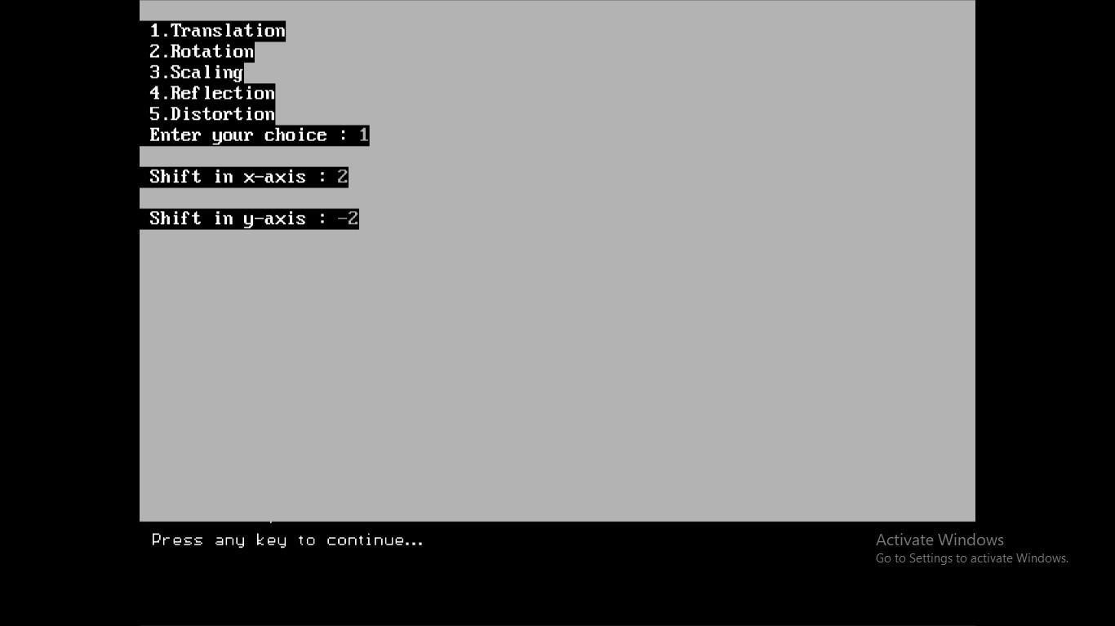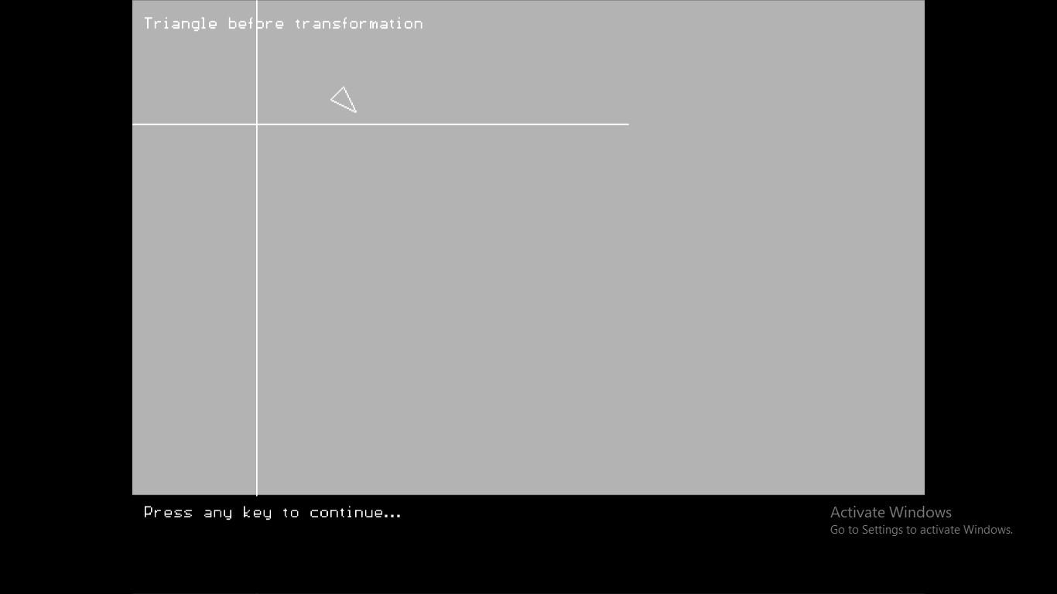

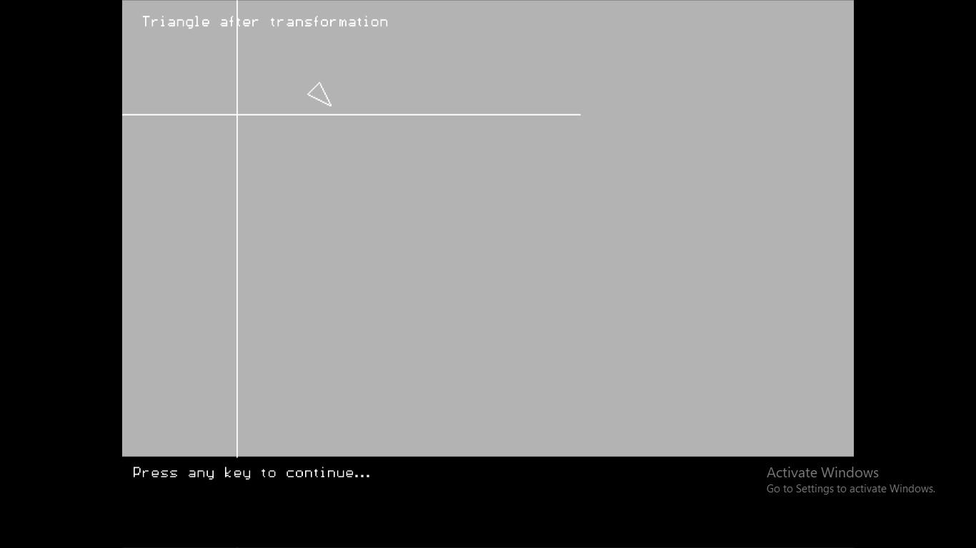

When we rotate it 90 degree

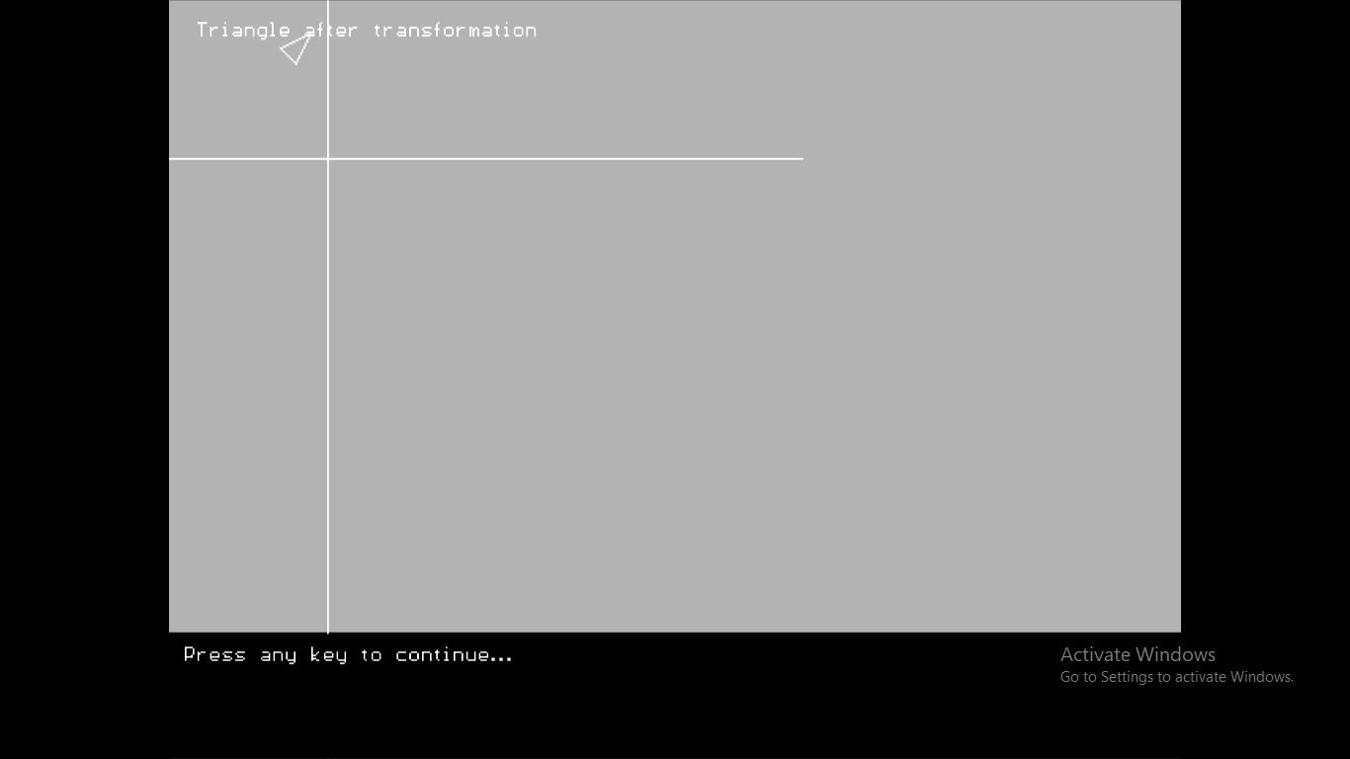

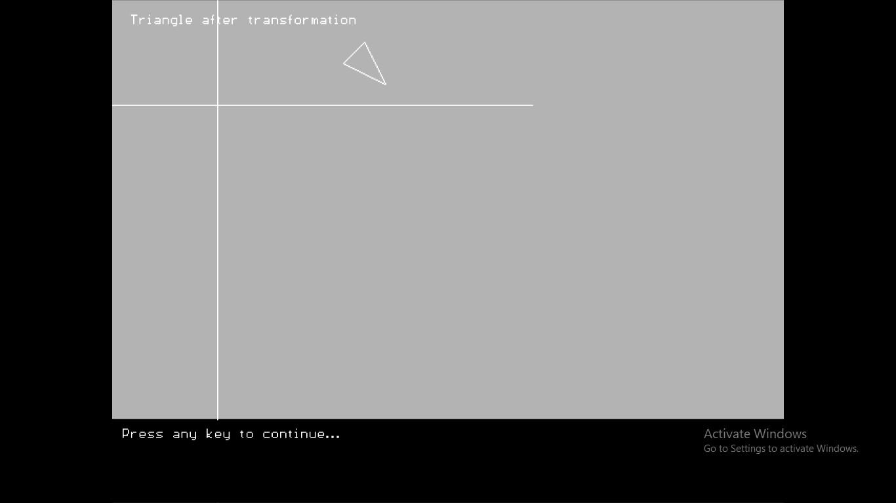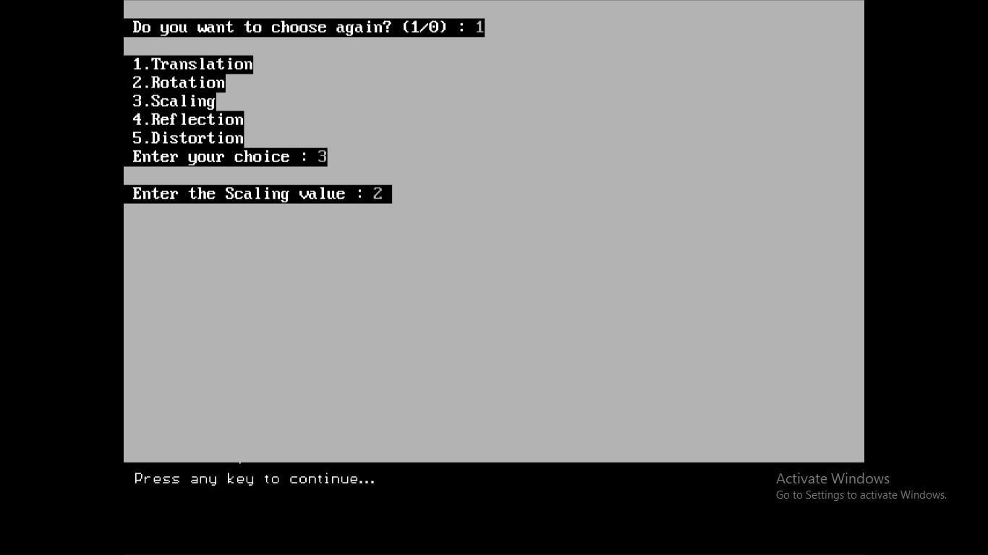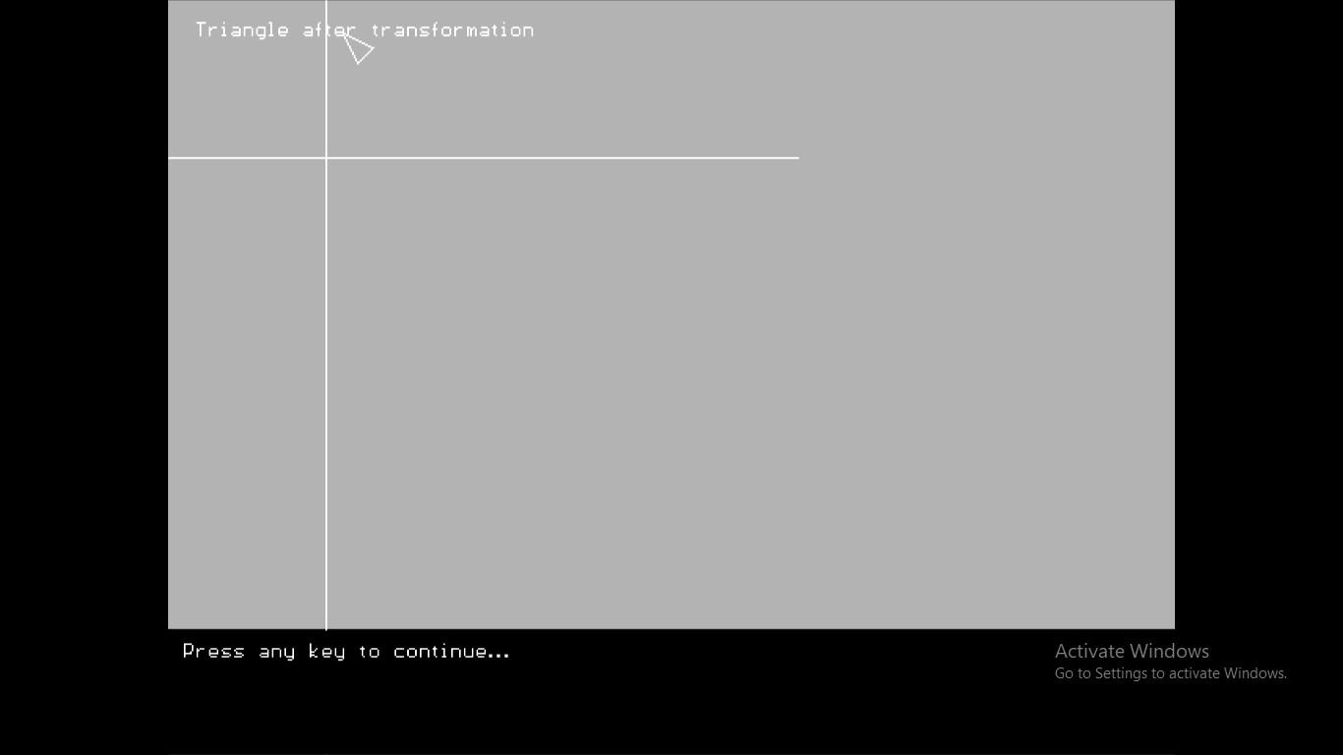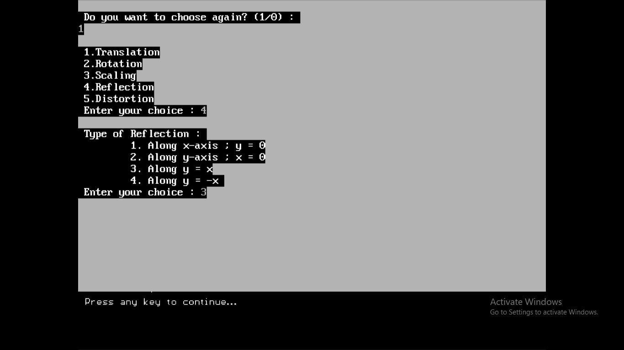

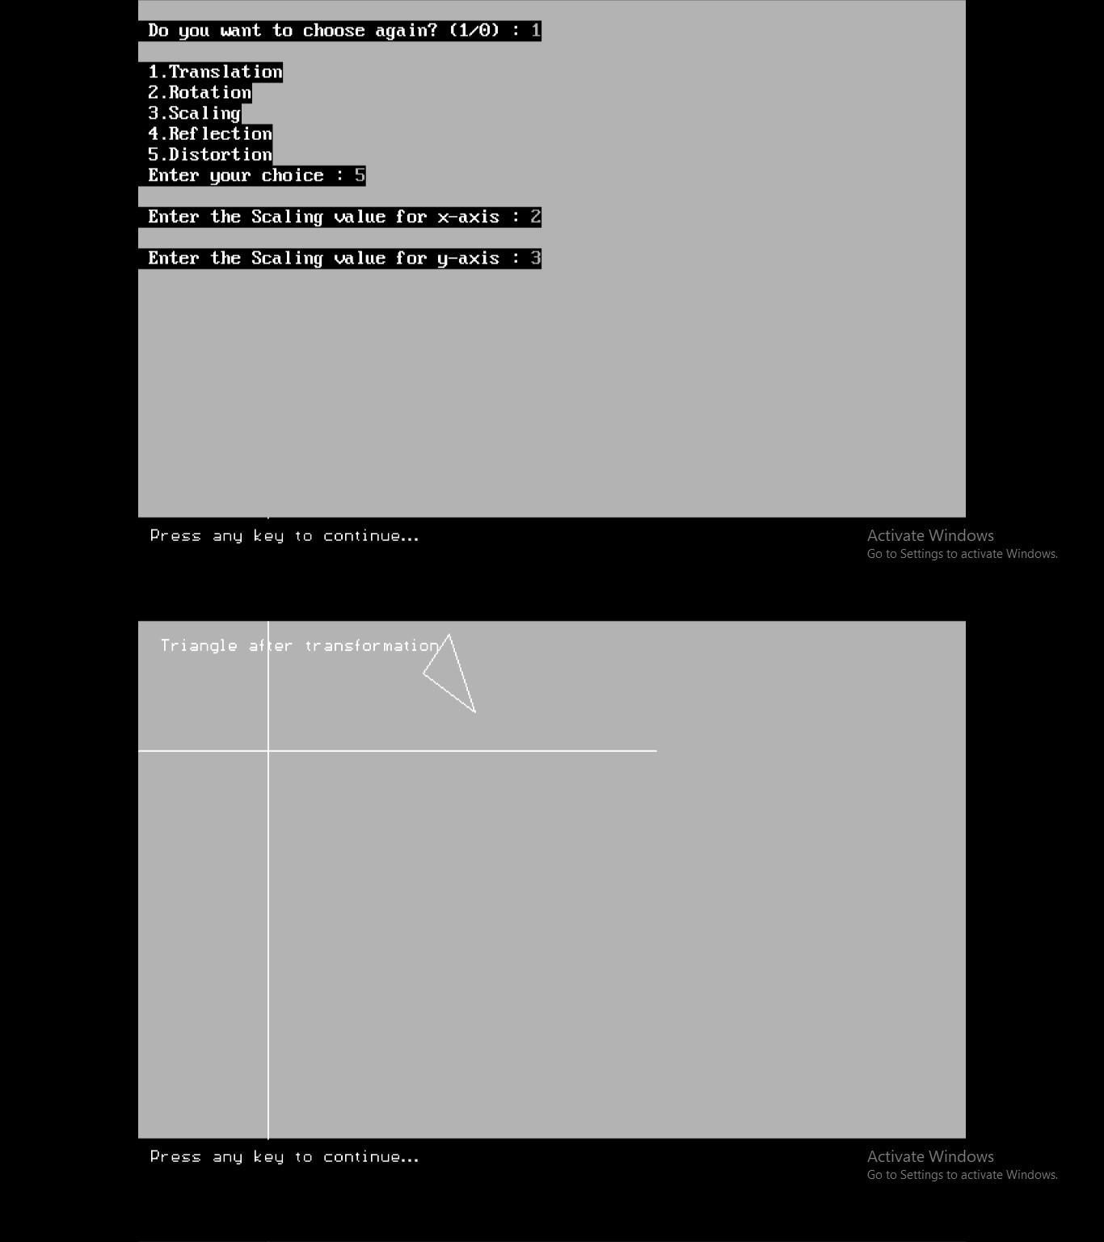

7. Write a program to apply various 3D transformations on a 3D

object and then apply parallel and perspective projection on it.

#include<stdio.h> #include<graphics.h>

#define pi (22/7) #define row 8

#define col 4

double x[8][4],res[8][4],tm[4][4]; int t2[8][4];

void prod(double a[row][col],double b[col][col],double c[row][col],int r1,int c1,int c2)

{

int i,j,k; for(i=0;i<r1;i++)

{

for(j=0;j<c2;j++)

{

for(k=0;k<c1;k++)

{

c[i][j] += a[i][k]*b[k][j];

}

}

}

}

void printmat(int arr[8][4])

{

int i,j; for(i=0;i<8;i++)

{

printf("\n "); for(j=0;j<4;j++)

{

printf("%d ",arr[i][j]);

}

}

printf("\n Press any key to continue..."); getch();

clrscr(); cleardevice();

}

void drawcuboid(int t1[8][4])

{

int i,j;

int t[8][4]; for(i=0;i<8;i++)

{

for(j=0;j<4;j++)

{

t[i][j] = t1[i][j];

}

}

for(i=0;i<4;i++)

{

for(j=0;j<3;j++)

{

t[i][j] += 20;

}

}

j = 4;

for(i=0;i<4;i++)

{

line(t[i][0],t[i][1],t[(i+1)%4][0],t[(i+1)%4][1]); // Forming sq ABCD

line(t[j][0],t[j][1],t[((j+1)%4)+4][0],t[((j+1)%4)+4][1]); // Forming sq EFGH

line(t[i][0],t[i][1],t[j][0],t[j][1]); // Joining AE,BF,CG,DH j++;

}

settextstyle(2,0,5);

outtextxy(10,405,"Press any key to continue..."); getch();

clrscr(); cleardevice();

}

void translation(int t1[8][4])

{

int i,j,val; for(i=0;i<8;i++)

{

for(j=0;j<3;j++)

{

x[i][j] = t1[i][j]; t2[i][j] = 0;

res[i][j] = 0; if(i == j)

tm[i][j] = 1;

else

tm[i][j] = 0;

}

x[i][j] = 1;

res[i][j] = 0; if(i == j)

tm[i][j] = 1;

else

tm[i][j] = 0;

}

printf("\n Shift in x-axis : "); scanf("%d",&val);

tm[3][0] = val;

printf("\n Shift in y-axis : "); scanf("%d",&val);

tm[3][1] = val;

printf("\n Shift in z-axis : "); scanf("%d",&val);

tm[3][2] = val; prod(x,tm,res,row,col,col); for(i=0;i<8;i++)

{

for(j=0;j<3;j++)

{

t2[i][j] = (int)res[i][j];

}

}

printf("\n Matrix X\' : "); printmat(t2);

printf("\n Cuboid after transformation "); drawcuboid(t2);

}

void rotation(int t1[8][4])

{

int i,j,ang,ch;

double sinx[] = {0,0.5,0.7,0.8,1,0,-1,0};

double cosx[] = {1,0.8,0.7,0.5,0,-1,0,1};

for(i=0;i<8;i++)

{

for(j=0;j<3;j++)

{

x[i][j] = t1[i][j]; t2[i][j] = 0;

res[i][j] = 0; if(i == j)

tm[i][j] = 1;

else

tm[i][j] = 0;

}

x[i][j] = 1;

res[i][j] = 0; if(i == j)

tm[i][j] = 1;

else

tm[i][j] = 0;

}

printf("\n Choose the type of rotation : \n\t 1. Rotation about x-axis\n\t 2. Rotation about y-

axis");

printf("\n\t 3. Rotation about z-axis\n Enter your choice : "); scanf("%d",&ch);

printf("\n Choose the angle of rotation : ");

printf("\n\t 1. 0 degree\n\t 2. 30 degree\n\t 3. 45 degree\n\t 4. 60 degree\n\t 5. 90 degree");

printf("\n\t 6. 180 degree\n\t 7. 270 degree\n\t 8. 360 degree\n Enter your choice : "); scanf("%d",&ang);

if(ch <= 1) // x-axis

{

if(ang > 0 && ang < 9)

{

tm[2][2] = tm[1][1] = cosx[ang-1];

tm[1][2] = tm[2][1] = sinx[ang-1];

}

else

{

tm[2][2] = tm[1][1] = cosx[0];

tm[1][2] = tm[2][1] = sinx[0];

}

tm[2][1] *= (-1);

}

else if(ch == 2) // y-axis

{

if(ang > 0 && ang < 9)

{

tm[2][2] = tm[0][0] = cosx[ang-1];

tm[0][2] = tm[2][0] = sinx[ang-1];

}

else

{

tm[2][2] = tm[1][1] = cosx[0];

tm[1][2] = tm[2][1] = sinx[0];

}

tm[2][0] *= (-1);

}

else // z-axis

{

if(ang > 0 && ang < 9)

{

tm[0][0] = tm[1][1] = cosx[ang-1];

tm[0][1] = tm[1][0] = sinx[ang-1];

}

else

{

tm[2][2] = tm[1][1] = cosx[0];

tm[1][2] = tm[2][1] = sinx[0];

}

tm[1][0] *= (-1);

}

prod(x,tm,res,row,col,col); for(i=0;i<8;i++)

{

for(j=0;j<3;j++)

{

t2[i][j] = (int)res[i][j];

}

}

printf("\n Matrix X\' : "); printmat(t2);

printf("\n Cuboid after transformation "); drawcuboid(t2);

}

void scaling(int t1[8][4])

{

int i,j; for(i=0;i<8;i++)

{

for(j=0;j<3;j++)

{

x[i][j] = t1[i][j]; t2[i][j] = 0;

res[i][j] = 0; if(i == j)

tm[i][j] = 1;

else

tm[i][j] = 0;

}

x[i][j] = 1;

res[i][j] = 0; if(i == j)

tm[i][j] = 1;

else

tm[i][j] = 0;

}

printf("\n Enter the Scaling value : "); scanf("%lf",&tm[0][0]);

tm[1][1] = tm[2][2] = tm[0][0];

prod(x,tm,res,row,col,col); for(i=0;i<8;i++)

{

for(j=0;j<3;j++)

{

t2[i][j] = (int)res[i][j];

}

}

printf("\n Matrix X\' : "); printmat(t2);

printf("\n Cuboid after transformation "); drawcuboid(t2);

}

void reflection(int t1[8][4])

{

int i,j,ch; for(i=0;i<8;i++)

{

for(j=0;j<3;j++)

{

x[i][j] = t1[i][j]; t2[i][j] = 0;

res[i][j] = 0; if(i == j)

tm[i][j] = 1;

else

tm[i][j] = 0;

}

x[i][j] = 1;

res[i][j] = 0; if(i == j)

tm[i][j] = 1;

else

tm[i][j] = 0;

}

printf("\n Type of Reflection : ");

printf("\n\t 1. About xy plane\n\t 2. About yz plane\n\t 3. About xz plane"); printf("\n Enter your choice : ");

scanf("%d",&ch); switch(ch)

{

case 1:

tm[2][2] = -1;

break;

case 2:

tm[0][0] = -1;

break;

case 3:

tm[1][1] = -1;

break;

default : tm[2][2] = -1;

}

prod(x,tm,res,row,col,col); for(i=0;i<8;i++)

{

for(j=0;j<3;j++)

{

t2[i][j] = (int)res[i][j];

}

}

printf("\n Matrix X\' : "); printmat(t2);

printf("\n Cuboid after transformation "); drawcuboid(t2);

}

void shearing(int t1[8][4])

{

int i,j; for(i=0;i<8;i++)

{

for(j=0;j<3;j++)

{

x[i][j] = t1[i][j]; t2[i][j] = 0;

res[i][j] = 0; if(i == j)

tm[i][j] = 1;

else

tm[i][j] = 0;

}

x[i][j] = 1;

res[i][j] = 0; if(i == j)

tm[i][j] = 1;

else

tm[i][j] = 0;

}

printf("\n Enter the Scaling value x-axis, a : "); scanf("%lf",&tm[0][0]);

printf("\n Enter the Scaling value y-axis, e (a != e) : "); scanf("%lf",&tm[1][1]);

prod(x,tm,res,row,col,col); for(i=0;i<8;i++)

{

for(j=0;j<3;j++)

{

t2[i][j] = (int)res[i][j];

}

}

printf("\n Matrix X\' : "); printmat(t2);

printf("\n Cuboid after transformation "); drawcuboid(t2);

}

void main()

{

int i,j,ch,gd = DETECT,gm,t1[8][4]; initgraph(&gd,&gm,"C:\\TURBOC3\\BGI"); clrscr();

cleardevice(); for(i=0;i<8;i++)

{

printf("\n Enter the value of x%d : ",i+1); scanf("%d",&t1[i][0]);

printf("\n Enter the value of y%d : ",i+1); scanf("%d",&t1[i][1]);

printf("\n Enter the value of z%d : ",i+1); scanf("%d",&t1[i][2]);

t1[i][3] = 1;

}

printf("\n Matrix X : "); printmat(t1);

printf("\n Cuboid before transformation "); drawcuboid(t1);

settextstyle(2,0,5);

outtextxy(10,405,"Press any key to continue..."); getch();

do

{

clrscr(); cleardevice();

printf("\n 1.Translation\n 2.Rotation\n 3.Scaling\n 4.Reflection\n 5.Shearing\n Enter

your choice : ");

scanf("%d",&ch); switch(ch)

{

case 1:

translation(t1); break;

case 2:

rotation(t1); break;

case 3:

scaling(t1); break;

case 4:

reflection(t1); break;

case 5:

shearing(t1); break;

default:

printf("\n Invalid Choice !");

}

printf("\n Do you want to choose again? (1/0) : "); scanf("%d",&ch);

}while(ch == 1); getch(); closegraph(); restorecrtmode();

}

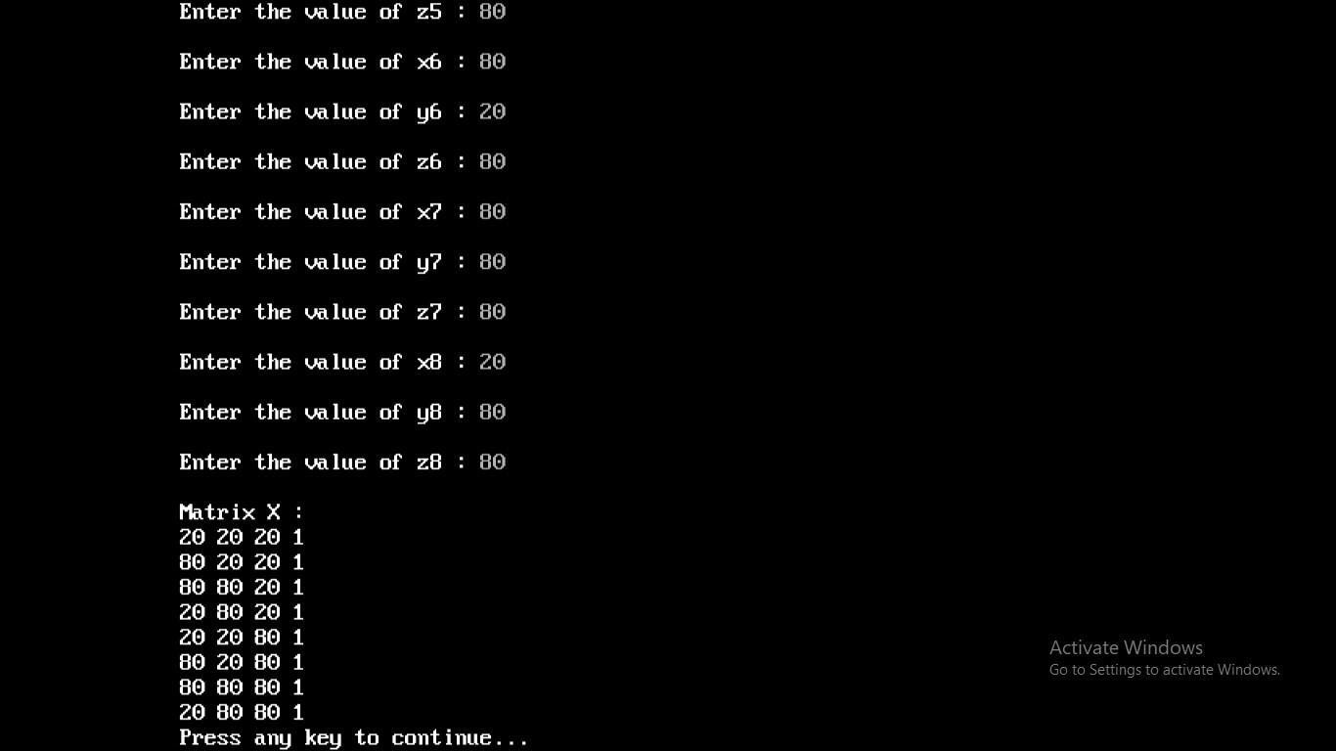

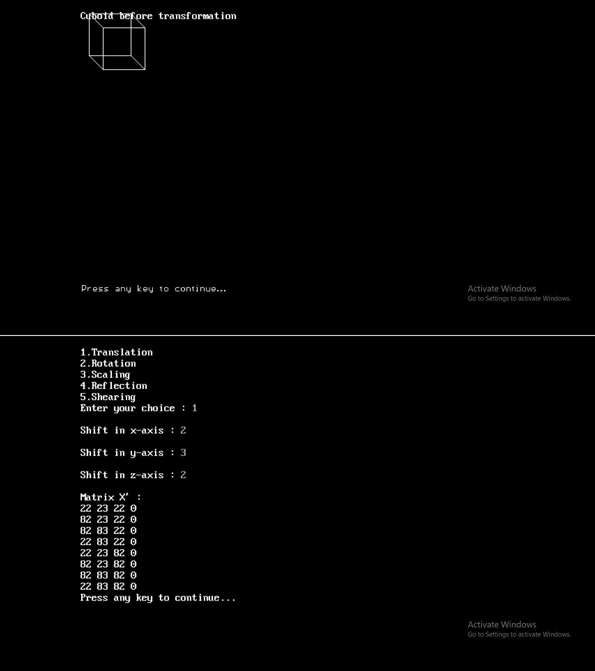

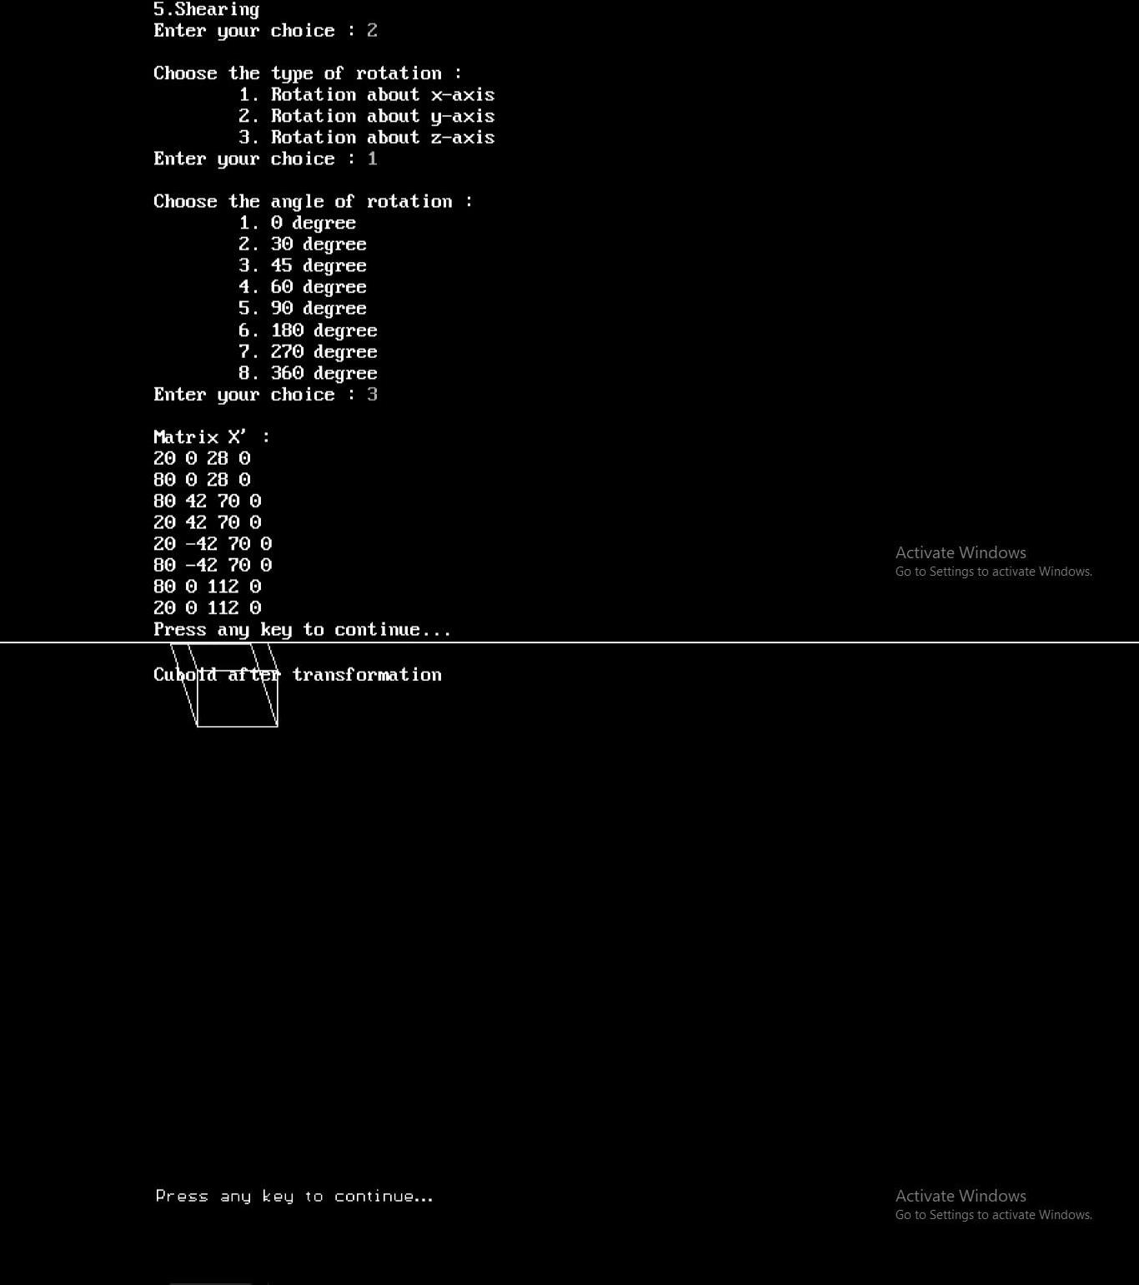

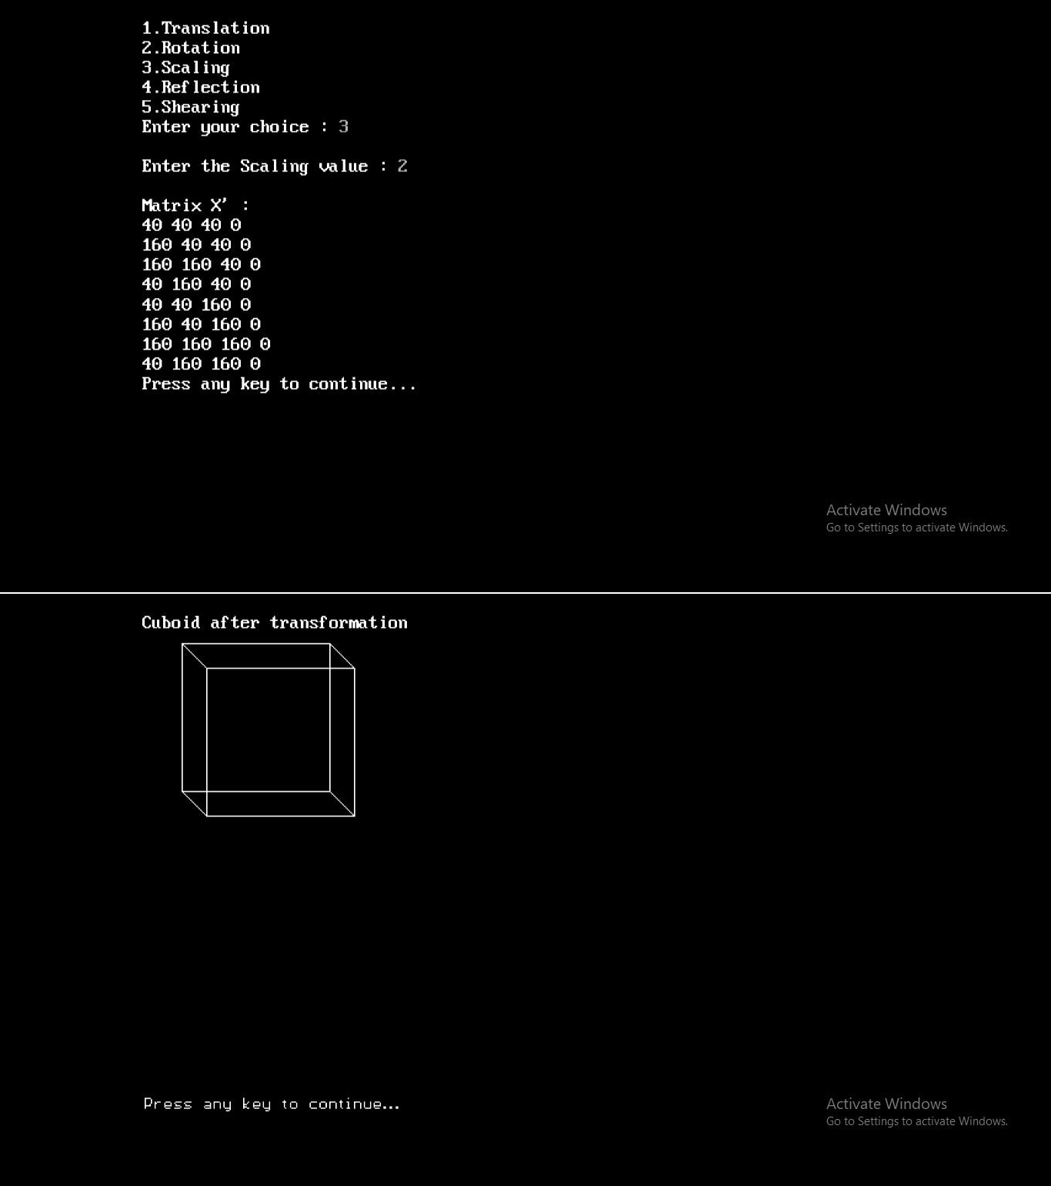

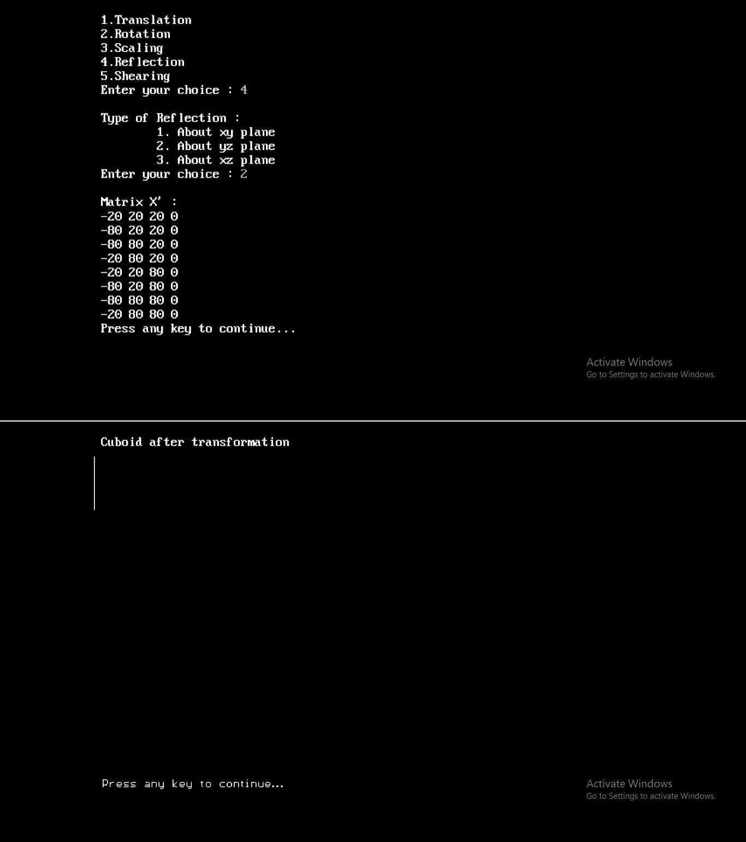

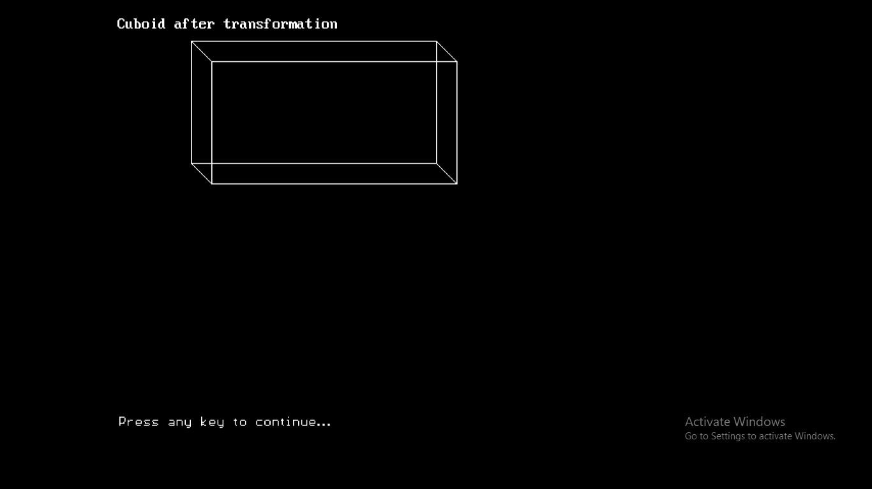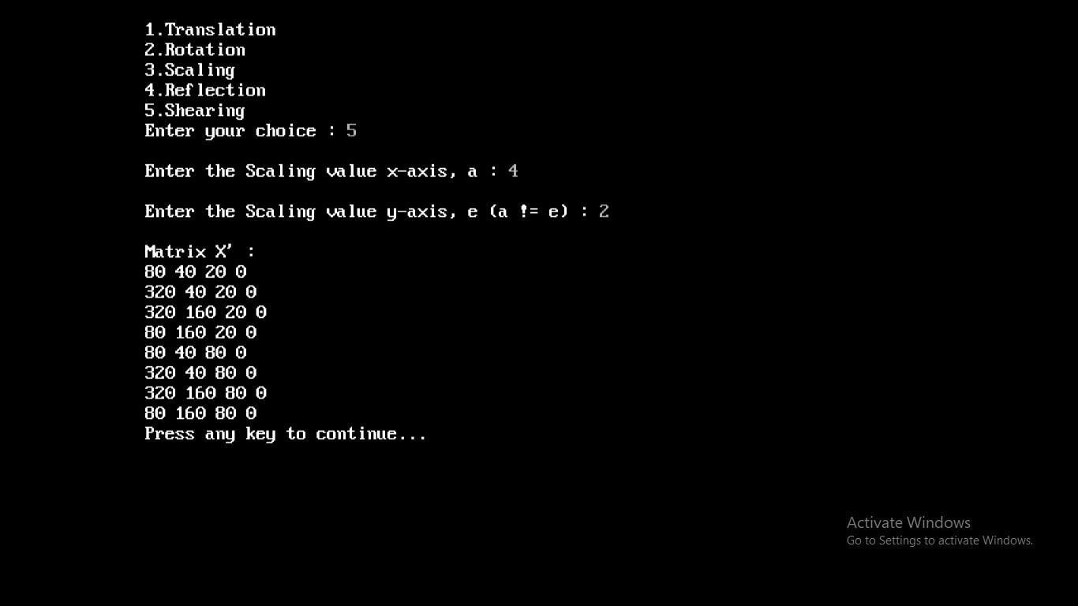

# 8. Write a program to draw Hermite/Bezier curve.

#include<stdio.h> #include<conio.h> #include<graphics.h>

int x,y,z;

void main()

{

float u;

int gd,gm,ymax,i,n,c[4][3];

for(i=0;i<4;i++) { c[i][0]=0; c[i][1]=0; }

printf("\n\n Enter four points : \n\n");

for(i=0; i<4; i++)

{

printf("\t X%d Y%d : ",i,i); scanf("%d %d",&c[i][0],&c[i][1]);

}

c[4][0]=c[0][0];

c[4][1]=c[0][1];

detectgraph(&gd,&gm); initgraph(&gd,&gm,"c:\\turboc3\\bgi");

ymax = 480;

setcolor(13); for(i=0;i<3;i++)

{

line(c[i][0],ymax-c[i][1],c[i+1][0],ymax-c[i+1][1]);

}

setcolor(3); n=3;

for(i=0;i<=40;i++)

{

u=(float)i/40.0; bezier(u,n,c);

if(i==0)

{ moveto(x,ymax-y);} else

{ lineto(x,ymax-y); } getch();

}

getch();

}

bezier(u,n,p)

float u;int n; int p[4][3];

{

int j; float v,b;

float blend(int,int,float);

x=0;y=0;z=0;

for(j=0;j<=n;j++)

{

b=blend(j,n,u);

x=x+(p[j][0]*b);

y=y+(p[j][1]*b);

z=z+(p[j][2]*b);

}

}

float blend(int j,int n,float u)

{

int k;

float v,blend; v=C(n,j); for(k=0;k<j;k++)

{ v*=u; } for(k=1;k<=(n-j);k++)

{ v *= (1-u); }

blend=v; return(blend);

}

C(int n,int j)

{

int k,a,c; a=1;

for(k=j+1;k<=n;k++) { a*=k; } for(k=1;k<=(n-j);k++) { a=a/k; } c=a;

return(c);

}

