CS5560 Knowledge Discovery and Management

Problem Set (PS-1B) - June 5, 2017

Name: P.Shankar

Class ID:22

Text : CHICAGO (AP) — Citing high fuel prices, United Airlines said Friday it has increased fares by $6 per round trip on flights to some cities also served by lower-cost carriers. American Airlines, a unit AMR, immediately matched the move, spokesman Tim Wagner said. United, a unit of UAL, said the increase took effect Thursday night and applies to most routes where it competes against discount carriers, such as Chicago to Dallas and Atlanta and Denver to San Francisco, Los Angeles and New York.

For the text above, perform the following NLP operations

A .Sentence detection/Tokenization

CHICAGO-1

-LRB--2

AP-3

-RRB--4

---5

Citing-6

high-7

fuel-8

prices-9

,-10

United-11

Airlines-12

said-13

Friday-14

it-15

has-16

increased-17

fares-18

by-19

$-20

6-21

per-22

round-23

trip-24

on-25

flights-26

to-27

some-28

cities-29

also-30

served-31

by-32

lower-cost-33

carriers-34

.-35

American-1

Airlines-2

,-3

a-4

unit-5

AMR-6

,-7

immediately-8

matched-9

the-10

move-11

,-12

spokesman-13

Tim-14

Wagner-15

said-16

.-17

United-1

,-2

a-3

unit-4

of-5

UAL-6

,-7

said-8

the-9

increase-10

took-11

effect-12

Thursday-13

night-14

and-15

applies-16

to-17

most-18

routes-19

where-20

it-21

competes-22

against-23

discount-24

carriers-25

,-26

such-27

as-28

Chicago-29

to-30

Dallas-31

and-32

Atlanta-33

and-34

Denver-35

to-36

San-37

Francisco-38

,-39

Los-40

Angeles-41

and-42

New-43

York-44

.-45

B .Lemmatization

CHICAGO-CHICAGO

AP-AP

Citing :cite

high :high

fuel :fuel

prices :price

United :United

Airlines :Airlines

Said :say

Friday :Friday

it :it

has :have

increased :increase

fares :fare

by :by

$ :$

6 :6

per :per

round :round

trip :trip

on :on

flights :flight

to :to

some :some

cities :city

also :also

served :serve

by :by

lower-cost :lower-cost

carriers :carrier

American :American

Airlines :Airlines

a :a

unit :unit

AMR :AMR

immediately :immediately

matched :match

the :the

move :move

spokesman :spokesman

Tim :Tim

Wagner :Wagner

said :say

United :United

of :of

UAL :UAL

said :say

increase :increase

took :take

effect :effect

Thursday :Thursday

night :night

and :and

applies :apply

to :to

most :most

routes :route

where :where

it :it

competes :compete

against :against

discount :discount

carriers :carrier

such :such

as :as

Chicago :Chicago

Dallas :Dallas

Atlanta :Atlanta

Denver :Denver

San Francisco :San Francisco

Los Angeles : Los Angeles

New York : New York

C .POS tagging/Chunking

CHICAGO-NNP

AP-NNP

Citing-VBG

high-JJ

fuel-NN

prices-NNS

United-NNP

Airlines-NNPS

said-VBD

Friday-NNP

it-PRP

has-VBZ

increased-VBN

fares-NNS

by-IN

$-$

6-CD

per-IN

round-NN

trip-NN

on-IN

flights-NNS

to-TO

some-DT

cities-NNS

also-RB

served-VBD

by-IN

lower-cost-JJ

carriers-NNS

American-NNP

Airlines-NNPS

a-DT

unit-NN

AMR-NNP

immediately-RB

matched-VBD

the-DT

move-NN

spokesman-NN

Tim-NNP

Wagner-NNP

said-VBD

United-NNP

a-DT

unit-NN

of-IN

UAL-NNP

said-VBD

the-DT

increase-NN

took-VBD

effect-NN

Thursday-NNP

night-NN

and-CC

applies-VBZ

to-TO

most-JJS

routes-NNS

where-WRB

it-PRP

competes-VBZ

against-IN

discount-NN

carriers-NNS

such-JJ

as-IN

Chicago-NNP

to-TO

Dallas-NNP

and-CC

Atlanta-NNP

and-CC

Denver-NNP

to-TO

San-NNP

Francisco-NNP

Los-NNP

Angeles-NNP

and-CC

New-NNP

York-NNP

D .Parsing

(ROOT (NP (NP (NP (NNP CHICAGO)) (PRN (-LRB- -LRB-) (NP (NNP AP)) (-RRB- -RRB-))) (: --) (S (S (VP (VBG Citing) (NP (JJ high) (NN fuel) (NNS prices)))) (, ,) (NP (NNP United) (NNPS Airlines)) (VP (VBD said) (NP-TMP (NNP Friday)) (SBAR (S (NP (PRP it)) (VP (VBZ has) (VP (VBN increased) (NP (NNS fares)) (PP (IN by) (NP (NP ($ $) (CD 6)) (PP (IN per) (NP (NN round) (NN trip))))) (PP (IN on) (NP (NNS flights))) (PP (TO to) (NP (NP (DT some) (NNS cities)) (VP (ADVP (RB also)) (VBD served) (PP (IN by) (NP (JJ lower-cost) (NNS carriers)))))))))))) (. .)))

(ROOT (S (S (NP (NP (NNP American) (NNPS Airlines)) (, ,) (NP (NP (DT a) (NN unit)) (NP (NNP AMR))) (, ,)) (ADVP (RB immediately)) (VP (VBD matched) (NP (DT the) (NN move)))) (, ,) (NP (NN spokesman) (NNP Tim) (NNP Wagner)) (VP (VBD said)) (. .)))

(ROOT (S (NP (NP (NNP United)) (, ,) (NP (NP (DT a) (NN unit)) (PP (IN of) (NP (NNP UAL)))) (, ,)) (VP (VBD said) (SBAR (S (NP (DT the) (NN increase)) (VP (VP (VBD took) (NP (NN effect)) (NP-TMP (NNP Thursday) (NN night))) (CC and) (VP (VBZ applies) (PP (TO to) (NP (JJS most) (NNS routes))) (SBAR (WHADVP (WRB where)) (S (NP (PRP it)) (VP (VBZ competes) (PP (IN against) (NP (NP (NN discount) (NNS carriers)) (, ,) (PP (JJ such) (IN as) (NP (NP (NP (NNP Chicago)) (PP (TO to) (NP (NNP Dallas) (CC and) (NNP Atlanta)))) (CC and) (NP (NP (NNP Denver)) (PP (TO to) (NP (NP (NNP San) (NNP Francisco)) (, ,) (NP (NNP Los) (NNP Angeles)) (CC and) (NP (NNP New) (NNP York))))))))))))))))) (. .)))

E .Name Entity Recognition

CHICAGO-:LOCATION

AP-:ORGANIZATION

United-:ORGANIZATION

Airlines-:ORGANIZATION

Friday-:DATE

$-:MONEY

6-:MONEY

American-:ORGANIZATION

Airlines-:ORGANIZATION

AMR-:ORGANIZATION

Tim-:PERSON

Wagner-:PERSON

United-:ORGANIZATION

UAL-:ORGANIZATION

Thursday-:DATE

night-:TIME

Chicago-:LOCATION

Dallas-:LOCATION

Atlanta-:LOCATION

Denver-:LOCATION

San-:LOCATION

Francisco-:LOCATION

Los-:LOCATION

Angeles-:LOCATION

New-:LOCATION

York-:LOCATION

F .Co-reference Resolution

[CHAIN1-["AP" in sentence 1], CHAIN2-["United Airlines" in sentence 1, "it" in sentence 1], CHAIN3-["CHICAGO -LRB- AP -RRB- -- Citing high fuel prices , United Airlines said Friday it has increased fares by $ 6 per round trip on flights to some cities also served by lower-cost carriers ." in sentence 1], CHAIN4-["high fuel prices" in sentence 1], CHAIN5-["Friday" in sentence 1], CHAIN7-["fares" in sentence 1], CHAIN8-["round trip" in sentence 1], CHAIN9-["flights" in sentence 1], CHAIN10-["some cities also served by lower-cost carriers" in sentence 1], CHAIN11-["lower-cost carriers" in sentence 1], CHAIN12-["American Airlines" in sentence 2, "a unit AMR" in sentence 2], CHAIN13-["AMR" in sentence 2], CHAIN14-["American Airlines , a unit AMR" in sentence 2], CHAIN16-["the move" in sentence 2], CHAIN17-["spokesman Tim Wagner" in sentence 2], CHAIN18-["United" in sentence 3, "a unit of UAL" in sentence 3], CHAIN19-["UAL" in sentence 3], CHAIN20-["Dallas" in sentence 3], CHAIN21-["Atlanta" in sentence 3], CHAIN22-["San Francisco" in sentence 3], CHAIN23-["Los Angeles" in sentence 3], CHAIN24-["New York" in sentence 3], CHAIN25-["United , a unit of UAL" in sentence 3], CHAIN27-["the increase" in sentence 3, "it" in sentence 3], CHAIN28-["Thursday night" in sentence 3], CHAIN29-["most routes" in sentence 3], CHAIN31-["discount carriers , such as Chicago to Dallas and Atlanta and Denver to San Francisco , Los Angeles and New York" in sentence 3], CHAIN32-["discount carriers" in sentence 3], CHAIN33-["Chicago to Dallas and Atlanta and Denver to San Francisco , Los Angeles and New York" in sentence 3], CHAIN34-["Chicago to Dallas and Atlanta" in sentence 3], CHAIN35-["Dallas and Atlanta" in sentence 3], CHAIN36-["Denver to San Francisco , Los Angeles and New York" in sentence 3], CHAIN37-["San Francisco , Los Angeles and New York" in sentence 3]]

b) Draw a knowledge graph.

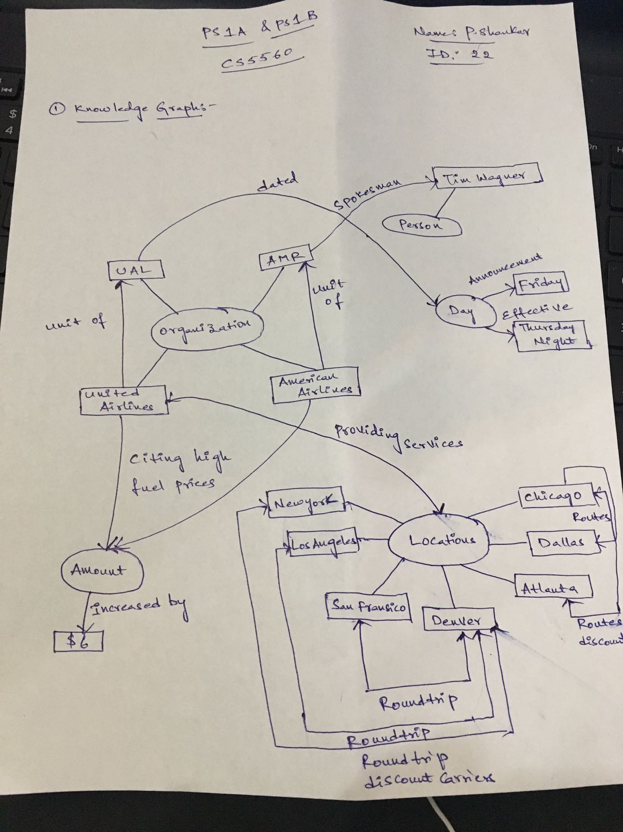

---------------\*\*\*\*\*\*\*\*\*\*\*\*\*\*\*THE END \*\*\*\*\*\*\*\*\*\*\*\*\*\*\*\*------------------