I. Introduction

Implement the text classification using CNN,RNN and LSTM.LSTM is a special type of RNN which is used to overcome the problem of vanishing gradient in recurrent neural networks.LSTM is useful when the gap between the current predicted output and its dependency on the past predicted output is very large.
Coming to CNN,it is a feed forward network and the output at ‘t’ is independent of output at ‘t-1’.So,each output is independent of the other output whereas RNN is not a feed forward network and output at time ‘t’ is dependent on the output at previous times.

II. Objectives

The objective is to compare models CNN,RNN and LSTM by running three models on the same data set.(i.e.. IMDB data set).

III. Approaches/Methods

1.Implemented using Multi layer neural networks.
2.Methods are Feed forward convolution network CNN
3.Back propagation RNN.
4.Special case of RNN.i.e..LSTM.

IV. Work flow

1.Import IMDB data set.
2.Set the training parameters
3.Define the Embedding Dimensions
4.Start with an efficient embedding layer which maps our vocab indices into embedding_dims dimensions
5.We add a Convolution1D,RNN,LSTM appropriately which will learn filters word group filters of size filter length
6.We use max pooling.
7.Add the hidden layers.
8.Project onto a single output layer and squash it with a sigmoid.
9.Training the model(RNN,LSTM or convolution N/W approach.choose the appropriate one)
10.Evaluate the model

V. Dataset

The data set used is IMDB data set. It contains movie reviews. Total they are 50,000 samples.
Training data set is of 25,000 samples and test data is size of 25,000 samples.
The data set is a combination of both positive and negative reviews.

VI. Parameters

1.No of Samples
2.Batch size
3.Learning rate
4..cost/loss function
5..Optimizer
6..Loss
7..Accuracy

VII. Evaluation & Discussion

CNN:

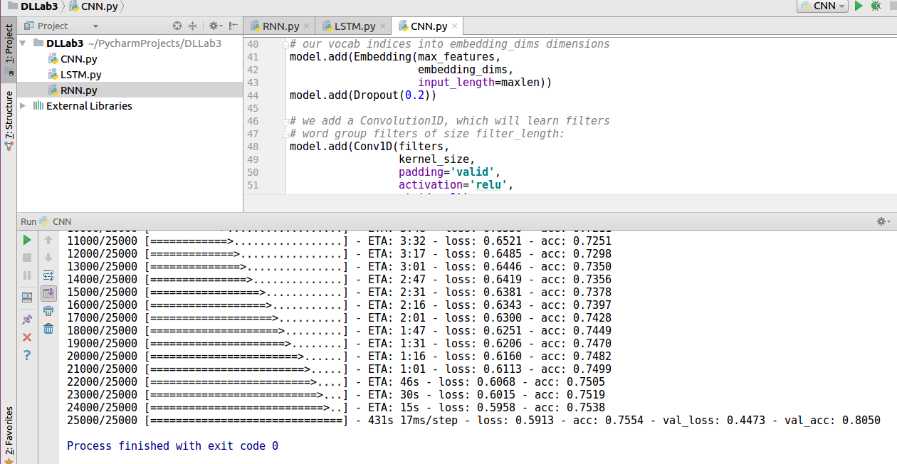
RNN:

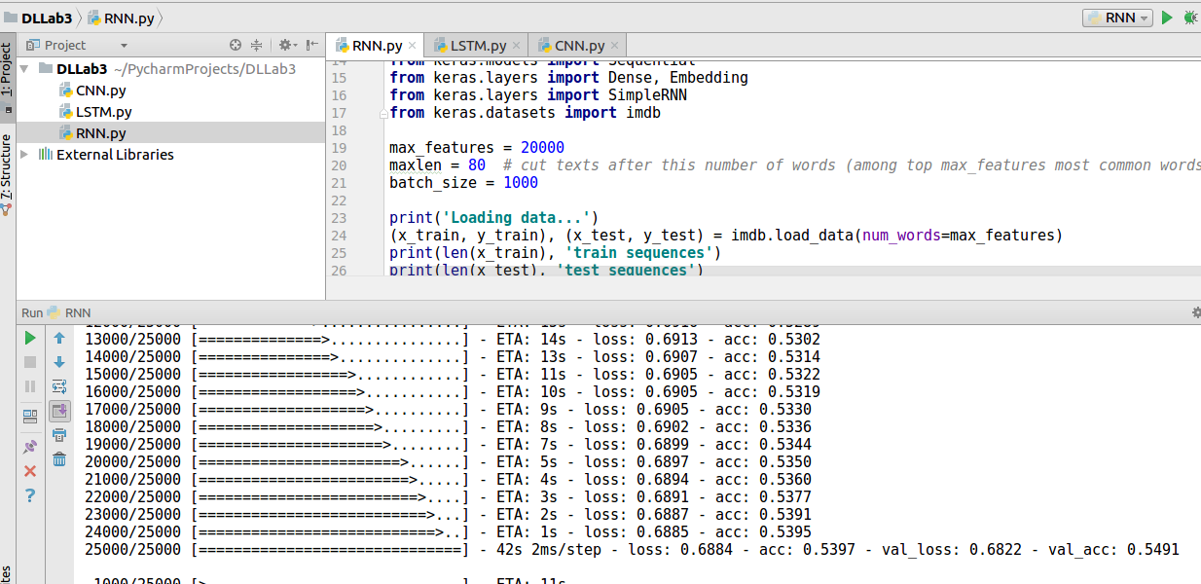

LSTM:

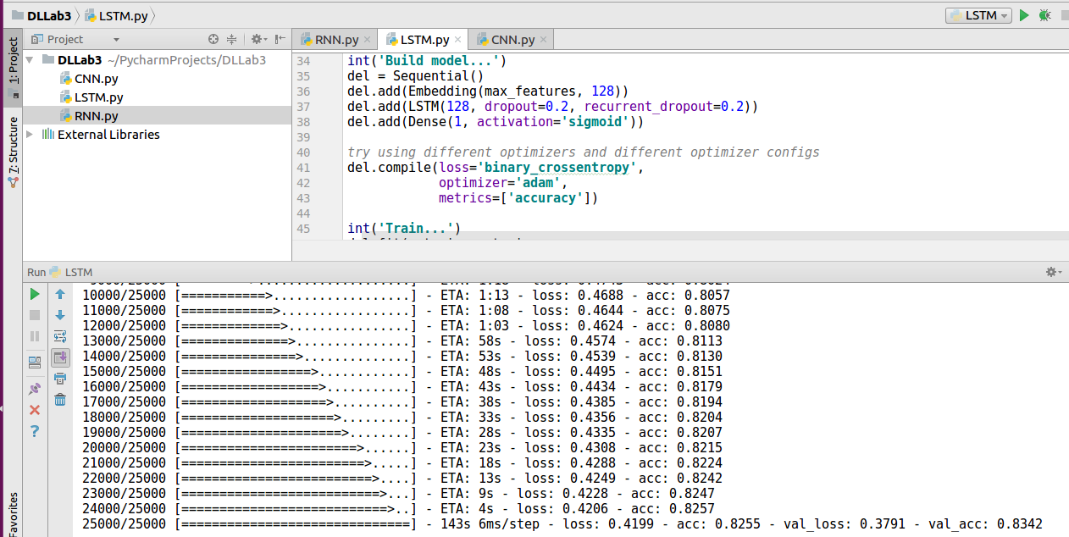

VIII. Conclusion

LSTM performs better than CNN and RNN. The data set is movie review sentiment data set.

No Of epochs : 2
Batch Size : 1000 samples.

CNN has an accuracy of 80.50%
RNN has an accuracy of 54.91%
LSTM has an accuracy of 83.42%

