Mutual Friends On Facebook :

Input:

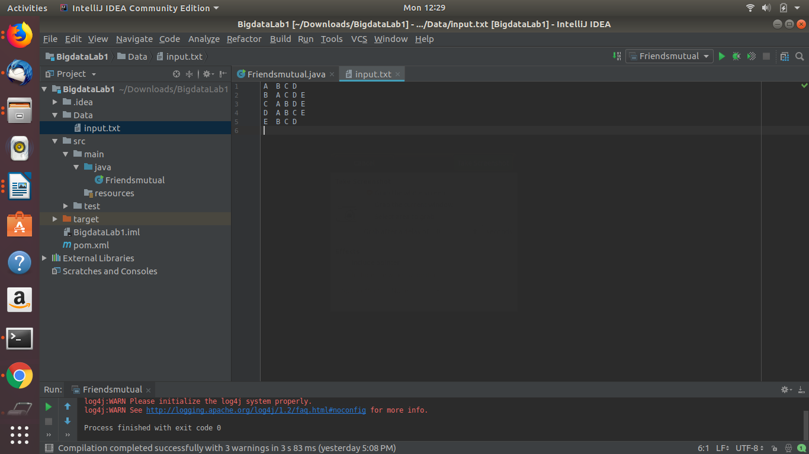
Output :

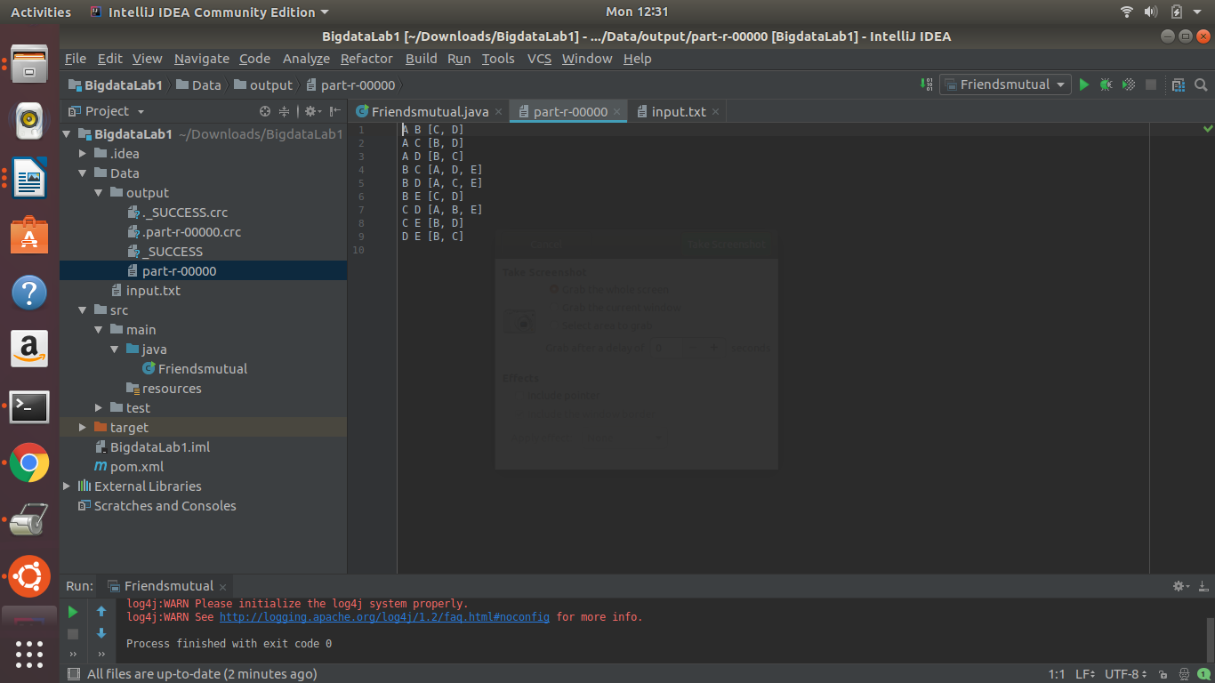
Map Code:

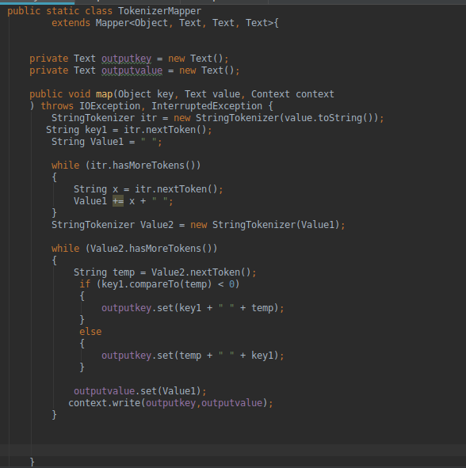

Reduce Code:

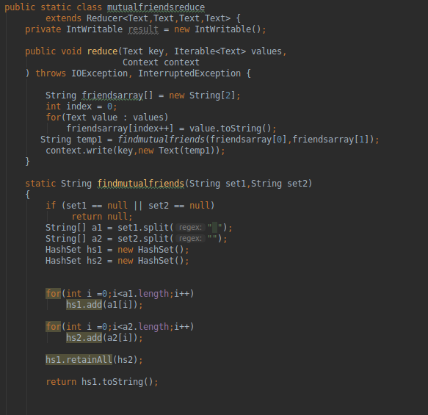

Hbase:

Data in the Facebook Inbox Search :

DataTypes:

ColumnFamilies :

TermSearch {Columns Data Type : MsgID’s- Number,Terms : Text}

UserIdSearch { MsgID’s- Number,UserID’s - Number}

hbase(main):105:0> scan 'Fb_Inbox_search' ,{VERSIONS => 10}

ROW COLUMN+CELL
1 column=TermSearch:Good, timestamp=1529340688648, value=11
1 column=TermSearch:Hi, timestamp=1529340628627, value=7
1 column=TermSearch:Hi, timestamp=1529340509877, value=1
1 column=TermSearch:How, timestamp=1529340634801, value=8
1 column=TermSearch:How, timestamp=1529340523586, value=2
1 column=TermSearch:I, timestamp=1529340603963, value=6
1 column=TermSearch:Know, timestamp=1529340697925, value=11
1 column=TermSearch:am, timestamp=1529340607156, value=6
1 column=TermSearch:are, timestamp=1529340639817, value=8
1 column=TermSearch:are, timestamp=1529340527673, value=2
1 column=TermSearch:good, timestamp=1529340613962, value=6
1 column=TermSearch:to, timestamp=1529340693490, value=11
1 column=TermSearch:you, timestamp=1529340643105, value=8
1 column=TermSearch:you, timestamp=1529340535259, value=2
1 column=UserIdSearch:2, timestamp=1529340862121, value=6
1 column=UserIdSearch:2, timestamp=1529340828752, value=2
1 column=UserIdSearch:2, timestamp=1529340790011, value=1
1 column=UserIdSearch:3, timestamp=1529340940870, value=11
1 column=UserIdSearch:3, timestamp=1529340880603, value=8
1 column=UserIdSearch:3, timestamp=1529340878580, value=7
2 column=TermSearch:Hi, timestamp=1529340550622, value=3
2 column=TermSearch:How, timestamp=1529340582362, value=5
2 column=TermSearch:I, timestamp=1529340561380, value=4
2 column=TermSearch:about, timestamp=1529340586761, value=5
2 column=TermSearch:am, timestamp=1529340566675, value=4
2 column=TermSearch:good, timestamp=1529340571186, value=4
2 column=TermSearch:you, timestamp=1529340590707, value=5
2 column=UserIdSearch:1, timestamp=1529340849346, value=5
2 column=UserIdSearch:1, timestamp=1529340845554, value=4
2 column=UserIdSearch:1, timestamp=1529340839789, value=3
3 column=TermSearch:Fantastic, timestamp=1529340675297, value=10
3 column=TermSearch:Hi, timestamp=1529340657688, value=9
3 column=TermSearch:I, timestamp=1529340664377, value=10
3 column=TermSearch:am, timestamp=1529340667624, value=10
3 column=UserIdSearch:1, timestamp=1529340902398, value=10
3 column=UserIdSearch:1, timestamp=1529340897214, value=9
3 row(s) in 0.0410 seconds

1. Query 1:

Term Search :

hbase(main):104:0> get 'Fb_Inbox_search',1,{COLUMN => 'TermSearch:Hi',VERSIONS => 10}
COLUMN CELL
TermSearch:Hi timestamp=1529340628627, value=7
TermSearch:Hi timestamp=1529340509877, value=1
2 row(s) in 0.0060 seconds

Here we searched user 1 with term Hi and the response message ID’s are 7 and 1.

2. Query 2:

Recipient ID Search :

hbase(main):106:0> get 'Fb_Inbox_search',1,{COLUMN => 'UserIdSearch:2',VERSIONS => 10}
COLUMN CELL
UserIdSearch:2 timestamp=1529340862121, value=6
UserIdSearch:2 timestamp=1529340828752, value=2
UserIdSearch:2 timestamp=1529340790011, value=1
3 row(s) in 0.0270 seconds

hbase(main):002:0> get 'Fb_Inbox_search',2,{COLUMN => 'UserIdSearch:1',VERSIONS=>10}
COLUMN CELL
UserIdSearch:1 timestamp=1529340849346, value=5
UserIdSearch:1 timestamp=1529340845554, value=4
UserIdSearch:1 timestamp=1529340839789, value=3
3 row(s) in 0.2510 seconds

Here we have the user 1 sent msgID’s to user 2 and the msgID’s are 1,2,6

Here we have the user 2 sent msgID’s to user 1 and the msgID’s are 5,4,3

3. Query 3:

User ID 1 Message Inbox:

hbase(main):017:0> get 'Fb_Inbox_search',1,{COLUMN =>['TermSearch','UserIdSearch'] , VERSIONS => 3}
COLUMN CELL
TermSearch:Good timestamp=1529340688648, value=11
TermSearch:Hi timestamp=1529340628627, value=7
TermSearch:Hi timestamp=1529340509877, value=1
TermSearch:How timestamp=1529340634801, value=8
TermSearch:How timestamp=1529340523586, value=2
TermSearch:I timestamp=1529340603963, value=6
TermSearch:Know timestamp=1529340697925, value=11
TermSearch:am timestamp=1529340607156, value=6
TermSearch:are timestamp=1529340639817, value=8
TermSearch:are timestamp=1529340527673, value=2
TermSearch:good timestamp=1529340613962, value=6
TermSearch:to timestamp=1529340693490, value=11
TermSearch:you timestamp=1529340643105, value=8
TermSearch:you timestamp=1529340535259, value=2
UserIdSearch:2 timestamp=1529340862121, value=6
UserIdSearch:2 timestamp=1529340828752, value=2
UserIdSearch:2 timestamp=1529340790011, value=1
UserIdSearch:3 timestamp=1529340940870, value=11
UserIdSearch:3 timestamp=1529340880603, value=8
UserIdSearch:3 timestamp=1529340878580, value=7
20 row(s) in 0.0230 seconds

Here we have queried User ID 1 inbox and we got all the recipient user ID’s and the message ID’s he exchanged with them.

For Hbase,we need to use versions if a same column family column repeats more than once. The Columns with the same name in the column family are stored as versions when repeated.

