

**Application Name: “COURSE BUDDY “**

**TEAM MEMBERS:**

**SHANKAR PENTYALA**

1. **INTRODUCTION:**

**COURSE BUDDY**

Course buddy is an interactive application which acts as lifeline between students and the teaching fraternity. Student fraternity has a tendency to work along deadlines and many of the times, they tend to forget the deadlines and lose marks even having competency to complete on time. Not only deadlines, many of the student fraternity has a feeling of introvert of not being able to directly interact with the teaching fraternity.

1. **Project Goal and Objectives:**
   1. **Overall goal:**

Our primary goal is to develop a hybrid application “COURSE BUDDY” which is an interface between students and faculty. This interface is made using android software development kit and various other services which are needed for smooth running of applications.

**3. Report:**

I have designed app mockups by designing wireframes and by keeping them in mind, we have designed all our app pages login page, course selection page and choosing the option to talk with anyone of the professors or teaching assistants or course buddies etc.

**Class diagram:**

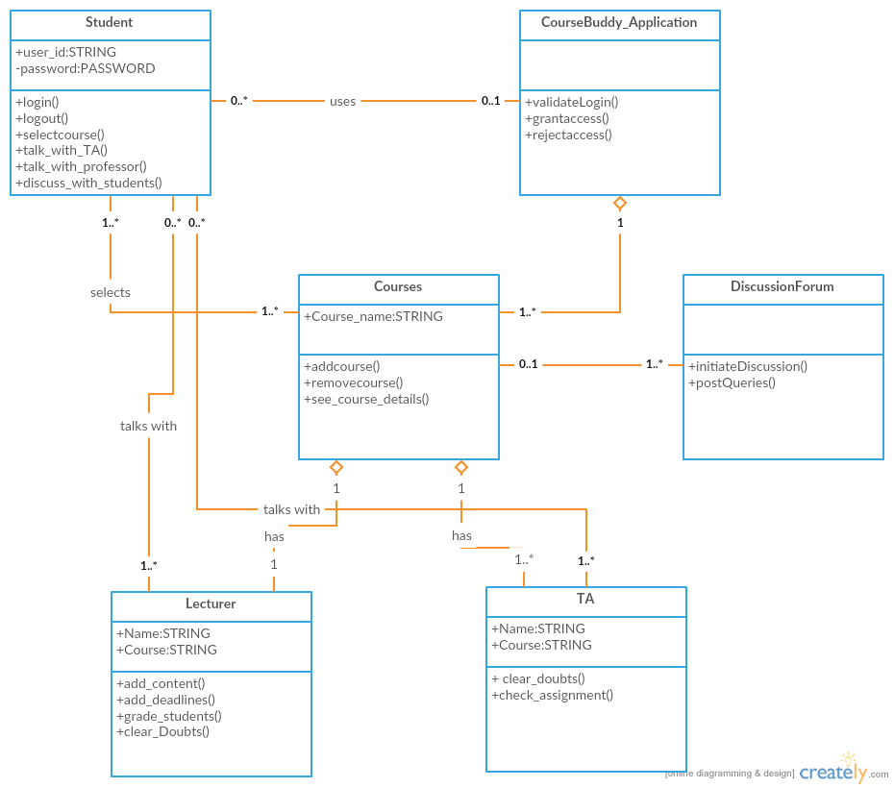

**Software architecture diagram:**

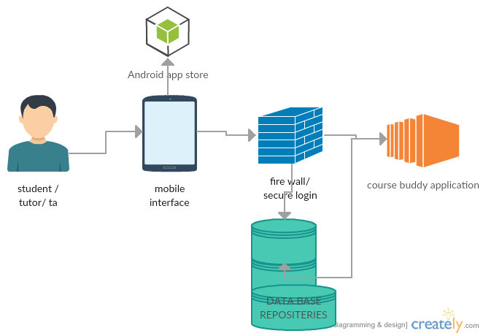

**Sequence diagram:**

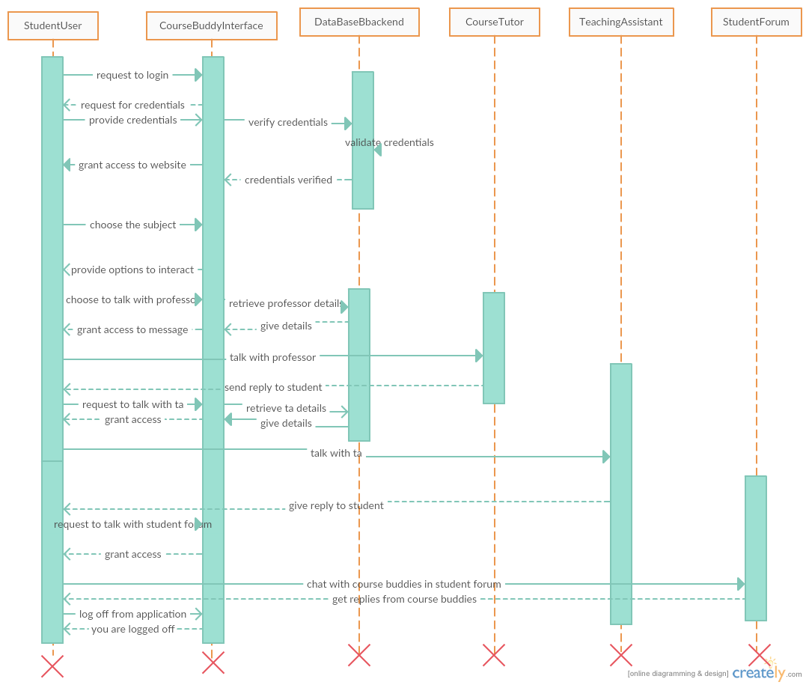

**Design Patterns Used:**

1. Observer Pattern: In our code,

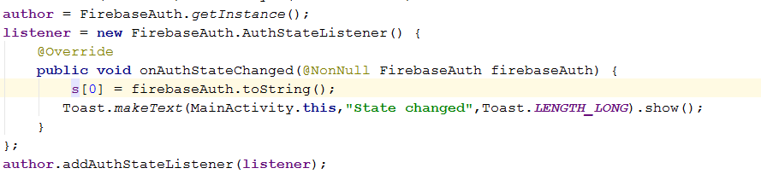

1. State Pattern : In our code,

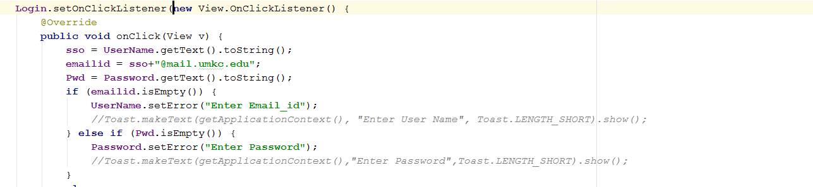

**4.3. Implementation:**

**Home page for application:**

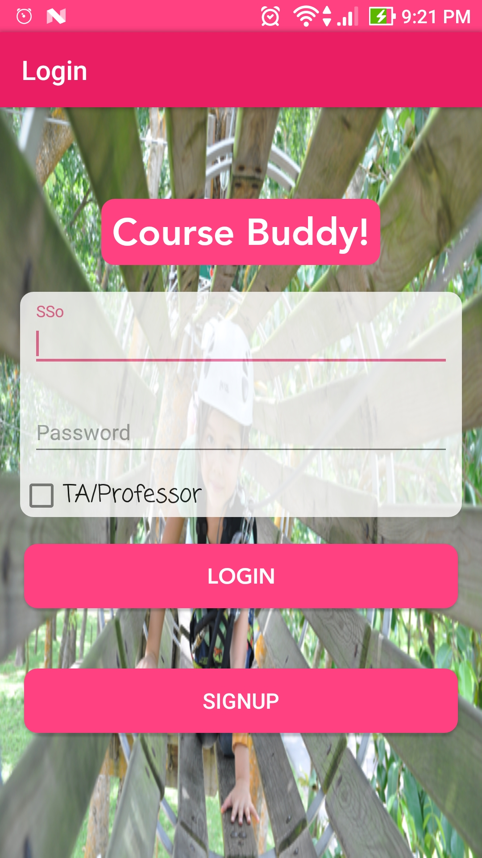

**On successful login**

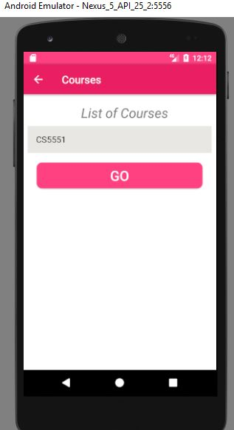

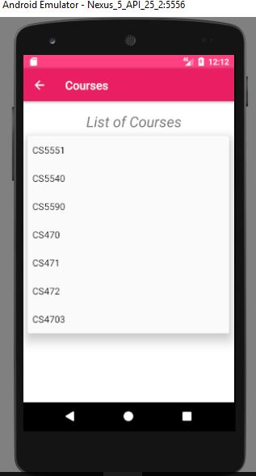

**On selecting the course, we would get an option to talk with anyone:** 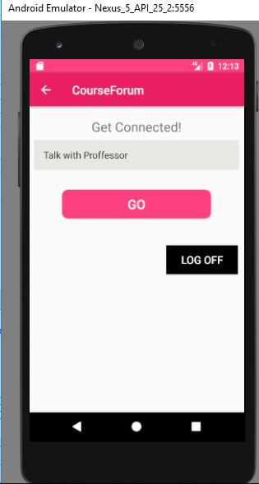

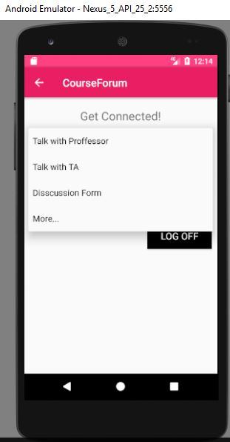

**On selecting the option Discussion Forum, A chat Screen opens.**

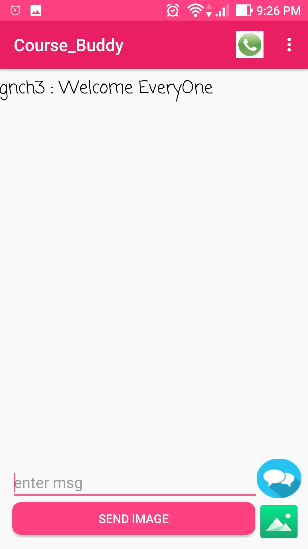

**On selecting the option Talk with professor, professor screen opens**

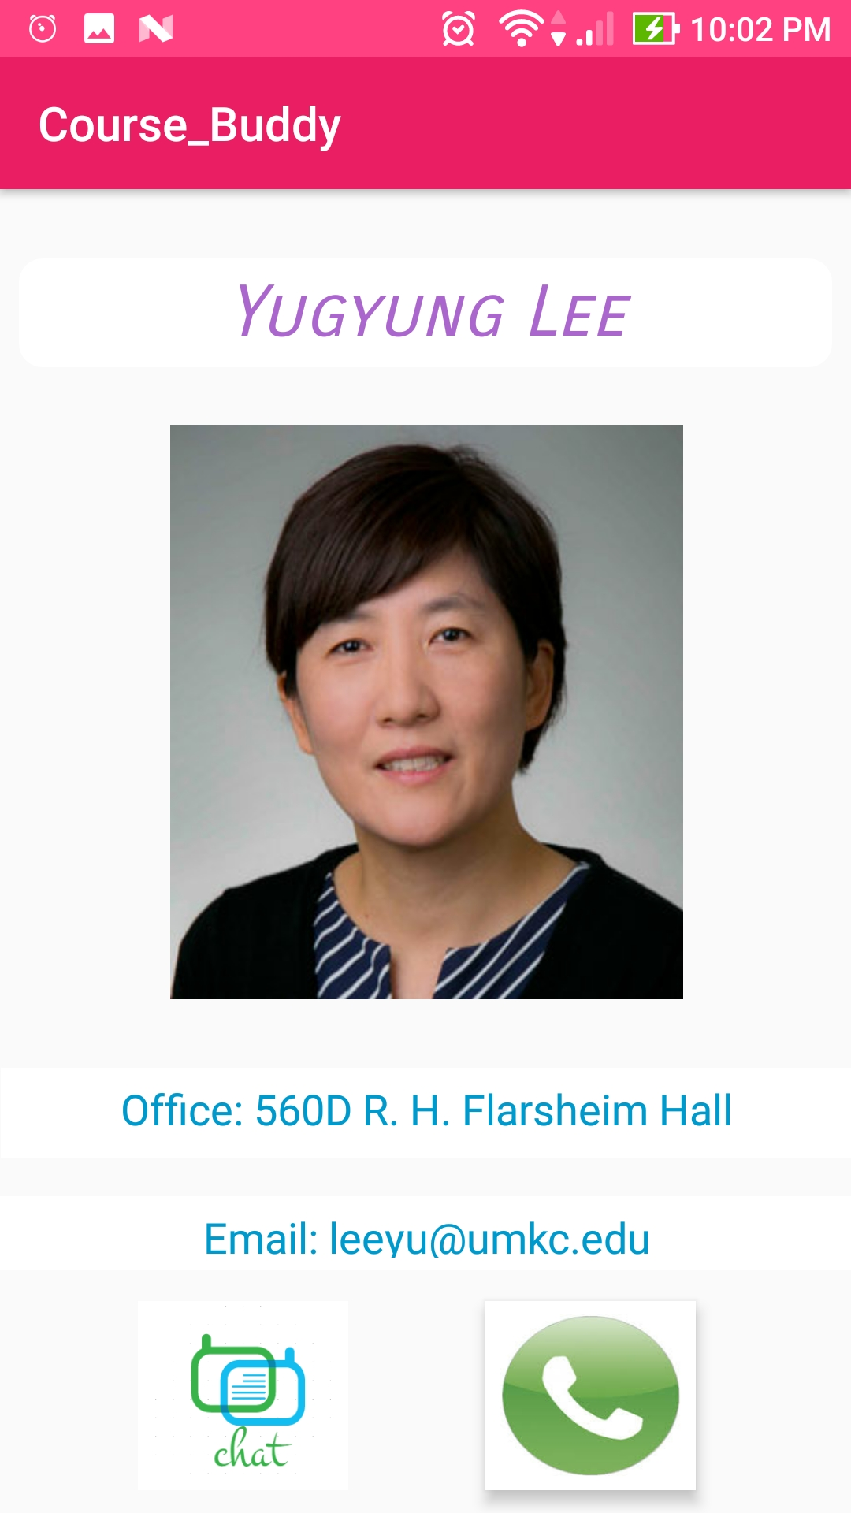

**Also, we can perform App-App Image Sharing:**

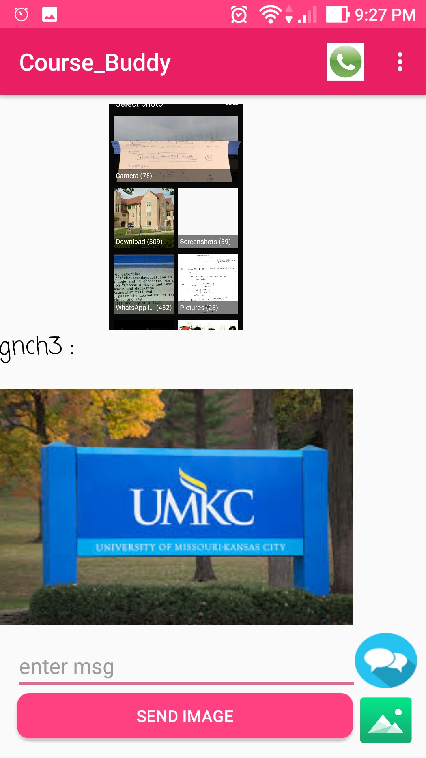

**Finally, App-App calling is possible,**

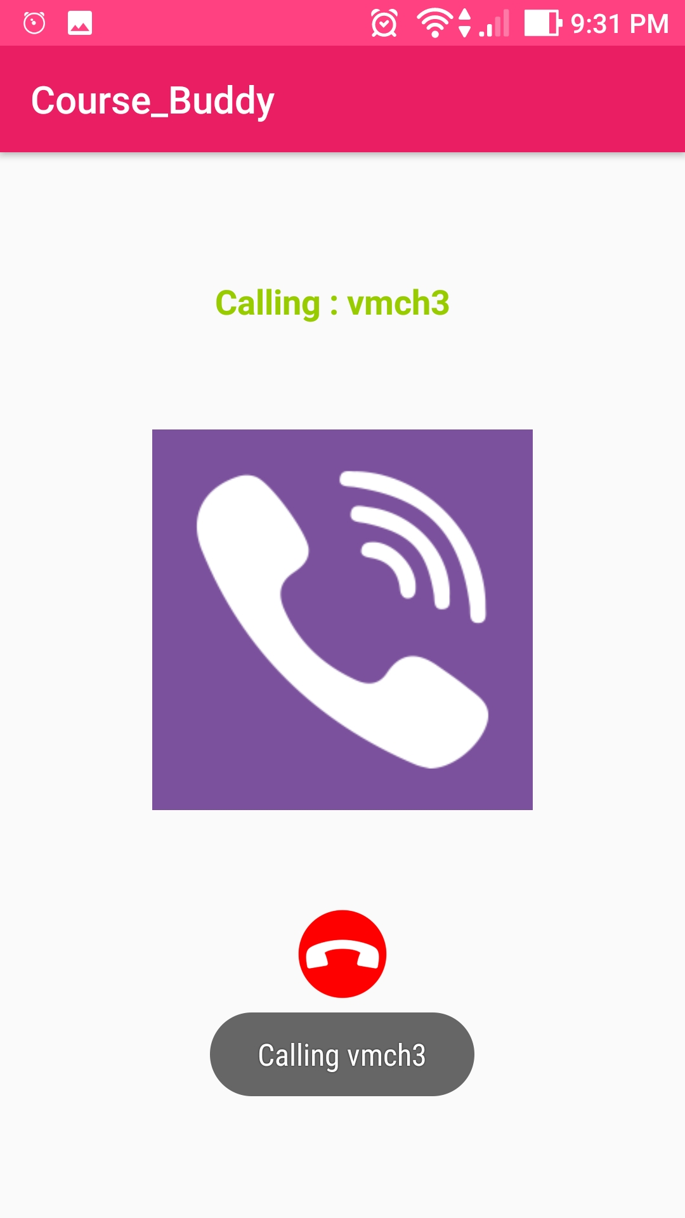

**If we login as Tutor/TA:**

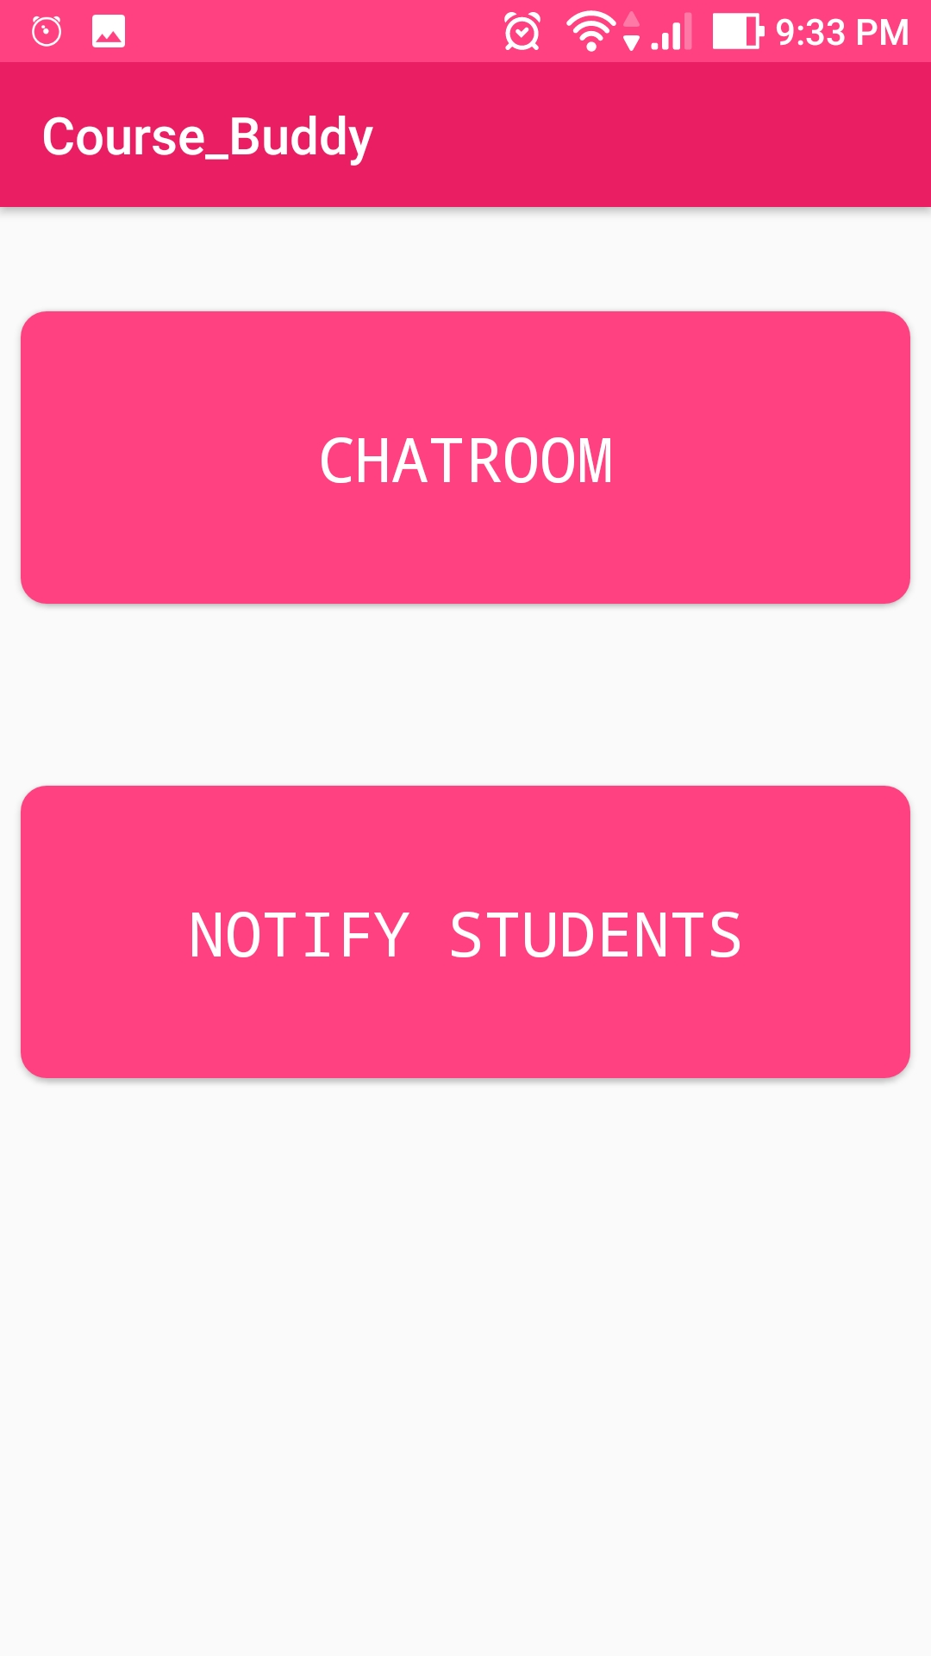

**Tutor/TA can send Important updates to students**,

