Check the switchport administrative mode:
show interfaces gig 0/1 switchport | include Administrative Mode
Native vlan mismatch: (show interface trunk)
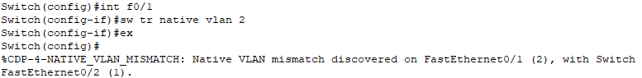
Password mismatch: (show vtp password)
Your best option is to use VTPv3 because only the VTP primary server will be considered a trusted source of VTP messages within the VTP domain, and any other VTP messages will be ignored, ensuring that your database is not overwritten by a rouge switch.
Change VTP mode to transparent or domain name so that the configuration revision number will be changed to 0.

