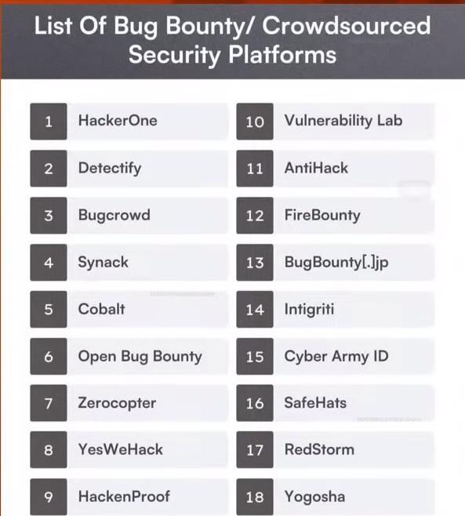
Step-1:
Reconnaissance – gathering information
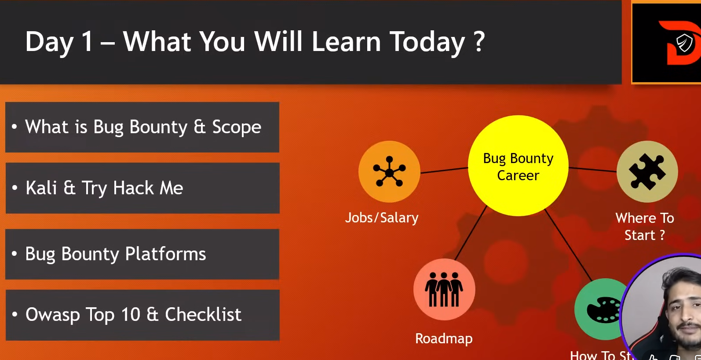
bugcrowd > hacker login
-mCw6H5t78j!Q)F
hackerone
password: Shankar@10981balanath@10981

OWASP Top 10:
the Open Web Application Security Project’s top 10 web security risks?
# | Category | Description
A01:2021 | Broken Access Control | Failures that allow users to act outside their intended permissions — e.g., accessing other users’ data.
A02:2021 | Cryptographic Failures | Weak or missing encryption leading to exposure of sensitive data. (Previously called “Sensitive Data Exposure”).
A03:2021 | Injection | SQL, NoSQL, command, and other injections that allow attackers to send malicious input to interpreters.
A04:2021 | Insecure Design | Design flaws rather than implementation bugs — missing security controls or misuse of patterns.
A05:2021 | Security Misconfiguration | Misconfigured security headers, open cloud storage, default accounts, or unnecessary features left enabled.
A06:2021 | Vulnerable and Outdated Components | Using outdated frameworks, libraries, or dependencies with known vulnerabilities.
A07:2021 | Identification and Authentication Failures | Weak authentication, credential stuffing, or session management flaws. (Previously “Broken Authentication”).
A08:2021 | Software and Data Integrity Failures | Issues like untrusted code updates, CI/CD pipeline flaws, or unverified integrity of critical data.
A09:2021 | Security Logging and Monitoring Failures | Insufficient logging and alerting that hinders detection and response to attacks.
A10:2021 | Server-Side Request Forgery (SSRF) | When a web app fetches a remote resource without properly validating user input — attackers can make the server send requests to unintended locations.

What are injection flaws?
Injection flaws happen when an app treats something the user types as if it were a real command or instruction. Because the app mixes user input with code, an attacker can send input that changes what the app does.
Two common kinds:
- SQL Injection: The app builds database queries using user input. If that input contains extra database commands, an attacker can change, read, or delete data in the database.
- Command Injection: The app puts user input into system commands. An attacker can make the server run commands they shouldn’t be allowed to run.
What can an attacker do if an injection works?
- Read private data (personal details, passwords, etc.)
- Change or delete data in the database
- Run harmful commands on the server (which can lead to stealing files or taking over systems)
The basic idea to stop injections
Don’t let user input be treated as code or commands. Make sure the app only uses input as plain data.
Ways to defend against injection (easy steps)
- Use an allow list (preferred): Only accept input that matches known-safe rules (for example: only letters for a name, only numbers for a phone). Reject everything else.
- Validate and normalize input: Check that the input is the right type and length before using it. Convert it into a safe format.
- Use parameterized queries / prepared statements: Instead of building database queries by joining strings, use the database library’s safe API so the database knows “this is data, not code.” (This is one of the strongest defenses for SQL injection.)
- Escape or encode output where needed: When showing user input in webpages, HTML-encode it so the browser won’t treat it as code.
- Avoid trying to “strip” dangerous characters as the only defense: Removing characters can help, but it’s easy to miss something. Parameterized queries and strict validation are safer.
- Run with least privilege: The database or OS account your app uses should only have the minimum rights it needs (so even if attacked, damage is limited).
- Use well-maintained libraries/frameworks: Frameworks often provide safe functions for database access and output encoding.
- Log and monitor: Record suspicious inputs and watch for unusual activity so you can react quickly.
Quick checklist for developers
- Use parameterized queries for DB access.
- Validate input against an allow list whenever possible.
- Encode output for the context (HTML, SQL, shell, etc.).
- Don’t pass raw user input directly into system commands.
- Give your app minimum permissions.
- Keep libraries and frameworks up to date.
- Add logging and alerts for suspicious behaviour.
command injection?
Command injection happens when a web app takes something a user types and puts it into a system (OS) command. If the app doesn’t treat that input as plain data, an attacker can change the command the server runs. That can let the attacker read files, run programs, or — in worst cases — take control of the server.
Why it’s dangerous
If an attacker can get the server to run commands, they can:
- Read secret files (passwords, keys).
- Add or remove files.
- Run programs that let them move deeper into your network.
Even simple commands can lead to bigger problems later.
Types (simple)
- Direct (reflected) injection — user data is used immediately in a command.
- Stored injection — dangerous input is stored and runs later (for example in a scheduled job).
- Blind/time-based — the app doesn’t show command output, but an attacker can infer success (e.g., by making the app pause).

Safe testing practices (do this only on systems you own or are authorized to test)
- Only test on systems you own or have permission to test. Don’t try this on other people’s servers.
- Use a local VM or a test/staging environment, not production.
- Use non-destructive checks that only confirm vulnerability without changing anything (for example, cause a harmless visible output or return a known string).
- Prefer automated scanners or safe manual techniques in a controlled lab.
I will not provide real exploit commands or reverse-shell payloads. If you’re testing, stick to harmless checks and get explicit permission.
Signs an app might be vulnerable
- The app calls system utilities (e.g., shell_exec, exec, system, popen in PHP; subprocess in Python) with user data.
- Inputs that appear in logs, file operations, or cronjobs and are not validated.
- Unexpected server responses or errors when you send unusual characters.
Example (vulnerable vs safer) — PHP (easy to follow)
Vulnerable pattern (DON’T do this):
// BAD: directly concatenating user input into a shell command
$dir = $_GET['dir'];
$output = shell_exec("ls " . $dir);
echo $output;
Why it’s bad: the dir value comes straight from the user and becomes part of the shell command.
Safer approaches:
- Use language functions instead of shell commands (best):
$dir = $_GET['dir'];
// Use PHP API to list directories instead of calling `ls`
$files = scandir($dir);
foreach ($files as $f) echo htmlentities($f)."<br>";
- If you must call a command, validate and restrict input:
- Accept only expected values (allow list).
- Convert the user input into a safe form.
- Run commands with least privilege and in a restricted environment.
(Using functions like escapeshellarg() can help reduce risk but is not a substitute for using safe APIs and proper validation.)
How to prevent command injection (quick checklist)
- Don’t call the shell unless you absolutely must. Use language/library functions instead.
- Allow-list input: only accept values that match a strict pattern (e.g., filenames matching ^[a-zA-Z0-9._-]+$).
- Validate type and length: ensure inputs are the expected type (number, short filename).
- Escape properly for the right context if you must pass data into a shell — and prefer built-in safe APIs over manual escaping.
- Run services with least privilege: the web server account should have minimal rights.
- Use containers / sandboxes to reduce impact if something runs.
- Log attempts and monitor for suspicious patterns.
- Keep software updated and scan code with static analysis tools.
Defensive testing ideas (benign)
- In a test environment, replace dangerous commands with a harmless program that prints a known token — verify that user input can’t change that token.
- Use static code analysis tools to find uses of shell execution functions in your codebase.
- Add automated tests that attempt malformed input and check that the app rejects it or treats it as plain data.
Final notes
- Command injection is critical but preventable. The best fix is to avoid running shell commands with user data.
- If you want, I can:
  - Convert the checklist into a one-page poster for developers.
  - Review a short snippet of your code (PHP, Python, etc.) and point out risky patterns and safer replacements.
  - Show safe validation examples for filenames, numeric inputs, or known command options.
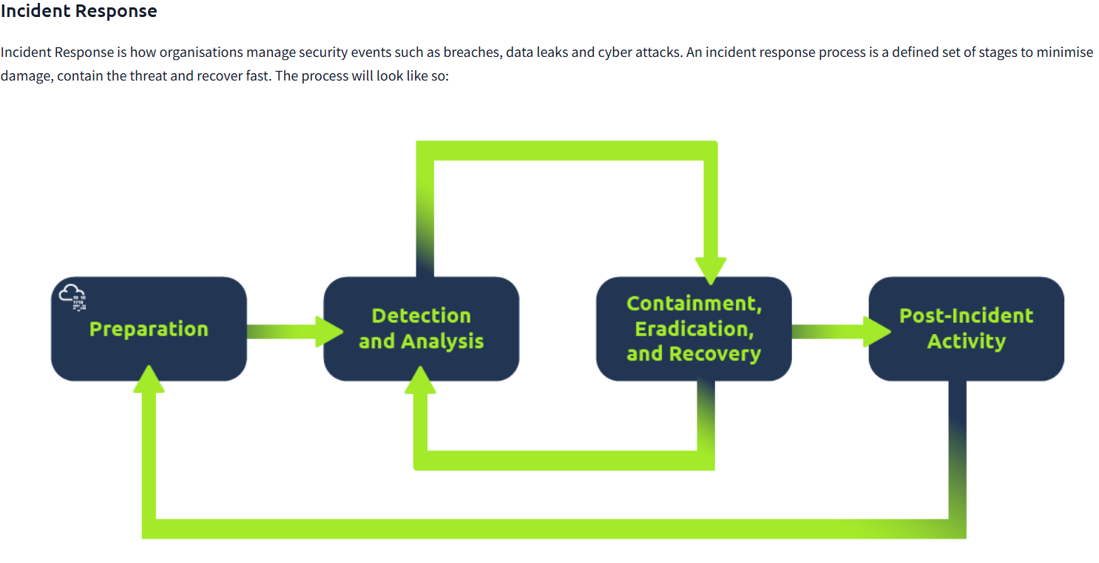
Containment – isolation after the event is confirmed, reduce the spreading after the attack is confirmed
Eradication – Removes the root cause of the incident
Penetration Testing:
1. Rules of Engagement (ROE)
Penetration tests can have a wide variety of objectives and targets within scope. Because of this, no penetration test is the same, and there are no one-case fits all as to how a penetration tester should approach it.
The steps a penetration tester takes during an engagement is known as the methodology. A practical methodology is a smart one, where the steps taken are relevant to the situation at hand. For example, having a methodology that you would use to test the security of a web application is not practical when you have to test the security of a network.
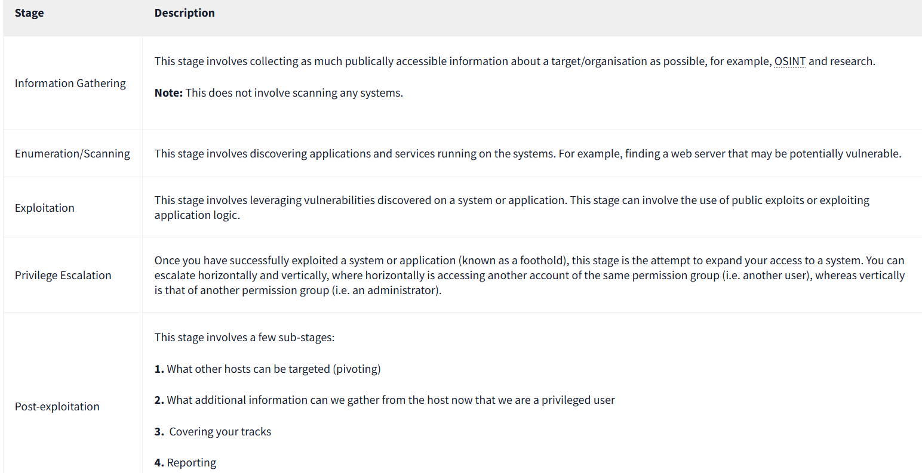
Before discussing some different industry-standard methodologies, we should note that all of them have a general theme of the following stages:

OSSTMM:
The Open Source Security Testing Methodology Manual provides a detailed framework of testing strategies for systems, software, applications, communications and the human aspect of cybersecurity.

The methodology focuses primarily on how these systems, applications communicate, so it includes a methodology for:
- Telecommunications (phones, VoIP, etc.)
- Wired Networks
- Wireless communications

OWASP:
The "Open Web Application Security Project" framework is a community-driven and frequently updated framework used solely to test the security of web applications and services.
The foundation regularly writes reports stating the top ten security vulnerabilities a web application may have, the testing approach, and remediation.
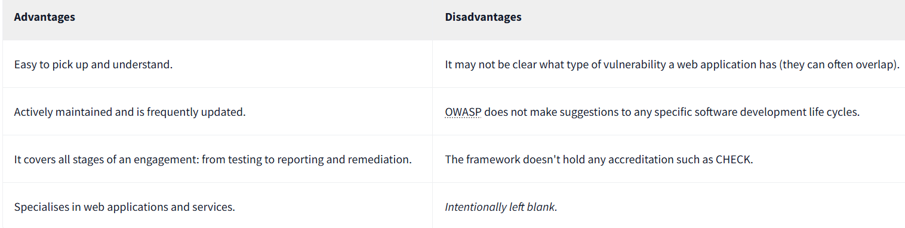

NIST Cybersecurity Framework 1.1
The NIST Cybersecurity Framework is a popular framework used to improve an organisations cybersecurity standard and manage the risk of cyber threats. This. framework is a bit of an honourable mention because of its popularity and detail.
The framework provides guidelines on security controls & benchmarks for success for organisations from critical infrastructure (power plants, etc.) all through to commercial. There is a limited section on a standard guideline for the methodology a penetration tester should take.
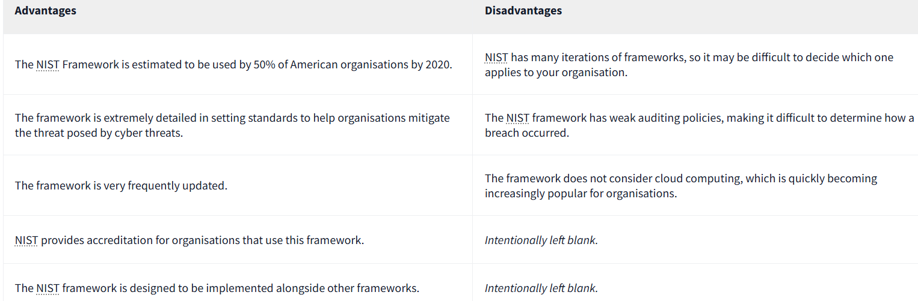
NCSC CAF:
The Cyber Assessment Framework (CAF) is an extensive framework of fourteen principles used to assess the risk of various cyber threats and an organisation's defences against these.
The framework applies to organisations considered to perform "vitally important services and activities" such as critical infrastructure, banking, and the likes. The framework mainly focuses on and assesses the following topics:
- Data security
- System security
- Identity and access control
- Resiliency
- Monitoring
- Response and recovery planning
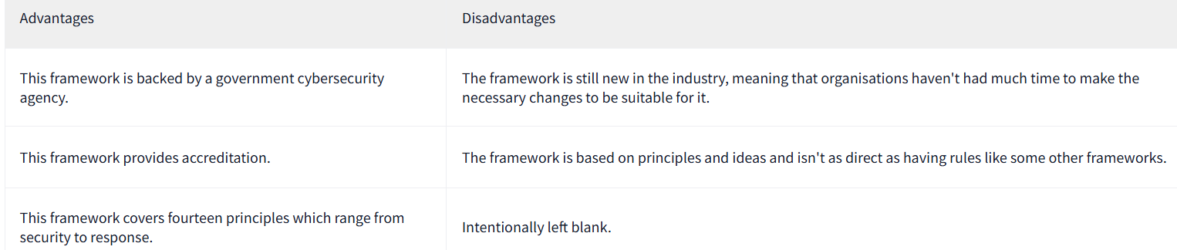

Black-Box Testing — tester has no internal knowledge; tests the app from an external/user perspective.
Grey-Box Testing — tester has limited/internal knowledge (e.g., architecture, credentials) and tests both externally and with that insight.
White-Box Testing — tester has full internal knowledge (source code, design); tests internals, logic, and complete attack surface.

