gobuster -u http://fakebank.thm -w wordlist.txt dir
In the command above, -u is used to state the website we're scanning, -w takes a list of words to iterate through to find hidden pages.
What careers are there?
The cyber careers lesson goes into more depth about the different careers in cyber. However, here is a short description of a few offensive security roles:
- Penetration Tester - Responsible for testing technology products for finding exploitable security vulnerabilities.
- Red Teamer - Plays the role of an adversary, attacking an organization and providing feedback from an enemy's perspective.
- Security Engineer - Design, monitor, and maintain security controls, networks, and systems to help prevent cyberattacks.
Defensive security, known as the blue team, is used to prepare and proactively protect an organisation's IT infrastructure. It is concerned with two main tasks:
- Preventing intrusions from occurring
- Detecting intrusions when they occur and responding properly
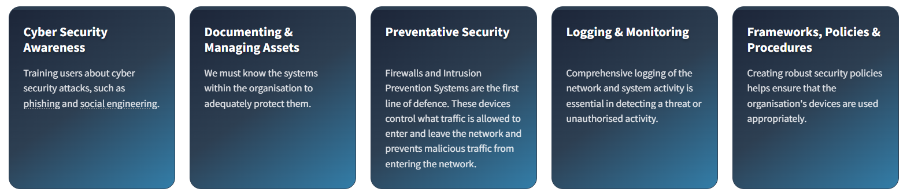

Q. What is SOC?
These are the guys who are cybersecurity professionals, they are responsible for monitoring the cybersecurity events.
Q. What is digital forensics??
Digital forensics is the application of traditional forensic science processes to digital devices. Digital forensics is used to preserve and analyse digital evidence to aide in the investigation of incidents, such as a breach.
File system, System memory, system logs and network logs
Q. What is incident response??
Incident Response is how organisations manage security events such as breaches, data leaks and cyber-attacks. An incident response process is a defined set of stages to minimise damage, contain the threat and recover fast.
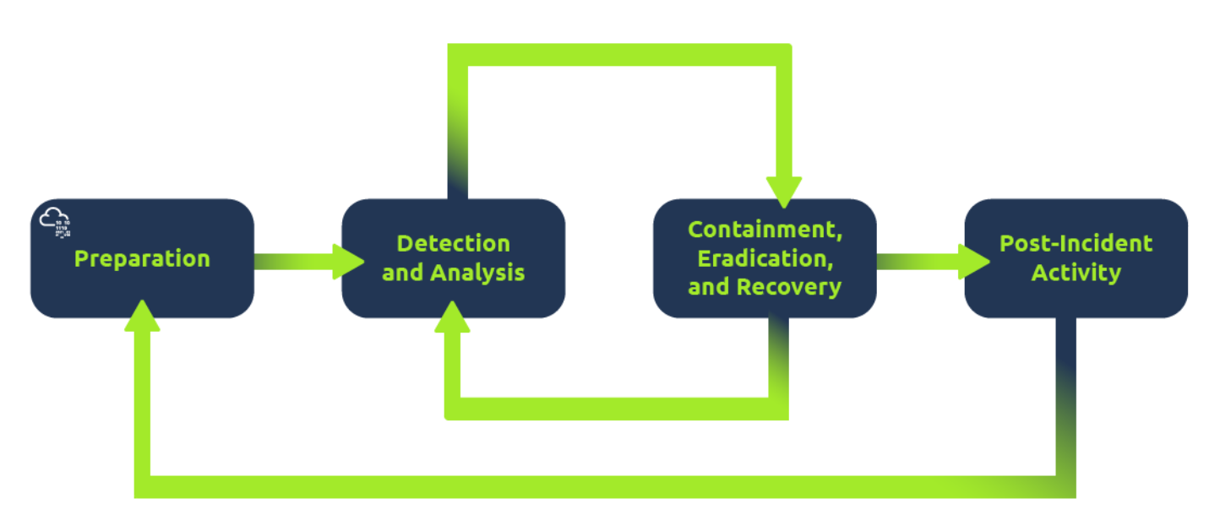
Q.

