TERMINAL EMULATOR:
We will be able to control our operating system like creating file, folder etc.
SHELL:
It is a kind of translator which convert our text into computer or OS understandable files.
first ubuntu – username
second ubuntu – host or server name

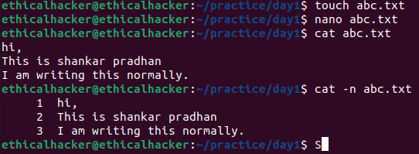
touch – creating file
nano – opening file
cat – read file

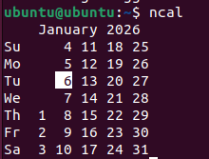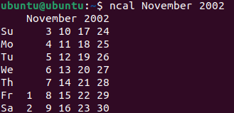
ncal – calender

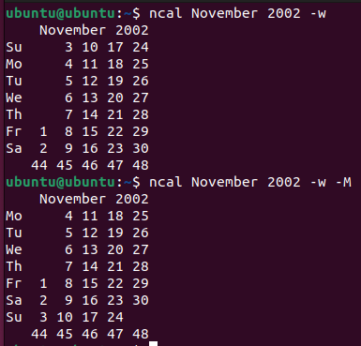
-w === nth weekend
-M === start from Monday

Documentation for particular command
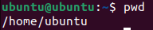 what is the current working directory

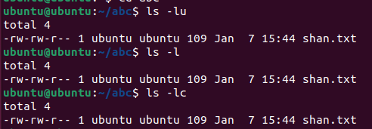
ls -lc == change time
ls -l == modification time
ls -lu == Access time of the file

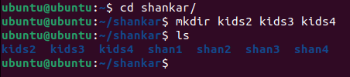
mkdir dir1 dir2 dir3 == Create many directories at a time

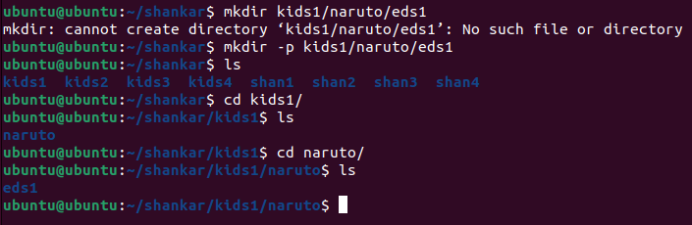
mkdir -p kids1/Naruto/eds1 == create a folder within a folder

