Email delivery occurs in three stages:
The first stage (sender to server) and the second stage (server to recipient’s server) use SMTP (Simple Mail Transfer Protocol), which is a push protocol. However, SMTP is not suitable for the third stage (recipient’s mail server to recipient’s computer) because this stage requires a pull protocol that allows the client to retrieve messages from the server.
This third stage is handled by Message Access Agents (MAAs) using either POP3 (Post Office Protocol 3) or IMAP4 (Internet Message Access Protocol 4).
- POP3 is a simple protocol that requires POP3 client software on the recipient’s computer and POP3 server software on the mail server. It uses TCP port 110 and requires a username and password for authentication. Users can then download messages from the server. However, POP3 has limitations:
  - Cannot organize or categorize emails on the server.
  - Cannot create folders for email storage.
  - Cannot partially download messages before retrieving them.
- IMAP4 provides all features of POP3 but with enhanced capabilities. It allows:
  - Creating hierarchical folders for email storage.
  - Searching emails on the server before downloading.
  - More flexibility and control compared to POP3.

Spam emails are unsolicited emails that are sent to recipients in quantity and, frequently, the majority of these spam emails are commercial in nature; however, chain emails are also possible. Spam emails can range from advertisements for products, services, or events to malicious scams and threats, making them a very dangerous form of communication. To combat the growing number of spam emails, many email providers and websites have adopted advanced anti-spam technology.
Email bombing is a way of sending a large number of emails to overrun the inbox or flood the email server, culminating in a DoS (denial-of-service) attack. It has become an increasingly popular form of cyber-attack, particularly as the cost of bandwidth and storage continues to decrease. Email bombing is a destructive and dangerous form of attack, and can have serious consequences for the recipient.

Email Spoofing:
Email spoofing is a technique used by attackers to disguise the true source of an email by falsifying the sender’s address. This makes the message appear to come from a trusted source, thereby masking its malicious intent. Spoofed emails are often used as a delivery mechanism for spam, malware, or phishing attacks.
Yes, email spoofing exploits the way servers exchange mail using SMTP. It happens between sending and receiving servers, because SMTP by default does not check if the “From” address is authentic.
prevented by enabling SPF, DKIM, and DMARC.
Phishing:
Phishing is a form of cybercrime that combines social engineering and technological deception to steal sensitive information such as bank account details, usernames, and passwords. Attackers typically send counterfeit emails that appear to originate from reputable organizations. These emails trick recipients into revealing personal data by clicking on malicious links or entering credentials into fake websites.
how we can secure our email message:
A digital signature added to an email message adds a degree of protection by ensuring the receiver that the originator is not an impostor who signed the email message’s contents. The digital Tenderer generates the digital signature, which comprises the sender certificate and public key. But also, that digital ID acts as the sender’s unique digital identifier, informing the recipient that the material was not changed in route. Furthermore, it also guarantees that the content of the email has not been tampered with or altered. Digital signatures, then, are a powerful tool in preventing fraud or tampering with emails and their contents
Email encryption techniques are important to achieve a secure email environment. Securing the email environment involves the encryption of connections and the encryption of emails.
Email encryption techniques, such as S/MIME (Secure/Multipurpose Internet Mail Extensions) and Open PGP (PGP stands for Pretty Good Privacy), are two widely used encryption protocols for securing email communication.

both PGP (Pretty Good Privacy) and S/MIME (Secure/Multipurpose Internet Mail Extensions) are used for email security (confidentiality, integrity, authentication, non-repudiation). They serve the same purpose, but the way they work is different.
How They Work:
i. PGP (Pretty Good Privacy):
- Keys: Uses a “web of trust” model (users exchange and verify each other’s public keys).
- Process:
  - The message is hashed → digital signature (sender’s private key).
  - The message + signature is compressed.
  - A session key is generated and used for encryption (symmetric).
  - The session key is encrypted with the recipient’s public key (as a digital envelope).
  - The final message is Base64 encoded and sent.
- Strength: Decentralized → doesn’t rely on central authorities.
- Weakness: Key management can be difficult (users must manually exchange and trust keys).
ii. S/MIME (Secure/Multipurpose Internet Mail Extensions):
- Keys: Uses a hierarchical PKI (Public Key Infrastructure) with trusted Certificate Authorities (CAs).
- Process:
  - A digital certificate (issued by a CA) contains the sender’s public key.
  - The message is signed (hash + private key) and/or encrypted (with recipient’s public key).
  - The receiver verifies the signature using the sender’s public key from the certificate.
- Strength: Easy to use → certificates are issued and managed by trusted CAs.
- Weakness: Relies on centralized trust (if CA is compromised, security is affected).

📌 Key Differences Between PGP and S/MIME
Feature | PGP | S/MIME
Trust Model | Web of Trust (users validate each other) | Hierarchical PKI (trusted Certificate Authorities)
Key Management | Manual exchange & verification | Automatic via certificates
Standardization | Open-source, widely used for personal email | Industry standard, often used in enterprises
Ease of Use | More complex for non-technical users | Easier, integrated in most corporate email clients
Control | Users control their own keys | Centralized control via CA
Adoption | Popular among individuals/security-conscious users | Common in businesses/organizations

To achieve a secure and protected email environment, there is a set of techniques in place including digital signatures, encryption techniques, and hashing algorithms.
• Digital signatures Digital signatures verify the authenticity of an email’s source, encryption techniques ensure that only authorized individuals can read the message, and hashing algorithms provide a secure way to store passwords and other sensitive information. Digital signatures generate a unique virtual fingerprint for a person or entity and are used to identify users and safeguard information in digital messages or documents. A digital signature added to an email message adds a degree of protection by ensuring the receiver that the originator is not an impostor who signed the email message’s contents. The sender’s digital ID generates the digital signature, which comprises the sender certificate and public key. But also, that digital ID acts as the sender’s unique digital identifier, informing the recipient that the material was not changed in route. Furthermore, it also guarantees that the content of the email has not been tampered with or altered. Digital signatures, then, are a powerful tool in preventing fraud or tampering with emails and their contents.

ESA – Email Security Appliance:
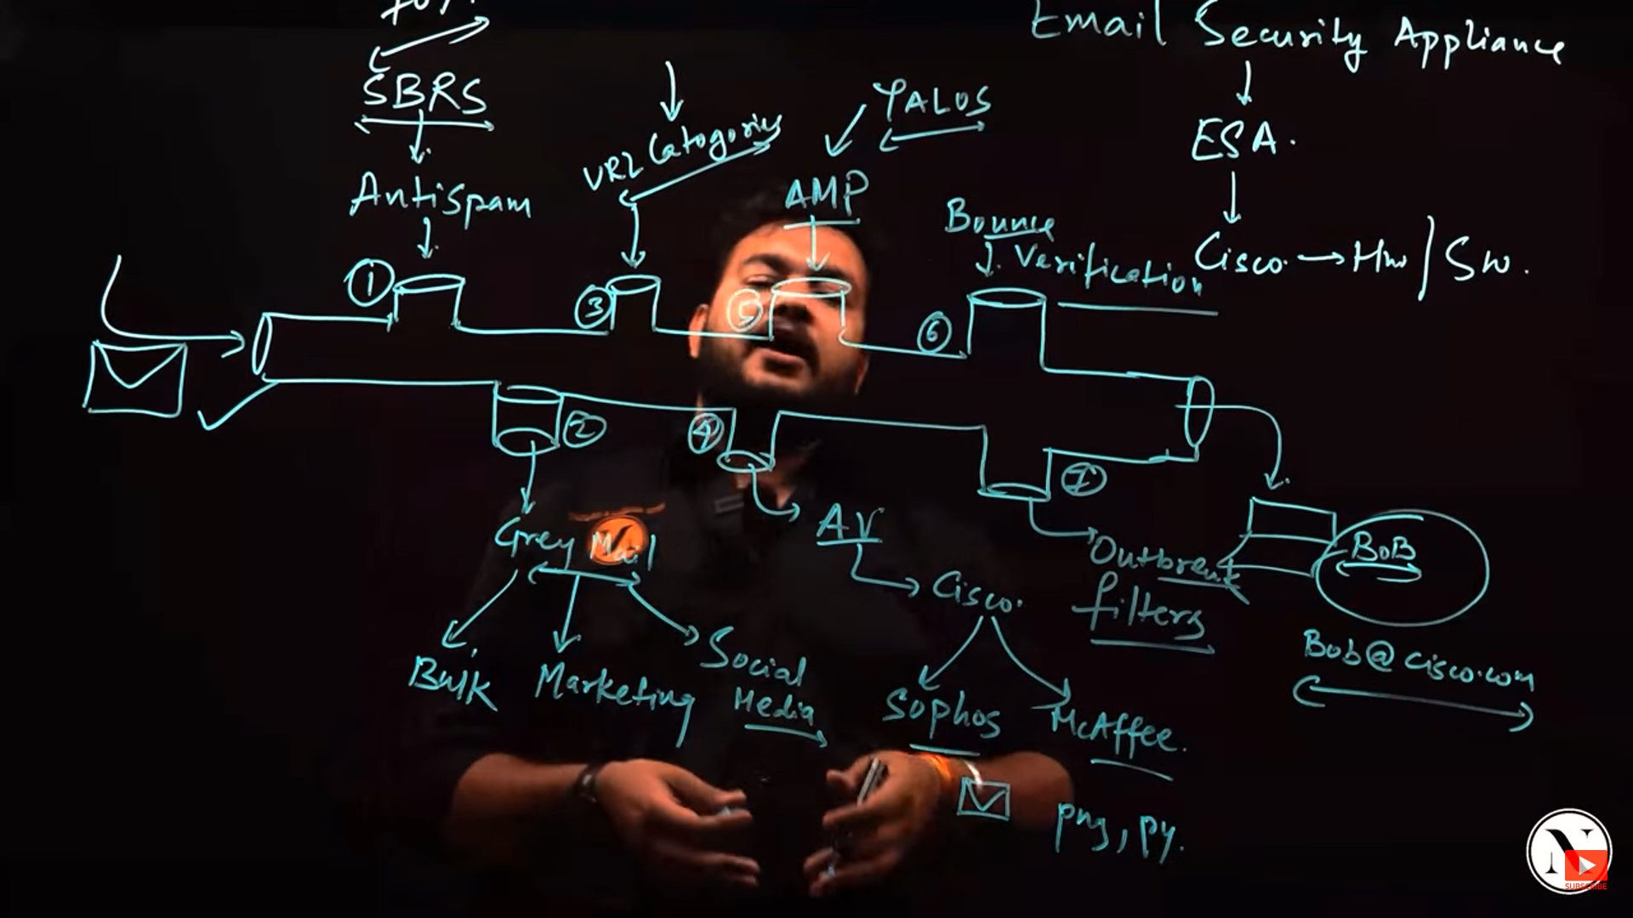
Anti-spam – SBRS (sender based reputation score)

