Topics:
DAY1:
Introduction to networking and internet (what, models)
LAN, CAN, MAN, WAN, and Devices
DAY2: IP addressing, Subnetting, ARP
DAY3: Switching Fundamentals (VLAN, STP, EtherChannel)
DAY4,5: Fundamentals of IP routing (static, dynamic, eigrp, and ospf)
DAY6: DHCP, DNS,
DAY7: Access Control List, NAT
DAY8: Wireless
DAY9: SDN, AAA
Mynotes: https://github.com/shankarpradhan/Networking/
OSI on above link
I didn’t want to give you notes because they might feel overwhelming. I’m just explaining it so you can remember it easily when revising.

DAY - 1
TOPIC-1 (BASICS)
Node:
A node is any device connected to a network that can send, receive, or forward data.
Examples:
A computer, Router, Switch, Printer, Server, Access point
NETWORK:
A network is a group of connected devices or nodes (like computers, phones, or printers) that can share information and resources with each other.
EX: When your laptop connects to Wi-Fi and you can print using a shared printer or browse the internet — that’s a network.
INTERNET:
Globally connections of private autonomous system is called internet.
or
The internet is a global network of computers that are connected together to share information and communicate with each other.
Private autonomous – local network of one organisation
TOPIC-2: (Network Devices)
SWITCH:
A switch is a network device that connects many computers or devices in a local area network (LAN) and forwards data only to the device that needs it.
Ex: In an office, a switch connects all the computers so they can share files and printers quickly.
ROUTER:
A router is a network device that connects different networks together and sends data to the correct destination.
Ex: Your home Wi-Fi router connects your devices (phones, laptops) to the internet.
ACCESS POINT:
An access point is a network device that lets wireless devices (like phones or laptops) connect to a network using Wi-Fi.
Ex: In an office or home, the Wi-Fi access point allows you to connect to the internet without cables.
FIREWALL:
A firewall is a security device or software that controls and protects the network by blocking harmful or unwanted traffic and allowing safe data to pass through.
EX: A firewall helps keep hackers and viruses out of your computer network.
TOPIC-3: (MODELS)
There are two types of models in networking that help us understand how devices communicate and exchange data with each other.
1. OSI (Open System Interconnection)
2. TCP/IP (Top 3 layers of the OSI model combined into a single layer)
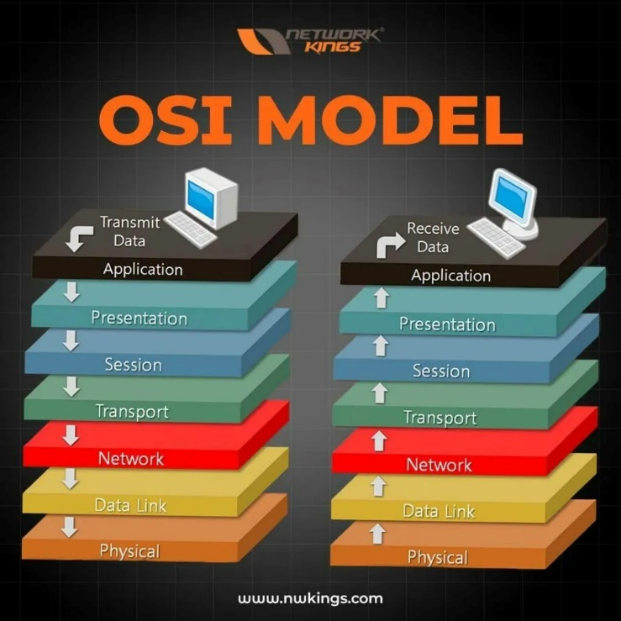
OSI was Developed by the International Organization For Standardization (ISO) and introduced in 1984. ❑ It is a layered architecture.
❑ Each layers define a set of functions which takes part in data communication.
❑ Based upon OSI model Physical, Datalink, and network are called network support layer (Here we are
creating physical topology).
❑ Session, Presentation, and Application layer are called user support layer (where logical topology
comes into picture).
Application:
The Application Layer is the part of a network that provides a user interface and lets people use applications or network services easily.
EX: Web browsers, email clients, and messaging apps work at the Application Layer,
IMPORTANT(Remember Protocols with their port no)
HTTP – 80 FTP – 20/21 TFTP – 69
HTTPS – 443 TELNET – 23 SSH – 22
Presentation:
It is responsible for defining the standard format to the data.
❑ The major functions described at this layer are: - Translation (Encoding and Decoding) (text to ASCII or
UNICODE, Video/autdio – Stream Data) Encryption – Decryption (plain text – Cipher text)
Compression –Decompression (big file to gzip)
Protocols:
SSL/TLS (Secure Sockets Layer / Transport Layer Security) – Encryption and Decryption
GZIP, DEFLATE – Compression and decompression
Session Layer:
It Establishes, Manages and Terminate the Connections between the Local and Remote Application.
❑ When an application wants to communicate, it requests a session from the Session Layer.
❑ Example: When you log into a website, a session is created to manage your connection during your
interaction
Protocols:
ASP (AppleTalk Session Protocol) Manages sessions in Apple's legacy.
Session Initiation Protocol (SIP) Used in VoIP and video calls to establish, manage, and terminate
sessions.
Transport Layer:
It safely delivers data between devices and makes sure it arrives correctly and in order.
Ex: When you send an email or browse a website, the Transport Layer ensures your data gets to the right place without errors.
Protocols: (Important to remember)
TCP – Transmission Control Protocol
UDP – User Datagram Protocol
Network Layer:
It decides how data travels from source to destination based on ip address.
EX: IP addresses used to send data across the internet.
The protocols that works in this layer are:-
i. Routed protcols
❑ It carries actual user data from host to host.
❑Ex:- Ip, Ipx, Appletalk, Ipsec
ii. Routing Protocols
❑ It is used to find path from source to destination.
❑Ex:- Rip, Eigrp, Ospf, Bgp
Datalink Layer:
Transfers data within the same network using mac-address.
This Layer has divided Into Two Sub Parts.
1. MAC – provides a reliable transmission of the data across a physical link. (Ethernet)
2. LLC - talks to the Network Layer and checks for errors in the data before sending it.
Ex: When sending a file over a LAN, LLC makes sure the data arrives correctly and without mistakes.
Protocols:
Frame Relay → Fast WAN connections (like leased lines).
MACSec → A security protocol for Layer 2 that provides encryption and integrity for Ethernet frames
Physical Layer:
The Physical Layer is responsible for sending raw data (0s and 1s) over a physical medium like copper wires, Fiber optics, or wireless signals.
It also defines how devices connect and communicate with each other, including the electrical, mechanical, and functional rules.
Main functions: Encoding/Decoding: Converts binary data into signals depending on the type of medium:
• Copper wires: Electrical signals with different voltages
• Fiber optics: Light pulses with different wavelengths
• Wireless: Radio waves
Components: Ethernet, Bluetooth, and USB standards
TOPIC-4: (Types of Computer Network)
LAN (Local Area Network) – Covers a small area, like a home, office, or school.
EX: Wi-Fi in your home or office.
CAN (Campus Area Network) – Connects multiple buildings in a campus or university.
EX: Network connecting all buildings in a university.
MAN (Metropolitan Area Network) – Covers a city or town.
EX: City-wide internet network for government offices.
WAN (Wide Area Network) – Covers large areas, even countries or continents.
EX: The Internet connecting the whole world.

Day-2: IP addressing and Subnetting
repeating ip addressing
subnetting with 1-2 practicals

