Topics:
DAY1:
Introduction to networking and internet (what, models – OSI, TCP/IP)
LAN, CAN, MAN, WAN, and Devices
DAY2: IP addressing, Subnetting, ARP
DAY3: Switching Fundamentals (VLAN, STP, EtherChannel)
DAY4,5: Fundamentals of IP routing (static, dynamic, eigrp, and ospf)
DAY6: DHCP, DNS,
DAY7: Access Control List, NAT
DAY8: Wireless
DAY9: SDN, AAA
Mynotes: https://github.com/shankarpradhan/Networking/
OSI on above link
I didn’t want to give you notes because they might feel overwhelming. I’m just explaining it so you can remember it easily when revising.

DAY - 1
TOPIC-1 (BASICS)
Node:
A node is any device connected to a network that can send, receive, or forward data.
Examples:
A computer, Router, Switch, Printer, Server, Access point
NETWORK:
A network is a group of connected devices or nodes (like computers, phones, or printers) that can share information and resources with each other.
EX: When your laptop connects to Wi-Fi and you can print using a shared printer or browse the internet — that’s a network.
INTERNET:
Globally connections of private autonomous system is called internet.
or
The internet is a global network of computers that are connected together to share information and communicate with each other.
Private autonomous – local network of one organisation
TOPIC-2: (Network Devices)
SWITCH:
A switch is a network device that connects many computers or devices in a local area network (LAN) and forwards data only to the device that needs it.
Ex: In an office, a switch connects all the computers so they can share files and printers quickly.
ROUTER:
A router is a network device that connects different networks together and sends data to the correct destination.
Ex: Your home Wi-Fi router connects your devices (phones, laptops) to the internet.
ACCESS POINT:
An access point is a network device that lets wireless devices (like phones or laptops) connect to a network using Wi-Fi.
Ex: In an office or home, the Wi-Fi access point allows you to connect to the internet without cables.
FIREWALL:
A firewall is a security device or software that controls and protects the network by blocking harmful or unwanted traffic and allowing safe data to pass through.
EX: A firewall helps keep hackers and viruses out of your computer network.
TOPIC-3: (MODELS)
There are two types of models in networking that help us understand how devices communicate and exchange data with each other.
1. OSI (Open System Interconnection, Understanding purpose)
2. TCP/IP (Top 3 layers of the OSI model combined into a single layer, real-world implemented)
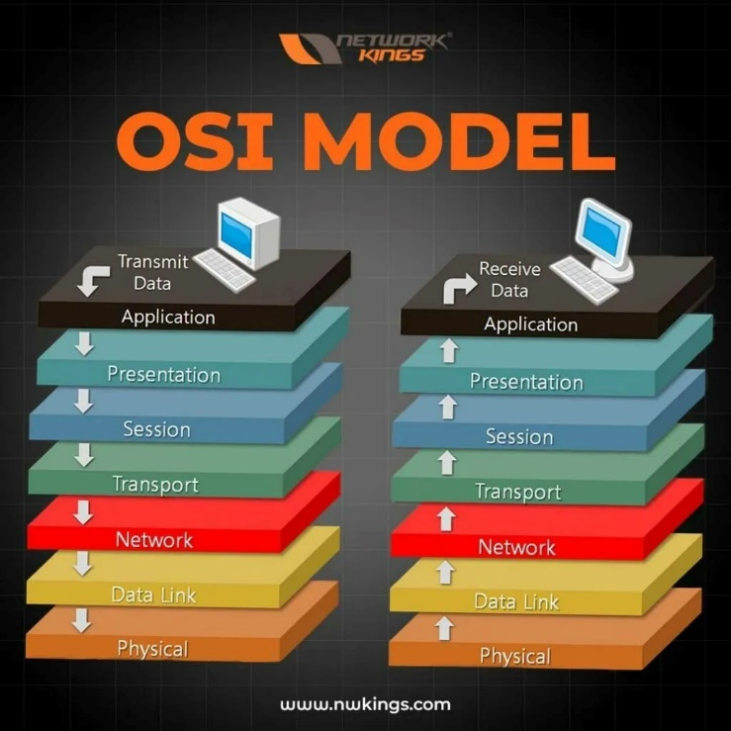
OSI was Developed by the International Organization For Standardization (ISO) and introduced in 1984. ❑ It is a layered architecture.
❑ Each layers define a set of functions which takes part in data communication.
❑ Based upon OSI model Physical, Datalink, and network are called network support layer (Here we are
creating physical topology).
❑ Session, Presentation, and Application layer are called user support layer (where logical topology
comes into picture).
Application:
The Application Layer is the part of a network that provides a user interface and lets people use applications or network services easily.
EX: Web browsers, email clients, and messaging apps work at the Application Layer,
IMPORTANT(Remember Protocols with their port no)
HTTP – 80 FTP – 20/21 TFTP – 69 DHCP – 67/68
HTTPS – 443 TELNET – 23 SSH – 22 DNS – 53
Presentation:
It is responsible for defining the standard format to the data.
❑ The major functions described at this layer are: - Translation (Encoding and Decoding) (text to ASCII or
UNICODE, Video/autdio – Stream Data) Encryption – Decryption (plain text – Cipher text)
Compression –Decompression (big file to gzip)
Protocols:
SSL/TLS (Secure Sockets Layer / Transport Layer Security) – Encryption and Decryption
GZIP, DEFLATE – Compression and decompression
Session Layer:
It Establishes, Manages and Terminate the Connections between the Local and Remote Application.
❑ When an application wants to communicate, it requests a session from the Session Layer.
❑ Example: When you log into a website, a session is created to manage your connection during your
interaction
Protocols:
ASP (AppleTalk Session Protocol) Manages sessions in Apple's legacy.
Session Initiation Protocol (SIP) Used in VoIP and video calls to establish, manage, and terminate
sessions.
Transport Layer:
It safely delivers data between devices and makes sure it arrives correctly and in order.
Ex: When you send an email or browse a website, the Transport Layer ensures your data gets to the right place without errors.
Protocols: (Important to remember)
TCP – Transmission Control Protocol
UDP – User Datagram Protocol
Network Layer:
It decides how data travels from source to destination based on ip address.
EX: IP addresses used to send data across the internet.
The protocols that works in this layer are:-
i. Routed protcols
❑ It carries actual user data from host to host.
❑Ex:- Ip, Ipx, Appletalk, Ipsec
ii. Routing Protocols
❑ It is used to find path from source to destination.
❑Ex:- Rip, Eigrp, Ospf, Bgp
Datalink Layer:
Transfers data within the same network using mac-address.
This Layer has divided Into Two Sub Parts.
1. MAC – provides a reliable transmission of the data across a physical link. (Ethernet)
2. LLC - talks to the Network Layer and checks for errors in the data before sending it.
Ex: When sending a file over a LAN, LLC makes sure the data arrives correctly and without mistakes.
Protocols:
Frame Relay → Fast WAN connections (like leased lines).
MACSec → A security protocol for Layer 2 that provides encryption and integrity for Ethernet frames
Physical Layer:
The Physical Layer is responsible for sending raw data (0s and 1s) over a physical medium like copper wires, Fiber optics, or wireless signals.
It also defines how devices connect and communicate with each other, including the electrical, mechanical, and functional rules.
Main functions: Encoding/Decoding: Converts binary data into signals depending on the type of medium:
• Copper wires: Electrical signals with different voltages
• Fiber optics: Light pulses with different wavelengths
• Wireless: Radio waves
Components: Ethernet, Bluetooth, and USB standards
TOPIC-4: (Types of Computer Network)
LAN (Local Area Network) – Covers a small area, like a home, office, or school.
EX: Wi-Fi in your home or office.
CAN (Campus Area Network) – Connects multiple buildings in a campus or university.
EX: Network connecting all buildings in a university.
MAN (Metropolitan Area Network) – Covers a city or town.
EX: City-wide internet network for government offices.
WAN (Wide Area Network) – Covers large areas, even countries or continents.
EX: The Internet connecting the whole world.

Day-2: IP addressing and Subnetting
TOPIC-1: IP Address ranges:
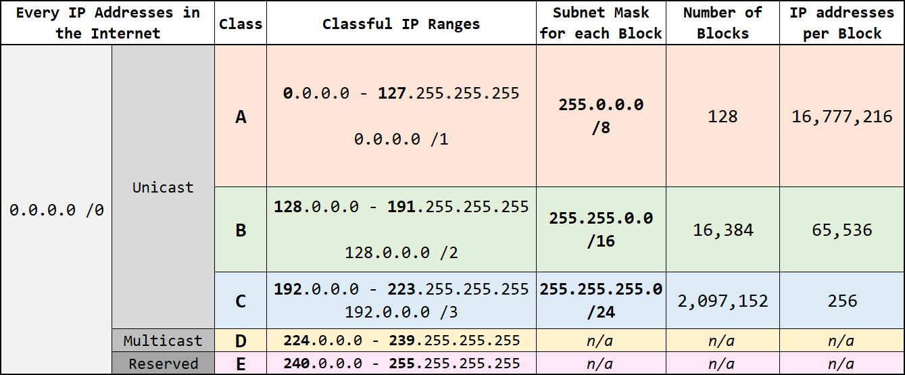
Remember:
class A, B, C private and public ip address range
Class C – Multicast address
class D – Research and Development
Public address = not belongs to private address: (1.0.0.0 - 9.255.255.255)
Classes Private IP subnet mask
A 10.0.0.0 - 10.255.255.255 /8
B 172.16.0.0 – 172.31.255.255 /16
C 192.168.0.0 – 192.168.255.255 /24

Class A
- Format: N.H.H.H (N = Network, H = Host)
- Binary: 11111111.00000000.00000000.00000000
- Default Subnet Mask: 255.0.0.0 or /8
- IP Range: 1.0.0.0 – 126.255.255.255
- Example IP: 10.0.0.1 → Network part = 10, Host part = 0.0.1
Class B
- Format: N.N.H.H
- Binary: 11111111.11111111.00000000.00000000
- Default Subnet Mask: 255.255.0.0 or /16
- IP Range: 128.0.0.0 – 191.255.255.255
- Example IP: 172.16.0.1 → Network part = 172.16, Host part = 0.1
Class C
- Format: N.N.N.H
- Binary: 11111111.11111111.11111111.00000000
- Default Subnet Mask: 255.255.255.0 or /24
- IP Range: 192.0.0.0 – 223.255.255.255
- Example IP: 192.168.1.1 → Network part = 192.168.1, Host part = 1

Q. What is APIPA IP address and its range? (Tell you tomorrow)
TOPIC-2: NETWORK, BROADCAST, AND USEABLE IP:
Q. Find the Network, Broadcast, and Usable IP address from below information
IP address: 192.168.1.10
Subnet mask: 255.255.255.0 (or /24)
That means the network has 256 total IPs (0–255) — from 192.168.1.0 to 192.168.1.255.
1. Network Address
The network address is the first address in the subnet.
It represents the entire network, not any one device.
(Part of my network or same group members)
EX:
192.168.1.0 → Network Address
It tells devices, “You are part of the 192.168.1.x network.”
2. Broadcast Address
The broadcast address is the last address in the subnet.
It’s used to send a message to all devices in that network at once.
EX:
192.168.1.255 → Broadcast Address
If a device sends data to 192.168.1.255, everyone in 192.168.1.x will receive it.
3. Valid (Usable) IP Addresses
These are the IPs that you can actually assign to computers, routers, printers, etc.
They’re the addresses between the network and broadcast address.
EX:
Valid IP range: 192.168.1.1 → 192.168.1.254
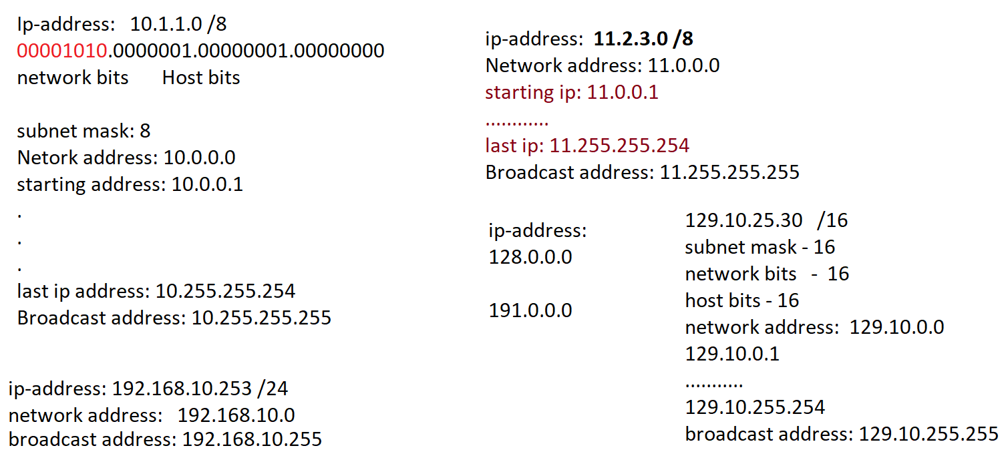
TOPIC-3: Subnetting (repeat tomorrow, just revise):
Subnetting is the process of dividing an IP address into a network address and a host address.
It helps to split one big network into smaller sub-networks (subnets) for better management and security.
(One subnet for each department)
Two Types of Subnetting (Important to remember)
- FLSM (Fixed Length Subnet Mask)
  - All subnets have equal size.
  - Each subnet has the same number of hosts.
  - Easy to manage, but sometimes wastes IP addresses.
EX: Dividing a /24 network into four /26 subnets (each with 64 IPs).
- VLSM (Variable Length Subnet Mask)
  - Subnets have different sizes based on need.
  - More efficient use of IP addresses.
EX: One subnet with 30 hosts, another with 14 hosts — each gets a different mask.

Subnet mask - Total Ips
32 1 (32-32 = 0, 2^0=1)
31 2 (32-31 = 1, 2^1=2)
30 4 (32-30 = 2, 2^2=4)
29 8 (32-29 = 3, 2^3=8)
28 16 (32-28 = 4, 2^4=16)
27 32 (32-27 = 5, 2^5=32)
26 64 (32-26 = 6, 2^6=64)
25 128 (32-25 = 7, 2^7=128)
24 256 (32-26 = 6, 2^6=64)
………
……..
Number of IPs can be assigned to device = total Ips – 2
/29 = 8-2 = 6 ( usable IP addresses)
(others two IP address are network address and broadcast address)
Network = IP address = logical address
Datalink = mac-address = physical address
VLSM: (Practical)
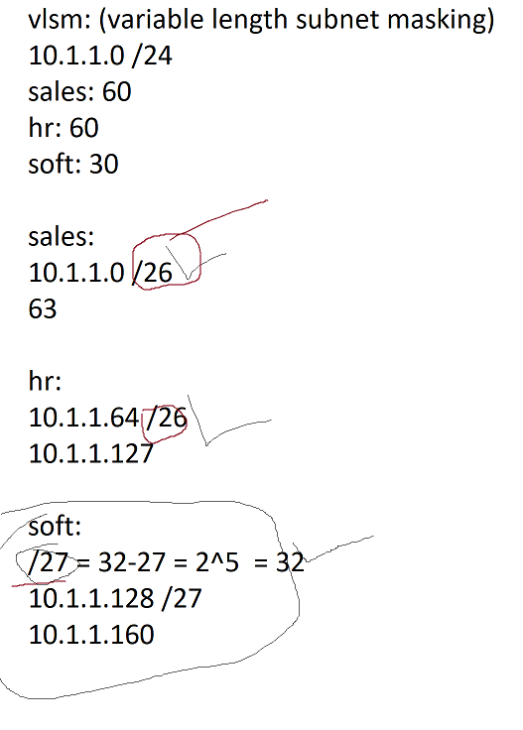

ARP (Address Resolution Protocol):
It is used to find the mac-address for known IP address.
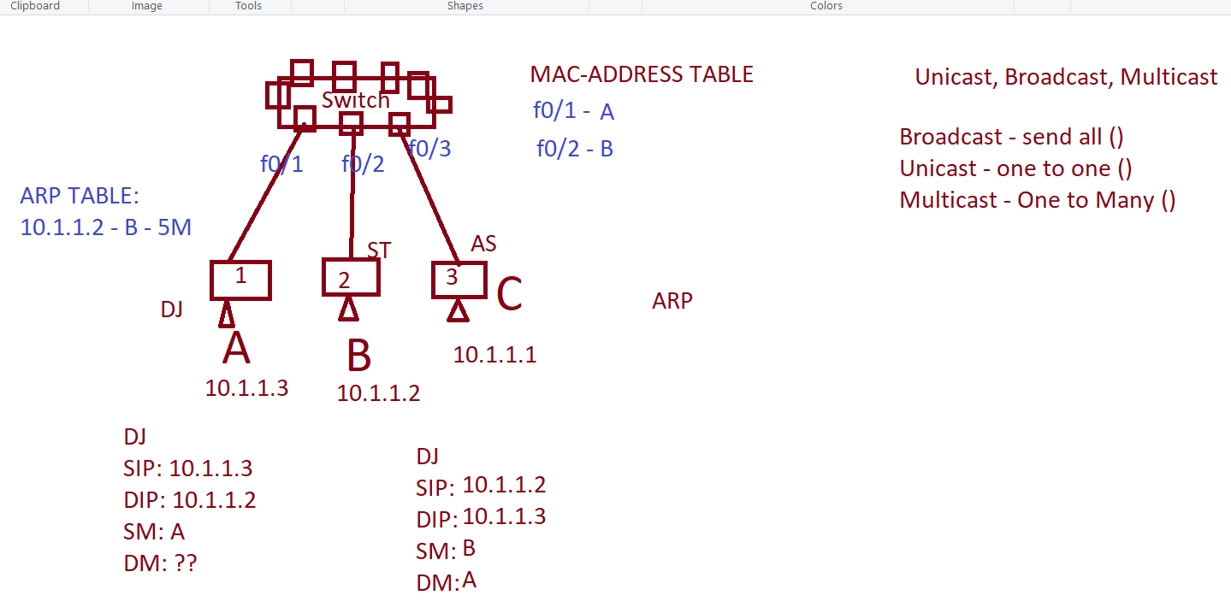

TYPES:
ARP – find mac address for known ip address
REVERSE ARP – find ip address for known mac address
Gratuitous ARP – used to find the duplicate ip address
Proxy ARP –

