Email delivery occurs in three stages:
The first stage (sender to server) and the second stage (server to recipient’s server) use SMTP (Simple Mail Transfer Protocol), which is a push protocol. However, SMTP is not suitable for the third stage (recipient’s mail server to recipient’s computer) because this stage requires a pull protocol that allows the client to retrieve messages from the server.
This third stage is handled by Message Access Agents (MAAs) using either POP3 (Post Office Protocol 3) or IMAP4 (Internet Message Access Protocol 4).
- POP3 is a simple protocol that requires POP3 client software on the recipient’s computer and POP3 server software on the mail server. It uses TCP port 110 and requires a username and password for authentication. Users can then download messages from the server. However, POP3 has limitations:
  - Cannot organize or categorize emails on the server.
  - Cannot create folders for email storage.
  - Cannot partially download messages before retrieving them.
- IMAP4 provides all features of POP3 but with enhanced capabilities. It allows:
  - Creating hierarchical folders for email storage.
  - Searching emails on the server before downloading.
  - More flexibility and control compared to POP3.
how we can secure our email message:
A digital signature added to an email message adds a degree of protection by ensuring the receiver that the originator is not an impostor who signed the email message’s contents. The digital Tenderer generates the digital signature, which comprises the sender certificate and public key. But also, that digital ID acts as the sender’s unique digital identifier, informing the recipient that the material was not changed in route. Furthermore, it also guarantees that the content of the email has not been tampered with or altered. Digital signatures, then, are a powerful tool in preventing fraud or tampering with emails and their contents
Email encryption techniques are important to achieve a secure email environment. Securing the email environment involves the encryption of connections and the encryption of emails.
Email encryption techniques, such as S/MIME (Secure/Multipurpose Internet Mail Extensions) and Open PGP (PGP stands for Pretty Good Privacy), are two widely used encryption protocols for securing email communication.

both PGP (Pretty Good Privacy) and S/MIME (Secure/Multipurpose Internet Mail Extensions) are used for email security (confidentiality, integrity, authentication, non-repudiation). They serve the same purpose, but the way they work is different.
How They Work:
i. PGP (Pretty Good Privacy):
- Keys: Uses a “web of trust” model (users exchange and verify each other’s public keys).
- Process:
  - The message is hashed → digital signature (sender’s private key).
  - The message + signature is compressed.
  - A session key is generated and used for encryption (symmetric).
  - The session key is encrypted with the recipient’s public key (as a digital envelope).
  - The final message is Base64 encoded and sent.
- Strength: Decentralized → doesn’t rely on central authorities.
- Weakness: Key management can be difficult (users must manually exchange and trust keys).
ii. S/MIME (Secure/Multipurpose Internet Mail Extensions):
- Keys: Uses a hierarchical PKI (Public Key Infrastructure) with trusted Certificate Authorities (CAs).
- Process:
  - A digital certificate (issued by a CA) contains the sender’s public key.
  - The message is signed (hash + private key) and/or encrypted (with recipient’s public key).
  - The receiver verifies the signature using the sender’s public key from the certificate.
- Strength: Easy to use → certificates are issued and managed by trusted CAs.
- Weakness: Relies on centralized trust (if CA is compromised, security is affected).
Key Differences Between PGP and S/MIME
Feature | PGP | S/MIME
Trust Model | Web of Trust (users validate each other) | Hierarchical PKI (trusted Certificate Authorities)
Key Management | Manual exchange & verification | Automatic via certificates
Standardization | Open-source, widely used for personal email | Industry standard, often used in enterprises
Ease of Use | More complex for non-technical users | Easier, integrated in most corporate email clients
Control | Users control their own keys | Centralized control via CA
Adoption | Popular among individuals/security-conscious users | Common in businesses/organizations

To achieve a secure and protected email environment, there is a set of techniques in place including digital signatures, encryption techniques, and hashing algorithms.
• Digital signatures verify the authenticity of an email’s source, encryption techniques ensure that only authorized individuals can read the message, and hashing algorithms provide a secure way to store passwords and other sensitive information. Digital signatures generate a unique virtual fingerprint for a person or entity and are used to identify users and safeguard information in digital messages or documents. A digital signature added to an email message adds a degree of protection by ensuring the receiver that the originator is not an impostor who signed the email message’s contents. The sender’s digital ID generates the digital signature, which comprises the sender certificate and public key. But also, that digital ID acts as the sender’s unique digital identifier, informing the recipient that the material was not changed in route. Furthermore, it also guarantees that the content of the email has not been tampered with or altered. Digital signatures, then, are a powerful tool in preventing fraud or tampering with emails and their contents.

The receiver uses the sender's public key to verify the digital signature.
It is critically important to understand that the receiver does not use their own key pair for this step. They use the public key that belongs to the sender.
Here’s a step-by-step breakdown of how it works:
1. The Goal: Verification, Not Decryption (of the message)
First, let's clarify the terminology. For a digital signature, the public key is used to verify the signature, not to "decrypt" the message content.
- Encryption uses the receiver's public key to scramble the message, and their private key to unscramble (decrypt) it.
- Signing uses the sender's private key to create a signature, and their public key to verify it.
The process of verifying the signature proves the email's authenticity and integrity.
2. How the Receiver Gets the Sender's Public Key
This is the crucial part of your question. The receiver's email client needs to find the sender's public key to perform the verification. There are two main ways this happens, depending on the technology used (DKIM or S/MIME):
Method A: For DKIM (Domain-Level Signing)
DKIM is used by mail servers to sign outgoing messages automatically. The public key is stored in a very public place:
- The Signature Header: The sending mail server adds a DKIM-Signature header to the email. This header contains crucial information, including the d= (domain) and s= (selector).
- DNS Query: The receiving mail server takes the domain (d=example.com) and the selector (s=selector1) from the DKIM header.
- Fetching the Key: The receiver server then performs a DNS lookup for a special TXT record at the address:
selector1._domainkey.example.com
- The Public Key is in DNS: The retrieved TXT record contains the sender's (domain's) public key. The receiving server uses this public key to verify the cryptographic signature in the email header.
In short: For DKIM, the public key is fetched from the sender's DNS records.

Method B: For S/MIME (User-Level Signing)
S/MIME is used by individuals to sign their emails. The public key is attached to the email itself.
- Digital Certificate: When a sender signs an email with S/MIME, they don't just attach a signature; they attach their digital certificate. This certificate contains their public key, identity (email address), and is issued by a trusted Certificate Authority (CA).
- Bundled with the Email: The receiver's email client (e.g., Outlook, Apple Mail) extracts the sender's public key directly from this attached certificate.
- Trust Chain: The email client checks if it trusts the CA that issued the sender's certificate. If it does, it uses the extracted public key to verify the signature.
Email Encryption:
PGP (Pretty Good Privacy):
NPPI (non-public personal information), PHI (protected health information)
i. A sender generates the hash value of the message and encrypts with the algorithms like 3des, DSC (signed by using private key).
ii. The sender’s digital ID generates the digital signature, which comprises the sender certificate and public key
iii. Receiver SMTP server queries to DNS server to find the public key of the Sender mail. It presents in the txt record of the DNS server.
iv. After getting the public key (integrity check), Receiver checks connection integrity then it decrypts the message with the private key of corresponding the public key of the sender.
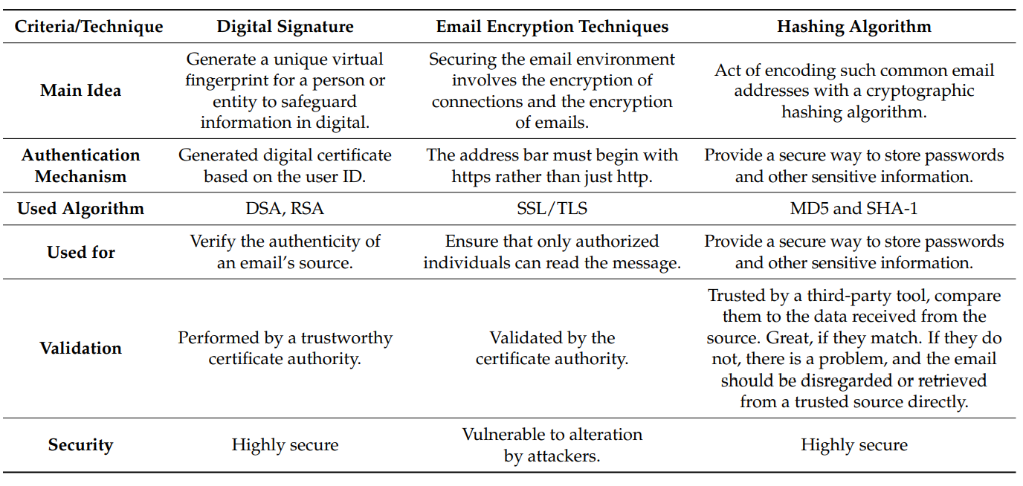
ESA – Email Security Appliance:
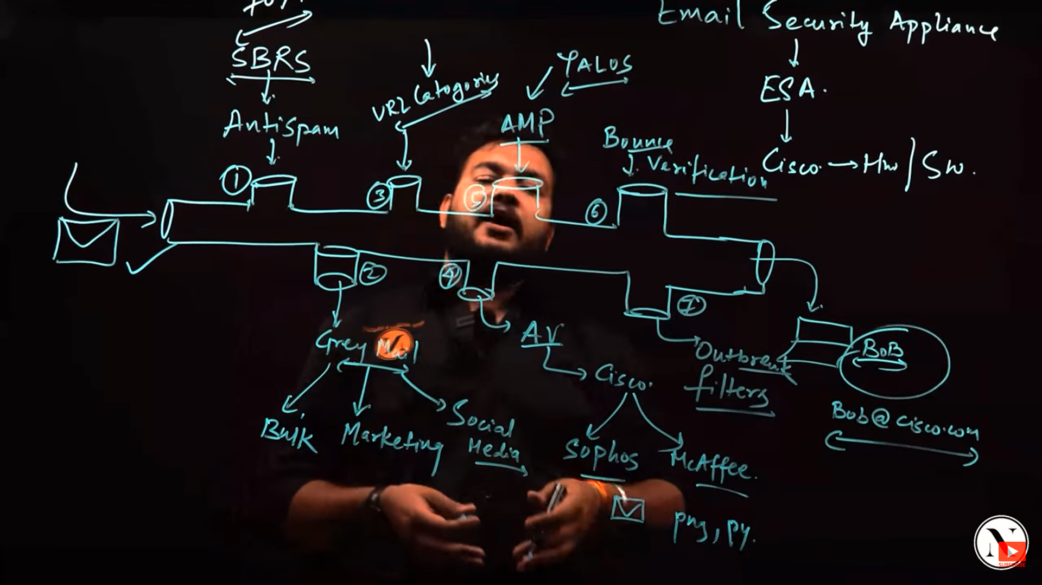
Anti-spam – SBRS (sender-based reputation score)

The investigation of email abuse scenarios including fraud email, spamming email, bombing email, spoofing email, and phishing email investigation scenarios.
Investigating email abuse can involve a wide range of activities such as analysing logs and headers, deciphering malicious code, decrypting data, and messages, collecting evidence, and even testifying in court.

Different types of attacks in an email: (page 16)
EMAIL SPAM:
i. Email spam, also known as junk email, refers to unsolicited email messages, usually sent in bulk to a large list of recipients.
ii. Email spam is typically used by companies to advertise their products, but it can also be used for malicious purposes such as phishing scams and identity theft.
Spam emails are unsolicited emails that are sent to recipients in quantity and, frequently, the majority of these spam emails are commercial in nature; however, chain emails are also possible. Spam emails can range from advertisements for products, services, or events to malicious scams and threats, making them a very dangerous form of communication. To combat the growing number of spam emails, many email providers and websites have adopted advanced anti-spam technology.
BOMBING:
i. Email bombing is a way of sending a large number of emails to overrun the inbox or flood the email server, culminating in a DoS (denial-of-service) attack. It has become an increasingly popular form of cyber-attack, particularly as the cost of bandwidth and storage continues to decrease. Email bombing is a destructive and dangerous form of attack, and can have serious consequences for the recipient.

Email Spoofing:
Email spoofing is a technique used by attackers to disguise the true source of an email by falsifying the sender’s address. This makes the message appear to come from a trusted source, thereby masking its malicious intent. Spoofed emails are often used as a delivery mechanism for spam, malware, or phishing attacks.
Yes, email spoofing exploits the way servers exchange mail using SMTP. It happens between sending and receiving servers, because SMTP by default does not check if the “From” address is authentic.
prevented by enabling SPF, DKIM, and DMARC.
(
Email spoofing is used to impersonate a supervisor, professor, or financial institution to deceive people into doing some kind of action. Scammers adopt this type of deception because they know that if a person knows who sent the message, they are more likely to engage with the content of the email. In order to identify the spoofed email address, we need to check the email header information. The email headers contain a lot of tracking information that shows where the message has been on the Internet. These headers are shown differently in different email systems. To access the header information, we need to open the message and view its source. The source code of the message contains all of the email headers, including IP addresses that are used to trace the location of the email sender.
)

Phishing:
Phishing is a form of cybercrime that combines social engineering and technological deception to steal sensitive information such as bank account details, usernames, and passwords. Attackers typically send counterfeit emails that appear to originate from reputable organizations. These emails trick recipients into revealing personal data by clicking on malicious links or entering credentials into fake websites.
INVESTIGATING EMAILS:
There are several techniques that are useful for conducting an email investigation during this step, including
i. header investigation
ii. server investigation
iii. investigation of software-embedded details
iv. investigation and discovery of hidden emails
v. investigation of anti-forensic activity
Signatures
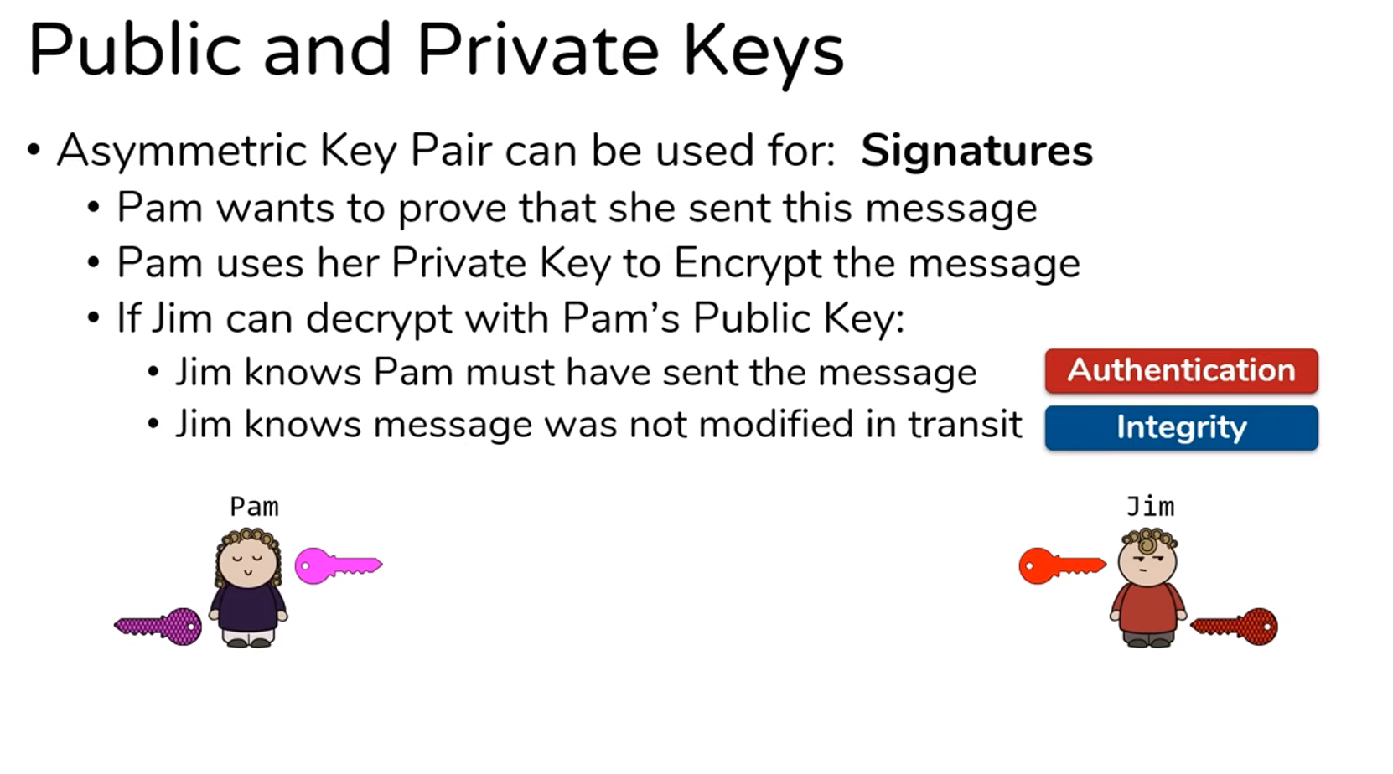
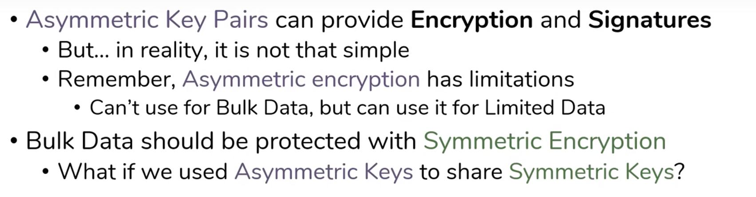
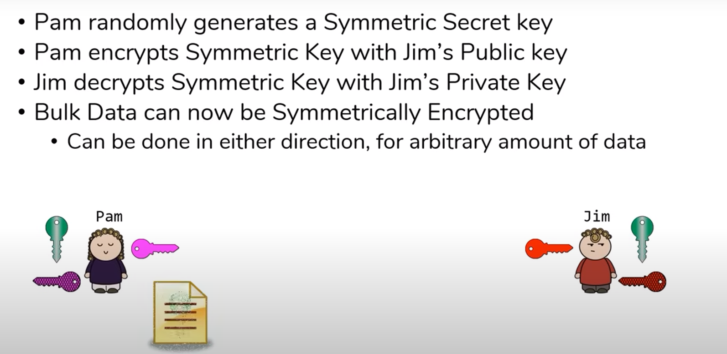
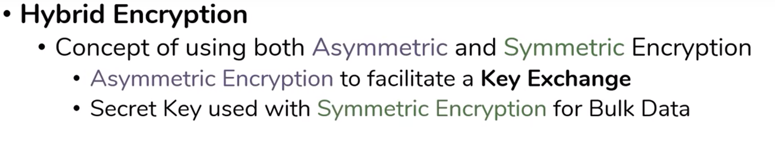
(SSL / TLS, IPSEC)
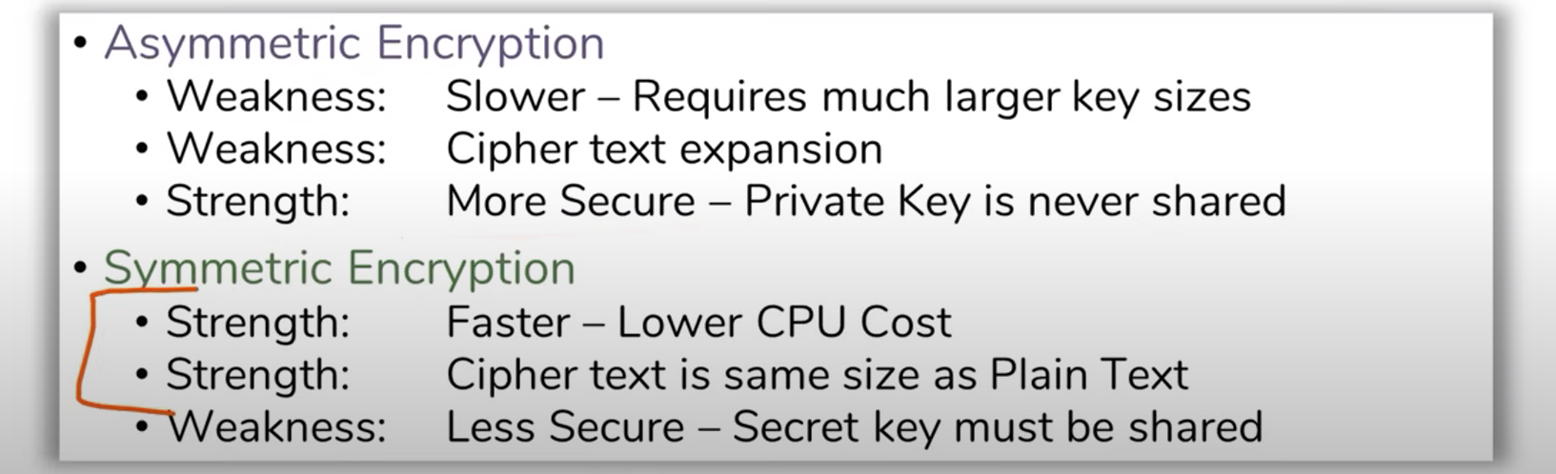
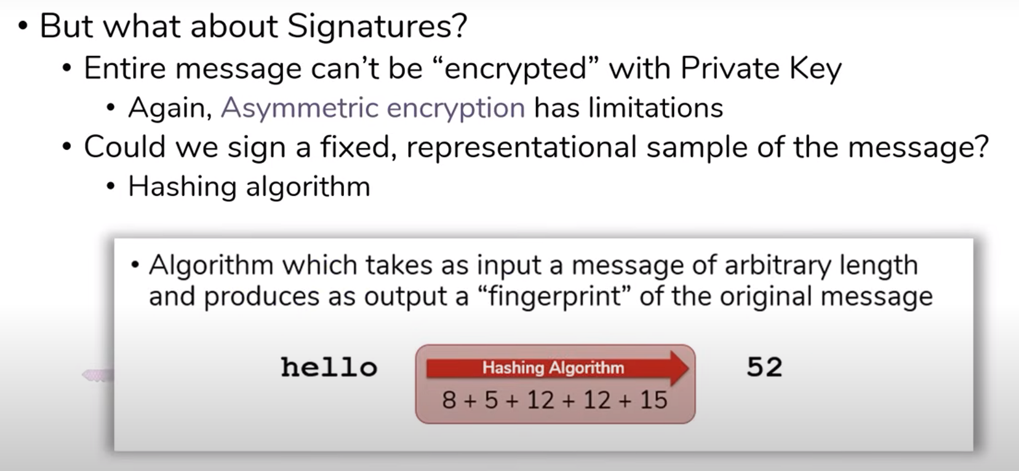
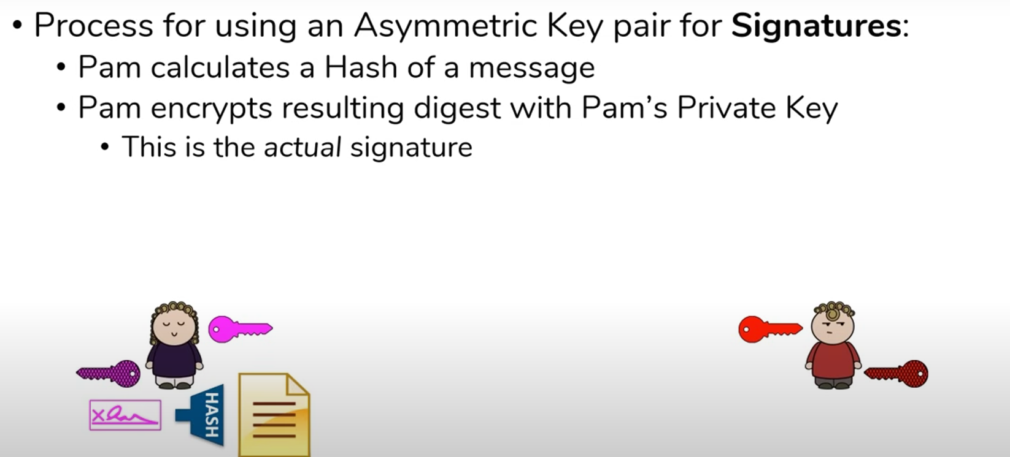
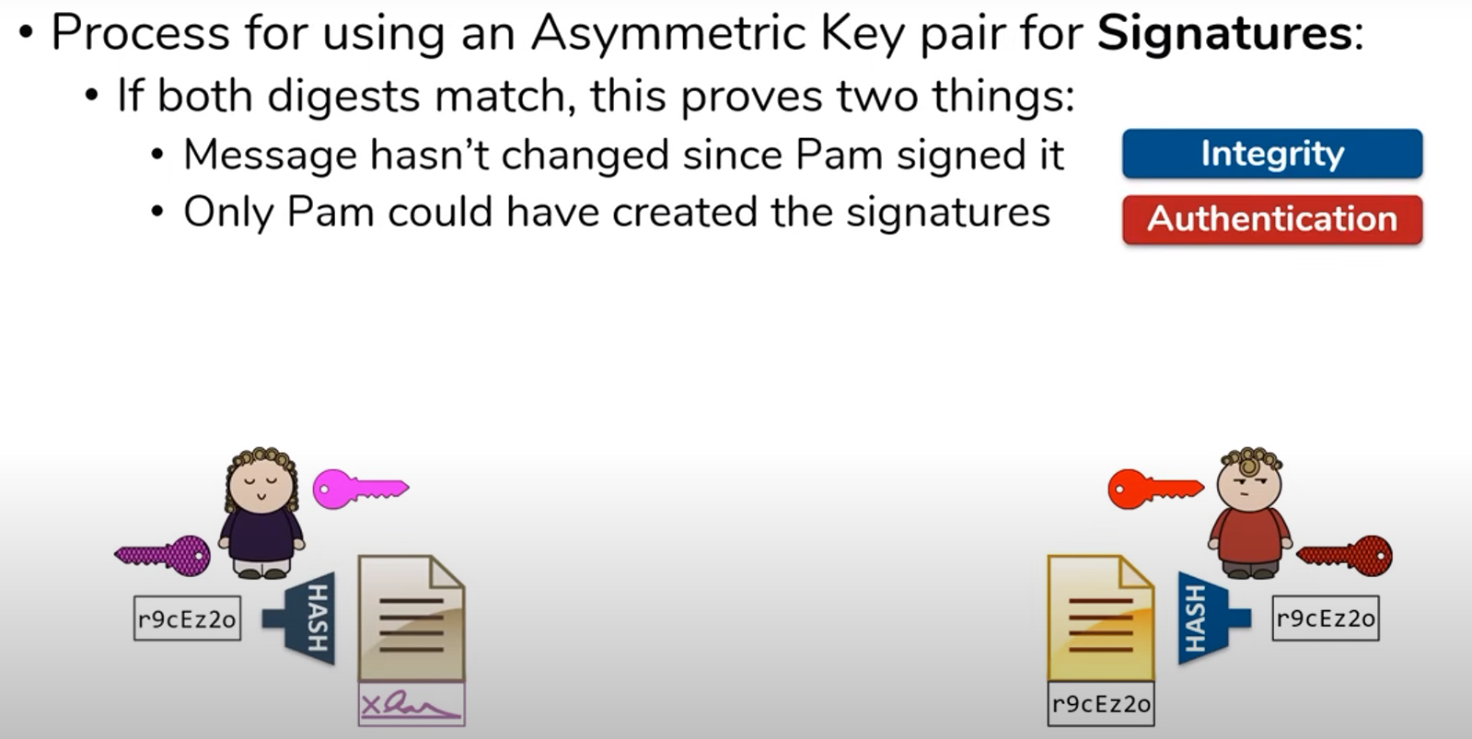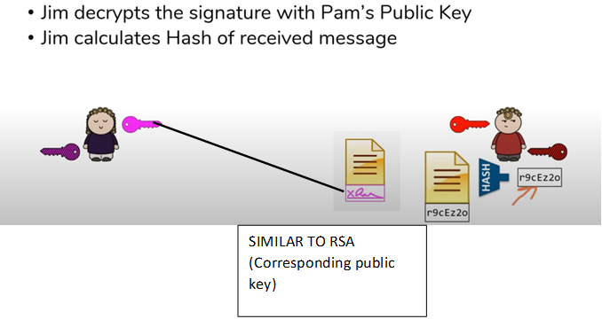
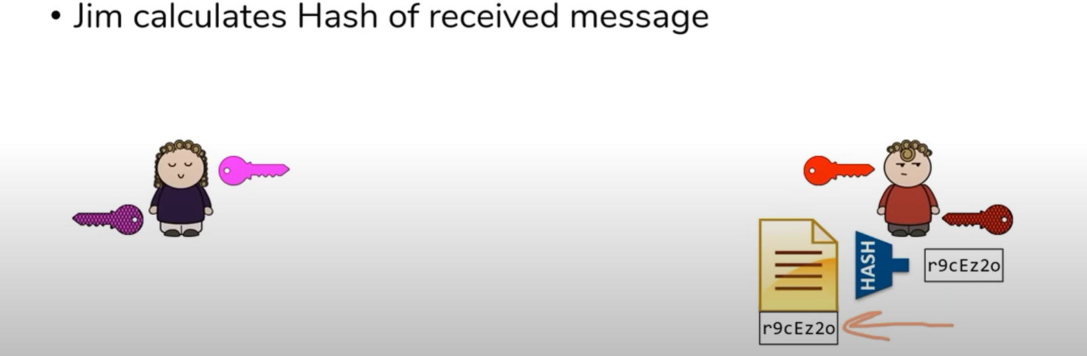
Finally:
