**ADITYA DEGREE COLLEGES**

**ANDHRA PRADESH**

**MID – 1 SYLLABUS**

**HINDI**

**SEMESTER – I**

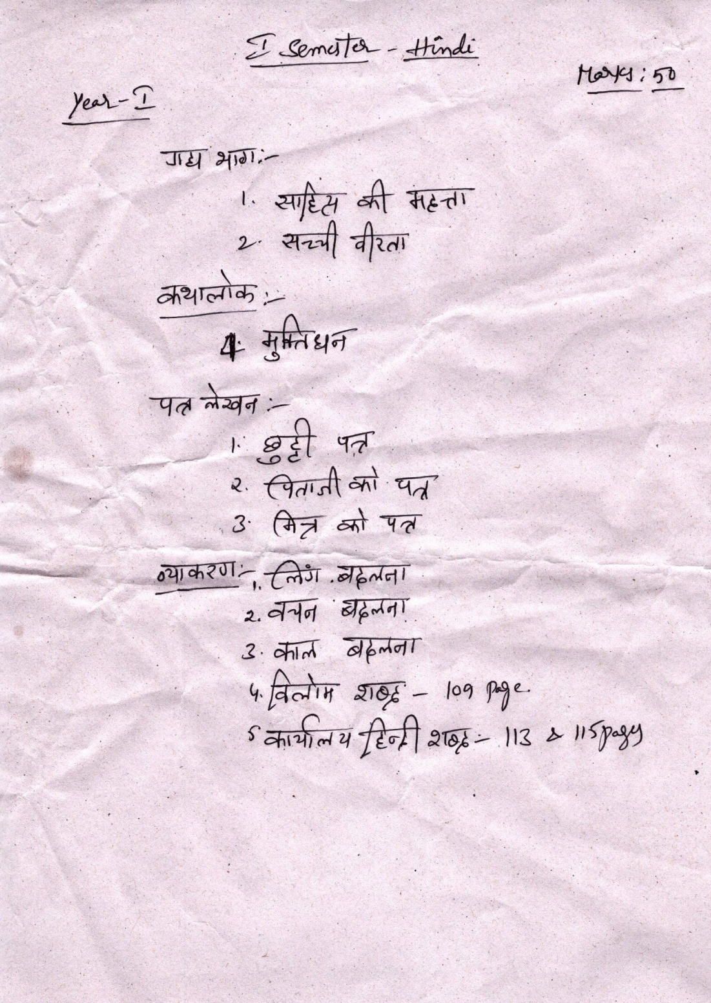

**SEMESTER – III**

