REACT TRAINING DAY 1

K Shankar Sravanth

221910304024

CSE IV year

1. **INSTALL LATEST VERSION OF VISUAL STUDIO CODE FROM WEB**
2. **INSTALLATION OF NPM**

**STEP 1:** Go to search bar and type ‘node js’ install.

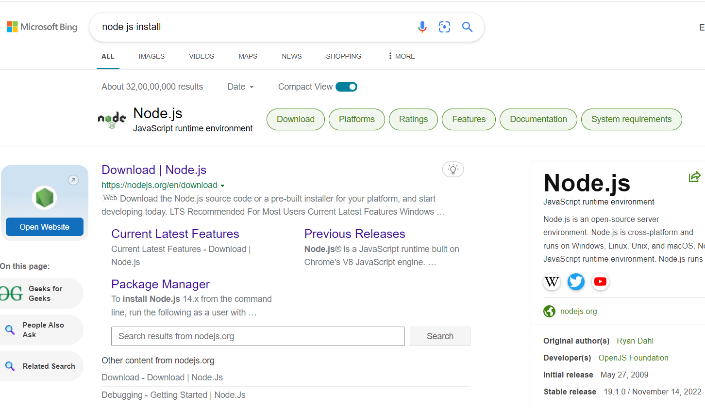

**STEP 2:** Redirect to the first link and install latest version to your supported operating system and configuration.

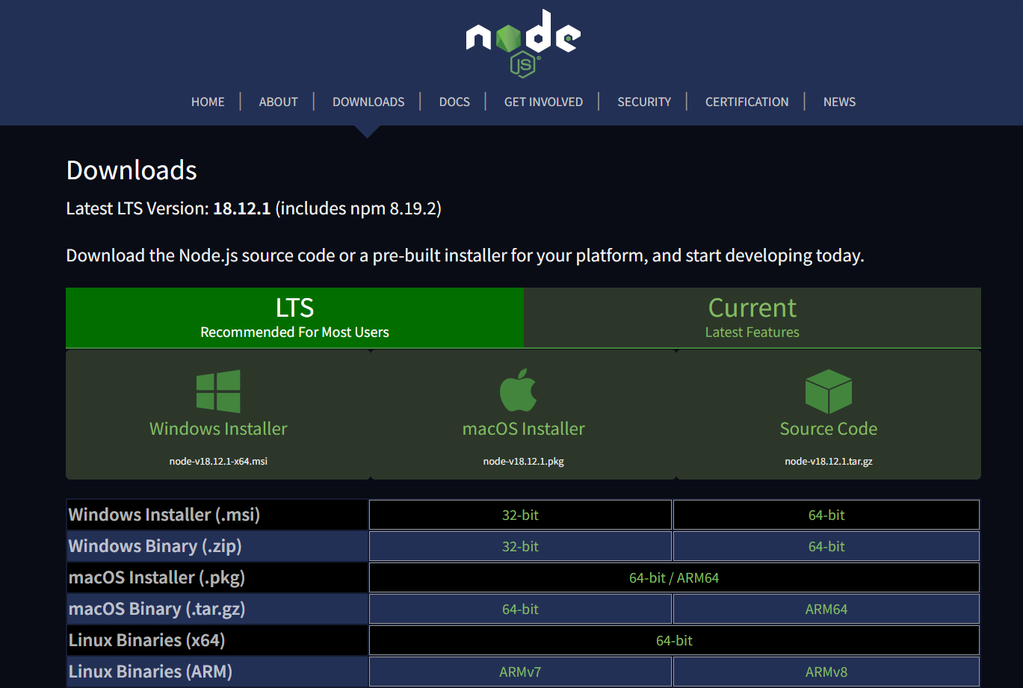

**STEP 3:**  now go to command prompt and check the latest version of npm installed with ***‘npm -v’***command.

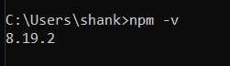

**STEP 4:** Now to create a react application, npm should contain prerequisites for it. So to install ***‘npm install crate-react-app’*** is the command to be noted and executed.

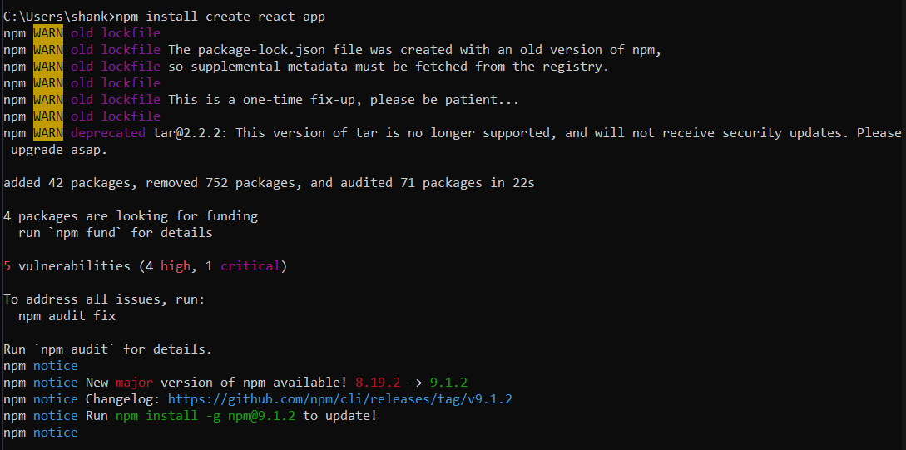

**NPM Audit report:**

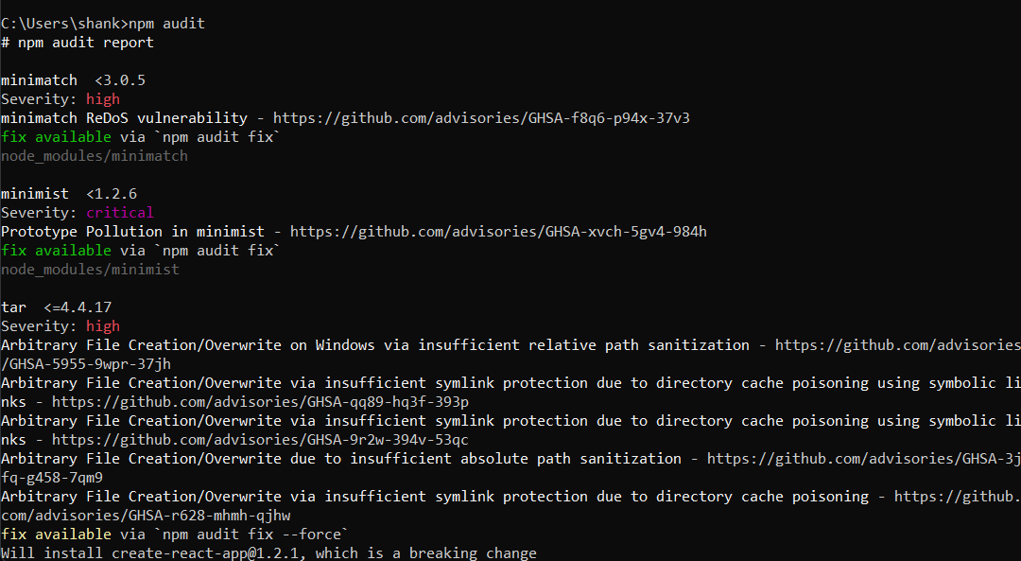

**STEP 5:** Make a folder to contain all the react projects. Now create a react file to execute the project named as *‘sravanth_react’*  by command

***npx create-react-app (project_name)***

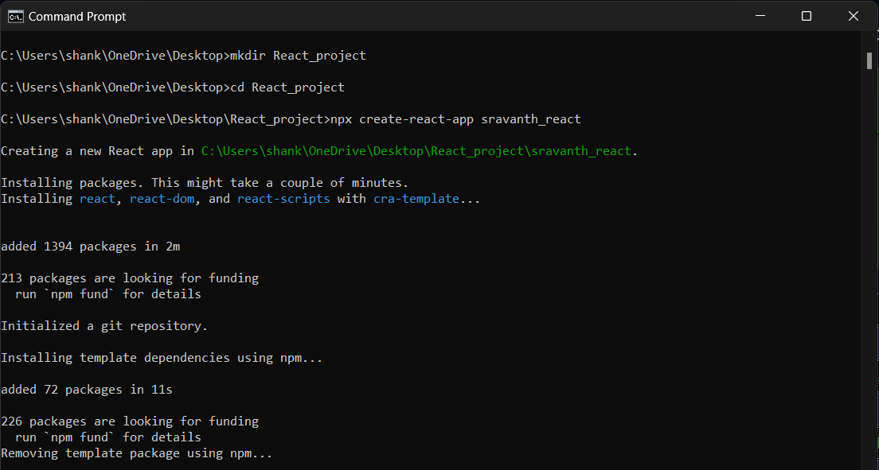

**STEP 6:**  Now redirect to the created project path and start the project by command :

***‘npm start’***

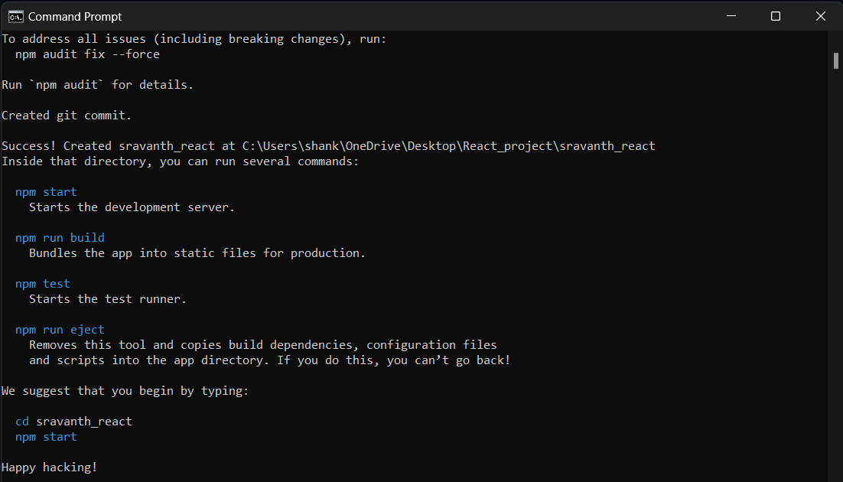

**STEP 7:** Verify the localhost port number as 3000. Make sure this execution should redirect you to the below mentioned site.

