REACT TRAINING DAY 2

K Shankar Sravanth

221910304024

CSE IV year

1. Printing content from app.js

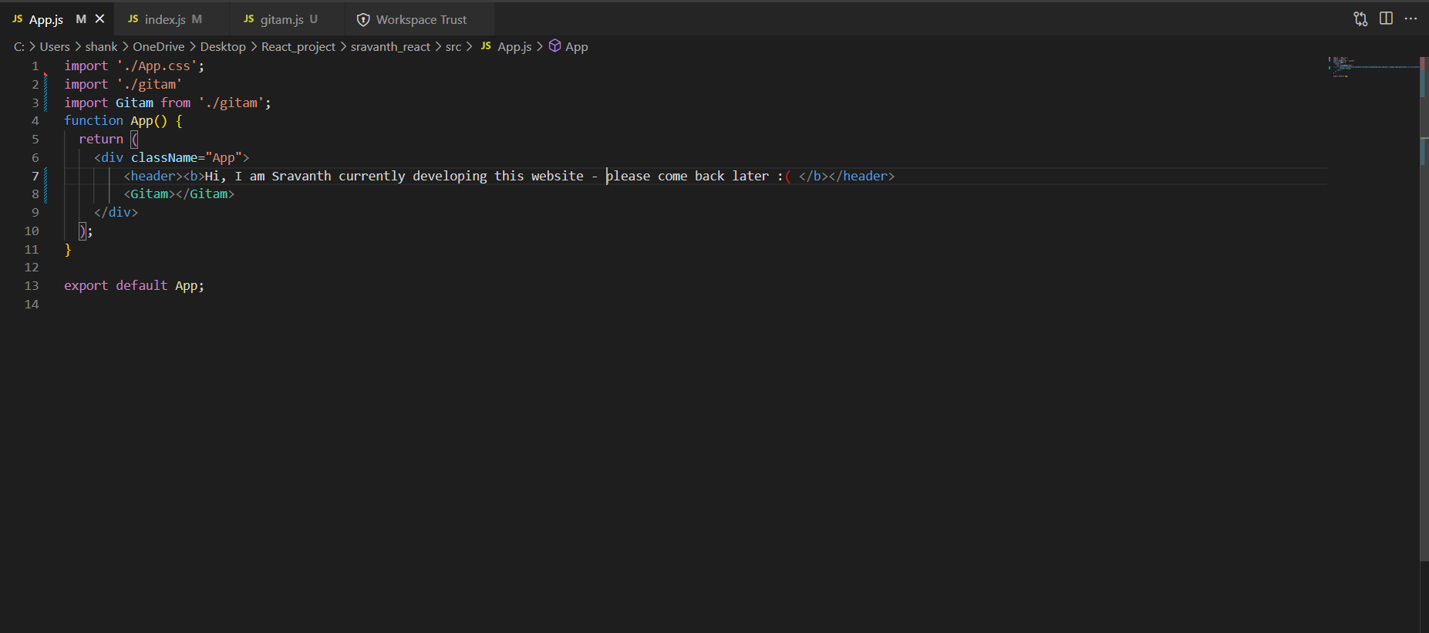

**Index.js file :**

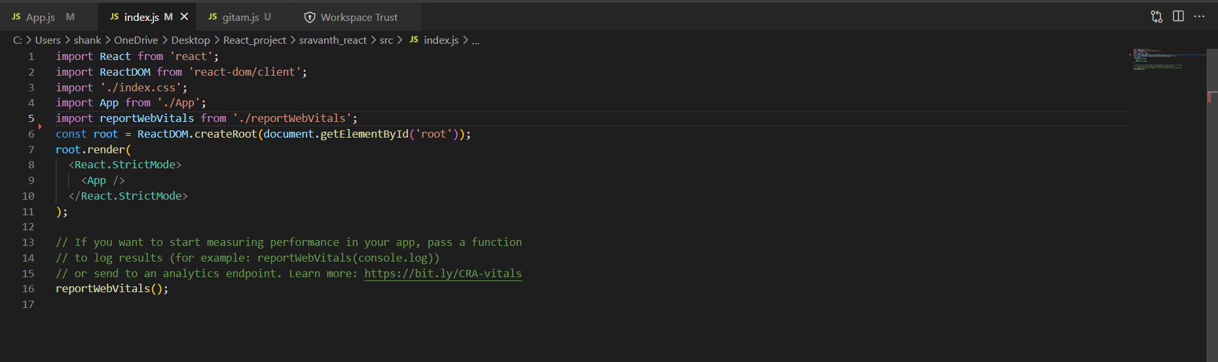

**User defined function that prints contents**

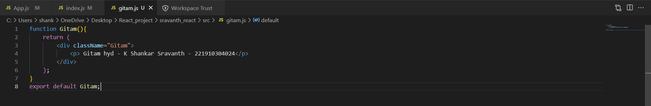

**Output**

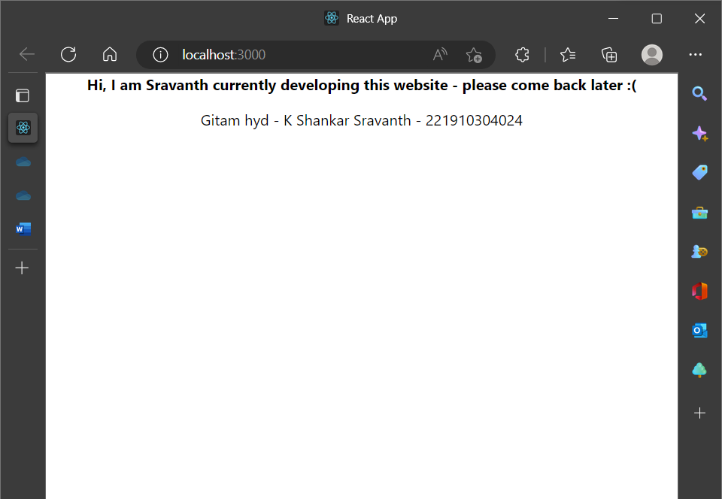

**Another function to print content – Functional component example**

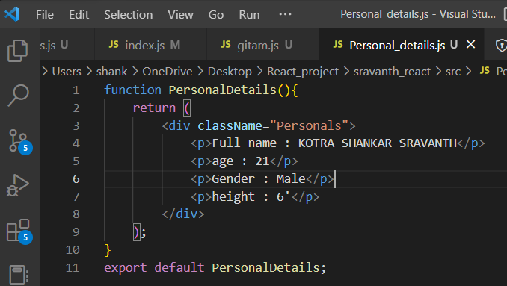

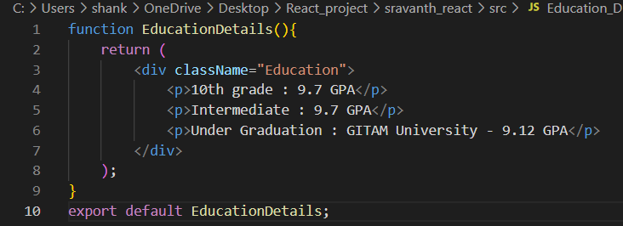

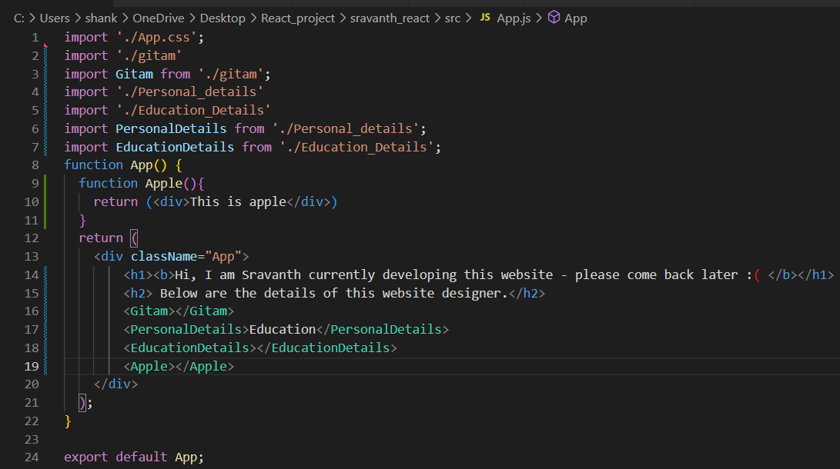

**Nested functional components**

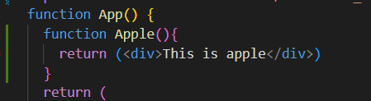

**Output:**

