REACT TRAINING DAY 3

K Shankar Sravanth

221910304024

CSE IV year

**Variable declaration:**

A variable can be declared as

Var

Let

Const

**Two types:** local variable and global variable

Whenever a variable is declared as let, the variable should be used in particular block

Whenever a variable is declared as const, the value of the variable remains same. It will be throwing error whenever, we try to change the value of the variable.

**Context :** To print “GITAM”

**Functional component:**

Function user()

{ return (

<h1>GITAM</h1>

)

}

Export default User;

**Class component:**

Import React,{component}

From ‘react’;

Function User extends component

{

Render() {

Return(

<h1>GITAM</h1>

)}

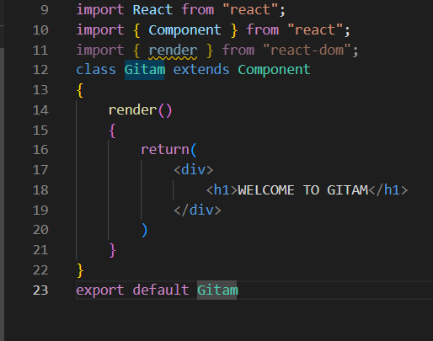

**Declare a class component “university” and functionality of that particular class component is to print your name and pin number, export that class component to App.js and run the application.**

A button can be created by using button tag

Function apps {

Alert{“Welcome”};

}

**<button onclick ={apps}>Submit</Button>**

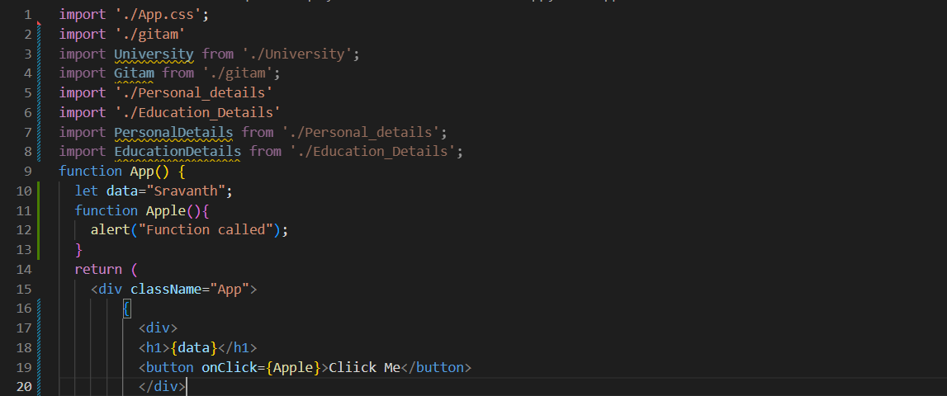

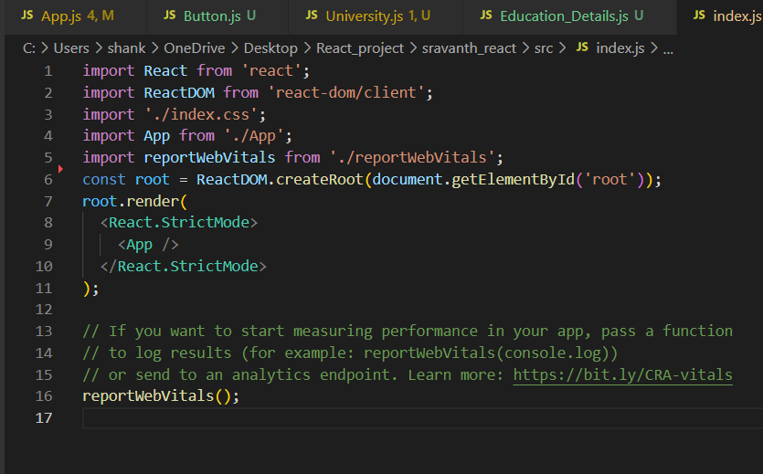

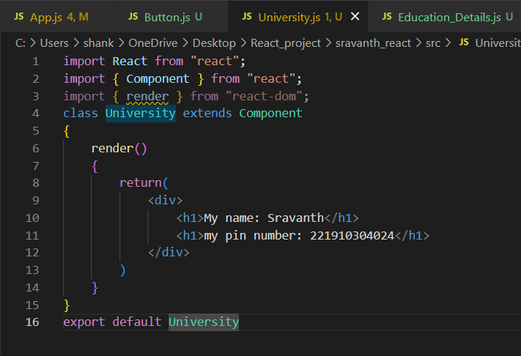

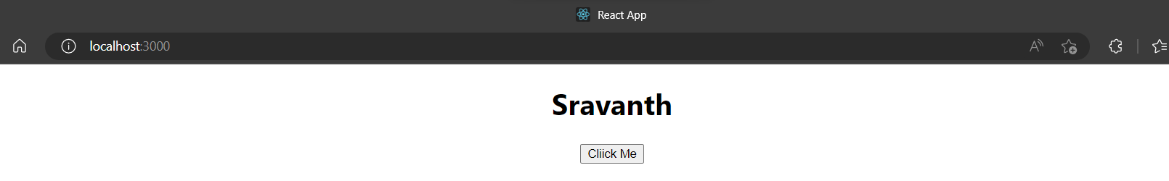

**Assignment:**

**Q1. Create a class component called "GITAM", that class Component needs to print "WELCOME TO GITAM". Export that class component to App.js and execute the program**

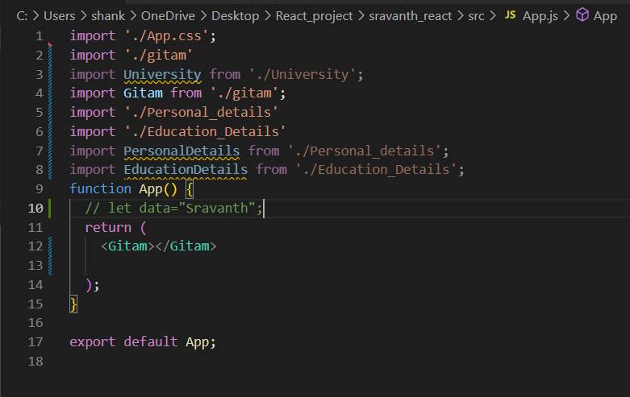

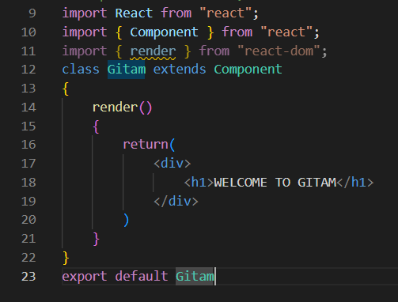

**OUTPUT:**

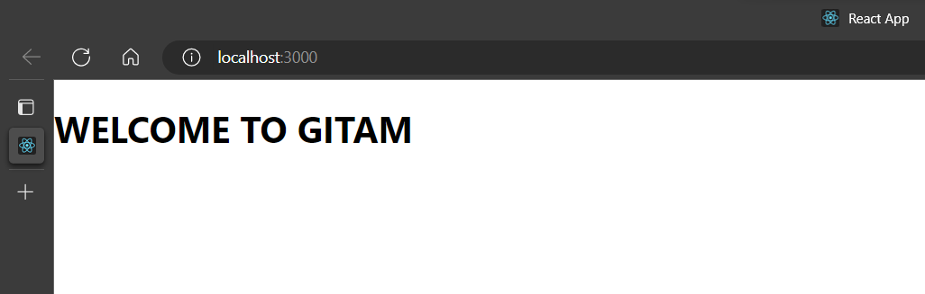

**Q2.** **In App.js, inside the App function, create one function called Banana and it need to return your name. Create a button called GITAM, whenever GITAM is clicked, the function should be called.**

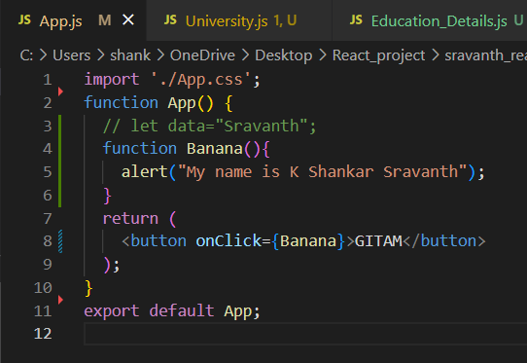

**Output:**

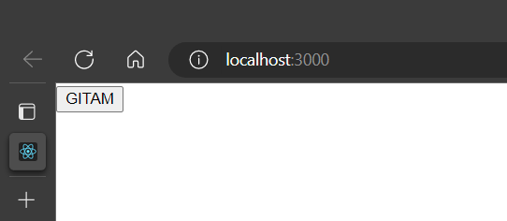

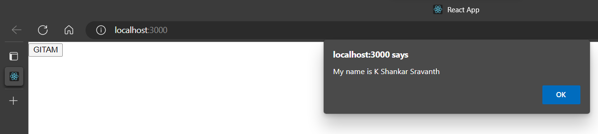

**Q3. In App.js, create a variable item, pass the value UNIVERSITY to that variable and print the value of that variable to the output screen two times by using the variable.**

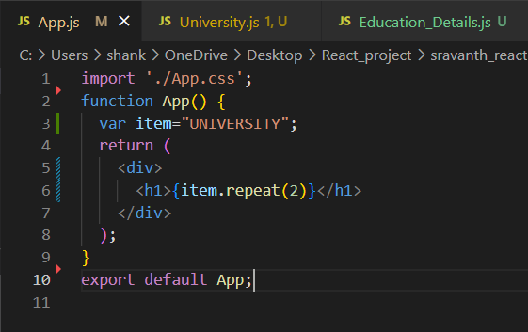

**OUTPUT:**

