REACT TRAINING DAY 4

K Shankar Sravanth

221910304024

CSE IV year

**State:** A state is a data container same as variable, whenever the value of the state is changed immediate effect will be there.

**Syntax: const(data, set data) = use data(“abc”);**

Data -> name of the variable

setData-> updating to the new value

useData -> to initialize starting value of the variable

State can be used in **both** functional component and class component.

In class component, if you want to use state concept, we need to have a constructor and in that constructor, we need to call super constructor and we need to access the variables with the help of ‘this’ keyword.

Declaration of a variable with related to state, in class component can be written as

**this.data={**

**data=1;**

**}**

‘this’ can be also declared as **this.state={ data=1;}**

**setState** is used to update the value of the present variable.

**Program to demonstrate the concept of variable without using state.**

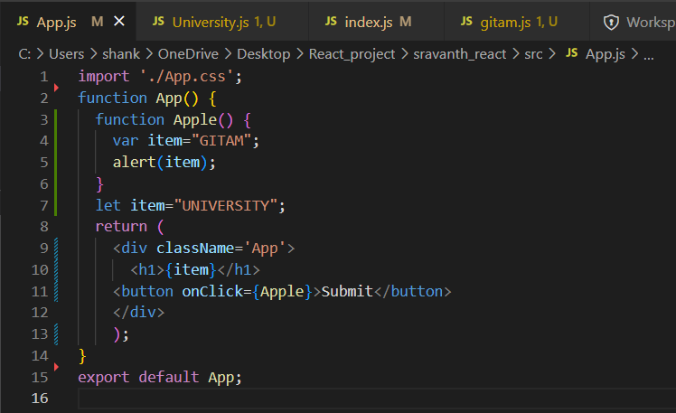

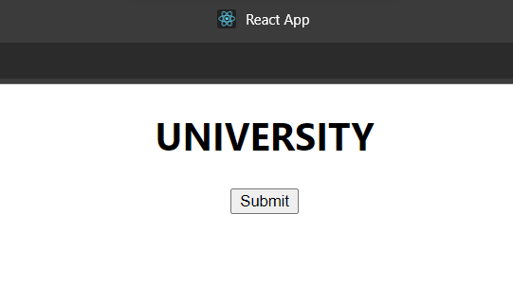

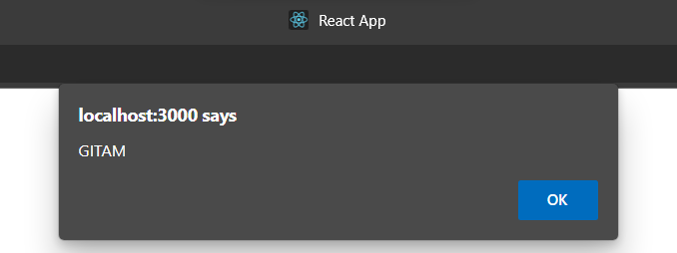

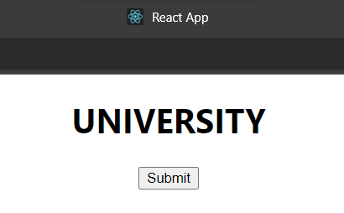

**Program to demonstrate the concept of state by using functional component**

**Code:**

import './App.css';

import { useState } from 'react';

function App() {

  const[item,setData] = useState("old")

  function update() {

    setData("new");

  }

  return (

    <div className='App'>

      <h1>{item}</h1>

    <button onClick={update}>Submit</button>

    </div>

    );

}

export default App;

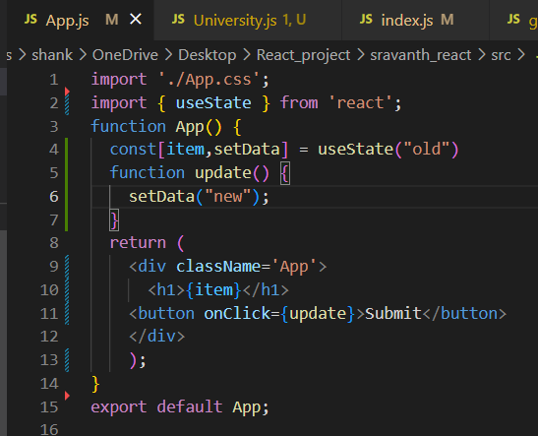

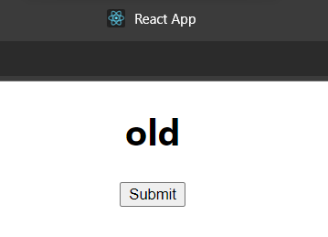

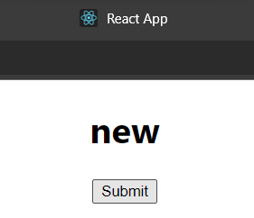

**Program to demonstrate the concept of state by using Class component.**

**Code:**

import './App.css';

import { useState } from 'react';

import React, {Component} from 'react'

class App extends Component {

  constructor() {

    super();

    this.state={

    data:1

    }

  }

update()

  {

    this.setState({data:this.state.data+1})

  }

  render() {

  return (

    <div className='App'>

      <h1>{this.state.data}</h1>

    <button onClick={()=>this.update()}>Submit</button>

    </div>

    );

  }

}

export default App;

**output:** before update

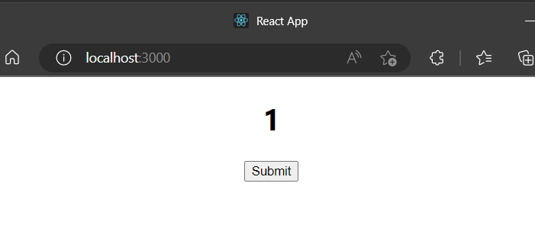

After 1 update:

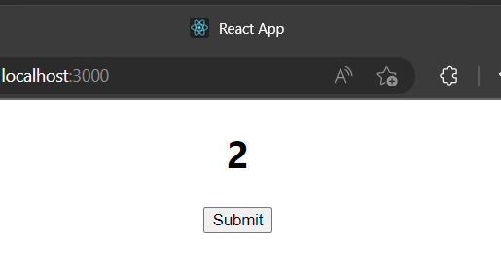

After some updates:

