REACT TRAINING DAY 5

K Shankar Sravanth

221910304024

CSE IV year

Program – In functional component, create one state called data. Initialize the value of the data as “GITAM”. Create a button “Click” whenever we click on button, the value of the data needs to be changed to “GITAM HYDERABAD”.

import './App.css';

import { useState } from 'react';

import React, {Component} from 'react'

import './App.css';

function App() {

  const[item,setData] = useState("GITAM")

  function update() {

    setData("GITAM HYDERABAD");

  }

  return (

    <div className='App'>

      <h1>{item}</h1>

    <button onClick={update}>Click</button>

    </div>

    );

}

export default App;

Output:

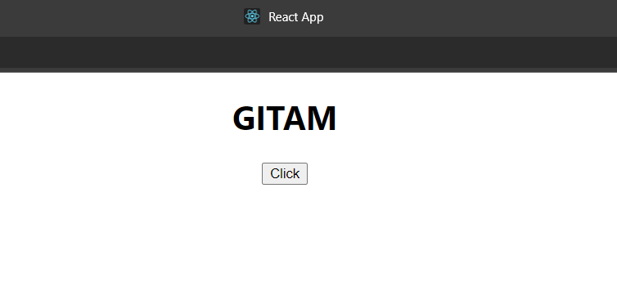



**Props:**

Also called as ‘arguments’

function App()

{

  return (

    <div>

      <h1>Props</h1>

      <Student Name={"sravanth"} email={"shankarsravanth2002@gmail.com"}/>

    </div>

  )

}

export default App;

Code: App.js

function App()

{

  return (

    <div>

      <h1>Props</h1>

      <Personals Name1={"Mahesh"} Name2={"Suresh"} MyName={"Sravanth"} Father_Name={"Narayana"} Mother_Name={"Parimala"}/>

    </div>

  )

}

export default App;

Personals.js :

import React from "react";

function Personals(Props)

{

    return(

        <div>

        <h1>Name : {Props.Name1}</h1>

        <h2>Name : {Props.Name2}</h2>

        <h2>Name : {Props.MyName}</h2>

        <h2>Name : {Props.Father_Name}</h2>

        <h2>Name : {Props.Mother_Name}</h2>

        </div>

    )

}

export default Personals;

Output:

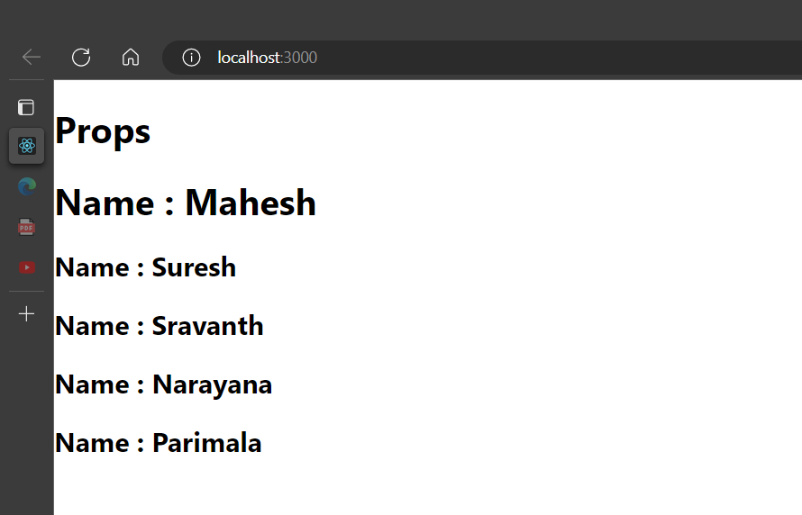

**Assignment:**

**1.Create a function called GITAM_YOURNAME and pass the Props as Surname, Mobile-Number, Father name.**

**Enter the minimum 10 values for the Props in App.js and Execute the application. This has to be done using Functional Component**

**App.js:**

//props with functional component

function App()

{

  return (

    <div>

      <h1>Student - Mobile - Father Name</h1>

      <GITAM_SRAVANTH Surname={"Kotra"} mobile={"7993534107"} Father_Name={"Narayana"}/>

      <GITAM_SRAVANTH Surname={"s1"} mobile={"7993534108"} Father_Name={"Narayan"}/>

      <GITAM_SRAVANTH Surname={"s2"} mobile={"7993534109"} Father_Name={"Naraya"}/>

      <GITAM_SRAVANTH Surname={"s3"} mobile={"7993534106"} Father_Name={"Naray"}/>

      <GITAM_SRAVANTH Surname={"s4"} mobile={"7993534105"} Father_Name={"Nara"}/>

      <GITAM_SRAVANTH Surname={"s5"} mobile={"7993534104"} Father_Name={"Anil"}/>

      <GITAM_SRAVANTH Surname={"s6"} mobile={"7993534103"} Father_Name={"Ramesh"}/>

      <GITAM_SRAVANTH Surname={"s7"} mobile={"7993534102"} Father_Name={"Shiva"}/>

      <GITAM_SRAVANTH Surname={"s8"} mobile={"7993534101"} Father_Name={"Ram"}/>

      <GITAM_SRAVANTH Surname={"s9"} mobile={"7993534100"} Father_Name={"Rohit"}/>

    </div>

  )

}

export default App;

**functional_props.js file:**

import React from "react";

function GITAM_SRAVANTH(Props)

{

    return(

        <div>

        <h2>Name : {Props.Surname}</h2>

        <h2>Name : {Props.mobile}</h2>

        <h2>Name : {Props.Father_Name}</h2>

        </div>

    )

}

export default GITAM_SRAVANTH;

**Output:**

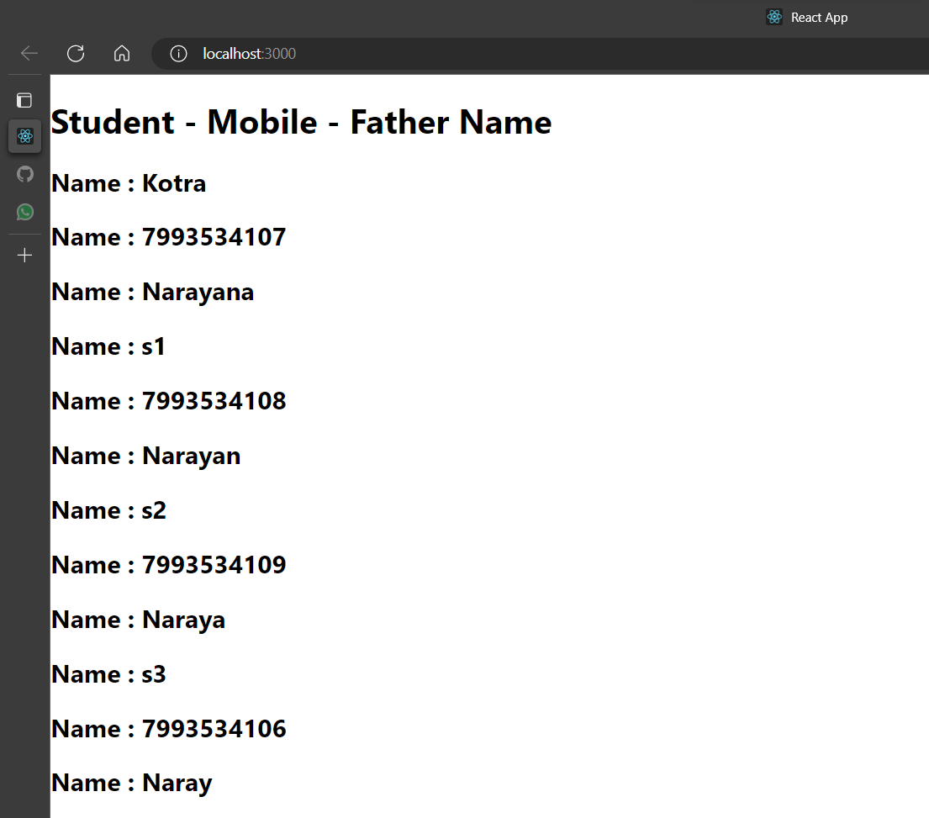

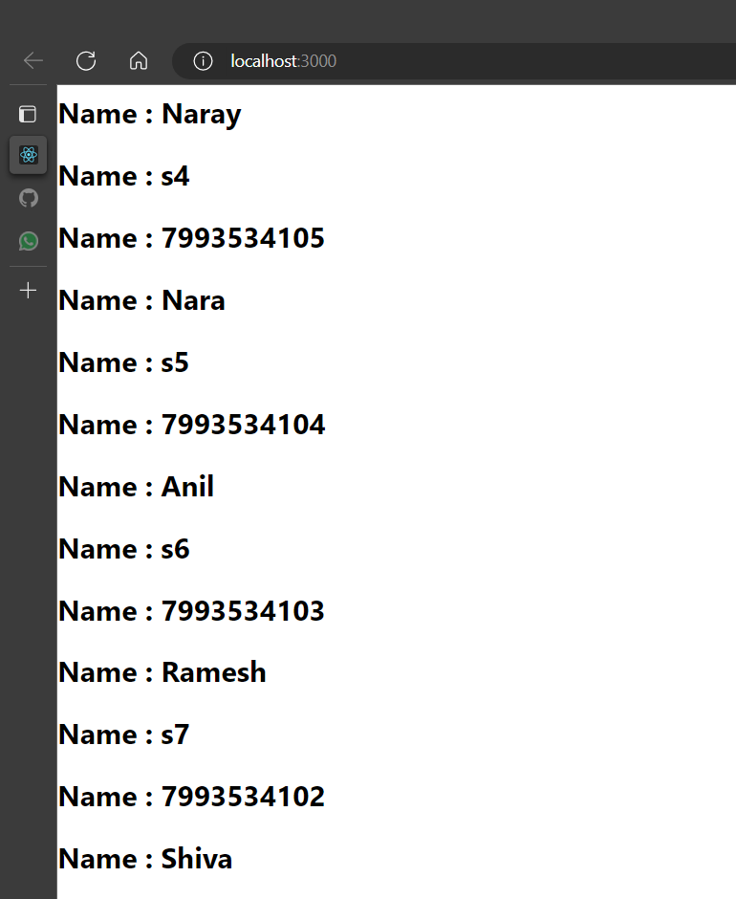

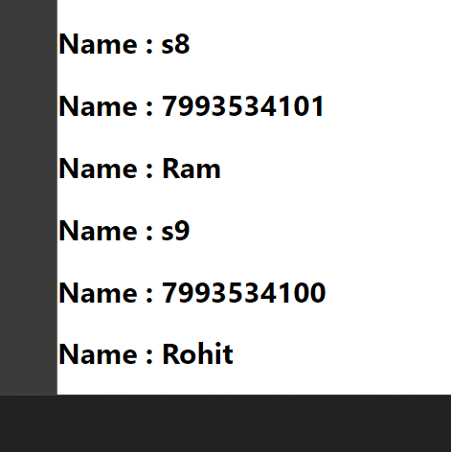

**2. Create a function called YOURNAME_GITAM and pass the Props as Surname, Mobile-Number, Father name .**

**Enter the minimum 10 values for the Props in App.js and Execute the application. This has to be done using Class Component.**

**Code:**

**App.js**

class App extends Component

{

      render()

      {

            return (

                  <div className='App'>

                        <h1>Props with class</h1>

                        <User Name1={"Shankar"} Name2={"Sravanth"}/>

                  </div>

            )

      }

}

export default App;

**User.js:**

import React,{Component} from 'react';

class User extends Component {

    render()

    {

        return (

            <div>

                <h1>Name: {this.props.Name1}</h1>

                <h2>Name: {this.props.Name2}</h2>

            </div>

        );

    }

}

export default User;

**Output:**

