REACT TRAINING DAY 6

K Shankar Sravanth

221910304024

CSE IV year

1. **Automate data to print from input**

function App(){

  const[data,setData]=useState(null)

  function getData(val){

    setData(val.target.value)

  }

  return (

    <div className='App'>

  <h1>{data}</h1>

  <input type="text" onChange={getData}/>

  </div>

  )

}

export default App;

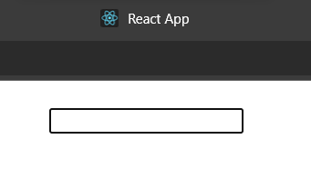

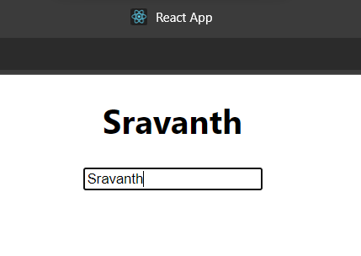

1. **Print data entered after clicking “print” button.**
2. function App(){
3. const[data,setData]=useState(null)
4. const[print,setPrint]=useState(false)
5. function getData(val)
6. {
7. setData(val.target.value)
8. }
9. return (
10. <div className='App'>
11. {
12. print?<h1>{data}</h1>:null
13. }
14. <input type="text" onChange={getData}/>
15. <button onClick={()=>setPrint(true)}>Print</button>
16. </div>
17. )
18. }
19. export default App;

Output:

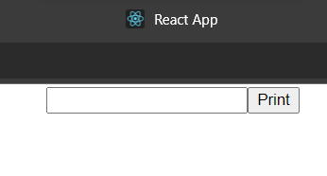

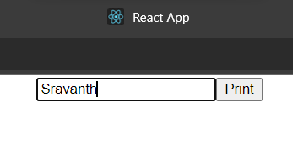

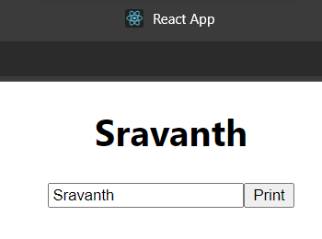

**3. Print and data whenever required and hide whenever not.**

function App()

{

  const[status,setStatus]=React.useState(false)

  return (

    <div className='App'>

      { status?<h1>Sravanth</h1>:null

}

      <button onClick={()=>setStatus(false)}>Hide</button>

      <button onClick={()=>setStatus(true)}>Show</button>

    </div>

  )

}

export default App;

Output:

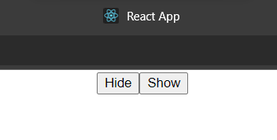

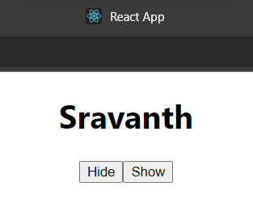

**Assignment:**

1. **Create a text field and create a button with the name "Print Your Name". Whenever, you are clicking on the button ,after clicking Your complete Name in the text field, That complete name should be displayed before the text field.**

**Code:** (App.js)

function App()

{

const[data,setData]=useState(null)

const[print,setPrint]=useState(false)

function getData(val)

{

setData(val.target.value)

}

return (

<div className="App">

{

print?

<h1>{data}</h1>

:null

}

<input type="text" onChange={getData}/>

<button onClick={()=>setPrint(true)}>Print Your name</button>

</div>

);

}

export default App;

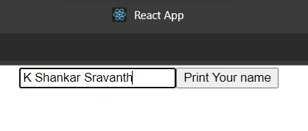

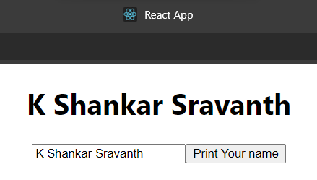

1. **Create two buttons called as Display and conceal. If you click on display, Your Complete Name should be displayed and if click on "conceal", Your Name should disappear.**

function App()

{

const[status,setStatus]=React.useState(false)

return (

<div className="App">

{

      status?<h1>K Shankar Sravanth</h1>:null}

<button onClick={()=>setStatus(false)}>Conceal</button>

<button onClick={()=>setStatus(true)}>Display</button>

</div>

)

}

export default App;

**Output:**

