REACT TRAINING DAY 7

K Shankar Sravanth

221910304024

CSE IV year

**Create a functional component called “your name.js”, create a state “CSE” in the functional component and assign the value “null”. In the declaration of state component, declare one more updated variable CSE1. If the value of CSE1 is true, print your name. if it is false, print your pin number.**

import React,{useState} from "react";

function Sravanth(){

    const[CSE,CSE1]= useState(false);

    return (

        <div>

            {

        CSE?<h1>Sravanth</h1>:<h1>221910304024</h1>

            }

        </div>

    );

}

 export default Sravanth;

**Output:**

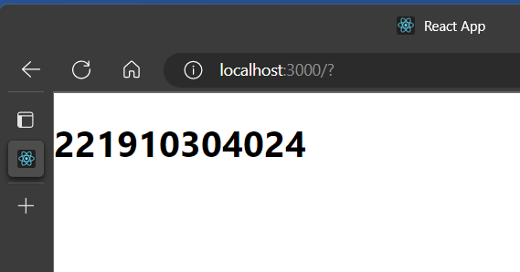

**Create a functional component, in that, declare a state CSE1 and assign the null value to CSE1. If the Value of CSE1 is 1, print your name, if CSE1=2, print pin number, if CSE1=3, print your surname, else print “Not found”.**

import React,{useState} from "react";

function Sravanth(){

    const[CSE,CSE1]= useState(4);

    return (

        <div>

            {

        CSE==1?<h1>{"Sravanth"}</h1>:CSE==2?<h1>{"221910304024"}</h1>:CSE==3?<h1>{"Kotra"}</h1>:CSE==4?<h1>{"Not found"}</h1>:null

            }

        </div>

    );

}

 export default Sravanth;

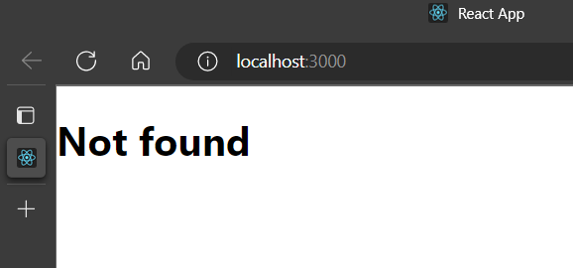

**Create a functional component, GITAM Hyd, in that, declare a state CSE1 and assign the null value to CSE1. If the Value of CSE1 is 1, print ECE, if CSE1=2, print Mechanical, for remaining print your name.**

import React,{useState} from "react";

function GitamHyd(){

    const[CSE1,setCSE1]= useState(2);

    return (

        <div>

            {

        CSE1==1?<h1>{"ECE"}</h1>:CSE1==2?<h1>{"Mechanical"}</h1>:CSE1>=3?<h1>{"Sravanth"}</h1>:null

            }

        </div>

    );

}

 export default GitamHyd;

**output:**

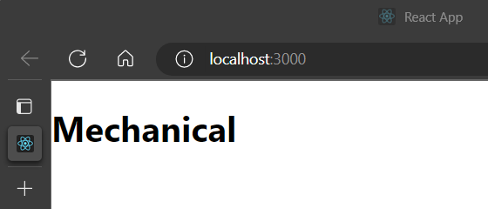

**Create a text field, whatever the input given to text field should display above the text field.**

function App()

{

    const[data,setData]=useState(null)

    function getData(val)

    {

        setData(val.target.value)

    }

    return (

        <div>

            <h1>{data}</h1>

            <input type="text" onChange={getData}></input>

        </div>

    )

}

export default App;

Output:

