REACT TRAINING DAY 9

K Shankar Sravanth

221910304024

CSE IV year

**Program to display name using class component and state:**

class App extends React.Component{

    constructor()

    {

    super();

    this.state={

        your_name:"Sravanth"

    }

    }

    render()

    {

       return (

        <div>

    <h1>Hello {this.state.your_name}</h1>

    </div>

    );

    }

    }

    export default App;

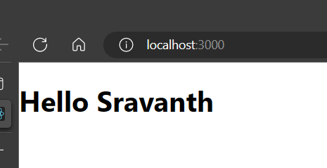

**React component life cycle**

It has 3 phases:

1. Mounting – creating a component class.
2. Updating - adding data
3. Unmounting – deleting data

With related to each and every phase, it contains some predefined methods. Each method will be meant for performing a specific task.

**React Hooks**

In the functional component, some of the functionalities of class component will not be performed. In order to perform the functionalities of class component in functional component, we have **React Hooks.** Some of the Hooks are

**useState, useEffect, useError.**

**useEffect:**

function App()

{

const[count,setCount]=useState(0);

useEffect(()=>{console.warn("Use Effect")})

return(

<div className="App">

<h1>{count}</h1>

<button onClick={()=>setCount(count+1)}>Update Counter</button>

</div>

);

}

export default App;

