Assignment

---------------

I am using python 2.7 and Django 1.11 for this project.

Approach

------------

I have created a project “techedison” and project directory consists of “log” app.

As the given data is in json, I am creating a models with the json object names which are “username”, ”event-type”, “time”, ”page”......etc. I have database.py file in where i am retrieving data from .txt file and pushing it into a database. Do to above step i am using Postgres database.

I have create a database “newdb” and in order to push data in database via database.py file, go to the project path in command prompt and enter the following command.

>database.py dummy

Once i have data in my database, I am creating a view where i am retrieving required data from database and passing it to the template.

I have also used Chart.js in order to represent the data in graph view.

Once database is populated we can run the app via command prompt, move to you project directory and enter following command.

>python manage.py runserver

Once that is done you can run the app in browser with the following url

><http://127.0.0.1:8000/log/name/>

Screenshots :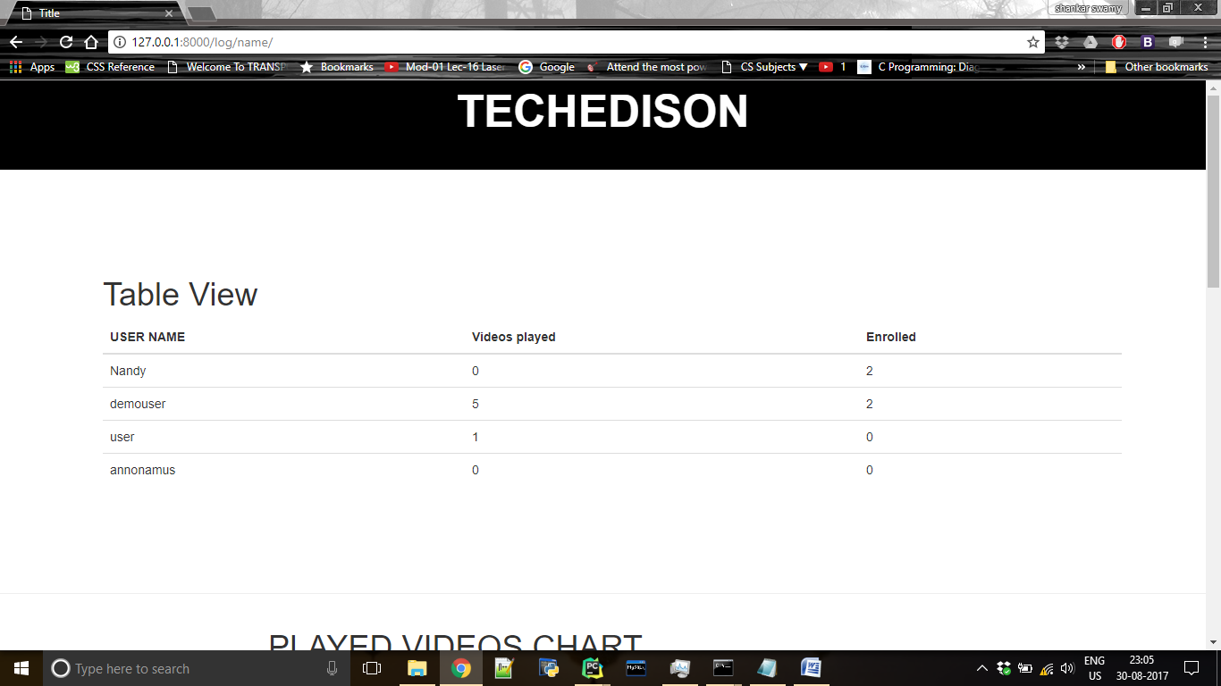

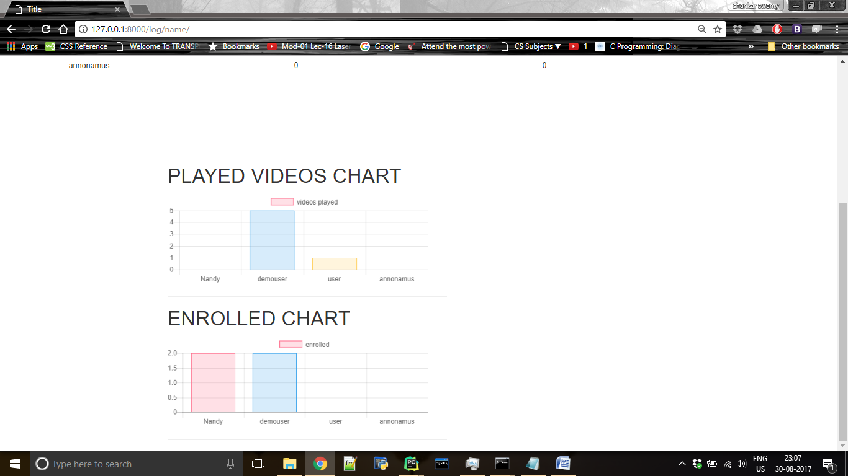

If there is any mistake please inform me.

Thank you

Shankar swamy