A First Project Final Report on

**College Engagement Portal**

Submitted in Partial Fulfillment of the Requirements for the

Degree of **Bachelor of Engineering in Information Technology**

Under **Pokhara University**

Submitted By:

**Shanker Pangeni 201549**

**Pradeep Bhatt 201540**

**Bimarsha Uprety 201550**

Under the supervision of

**Dr. Roshan Chitrakar**

Date:

2 Aug 2023

**Department of Computer Engineering**

**NEPAL COLLEGE OF**

**INFORMATION TECHNOLOGY**

Balkumari, Lalitpur, Nepal.



**ACKNOWLEDGEMENT**

First and foremost, we would like to express our gratitude to the Department of Information & Technology at the Nepal College of Information Technology for accepting our project proposal for the "Student Engagement Portal" and giving us the chance to complete the task. For us, it has been a pleasure to recognize the help and efforts that were crucial and helpful throughout the project.

We especially thank Dr.Roshan Chitrakar, our project coordinator, for his assistance and insightful advice throughout this process. Throughout the era of doubts and uncertainty, it was his constant inspiration and direction that allowed us to continue with this endeavor.

Last but not least, it would be unfair on our part if we did not extend our sincere gratitude to all of the department's staff members and friends for sharing their excellent collection of materials, engaging in discussion about our ideas, and providing one another with technical support. We want to express our profound gratitude to each and every one of them and hope to continue receiving their knowledgeable assistance in the future.

**ABSTRACT**

College Engagement Portal is a web-based system that allows us to efficiently manage student records and increase engagement between college and student. It can be used by schools/colleges to keep track of student’s records. This system effectively helps administration to store, edit and analyze the record of a student and the activities of student in college premises. It also provides the security restriction as it asks for username and password to access the student’s information. Once this management application is opened, it will open in home page where user can see the facillities and utilities provided in it . Inorder to give any input in this web page first the user have to login if they are already signup ,if not they have to register their account. This web-based application can be accessed by either admin or student. Once it is accessed by administration, the record of the student can be added, edited and deleted. And student can view their profile through student login and take part in college activities , see notice of college etc.

**Table of Contents**

1. Introduction 1

1.1. Problem Statement 1

1.2. Project Objectives 1

1.3. Significance of Study 1

2. Scope and Limitations 2

2.1. Scope 2

2.2. Limitations 2-

3. Literature Study/Review 3

4. Methodology 4

4.1. Software Development Life Cycle 4

4.2. Use Case Model 6

4.3. Tools and Technologies used in the Development of Project 7

5. Conclusion 10

6. Further Works 11

7. REFERENCES 12

**List of Figures**

Figure 1: Incremental Model……………………………………………………………………...4

Figure 2: Use Case Model………………………………………………………………………...7

Figure 3: Page to select student or admin login…………………………………………………..9

Figure 4 : Admin login…………………………………………………………………………....9

Figure 5: Admin dashboard……………………………………………………….……………..10

Figure 6 : Student dashboard…………………………………………………………………….10

**List of Tables**

Table 1: Tools and Technologies used in the development of project……………………………8

# Introduction

In today's rapidly evolving digital age, it is imperative for educational institutions to adapt and harness the power of technology to enhance communication, engagement, and collaboration between colleges and their students. We are delighted to present a project proposal that aims to create a comprehensive College Engagement Portal, revolutionizing the way students interact with their academic environment, college programs, and stay updated on important college activities and notices.

The proposed College Engagement Portal will serve as a centralized platform, offering students easy access to a wide range of features and functionalities that will streamline their academic journey and provide a seamless college experience. By leveraging modern technology, this portal will bridge the gap between students and the college administration, fostering a vibrant, interactive, and efficient learning environment.

This project proposal aims to analyze the existing data management practices within our college and identify areas that can benefit from a centralized and automated DBMS. The proposed system will incorporate essential features such as data entry, storage, retrieval, and analysis, ensuring the integrity, security, and availability of information at all times.

The College Engagement Portal project aims to revolutionize the way colleges interact with students, promoting academic excellence, student engagement, and a vibrant campus community. By leveraging modern technology, this platform will empower students to take ownership of their education, access resources efficiently, participate actively in college programs, and stay informed about important notices and updates. Through this project, we envision an inclusive and collaborative college environment that nurtures student growth, fosters academic achievement, and prepares students for success in their future endeavors

Together, let us embark on this exciting journey of transforming our college experience through technology, making education more accessible, engaging, and empowering for all students.

## Problem Statement

1. The current communication channels between the college administration and students are disjointed, leading to inefficiencies, delays, and missed opportunities for important information dissemination.
2. Planning and managing college events, such as workshops, seminars, and cultural activities, can be a cumbersome task due to manual processes and limited visibility.

## Project Objectives

## To create a centralized platform that facilitates seamless communication and information sharing between the college administration and students.

## To promote active student engagement and participation within the college community.

## Significance of Study

1. Enhancing Communication between Students and Administration
2. Improving Students Experience and Engagement in college activities.
3. Improving Administrative Processes and Efficiency

# Scope and Limitations

## Scope

1. Development of a comprehensive platform that facilitates efficient management and dissemination of information and communication between the college administration, faculty, and students.
2. Creating a platform that promotes active student engagement and participation within the college community.

## Limitations

* No backup in case of data loss
* The risk of data mishandling
* Specific information regarding the student cannot be searched
* Minor technical glitches and issues

# Literature Study/Review

Web based College Engagement Portal allows one to manage and operate various operations like create, retrieve, update and delete as well as take part in various college activities as well as get notified of events happening. This system eradicates the traditional file system, or we can say the ledger system. These kinds of traditional database management system is prone to various risks like:

* Fire hazard,
* Water hazard,
* Weathering hazard and many more.

The electronic web based management system helps avoiding all those risks by making the various database backup, making use of distributed database system and so on.

# Methodology

The developed project is constructed using HTML, CSS, JavaScript, PHP and MySQL.

## Software Development Life Cycle

The framework of this project software development is done on the basis of Incremental Model. Incremental Model is a process of software development where requirements are divided into multiple standalone modules of the software development cycle. In this model, each module goes through the requirements, design, implementation and testing phases. Every subsequent release of the module adds function to the previous release. The process continues until the complete system is achieved.

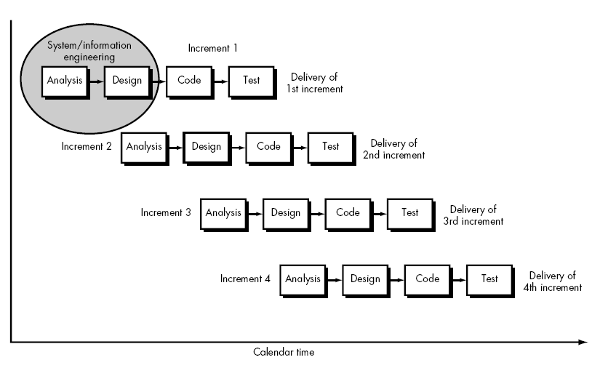

Fig: Incremental Model

**Analysis phase**

Analysis will be performed in order to find out the requirements of the system in this phase. The type of technology implemented in the system is not defined in this phase.

**Design phase**

The technical details of the product are defined in this phase. Depending on the project ER-Diagram, use case diagram and system design is created in this phase.

**Coding phase**

In this phase, coding will be done according to the design and a working system will be developed by the end of this process.

**Testing phase**

In this phase, the system will be tested to identify and list out the required changes in the system and remove any possible bugs as well as.

## Use Case Model

Currently, only admin and students can access this system where admin is responsible for managing student records and students can only view their information.

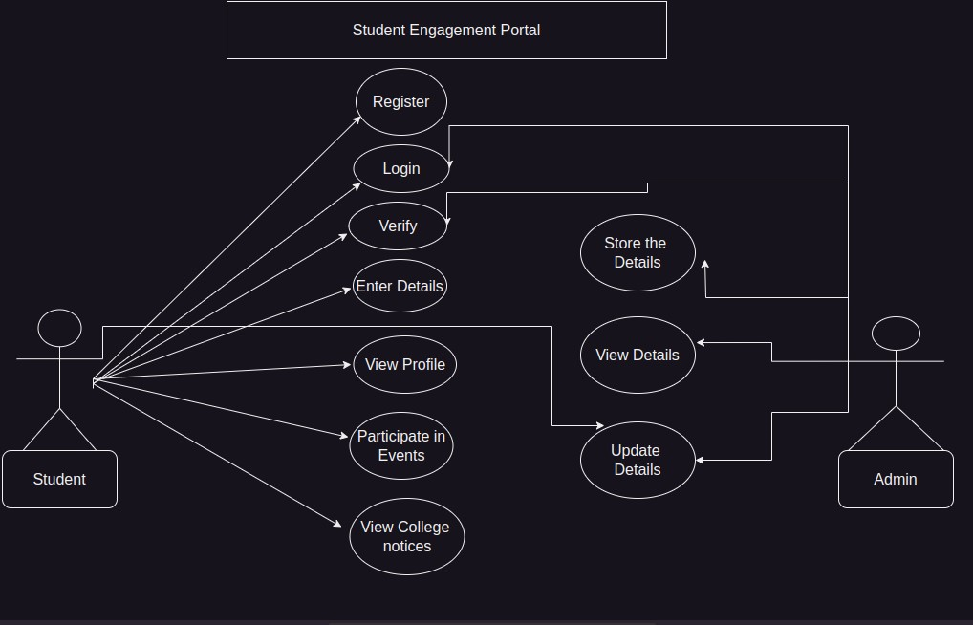

## Tools and Technologies used in the Development of Project

|  |  |
| --- | --- |
| HTML, CSS, JavaScript | Front-end |
| MySQL, PHP | Back-end |
| Microsoft Word | Documentation |
| XAMPP | Local Host |
| Microsoft Windows | Operating System |

**Page to select student or admin login**

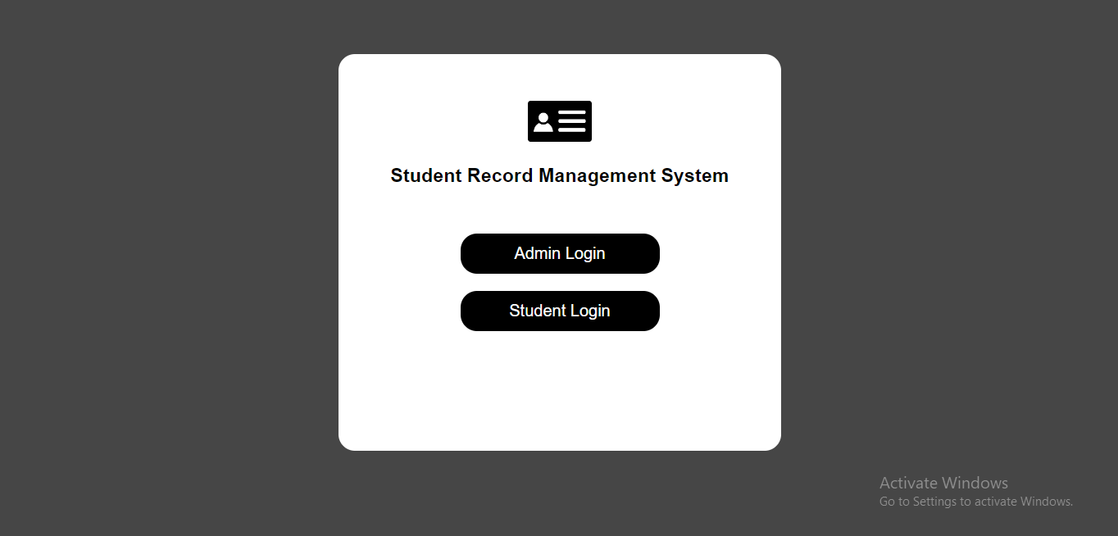

**Admin Login**

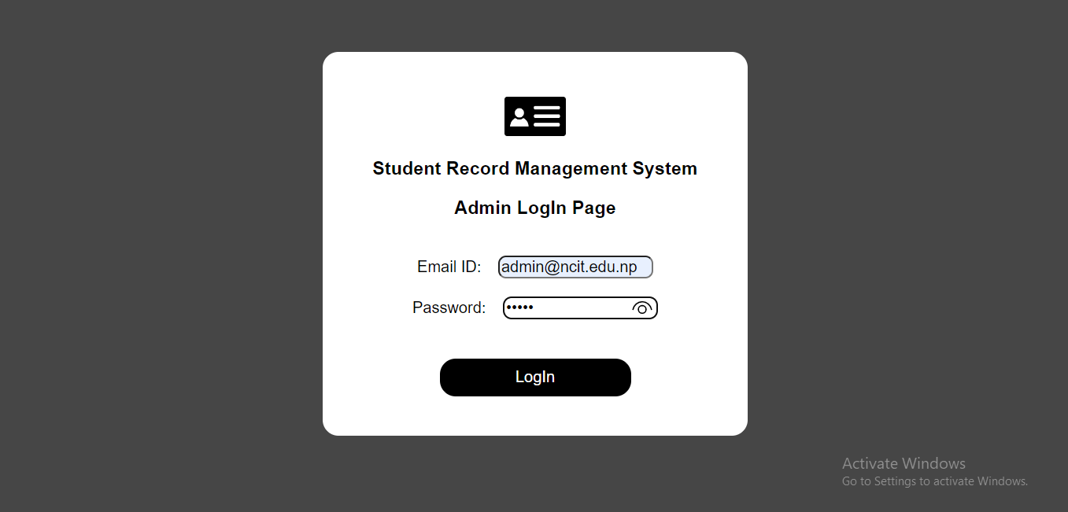

**Admin Dashboard**

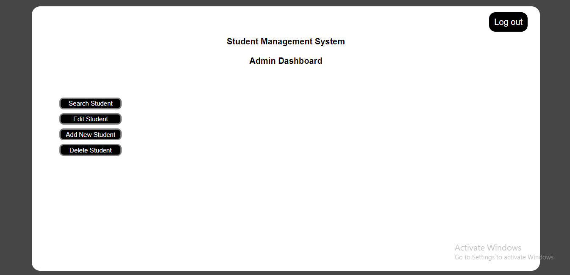

**Student Dashboard**

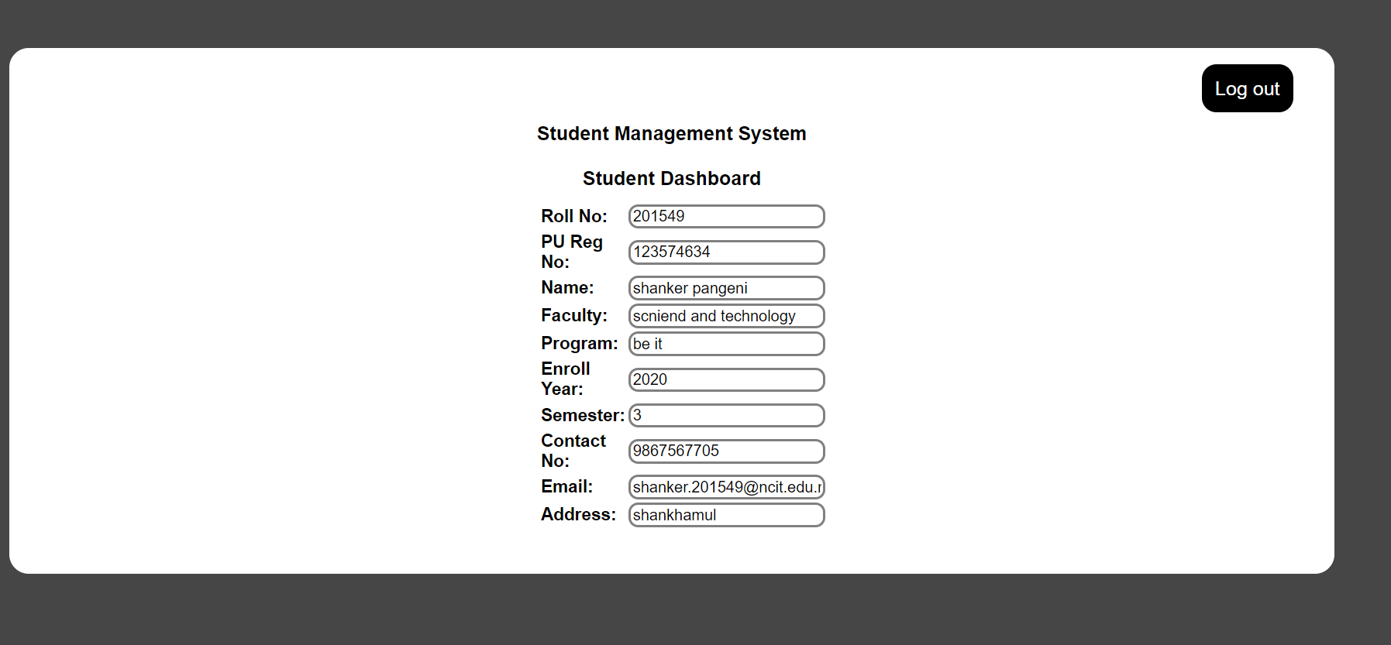

# Conclusion

When the population of students in a school is less than a hundred, the manual approach works perfectly, but it is not the best technique of handling student records. Manual and disintegrated electronic systems have numerous disadvantages because these methods of capturing and managing data about students are prone to data inconsistency, data redundancy, difficult to update and maintain data, bad security, difficult to impose constraints on various data files, and difficult to backup.

An integrated student database system offers practical answers to challenges associated with manual systems. To analyze the success of the school and pupils over time, prior records of students with no missing data must be used. The integrated student database system, which captures and retains longitudinal data on students, would give present and past students with accurate and reliable data. Because of the attention used in developing it, the system is error-free, very efficient, and takes less time. All parts of the software development cycle are used, and it is worth noting that the system is extremely robust. The system is designed to accommodate future growth.

# Further Works

The scope of this project only addresses a tiny portion of the student information system because the student database system is so vast, and the time allotted for completion of the project is insufficient.

Students who want to construct databases should be encouraged to work on other aspects of student information systems so that they may link all the relevant databases that are now available.

Anyone who want to complete a project on a related subject may find this report to be helpful.

# REFERENCES

[www.google.com](http://www.google.com/)

<https://www.w3schools.com/php/>

<https://lms.ncit.edu.np/>

<https://youtu.be/1SnPKhCdlsU>