KPR INSTITUTE OF ENGINEERING AND TECHNOLOGY
(Autonomous Institution, Affiliated to Anna University, Chennai)
Coimbatore – 641 407
DEPARTMENT OF COMPUTER SCIENCE AND ENGINEERING

U21CS501 – WEB TECHNOLOGY
ASSIGNMENT II
STUDENT ADMISSION PORTAL WITH REGISTRATION, STUDENT MANAGEMENT AND STUDENT PROFILE VIEWING SYSTEM

Submitted by
Student Name | Mohammed Ihsan I
Roll Number | 24CS120
Department | Computer Science and Engineering
Course Code & Title | U21CS501 – Web Technology
Assignment | Assignment II
Academic Year | 2026–2027
Maximum Marks | 40

Signature of the Student Signature of the Course Faculty
TABLE OF CONTENTS

S.No. | Title
1 | Assignment Objectives and General Project Structure
2 | Project Folder Structure
3 | Question 1 – HTML, CSS and JavaScript Student Registration Form
4 | Question 2 – PHP and MySQL Student Management System
5 | Question 3 – Servlet, JSP, JDBC and MySQL Student Portal
6 | Overall Testing and Results Summary
7 | Submission Requirements
8 | Conclusion
9 | GitHub Repository

List of Figures
Figure | Caption
1.1 | Student Registration Form
1.2 | Validation Error Messages
1.3 | Profile Image Preview
1.4 | Successful Form Submission
1.5 | Responsive Mobile View
2.1 | Student Directory Table
2.2 | Add Student Form
2.3 | File Upload Interface
2.4 | Student Profile View
2.5 | Edit Student Form
2.6 | Delete Student Operation
2.7 | Search Student Result
3.1 | Login Page
3.2 | Invalid Login Warning
3.3 | Student Dashboard
3.4 | Student List Rendered by JSP
3.5 | Dynamic Student Profile Rendering
3.6 | Document Streaming Output

1. ASSIGNMENT OBJECTIVES AND GENERAL PROJECT STRUCTURE

1.1 Introduction
Admission to an engineering college involves the collection of a large amount of personal information and supporting documents from every applicant. In many institutions this process is still carried out with printed application forms and photocopies of certificates. Such a manual system is slow, difficult to search, prone to data entry errors and requires considerable physical storage space. A web-based admission portal addresses these problems by allowing applicants to submit their details online and by allowing administrators to maintain, search and verify the records from a central database.
This assignment presents the design and implementation of a Student Admission Portal with Registration, Student Management and Student Profile Viewing System. The work is divided into three questions, each of which concentrates on a different web technology. Question 1 develops the client-side registration interface using HTML5, CSS3 and Vanilla JavaScript. Question 2 implements the server-side student management system using PHP and MySQL. Question 3 builds an administrative student portal using Java Servlets, JSP and JDBC deployed on Apache Tomcat. All three modules operate on a single MySQL database named student_portal, which demonstrates how different server technologies can share the same data layer.

1.2 Objectives of the Assignment
- To design a neat, responsive and user-friendly student registration form using semantic HTML5 elements and CSS3 styling.
- To perform client-side validation of every input field using JavaScript regular expressions before the form is submitted.
- To design a normalised relational database with primary keys, unique constraints and foreign keys for storing student details and uploaded file metadata.
- To implement Create, Read, Update, Delete and Search (CRUD) operations on student records using PHP and the mysqli extension.
- To upload profile images and certificates securely by restricting file type and size and by preventing overwriting through timestamp-based file names.
- To connect a Java web application to MySQL using JDBC and to organise the code using Model, DAO and Servlet layers.
- To restrict access to administrative pages using HTTP sessions, and to implement login and logout functionality.
- To render student photographs and stream uploaded documents dynamically through a dedicated Servlet.

1.3 General Project Structure
The complete project follows a three-tier architecture consisting of a presentation tier, an application tier and a data tier. The presentation tier is the web browser, which displays HTML pages styled with CSS and executes the JavaScript validation code. The application tier contains two independent server-side applications: the PHP application executed by the Apache web server of XAMPP, and the Java web application executed by Apache Tomcat. The data tier is the MySQL database server together with the uploads directory in which the physical files are stored.
Tier | Component | Technology Used | Responsibility
Presentation | Web Browser | HTML5, CSS3, JavaScript | Displays forms and tables, validates input on the client side
Application (Q2) | Apache + PHP | PHP 8, mysqli | CRUD operations, server-side validation, file upload handling
Application (Q3) | Apache Tomcat 9 | Servlet, JSP, JDBC | Login, session handling, profile rendering, file streaming
Data | MySQL Server | MySQL 8 / MariaDB | Stores students, file metadata and admin accounts
Storage | File System | uploads/images, uploads/documents | Stores the actual image and PDF files

1.4 Software and Hardware Requirements
Category | Requirement
Operating System | Windows 10 / 11 (64-bit)
Web Server and Database | XAMPP 8.x (Apache 2.4, PHP 8.x, MySQL / MariaDB)
Java Development Kit | JDK 11 or above
Servlet Container | Apache Tomcat 9.0
JDBC Driver | MySQL Connector/J 8.x
IDE / Editor | Eclipse IDE for Enterprise Java, Visual Studio Code
Browser | Google Chrome / Microsoft Edge / Mozilla Firefox
Processor and Memory | Intel Core i3 or above, minimum 4 GB RAM (8 GB recommended)
Storage | Minimum 2 GB of free disk space

2. PROJECT FOLDER STRUCTURE
The source code has been organised into separate folders for each question so that every module can be evaluated and executed independently. The database script and the documentation are kept in their own folders. The complete folder structure of the project is shown below.
StudentAdmissionPortal/
│
├── README.md
├── Frontend/ (Question 1)
│ ├── index.html Student Registration Form
│ ├── style.css Common stylesheet
│ └── script.js Client-side validation
│
├── PHP/ (Question 2)
│ ├── index.php Redirects to student list
│ ├── db.php Connection, settings, helper functions
│ ├── header.php / footer.php Common page layout
│ ├── add_student.php Registration form (server version)
│ ├── insert_student.php Validates and inserts a student
│ ├── view_students.php Student directory and search
│ ├── edit_student.php Edit form
│ ├── update_student.php Validates and updates a student
│ ├── delete_student.php Deletes a student and files
│ ├── upload_file.php Uploads additional documents
│ ├── student_details.php Profile and uploaded files
│ └── uploads/
│ ├── .htaccess Blocks script execution
│ ├── images/ jpg, jpeg, png files
│ └── documents/ pdf files
│
├── Servlet/StudentPortalServlet/ (Question 3)
│ ├── src/com/studentportal/
│ │ ├── util/ DBConnection.java, SessionUtil.java
│ │ ├── model/ Admin.java, Student.java, StudentFile.java
│ │ ├── dao/ AdminDAO.java, StudentDAO.java, StudentFileDAO.java
│ │ └── servlet/ LoginServlet, LogoutServlet, DashboardServlet,
│ │ StudentListServlet, StudentProfileServlet, FileServlet
│ └── WebContent/
│ ├── login.jsp, error.jsp, css/style.css
│ └── WEB-INF/
│ ├── web.xml
│ ├── lib/ mysql-connector-j-8.x.jar
│ └── views/ dashboard.jsp, student_list.jsp, student_profile.jsp,
│ header.jspf, footer.jspf
│
├── Database/
│ └── student_portal.sql Database, tables, keys, sample data
│
└── Documentation/
└── Project_Report.md

The Frontend folder contains the static registration page. The stylesheet and script in this folder are reused by the PHP pages, which keeps the appearance of both modules consistent and avoids duplication of code. The PHP folder contains one file for each operation, and the uploads directory is placed inside it so that uploaded files can be served directly by Apache. The Servlet project follows the standard Eclipse Dynamic Web Project layout, in which the Java source files are kept in src and the web resources are kept in WebContent. The JSP view pages are placed inside WEB-INF/views, which cannot be accessed directly from the browser.

3. QUESTION 1 – HTML, CSS AND JAVASCRIPT STUDENT REGISTRATION FORM

3.1 Scenario
A college wishes to replace its paper application form with an online registration page. The page must collect the student name, roll number, e-mail address, password, course, mobile number, gender, address, profile photograph and certificate. Since incorrect data at this stage leads to problems in every later stage of admission, the page must validate each field in the browser itself and display clear error messages before the data is sent to the server. The page must also work correctly on desktop computers, tablets and mobile phones.

3.2 Objectives
- To build a registration form using HTML5 form controls such as text boxes, password field, drop-down list, radio buttons, text area and file inputs.
- To style the form as a centred card with a simple header and footer using CSS3.
- To make the layout responsive using CSS media queries.
- To validate required fields, e-mail format, password strength, mobile number, roll number format, file type and file size using JavaScript.
- To show a live preview of the selected profile image before upload.

3.3 Project Structure
File | Purpose
Frontend/index.html | Contains the complete registration form, header, navigation bar and footer.
Frontend/style.css | Defines the colour scheme, card layout, form controls, buttons, error messages, tables and media queries.
Frontend/script.js | Contains the validation rules, error display functions, image preview and reset handling.

3.4 Implementation Details
The registration page is a single HTML document. When the user presses the Submit button, the browser calls the JavaScript function validateForm(). The function checks every field one by one, displays an error message below each invalid field and returns false if any error is found, which prevents the form from being submitted. Only when all the fields are valid does the function return true, after which the browser sends the data to ../PHP/insert_student.php using the HTTP POST method.

3.4.1 HTML Form Structure
The form element is declared with three important attributes. The method="post" attribute sends the data in the body of the request rather than in the URL. The enctype="multipart/form-data" attribute is mandatory for file uploads, because without it the browser sends only the file name and not the content of the file. The novalidate attribute disables the default browser pop-ups so that the custom error messages written in JavaScript are displayed instead.
Code Snippet 1.1 – Form declaration and a sample field (index.html)
<form name="registrationForm" action="../PHP/insert_student.php" method="post"
enctype="multipart/form-data" onsubmit="return validateForm('add')"
onreset="return resetForm()" novalidate>

<!-- 1. Student Name -->
<div class="form-group">
<label for="name">Student Name <span class="required">*</span></label>
<input type="text" id="name" name="name" maxlength="100"
placeholder="Enter full name">
<span class="error" id="err_name"></span>
</div>

Every field is wrapped in a div with the class form-group, which contains a label, the input control and an empty span element with the class error. The identifier of each error span is formed by adding the prefix err_ to the identifier of the field, which allows a single JavaScript function to locate the correct span for any field. The gender options are implemented as radio buttons with the same name attribute so that only one option can be selected, and the course is implemented as a drop-down list.
Code Snippet 1.2 – Radio buttons and file input (index.html)
<!-- 7. Gender Radio Buttons -->
<div class="radio-group">
<label><input type="radio" name="gender" value="Male"> Male</label>
<label><input type="radio" name="gender" value="Female"> Female</label>
<label><input type="radio" name="gender" value="Other"> Other</label>
</div>

<!-- 9. Profile Image Upload -->
<input type="file" id="profile_image" name="profile_image"
accept=".jpg,.jpeg,.png" onchange="previewImage(this, 'imagePreview')">
<img id="imagePreview" class="preview-img" src="" alt="Image preview">

The accept attribute of the file inputs restricts the file chooser dialog to the permitted extensions. However, this attribute can be bypassed by the user, and therefore the extension and size are checked again in JavaScript and once more on the server.
S.No. | Field | HTML Control | Validation Applied
1 | Student Name | input type="text" | Required, letters and spaces only, minimum 3 characters
2 | Roll Number | input type="text" | Required, format YY + DEPT + 3 digits (e.g. 24CS120)
3 | Email | input type="email" | Required, valid e-mail format
4 | Password | input type="password" | Minimum 8 characters, one uppercase, one lowercase, one digit
5 | Course | select | A course must be selected
6 | Mobile Number | input type="text" | Exactly 10 digits
7 | Gender | input type="radio" | One option must be selected
8 | Address | textarea | Required, minimum 10 characters
9 | Profile Image | input type="file" | JPG, JPEG or PNG only, maximum 2 MB
10 | Certificate | input type="file" | PDF, JPG, JPEG or PNG only, maximum 2 MB
11 | Submit | input type="submit" | Triggers validateForm()
12 | Reset | input type="reset" | Clears the form and the error messages

3.4.2 CSS Styling
The visual design uses a restrained colour scheme of blue, white and grey, which is suitable for an academic institution. The page background is light grey, the header and footer are blue, and the form is placed inside a white card with a thin border, rounded corners and a soft shadow. The card is limited to a maximum width of 650 pixels and is centred horizontally using automatic margins.
Code Snippet 1.3 – Card container and error styles (style.css)
.card {
background-color: #ffffff;
border: 1px solid #d9dee5;
border-radius: 6px;
box-shadow: 0 2px 6px rgba(0, 0, 0, 0.08);
padding: 25px 30px;
margin: 0 auto 25px auto; /* centres the card */
}
.form-card { max-width: 650px; }

/* Red border added by JavaScript when a field is invalid */
.input-error { border-color: #c62828 !important; }

.error {
display: block;
color: #c62828;
font-size: 13px;
margin-top: 4px;
}

Input fields, drop-down lists and text areas share a common style with full width, internal padding and a grey border. When a field receives focus its border changes to blue, which helps the user to identify the active field. Error messages are displayed in red text directly below the related field, and the invalid field itself receives the class input-error, which changes its border to red. Buttons are styled in three variants: a blue primary button for Submit, a grey secondary button for Reset and a red button for Delete operations used in Question 2.

3.4.3 Responsive Design
The page is made responsive using the viewport meta tag together with two CSS media queries. The viewport meta tag instructs mobile browsers to use the actual device width instead of a zoomed-out desktop width. The first media query applies to screens up to 768 pixels wide (tablets) and reduces the padding of the card. The second media query applies to screens up to 480 pixels wide (mobile phones), where the navigation links are stacked vertically, the buttons occupy the full width of the screen and the radio buttons are displayed one below another.
Code Snippet 1.4 – Viewport meta tag and media queries
<meta name="viewport" content="width=device-width, initial-scale=1.0">

@media (max-width: 768px) {
.card { padding: 20px; }
.profile-layout { flex-direction: column; align-items: center; }
}

@media (max-width: 480px) {
.nav-bar a { display: block; margin: 2px 0; }
.button-row .btn { display: block; width: 100%; margin: 8px 0; }
.radio-group label { display: block; }
}

3.4.4 JavaScript Validation Rules
All the validation rules are defined at the beginning of script.js as regular expression constants. Keeping the rules in one place makes them easy to read and modify. The same patterns are repeated on the server in PHP so that both layers apply identical rules.
Code Snippet 1.5 – Validation rules (script.js)
var NAME_PATTERN = /^[A-Za-z][A-Za-z .]{2,99}$/;
var ROLL_PATTERN = /^[0-9]{2}[A-Z]{2,4}[0-9]{3}$/; // e.g. 24CS120
var EMAIL_PATTERN = /^[^\s@]+@[^\s@]+\.[A-Za-z]{2,}$/;
var PASSWORD_PATTERN = /^(?=.*[a-z])(?=.*[A-Z])(?=.*[0-9]).{8,}$/;
var MOBILE_PATTERN = /^[0-9]{10}$/;

var MAX_FILE_SIZE = 2 * 1024 * 1024; // 2 MB
var IMAGE_EXTENSIONS = ["jpg", "jpeg", "png"];
var DOCUMENT_EXTENSIONS = ["jpg", "jpeg", "png", "pdf"];

The password pattern uses three positive look-ahead groups. The expression (?=.*[a-z]) confirms the presence of at least one lowercase letter, (?=.*[A-Z]) confirms at least one uppercase letter and (?=.*[0-9]) confirms at least one digit, while .{8,} enforces the minimum length of eight characters. The roll number pattern accepts a two-digit year, a department code of two to four capital letters and a three-digit serial number.
File validation is performed by the function checkFile(). The function reads the selected file through the files property of the input element, extracts the extension from the file name and compares it with the list of permitted extensions. It then compares the size property of the file, which is expressed in bytes, with the 2 MB limit.
Code Snippet 1.6 – File type and size validation (script.js)
function checkFile(fieldId, allowedExtensions, isRequired) {
var input = document.getElementById(fieldId);
if (input.files.length === 0) {
return isRequired ? "Please choose a file." : "";
}
var file = input.files[0];
var ext = getExtension(file.name);

// File type validation
if (allowedExtensions.indexOf(ext) === -1) {
return "Only " + allowedExtensions.join(", ").toUpperCase() + " files are allowed.";
}
// File size validation
if (file.size > MAX_FILE_SIZE) {
return "File size must not exceed 2 MB.";
}
return "";
}

The main function validateForm() first clears the previous messages and then evaluates each field. Whenever a rule fails, the function showError() writes the message into the corresponding error span and marks the field in red. A boolean variable isValid records whether any error has occurred, and its value is returned to the onsubmit handler of the form.
Code Snippet 1.7 – Extract from validateForm() (script.js)
// 6. Mobile number
var mobile = document.getElementById("mobile").value.trim();
if (mobile === "") {
showError("mobile", "Mobile number is required.");
isValid = false;
} else if (!MOBILE_PATTERN.test(mobile)) {
showError("mobile", "Mobile number must contain exactly 10 digits.");
isValid = false;
}

// 7. Gender radio buttons - at least one must be checked
var genderChecked = document.querySelector('input[name="gender"]:checked');
if (!genderChecked) {
document.getElementById("err_gender").innerHTML = "Please select gender.";
isValid = false;
}

In addition to validation, the script provides an image preview. When a profile photograph is selected, the previewImage() function reads the file with the FileReader object and assigns the resulting data URL to an img element, so the student can confirm that the correct photograph has been chosen before submitting the form.

3.5 Testing
The registration form was tested with valid and invalid inputs for every field. The results are recorded in Table 3.1.
Table 3.1 – Test cases for Question 1
TC No. | Test Case Description | Expected Result | Actual Result | Status
TC1.1 | Submit the form with all fields empty | Error message displayed below every field | All required-field messages displayed | PASS
TC1.2 | Enter name as "A1" | Name format error displayed | Error displayed as expected | PASS
TC1.3 | Enter roll number as "CS24120" | Roll number format error | Format error displayed | PASS
TC1.4 | Enter roll number as "24cs120" (lowercase) | Converted to 24CS120 and accepted | Converted and accepted | PASS
TC1.5 | Enter e-mail as "ihsan@gmail" | Invalid e-mail message | Message displayed | PASS
TC1.6 | Enter password "abc12345" | Password strength error (no uppercase) | Error displayed | PASS
TC1.7 | Enter password "Ihsan2026" | Password accepted | Accepted | PASS
TC1.8 | Enter mobile number "98765" | "Exactly 10 digits" error | Error displayed | PASS
TC1.9 | Enter mobile number "98765abcde" | "Exactly 10 digits" error | Error displayed | PASS
TC1.10 | Submit without selecting course or gender | Course and gender errors | Both errors displayed | PASS
TC1.11 | Select a .docx file as certificate | File type error | Error displayed | PASS
TC1.12 | Select a 3.15 MB image as profile photo | File size error | "File size must not exceed 2 MB (selected: 3.15 MB)" | PASS
TC1.13 | Select a valid JPG profile photo | Preview of the image displayed | Preview displayed | PASS
TC1.14 | Press Reset after errors are shown | Form and error messages cleared | Cleared successfully | PASS
TC1.15 | Submit the form with all valid data | Form submitted to the server | Submitted and success page shown | PASS
TC1.16 | Open the page at 375 px width | Single-column layout, full-width buttons | Layout adapted correctly | PASS

3.6 Output Screenshots
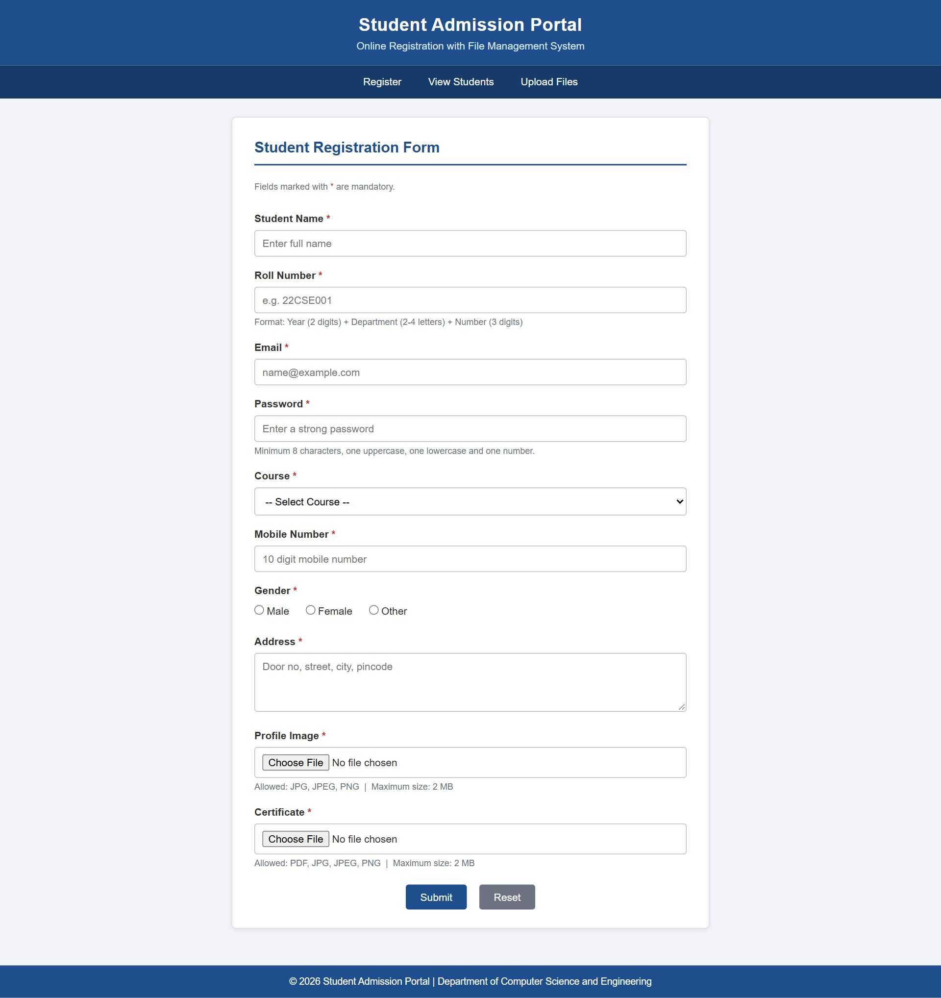
Figure 1.1 – Student Registration Form
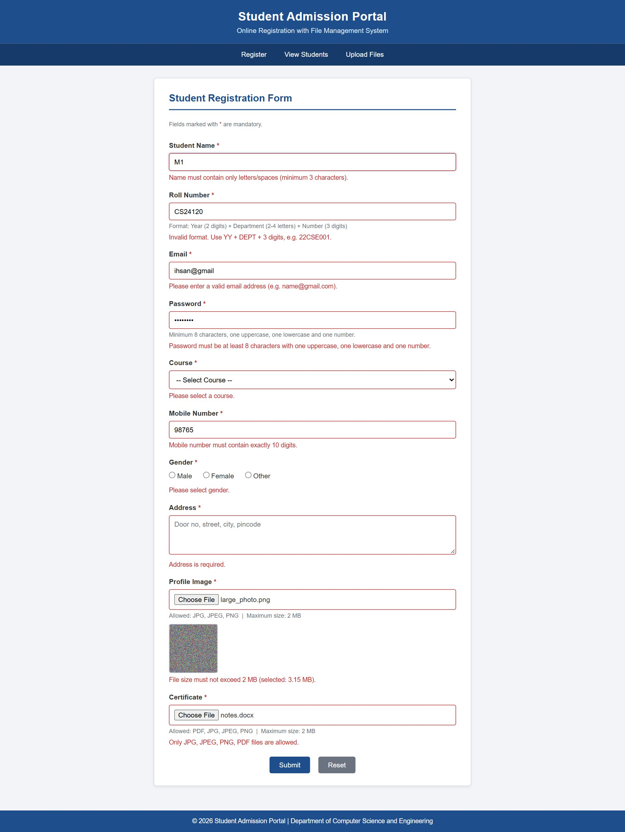
Figure 1.2 – Validation Error Messages
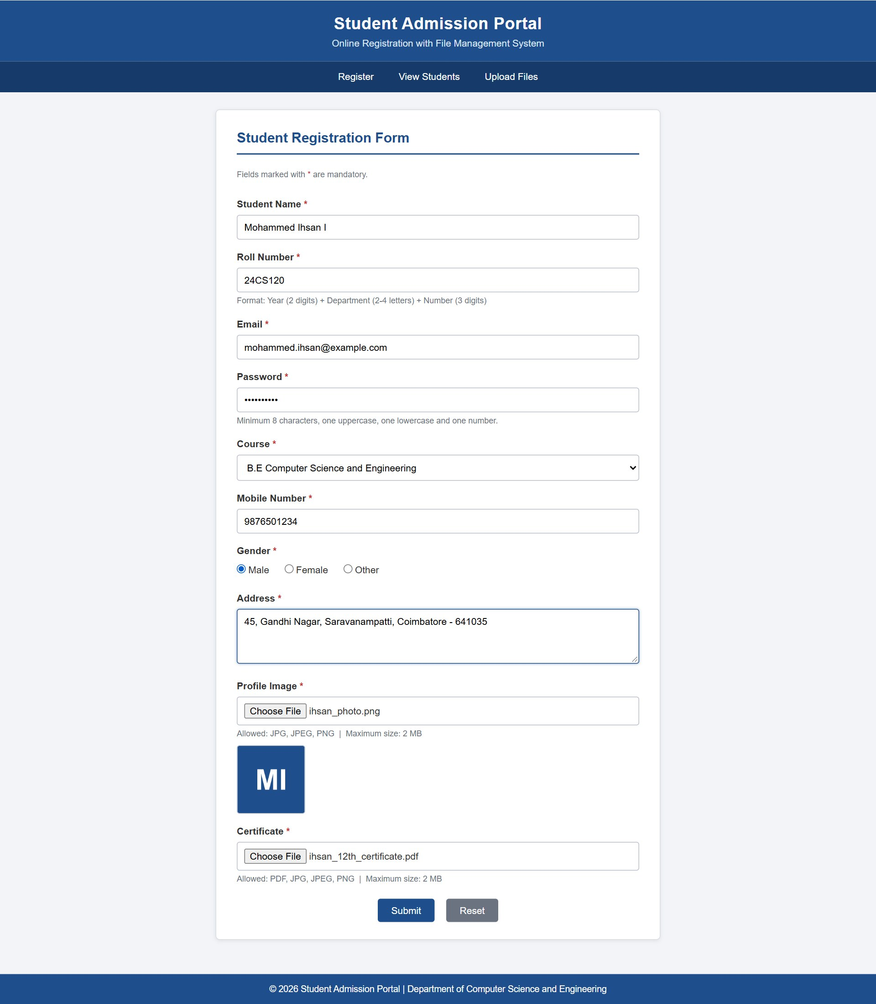
Figure 1.3 – Profile Image Preview
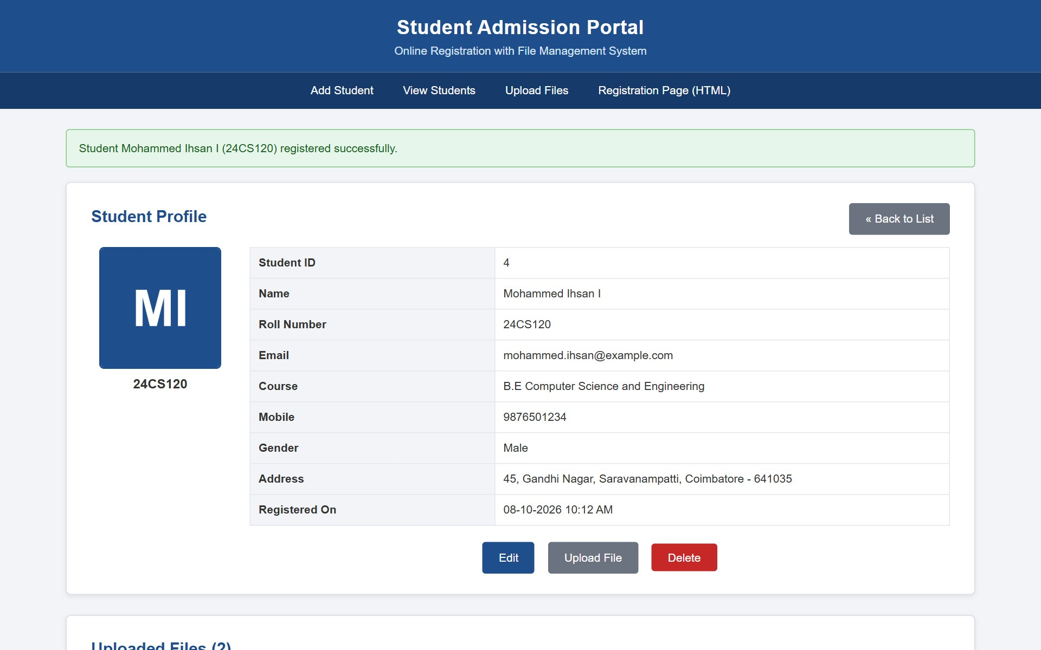
Figure 1.4 – Successful Form Submission
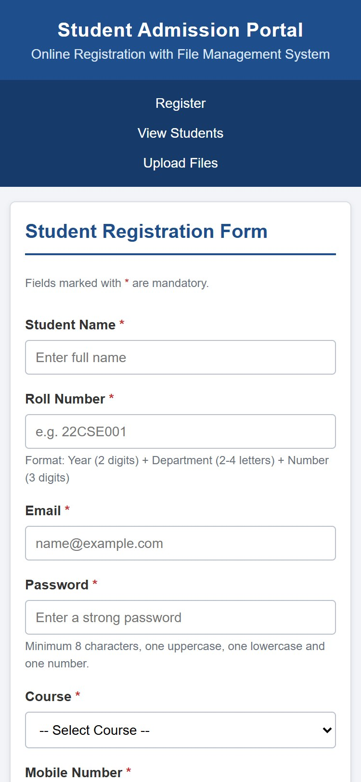
Figure 1.5 – Responsive Mobile View

4. QUESTION 2 – PHP AND MYSQL STUDENT MANAGEMENT SYSTEM

4.1 Scenario
After the registration form has been designed, the college requires a server-side system to store the submitted data permanently and to manage it. The administrative staff must be able to add new students, view all students in a table, search for a particular student, modify incorrect details and delete records. Each student may upload a profile photograph and one or more documents, and the staff must be able to preview the images and download the documents. The system must reject duplicate roll numbers, accept only safe file types within the size limit and never overwrite an existing file.

4.2 Objectives
- To design the student_portal database with the tables students and student_files.
- To connect PHP to MySQL using the object-oriented mysqli interface with exception-based error handling.
- To implement the Add, View, Edit, Delete and Search operations using prepared statements.
- To upload images into uploads/images/ and documents into uploads/documents/ with timestamp-based file names.
- To store metadata of every uploaded file (original name, path, type and upload date) in the database.
- To repeat all validations on the server and to display clear success and error messages.

4.3 Project Structure
File | Description
db.php | Database connection, upload settings and common helper functions
header.php, footer.php | Common page header, navigation bar, flash message and footer
add_student.php | Displays the registration form and server-side error messages
insert_student.php | Validates input and files, saves files and inserts the record
view_students.php | Displays the student directory and performs search
edit_student.php | Displays the edit form pre-filled with existing data
update_student.php | Validates and updates the record, replaces the profile image
delete_student.php | Deletes the record, file metadata and physical files
upload_file.php | Uploads additional documents for a selected student
student_details.php | Displays the profile, image preview and download links
uploads/.htaccess | Prevents execution of scripts inside the uploads folder

4.4 Database Design
The database student_portal is created with the utf8mb4 character set so that names in any language can be stored. The tables use the InnoDB storage engine, which supports foreign keys and transactions. The relationship between the two main tables is one-to-many: one student can have many uploaded files, while each file belongs to exactly one student.
Code Snippet 2.1 – Database and students table (student_portal.sql)
CREATE DATABASE IF NOT EXISTS student_portal
CHARACTER SET utf8mb4 COLLATE utf8mb4_general_ci;
USE student_portal;

CREATE TABLE students (
student_id INT AUTO_INCREMENT,
name VARCHAR(100) NOT NULL,
roll_number VARCHAR(20) NOT NULL,
email VARCHAR(100) NOT NULL,
password VARCHAR(255) NOT NULL,
course VARCHAR(50) NOT NULL,
mobile CHAR(10) NOT NULL,
gender ENUM('Male','Female','Other') NOT NULL,
address TEXT NOT NULL,
profile_image VARCHAR(255) DEFAULT NULL,
created_at TIMESTAMP NOT NULL DEFAULT CURRENT_TIMESTAMP,
CONSTRAINT pk_students PRIMARY KEY (student_id),
CONSTRAINT uq_students_roll UNIQUE (roll_number),
CONSTRAINT uq_students_email UNIQUE (email)
) ENGINE = InnoDB;

Code Snippet 2.2 – student_files table with foreign key
CREATE TABLE student_files (
file_id INT AUTO_INCREMENT,
student_id INT NOT NULL,
file_name VARCHAR(255) NOT NULL,
file_path VARCHAR(255) NOT NULL,
file_type VARCHAR(10) NOT NULL,
upload_date TIMESTAMP NOT NULL DEFAULT CURRENT_TIMESTAMP,
CONSTRAINT pk_student_files PRIMARY KEY (file_id),
CONSTRAINT fk_files_student FOREIGN KEY (student_id)
REFERENCES students (student_id)
ON DELETE CASCADE ON UPDATE CASCADE
) ENGINE = InnoDB;

4.4.1 Database Schema Explanation
The student_id column is the primary key of the students table and is generated automatically by AUTO_INCREMENT. The roll_number and email columns carry UNIQUE constraints, so the database itself refuses a second record with the same roll number or e-mail address, even if the application check is bypassed. The password is never stored in plain text; the column holds a bcrypt hash produced by the PHP function password_hash(). The profile_image column stores only the relative path of the photograph, while the image itself is stored in the file system.
In the student_files table, the student_id column is a foreign key that references the primary key of students. The clause ON DELETE CASCADE instructs MySQL to delete all the file records of a student automatically when the student is deleted, which preserves referential integrity without additional code. A third table, admin_users, is used only by the Servlet module of Question 3 and is described in that section.

4.4.2 Table Descriptions
Table 4.1 – Structure of the students table
Column | Data Type | Constraint | Description
student_id | INT | PRIMARY KEY, AUTO_INCREMENT | Unique identifier of the student
name | VARCHAR(100) | NOT NULL | Full name of the student
roll_number | VARCHAR(20) | NOT NULL, UNIQUE | Roll number, e.g. 24CS120
email | VARCHAR(100) | NOT NULL, UNIQUE | E-mail address
password | VARCHAR(255) | NOT NULL | bcrypt hash of the password
course | VARCHAR(50) | NOT NULL | Selected course
mobile | CHAR(10) | NOT NULL | Ten-digit mobile number
gender | ENUM | NOT NULL | Male, Female or Other
address | TEXT | NOT NULL | Postal address
profile_image | VARCHAR(255) | NULL | Relative path of the photograph
created_at | TIMESTAMP | DEFAULT CURRENT_TIMESTAMP | Date and time of registration

Table 4.2 – Structure of the student_files table
Column | Data Type | Constraint | Description
file_id | INT | PRIMARY KEY, AUTO_INCREMENT | Unique identifier of the file
student_id | INT | FOREIGN KEY, ON DELETE CASCADE | Owner of the file
file_name | VARCHAR(255) | NOT NULL | Original name of the uploaded file
file_path | VARCHAR(255) | NOT NULL | Stored path on the server
file_type | VARCHAR(10) | NOT NULL | jpg, jpeg, png or pdf
upload_date | TIMESTAMP | DEFAULT CURRENT_TIMESTAMP | Date and time of upload

4.5 PHP Configuration
All PHP pages include the file db.php at the beginning. This file starts the session that carries the success and error messages between pages, defines the connection parameters and upload settings as constants and opens the database connection. The statement mysqli_report() configures mysqli to throw an exception for every SQL error, which allows errors to be handled in try ... catch blocks instead of producing PHP warnings on the page.
Code Snippet 2.3 – Connection and settings (db.php)
define('DB_HOST', 'localhost');
define('DB_USER', 'root');
define('DB_PASS', '');
define('DB_NAME', 'student_portal');

define('UPLOAD_IMAGE_DIR', 'uploads/images/');
define('UPLOAD_DOC_DIR', 'uploads/documents/');
define('MAX_FILE_SIZE', 2 * 1024 * 1024); // 2 MB
define('IMAGE_EXTENSIONS', ['jpg', 'jpeg', 'png']);
define('ALL_EXTENSIONS', ['jpg', 'jpeg', 'png', 'pdf']);

mysqli_report(MYSQLI_REPORT_ERROR | MYSQLI_REPORT_STRICT);
try {
$conn = new mysqli(DB_HOST, DB_USER, DB_PASS, DB_NAME);
$conn->set_charset('utf8mb4');
} catch (mysqli_sql_exception $ex) {
echo 'Database connection failed: ' . htmlspecialchars($ex->getMessage());
exit;
}

The file also contains reusable helper functions: e() escapes text before it is printed in HTML to prevent cross-site scripting, validate_student() applies the field validation rules, find_duplicates() checks for an existing roll number or e-mail, validate_upload() checks an uploaded file, save_upload() stores the file with a unique name and delete_upload() removes a file from the disk.

4.6 CRUD Operations

4.6.1 Add Student (Create)
The form on add_student.php is submitted to insert_student.php. This script reads and trims the input, validates every field, checks for a duplicate roll number or e-mail and validates both uploaded files. If any check fails, the errors and the previously typed values are stored in the session and the user is redirected back to the form, where the messages are listed and the fields are refilled. If all checks pass, the files are saved and the record is inserted using a prepared statement inside a transaction.
Code Snippet 2.4 – Insertion inside a transaction (insert_student.php)
$conn->begin_transaction();
try {
$passwordHash = password_hash($data['password'], PASSWORD_DEFAULT);

$stmt = $conn->prepare('INSERT INTO students
(name, roll_number, email, password, course, mobile, gender, address, profile_image)
VALUES (?, ?, ?, ?, ?, ?, ?, ?, ?)');
$stmt->bind_param('sssssssss', $data['name'], $data['roll_number'], $data['email'],
$passwordHash, $data['course'], $data['mobile'], $data['gender'],
$data['address'], $imagePath);
$stmt->execute();
$studentId = $conn->insert_id;

/* ... file metadata inserted into student_files ... */

$conn->commit();
} catch (mysqli_sql_exception $ex) {
$conn->rollback(); // undo database changes
delete_upload($imagePath); // remove the saved files
delete_upload($certPath);
}

The question marks in the SQL statement are placeholders. The values are sent to MySQL separately from the query through bind_param(), so input such as ' OR '1'='1 is treated as ordinary text and cannot alter the query. This technique protects the application from SQL injection. The transaction guarantees that the student record and the file records are saved together; if any statement fails, rollback() undoes the changes and the files already copied to the server are deleted.

4.6.2 View and Search Student (Read)
The page view_students.php lists all the students in an HTML table, ordered with the most recent registration first. Each row shows a thumbnail of the profile photograph together with the name, roll number, e-mail, course, mobile number, gender, registration date and action buttons. A search box at the top submits a keyword using the GET method. When a keyword is present, the query uses the LIKE operator on the name, roll number, e-mail and course columns.
Code Snippet 2.5 – Search query (view_students.php)
$like = '%' . $search . '%';
$stmt = $conn->prepare('SELECT * FROM students
WHERE name LIKE ? OR roll_number LIKE ? OR email LIKE ? OR course LIKE ?
ORDER BY student_id DESC');
$stmt->bind_param('ssss', $like, $like, $like, $like);
$stmt->execute();
$result = $stmt->get_result();

4.6.3 Edit Student (Update)
Clicking the Edit button opens edit_student.php?id=N, which loads the record and displays a form pre-filled with the existing values and the current photograph. The password and photograph fields are optional on this form; if they are left empty, the previous values are retained. The script update_student.php validates the data, checks for duplicates while excluding the current student, and executes an UPDATE statement. When a new photograph is uploaded, its metadata replaces the old entry in student_files, and the old image file is deleted from the disk only after the database update has been committed successfully.

4.6.4 Delete Student (Delete)
The Delete button is implemented as a small form that uses the POST method, so that a record cannot be deleted merely by visiting a URL. A JavaScript confirmation dialog is displayed before the form is submitted. The script delete_student.php first collects the paths of all the files belonging to the student, then deletes the student record. Because of the ON DELETE CASCADE constraint, the related rows of student_files are removed automatically, after which the physical files are deleted from the uploads folder.
Code Snippet 2.6 – Deleting the record and files (delete_student.php)
$stmt = $conn->prepare('DELETE FROM students WHERE student_id = ?');
$stmt->bind_param('i', $id);
$stmt->execute();

// student_files rows are removed by ON DELETE CASCADE
foreach (array_unique($paths) as $path) {
delete_upload($path); // remove the physical file
}

4.7 File Upload Handling
File uploads are validated by the function validate_upload() in four stages. First, the PHP upload error code is examined to detect missing files and files that exceed the server limit. Second, the file size is compared with the 2 MB limit. Third, the extension is compared with the list of permitted extensions. Finally, the actual content of the file is examined using the finfo extension, which reads the MIME type from the file data. This last check ensures that a harmful file that has merely been renamed with a .jpg extension is rejected.
Code Snippet 2.7 – Extension and MIME type validation (db.php)
$ext = strtolower(pathinfo($file['name'], PATHINFO_EXTENSION));
if (!in_array($ext, $allowedExt, true)) {
return "$label: only JPG, JPEG, PNG, PDF files are allowed.";
}

$finfo = finfo_open(FILEINFO_MIME_TYPE);
$mime = finfo_file($finfo, $file['tmp_name']);
$allowedMime = [
'jpg' => ['image/jpeg'], 'jpeg' => ['image/jpeg'],
'png' => ['image/png'], 'pdf' => ['application/pdf'],
];
if (!in_array($mime, $allowedMime[$ext], true)) {
return "$label: file content does not match its extension.";
}

After validation, the function save_upload() decides the destination folder from the extension: images are stored in uploads/images/ and PDF documents in uploads/documents/. To prevent an existing file from being overwritten, a new file name is generated by combining the current Unix timestamp, a random four-digit number and a cleaned version of the original name. The loop repeats in the rare event that a file with the generated name already exists. The function move_uploaded_file() moves the file from the temporary upload location to the destination, and it also verifies that the file was genuinely received through an HTTP upload.
Code Snippet 2.8 – Timestamp-based file naming (db.php)
$folder = in_array($ext, IMAGE_EXTENSIONS, true) ? UPLOAD_IMAGE_DIR : UPLOAD_DOC_DIR;

$base = preg_replace('/[^A-Za-z0-9_-]/', '_', pathinfo($file['name'], PATHINFO_FILENAME));
do {
$newName = time() . '_' . mt_rand(1000, 9999) . '_' . $base . '.' . $ext;
} while (file_exists(__DIR__ . '/' . $folder . $newName));

move_uploaded_file($file['tmp_name'], __DIR__ . '/' . $folder . $newName);
return $folder . $newName; // e.g. uploads/images/1791432158_4821_photo.jpg

As an additional safety measure, an .htaccess file inside the uploads folder denies the execution of PHP and other script files and disables directory listing. Even if a script were somehow placed in this folder, Apache would refuse to run it.

4.8 Metadata Storage
For every file that is uploaded, a row is inserted into student_files containing the identifier of the student, the original file name as chosen by the user, the stored path, the file type and the upload date. The original name is preserved so that a downloaded file receives a meaningful name, while the stored path contains the unique timestamp-based name. The page student_details.php reads this metadata to display a table of all the files belonging to a student, with a thumbnail preview for images, the file size, the upload date, a View link and a Download link that uses the HTML download attribute.
Code Snippet 2.9 – Storing file metadata (upload_file.php)
$stmt = $conn->prepare('INSERT INTO student_files (student_id, file_name, file_path, file_type)
VALUES (?, ?, ?, ?)');
$stmt->bind_param('isss', $studentId, $originalName, $path, $fileType);
$stmt->execute();

4.9 Validation and Error Handling
Every validation performed in JavaScript is repeated on the server in PHP, because client-side validation can be disabled or bypassed. Duplicate roll numbers are prevented at two levels: the function find_duplicates() checks the database before insertion and reports a clear message, and the UNIQUE constraint rejects the record if two requests arrive at the same moment. In that case MySQL returns error code 1062, which the script translates into the message "Roll number or email already exists." All database operations are enclosed in try ... catch blocks, and the outcome of every operation is shown as a green success message or a red error message through the session-based flash message mechanism in header.php. All values printed in HTML pass through htmlspecialchars() to prevent cross-site scripting.

4.10 Testing
Table 4.3 – Test cases for Question 2
TC No. | Test Case Description | Expected Result | Actual Result | Status
TC2.1 | Add a student with valid details and files | Record and two file entries created | Record inserted, success message shown | PASS
TC2.2 | Add a student with an existing roll number | "Roll number already registered" | Duplicate rejected with message | PASS
TC2.3 | Add a student with an existing e-mail | "Email already registered" | Duplicate rejected with message | PASS
TC2.4 | Submit invalid data with JavaScript disabled | Server lists all errors | Errors listed, values refilled | PASS
TC2.5 | Open View Students | All records shown with thumbnails | Table displayed correctly | PASS
TC2.6 | Search with keyword "24CS" | Only matching students listed | 2 matching students displayed | PASS
TC2.7 | Search with "' OR '1'='1" | Treated as text, no extra rows | No records returned | PASS
TC2.8 | Edit details without new password or photo | Old password and photo retained | Updated, old values kept | PASS
TC2.9 | Edit with a new profile photo | New photo shown, old file deleted | Photo replaced, old file removed | PASS
TC2.10 | Delete a student | Record, metadata and files removed | All removed, message shown | PASS
TC2.11 | Open delete_student.php directly in the URL | Request refused | "Invalid request" displayed | PASS
TC2.12 | Upload a 1 MB PDF document | Stored in uploads/documents/ | Stored and listed in profile | PASS
TC2.13 | Upload a 3.15 MB file | Size error displayed | "File must not exceed 2 MB." | PASS
TC2.14 | Upload a .exe file renamed to .jpg | Content mismatch error | Rejected with message | PASS
TC2.15 | Upload the same file name twice | Both stored with different names | Three distinct file names stored | PASS
TC2.16 | Click Download on a document | File downloaded with original name | Downloaded successfully | PASS
TC2.17 | Stop MySQL and open any page | Friendly connection error | Error message displayed | PASS

4.11 Output Screenshots
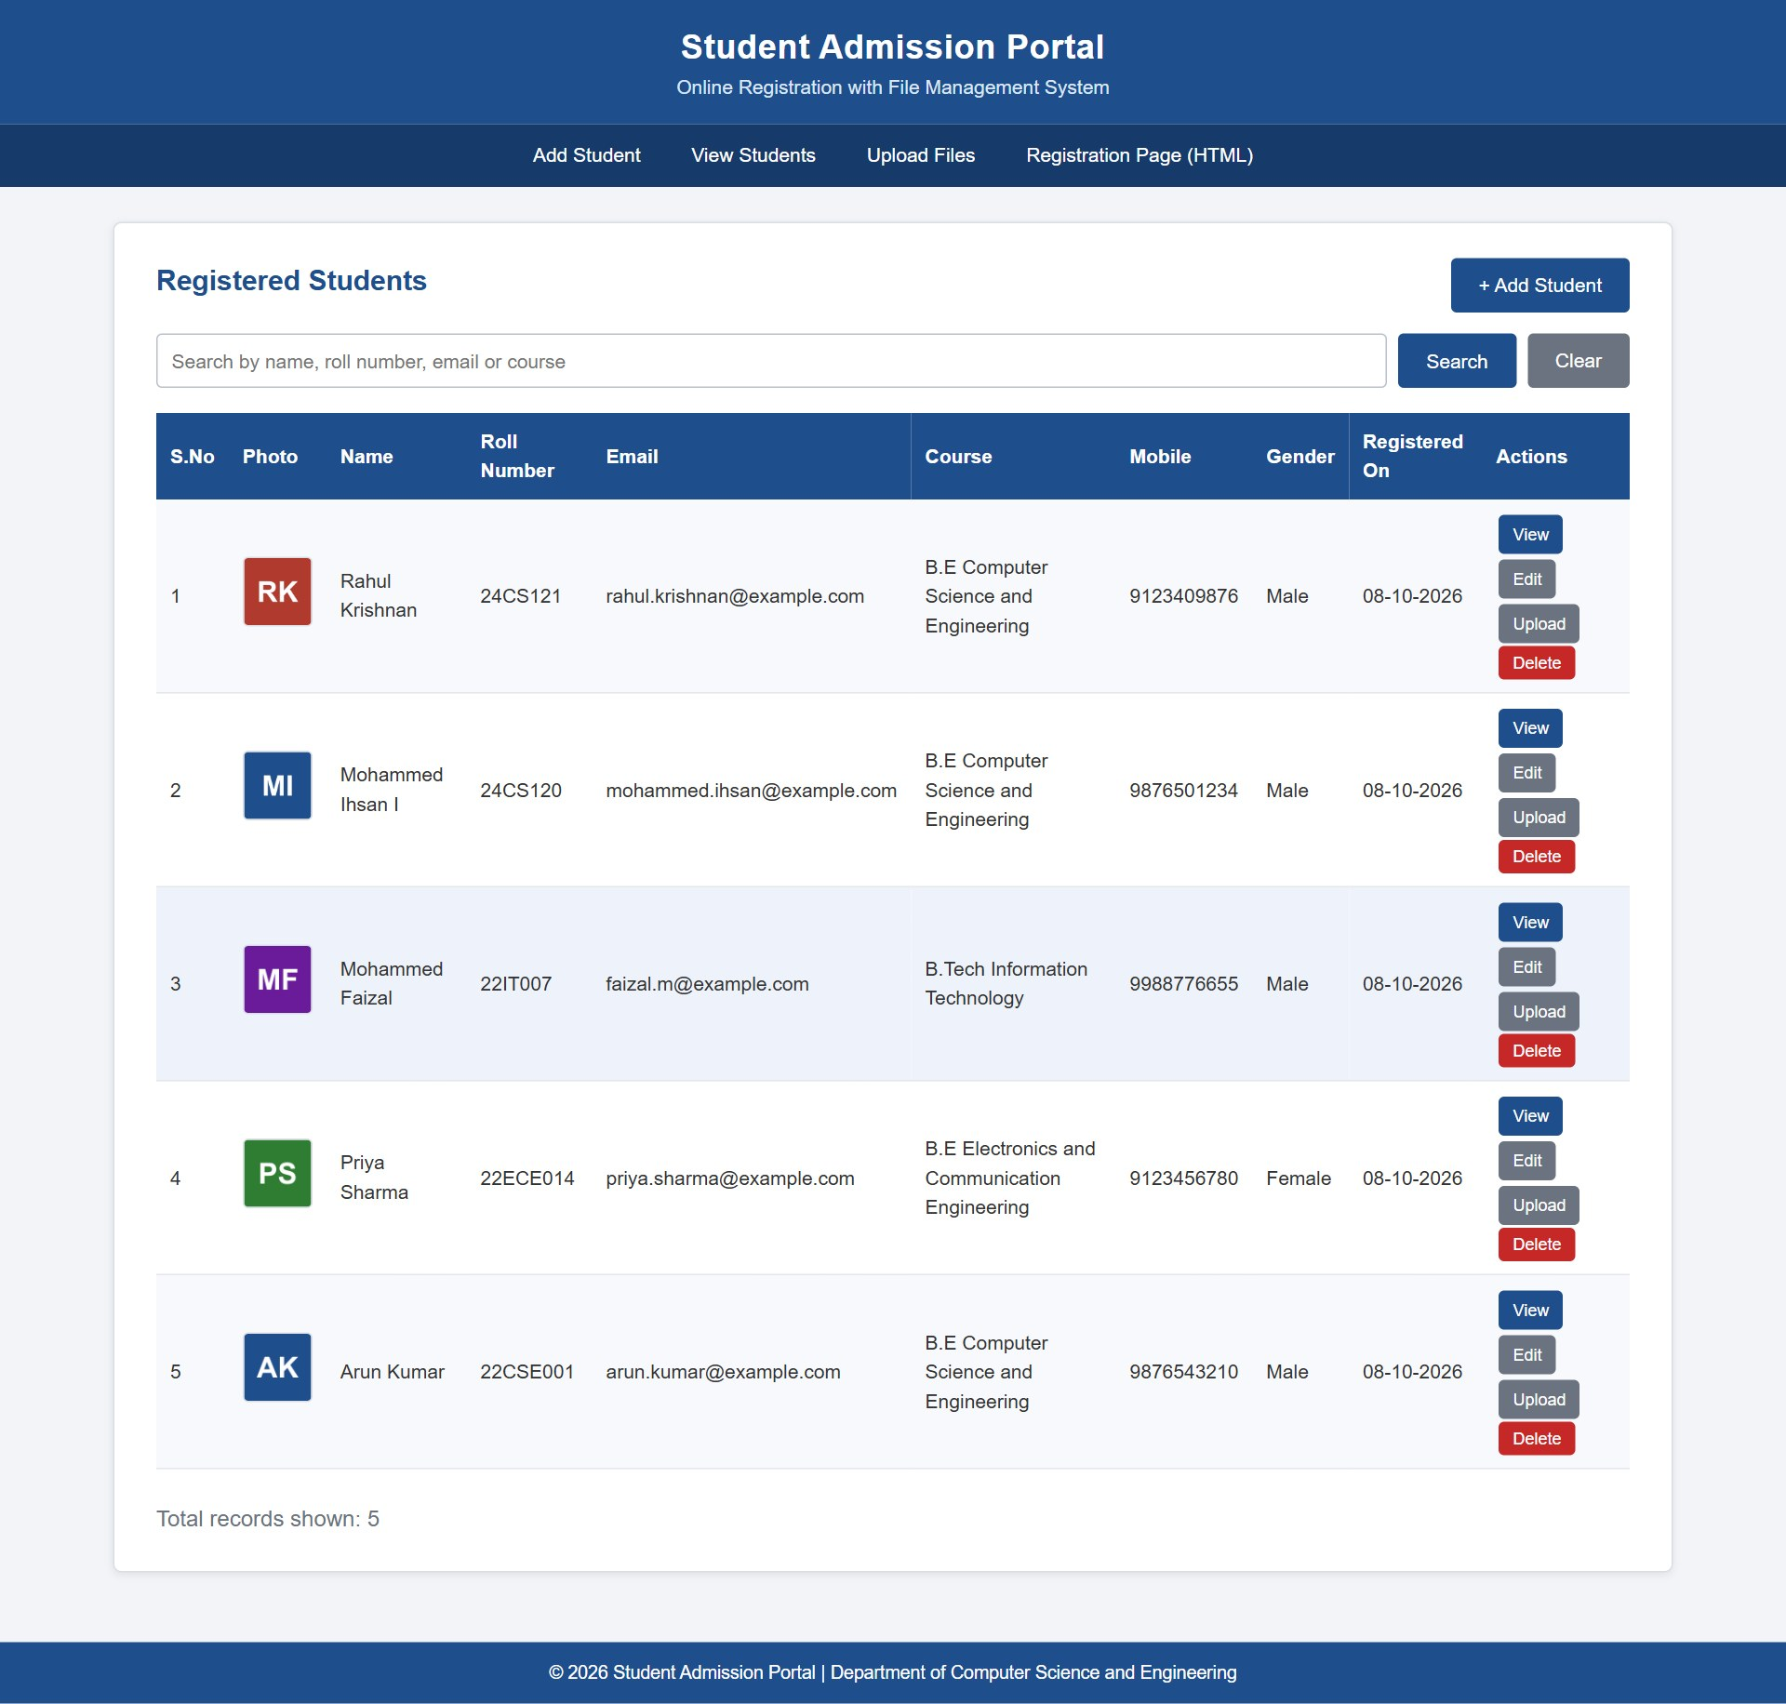
Figure 2.1 – Student Directory Table
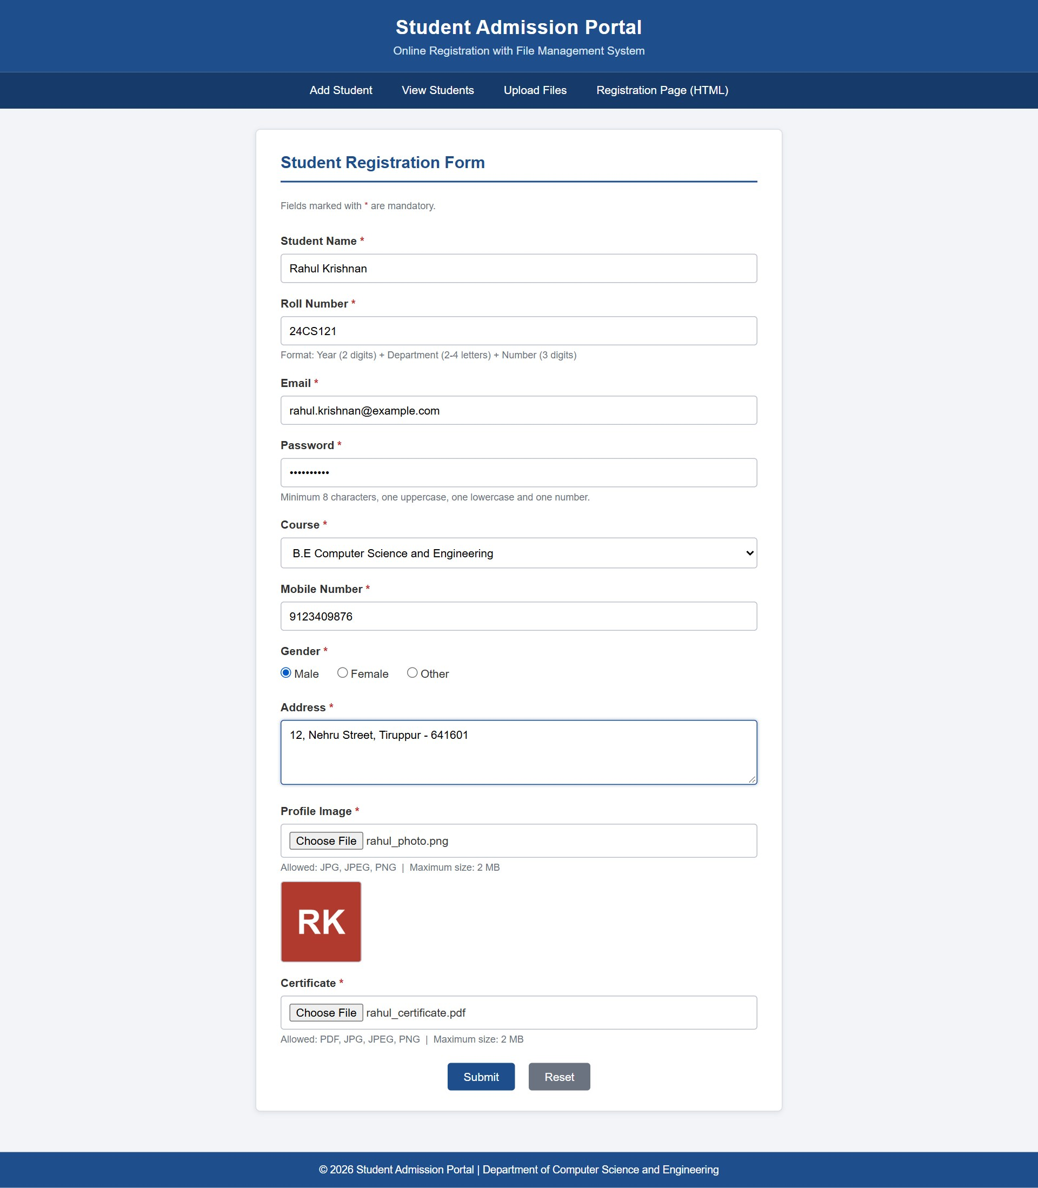
Figure 2.2 – Add Student Form
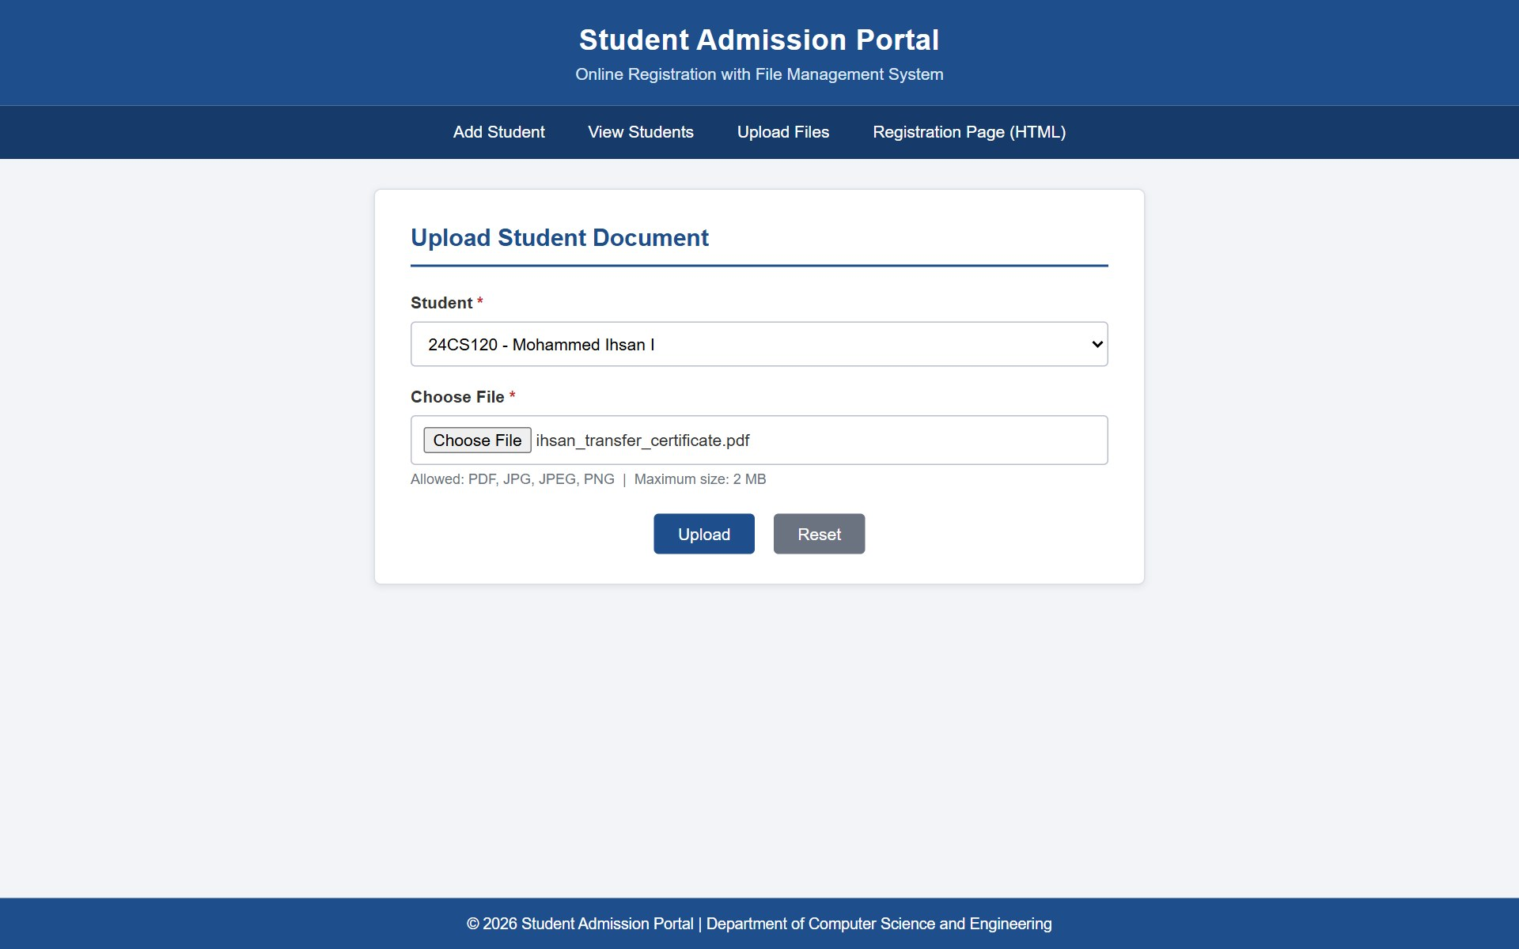
Figure 2.3 – File Upload Interface
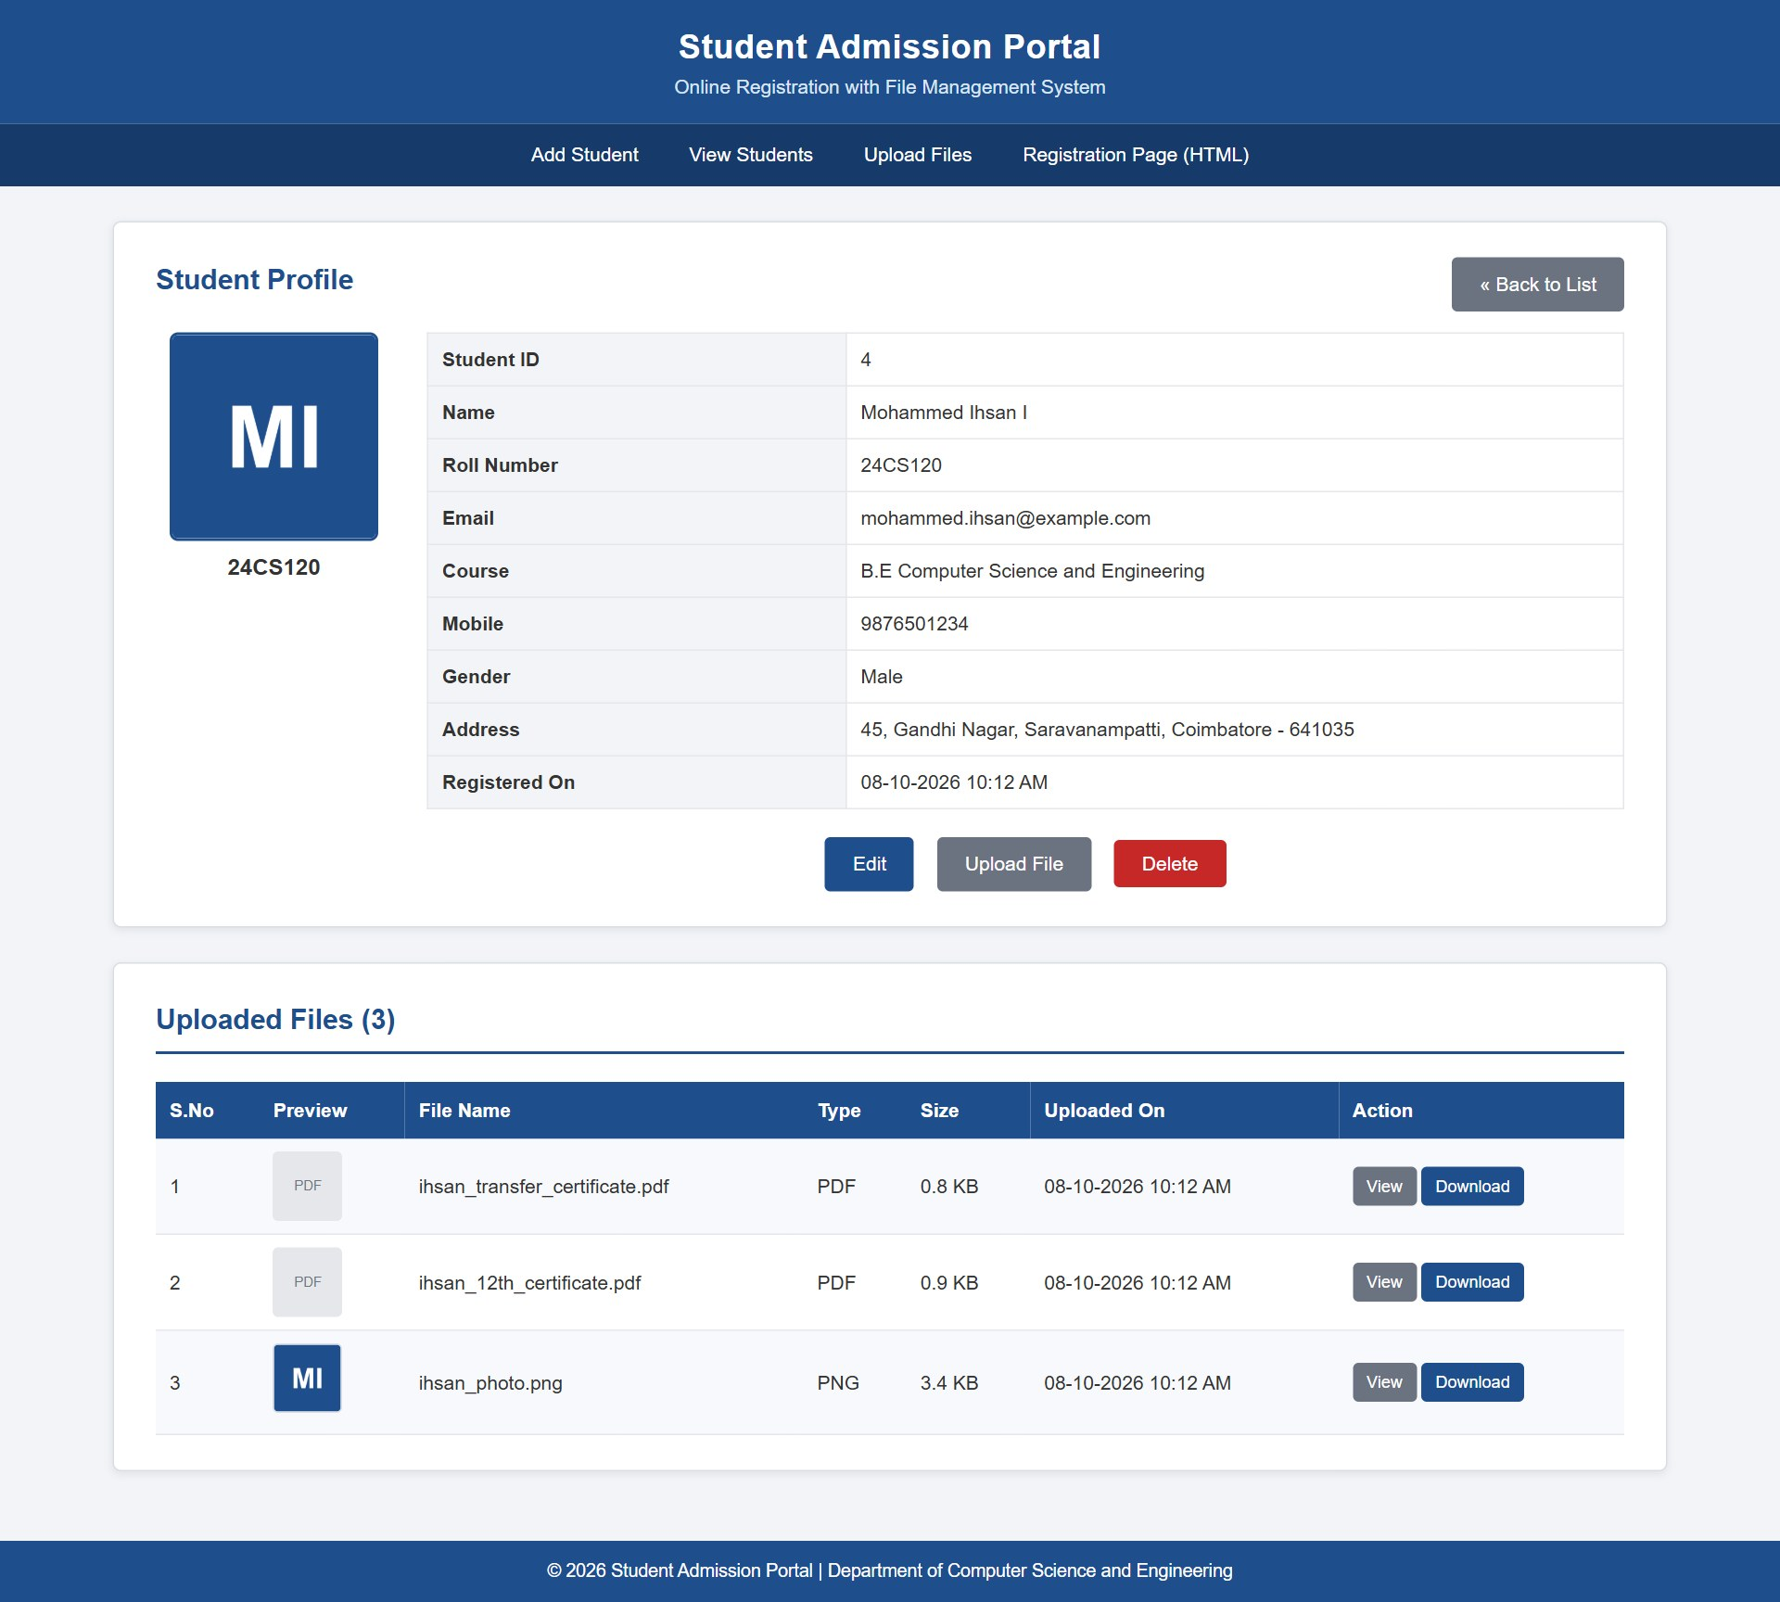
Figure 2.4 – Student Profile View
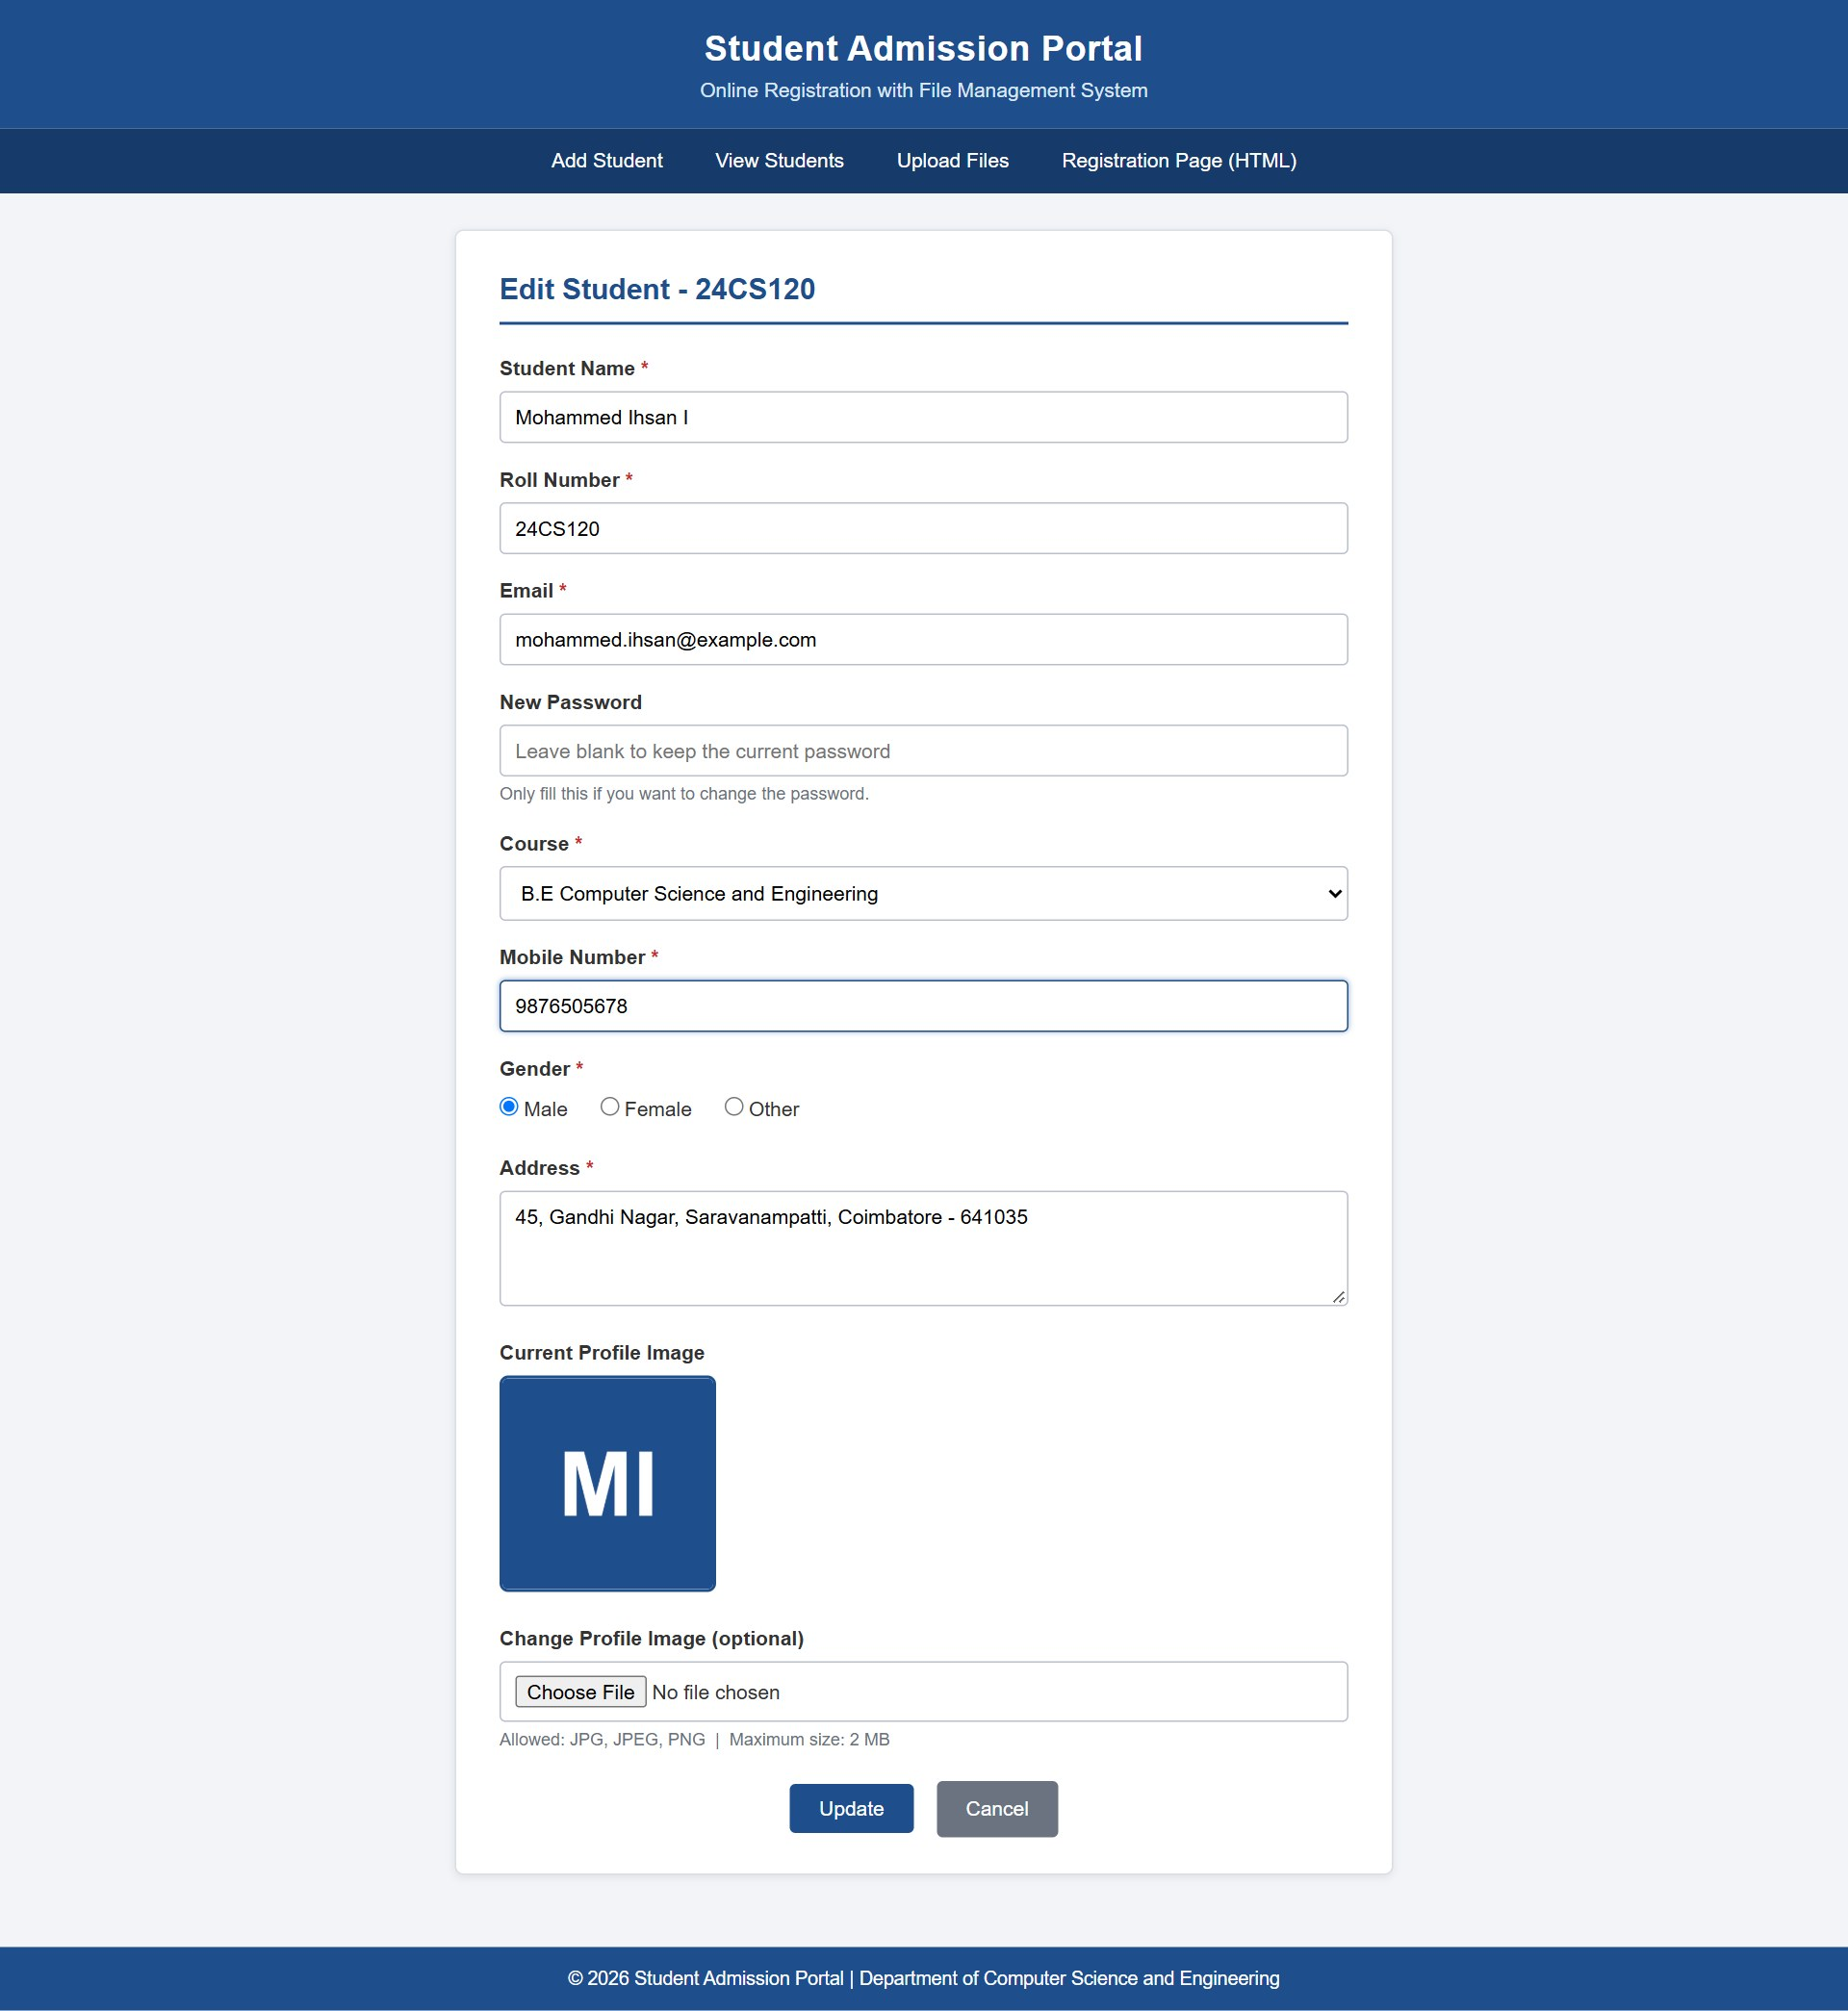
Figure 2.5 – Edit Student Form
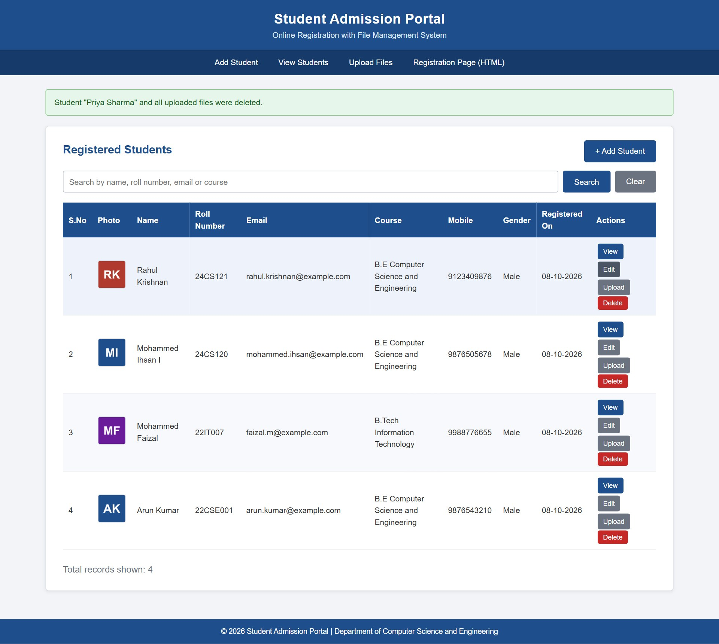
Figure 2.6 – Delete Student Operation
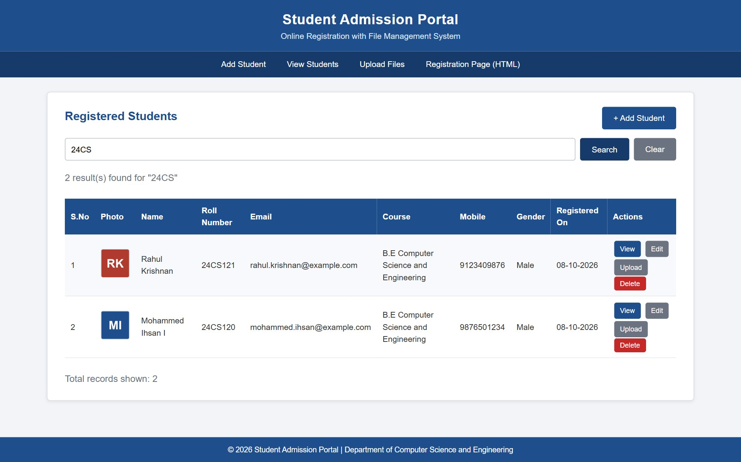
Figure 2.7 – Search Student Result

5. QUESTION 3 – SERVLET, JSP, JDBC AND MYSQL STUDENT PORTAL

5.1 Scenario
The college administration requires a secure portal through which authorised staff can view the details of admitted students. The portal must be developed in Java and deployed on Apache Tomcat. Only users who have logged in must be able to access the pages, and the session must end when the user logs out. The portal must display the list of students, show the complete profile of a selected student with the photograph, and list the uploaded documents, which should be viewable and downloadable through the application.

5.2 Objectives
- To create a Java Dynamic Web Project named StudentPortalServlet.
- To connect to the MySQL database using JDBC through a reusable connection utility class.
- To separate the code into Model, DAO, Servlet (controller) and JSP (view) layers.
- To implement login authentication with session creation and logout with session invalidation.
- To restrict all pages to logged-in users and redirect unauthorised users to the login page.
- To render student details dynamically in JSP using loops and conditional statements.
- To display images using <img src="FileServlet?id=1"> and to stream documents through a Servlet.

5.3 Project Structure
Layer | Files | Responsibility
Utility | DBConnection.java, SessionUtil.java | JDBC connection; session check, cache control and HTML escaping
Model | Admin.java, Student.java, StudentFile.java | JavaBeans representing rows of the database tables
DAO | AdminDAO.java, StudentDAO.java, StudentFileDAO.java | All SQL queries using PreparedStatement
Controller | LoginServlet, LogoutServlet, DashboardServlet, StudentListServlet, StudentProfileServlet, FileServlet | Receive requests, check the session, call DAOs and forward to JSP
View | login.jsp, dashboard.jsp, student_list.jsp, student_profile.jsp, error.jsp | Generate HTML dynamically
Configuration | WEB-INF/web.xml | Servlet mappings, session timeout, error pages, upload folder

5.4 JDBC Connectivity
Java Database Connectivity (JDBC) is the standard Java API for communicating with relational databases. The class DBConnection loads the MySQL Connector/J driver once in a static block and provides a method getConnection() that returns a new connection to the student_portal database. The driver JAR file is placed in WEB-INF/lib, from where Tomcat adds it to the classpath of the application automatically.
Code Snippet 3.1 – JDBC connection utility (DBConnection.java)
public class DBConnection {
private static final String URL =
"jdbc:mysql://localhost:3306/student_portal"
+ "?useSSL=false&allowPublicKeyRetrieval=true&serverTimezone=Asia/Kolkata";
private static final String USER = "root";
private static final String PASSWORD = "";

static {
try {
Class.forName("com.mysql.cj.jdbc.Driver"); // register the driver
} catch (ClassNotFoundException e) {
throw new RuntimeException("MySQL JDBC Driver not found", e);
}
}

public static Connection getConnection() throws SQLException {
return DriverManager.getConnection(URL, USER, PASSWORD);
}
}

The Data Access Object classes use this connection to execute queries. Every query uses a PreparedStatement, and the connection, statement and result set are declared in a try-with-resources block so that they are closed automatically even if an exception occurs. The example below shows how a student is fetched by identifier and converted into a Student object.
Code Snippet 3.2 – DAO method using PreparedStatement (StudentDAO.java)
public Student getStudentById(int studentId) throws SQLException {
String sql = "SELECT " + COLUMNS + " FROM students WHERE student_id = ?";
try (Connection con = DBConnection.getConnection();
PreparedStatement ps = con.prepareStatement(sql)) {
ps.setInt(1, studentId);
try (ResultSet rs = ps.executeQuery()) {
if (rs.next()) {
return mapRow(rs); // copies columns into a Student object
}
}
}
return null;
}

5.5 Servlet Architecture
The application follows the Model-View-Controller (MVC) design pattern. The Servlets act as controllers: they receive the HTTP request, verify the session, call the appropriate DAO methods and store the results as request attributes. They then forward the request to a JSP page, which acts as the view and generates the HTML. The JSP pages do not contain any SQL statements. The responsibilities of each Servlet are summarised in Table 5.1.
Table 5.1 – Servlets and their URL mappings
Servlet | URL Pattern | Function
LoginServlet | /LoginServlet | Displays the login page (GET) and authenticates the user (POST)
LogoutServlet | /LogoutServlet | Invalidates the session and returns to the login page
DashboardServlet | /DashboardServlet | Collects summary statistics and forwards to dashboard.jsp
StudentListServlet | /StudentListServlet | Fetches all students or search results for student_list.jsp
StudentProfileServlet | /StudentProfileServlet?id=N | Fetches one student and the related files for student_profile.jsp
FileServlet | /FileServlet?id=N or ?fileId=N | Streams the profile image or an uploaded document

5.6 Request–Response Flow
The flow of a request through the application is illustrated below. The browser never accesses a JSP page directly; every request first reaches a Servlet, which checks the session before any data is read from the database.
Figure 5.1 – Request–response flow of the Servlet module
┌───────────┐ 1. HTTP GET /StudentProfileServlet?id=1 ┌──────────────────────┐
│ Browser │ ─────────────────────────────────────────► │ StudentProfileServlet│
└───────────┘ │ (Controller) │
▲ └──────────┬───────────┘
│ 2. checkLogin(session)│
│ ▼
│ ┌──────────────────────┐
│ │ StudentDAO / │
│ │ StudentFileDAO (DAO) │
│ └──────────┬───────────┘
│ 3. JDBC query │
│ ▼
│ ┌──────────────────────┐
│ │ MySQL Database │
│ └──────────┬───────────┘
│ 4. Student + List<StudentFile> │
│ ▼
│ 6. HTML response ┌──────────────────────┐
└───────────────────────────────────────────────── │ student_profile.jsp │
│ (View) 5. forward │
7. <img src="FileServlet?id=1"> → FileServlet └──────────────────────┘
reads uploads/images/... and streams bytes

5.7 Login Authentication Flow
The login page login.jsp submits the username and password to LoginServlet using the POST method. The Servlet verifies that both fields are filled and then calls AdminDAO.validateLogin(). The password is compared in the database using the MySQL function SHA2(), so the password is stored only as a SHA-256 hash in the admin_users table. The default account has the username admin and the password admin123.
Code Snippet 3.3 – Admin table and authentication query
CREATE TABLE admin_users (
admin_id INT AUTO_INCREMENT PRIMARY KEY,
username VARCHAR(50) NOT NULL UNIQUE,
password CHAR(64) NOT NULL, -- SHA-256 hash
full_name VARCHAR(100) NOT NULL
);
INSERT INTO admin_users (username, password, full_name)
VALUES ('admin', SHA2('admin123', 256), 'Portal Administrator');

-- AdminDAO.validateLogin()
SELECT admin_id, username, full_name FROM admin_users
WHERE username = ? AND password = SHA2(?, 256);

If the credentials are incorrect, the Servlet stores an error message as a request attribute and forwards back to login.jsp, which displays "Invalid username or password." If the credentials are correct, a session is created as described in the next section and the user is redirected to the dashboard. A redirect is used instead of a forward so that refreshing the dashboard does not resubmit the password.

5.8 Session Handling
HTTP is a stateless protocol, so the server uses a session to remember that a user has logged in. After successful authentication, LoginServlet invalidates any existing session to prevent session fixation, creates a new session, stores the Admin object in it and sets an inactivity timeout of thirty minutes.
Code Snippet 3.4 – Session creation (LoginServlet.java)
HttpSession oldSession = request.getSession(false);
if (oldSession != null) {
oldSession.invalidate();
}
HttpSession session = request.getSession(true);
session.setAttribute(SessionUtil.SESSION_ADMIN, admin);
session.setMaxInactiveInterval(30 * 60); // 30 minutes
response.sendRedirect("DashboardServlet");

Every protected Servlet begins with a call to SessionUtil.checkLogin(). This method sets response headers that prevent the browser from caching the page and checks whether the session contains the admin attribute. If the attribute is absent, the user is redirected to login.jsp?auth=required, where the message "Please login to continue." is displayed. The JSP views are placed inside WEB-INF/views, which the browser cannot access directly, and the common fragment header.jspf repeats the session check as an additional safeguard.
Code Snippet 3.5 – Session check (SessionUtil.java)
public static boolean checkLogin(HttpServletRequest request, HttpServletResponse response)
throws IOException {
noCache(response);
HttpSession session = request.getSession(false);
if (session == null || session.getAttribute(SESSION_ADMIN) == null) {
response.sendRedirect(request.getContextPath() + "/login.jsp?auth=required");
return false;
}
return true;
}

The LogoutServlet calls session.invalidate(), which removes all the attributes of the session, and redirects to the login page with a confirmation message. Because the protected pages are sent with no-cache headers, pressing the browser Back button after logging out does not display the previous page; the request reaches the Servlet again and is redirected to the login page.

5.9 JSP Dynamic Rendering
The JSP pages read the objects supplied by the Servlets using request.getAttribute() and generate HTML using Java loops and conditional statements written in scriptlets. In student_list.jsp, an if statement checks whether the list is empty and displays a message, otherwise a for loop generates one table row for every Student object. A second condition decides whether to display the photograph through FileServlet or a "No Image" placeholder.
Code Snippet 3.6 – Loop and condition in JSP (student_list.jsp)
<% if (students == null || students.isEmpty()) { %>
<tr><td colspan="10">No student records found.</td></tr>
<% } else {
int serial = 1;
for (Student s : students) { %>
<tr>
<td><%= serial++ %></td>
<td>
<% if (s.hasProfileImage()) { %>
<img src="FileServlet?id=<%= s.getStudentId() %>" class="thumb" alt="Photo">
<% } else { %>
<span class="no-image">No Image</span>
<% } %>
</td>
<td><%= SessionUtil.escape(s.getName()) %></td>
<td><%= SessionUtil.escape(s.getRollNumber()) %></td>
...
</tr>
<% }
} %>

Every value printed from the database passes through SessionUtil.escape(), which converts the characters <, >, &, " and ' into HTML entities. The profile page student_profile.jsp follows the same approach: it displays the student details in a two-column table, shows the photograph using <img src="FileServlet?id=N">, and loops through the list of StudentFile objects to display each document with View and Download links.

5.10 File Streaming Mechanism
Uploaded files are not linked directly from the Java application. Instead, every image and document is delivered by FileServlet. The Servlet accepts either id, which returns the profile photograph of a student, or fileId, which returns any file from the student_files table. It obtains the stored relative path from the database, combines it with the base folder configured in web.xml and verifies that the resulting canonical path remains inside the base folder, which prevents path traversal attacks such as ../../. It then sets the content type, the content length and the Content-Disposition header, and copies the file to the response output stream in blocks of 8 KB.
Code Snippet 3.7 – Streaming a file to the browser (FileServlet.java)
File file = new File(baseDir, relativePath);
String basePath = baseDir.getCanonicalPath() + File.separator;
if (!file.getCanonicalPath().startsWith(basePath) || !file.isFile()) {
response.sendError(HttpServletResponse.SC_NOT_FOUND, "File not found on the server.");
return;
}

String mimeType = getServletContext().getMimeType(file.getName()); // image/png, application/pdf
response.setContentType(mimeType != null ? mimeType : "application/octet-stream");
response.setContentLengthLong(file.length());
response.setHeader("Content-Disposition",
(download ? "attachment" : "inline") + "; filename=\"" + encodedName + "\"");

try (InputStream in = new FileInputStream(file);
OutputStream out = response.getOutputStream()) {
byte[] buffer = new byte[8192];
int bytesRead;
while ((bytesRead = in.read(buffer)) != -1) {
out.write(buffer, 0, bytesRead);
}
}

When the value of Content-Disposition is inline, the browser displays the image or opens the PDF in a new tab; when the parameter download=true is supplied, the value becomes attachment and the browser saves the file with its original name. Since FileServlet also checks the session, students' documents cannot be viewed by anyone who has not logged in.

5.11 web.xml Configuration
The deployment descriptor web.xml declares every Servlet and maps it to a URL pattern. It also defines the context parameter uploadBaseDir, which tells FileServlet where the uploads folder of the PHP module is located, sets the session timeout, specifies login.jsp as the welcome page and configures error.jsp for HTTP errors 404 and 500.
Code Snippet 3.8 – Extract from web.xml
<context-param>
<param-name>uploadBaseDir</param-name>
<param-value>C:/xampp/htdocs/StudentAdmissionPortal/PHP</param-value>
</context-param>

<servlet>
<servlet-name>FileServlet</servlet-name>
<servlet-class>com.studentportal.servlet.FileServlet</servlet-class>
</servlet>
<servlet-mapping>
<servlet-name>FileServlet</servlet-name>
<url-pattern>/FileServlet</url-pattern>
</servlet-mapping>

<session-config>
<session-timeout>30</session-timeout>
<cookie-config><http-only>true</http-only></cookie-config>
</session-config>

<welcome-file-list>
<welcome-file>login.jsp</welcome-file>
</welcome-file-list>

<error-page>
<error-code>404</error-code>
<location>/error.jsp</location>
</error-page>

5.12 Testing
Table 5.2
TC No. | Test Case Description | Expected Result | Actual Result | Status
TC3.1 | Open the application URL | login.jsp displayed as welcome page | Login page displayed | PASS
TC3.2 | Login with admin / admin123 | Session created, dashboard opened | Dashboard displayed | PASS
TC3.3 | Login with an incorrect password | "Invalid username or password." | Warning displayed | PASS
TC3.4 | Submit login with empty fields | Validation message displayed | Message displayed | PASS
TC3.5 | Open StudentListServlet without login | Redirected to login page | Redirected with message | PASS
TC3.6 | Open /WEB-INF/views/dashboard.jsp directly | Access denied (404) | Error page displayed | PASS
TC3.7 | View the dashboard | Totals and recent students shown | Statistics displayed | PASS
TC3.8 | Search "24CS" in the student list | Matching students listed | 2 matching students displayed | PASS
TC3.9 | Open StudentProfileServlet?id=1 | Profile with photograph and documents | Profile rendered dynamically | PASS
TC3.10 | Open StudentProfileServlet?id=999 | "No student found" message | Message displayed | PASS
TC3.11 | Image tag FileServlet?id=1 | Profile photograph displayed | Image rendered | PASS
TC3.12 | Click View on a PDF document | PDF opens in a new tab | PDF displayed inline | PASS
TC3.13 | Click Download on a PDF document | PDF saved with original name | Downloaded successfully | PASS
TC3.14 | Request FileServlet without a session | 401 Unauthorized | Access refused | PASS
TC3.15 | Logout and press the Back button | Login page displayed | Redirected to login | PASS
TC3.16 | Inspect the session cookie after login | JSESSIONID marked HttpOnly | Cookie flagged HttpOnly | PASS

5.13 Output Screenshots
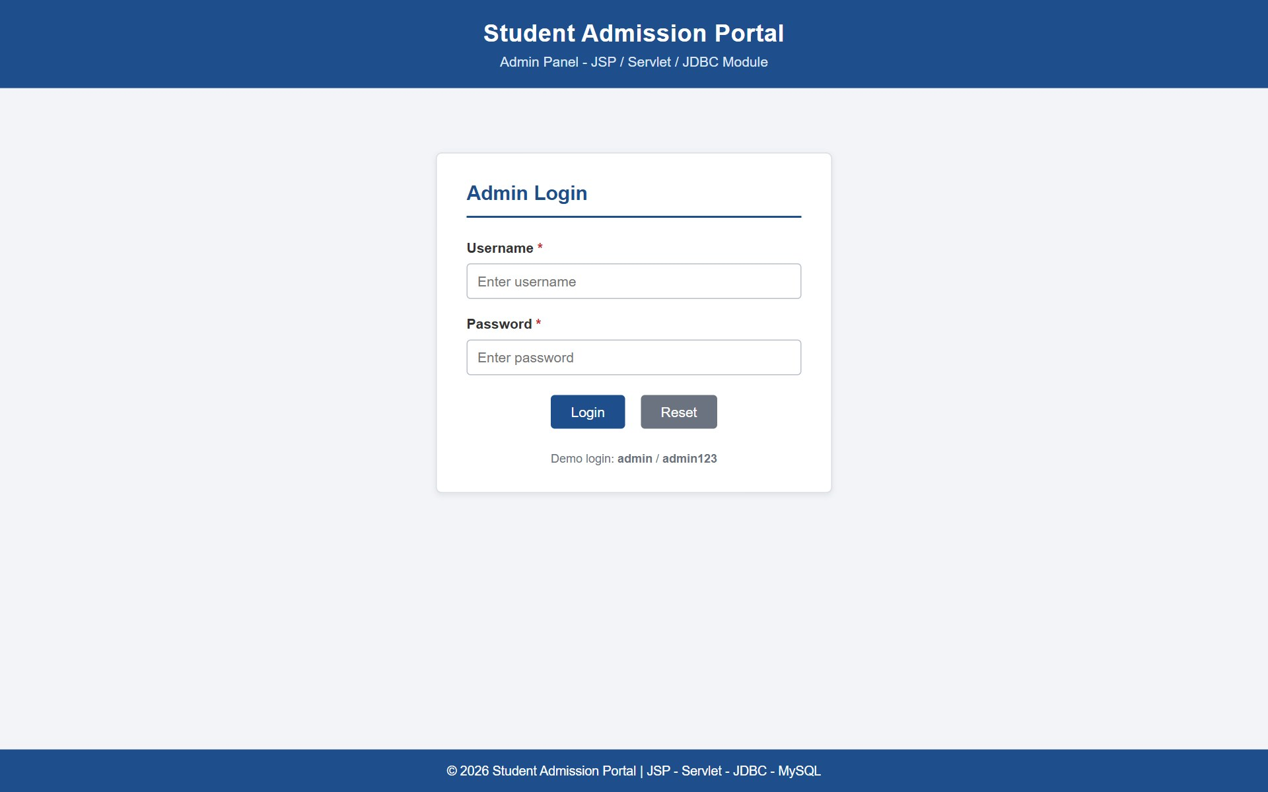
Figure 3.1 – Login Page
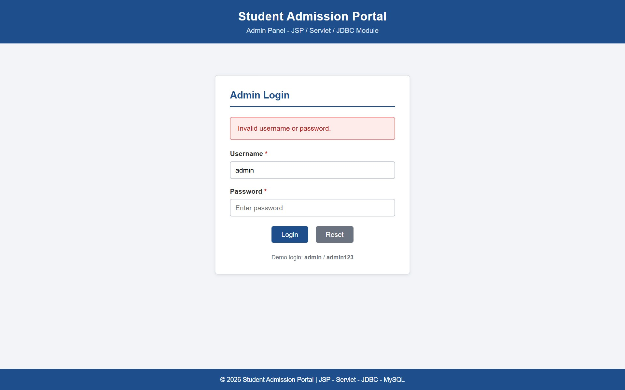
Figure 3.2 – Invalid Login Warning
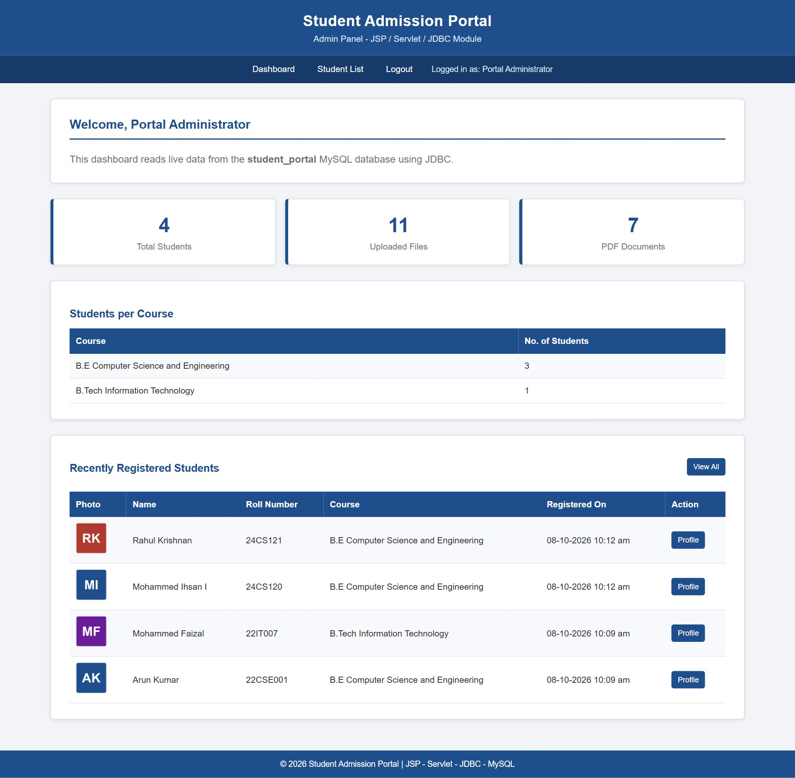
Figure 3.3 – Student Dashboard
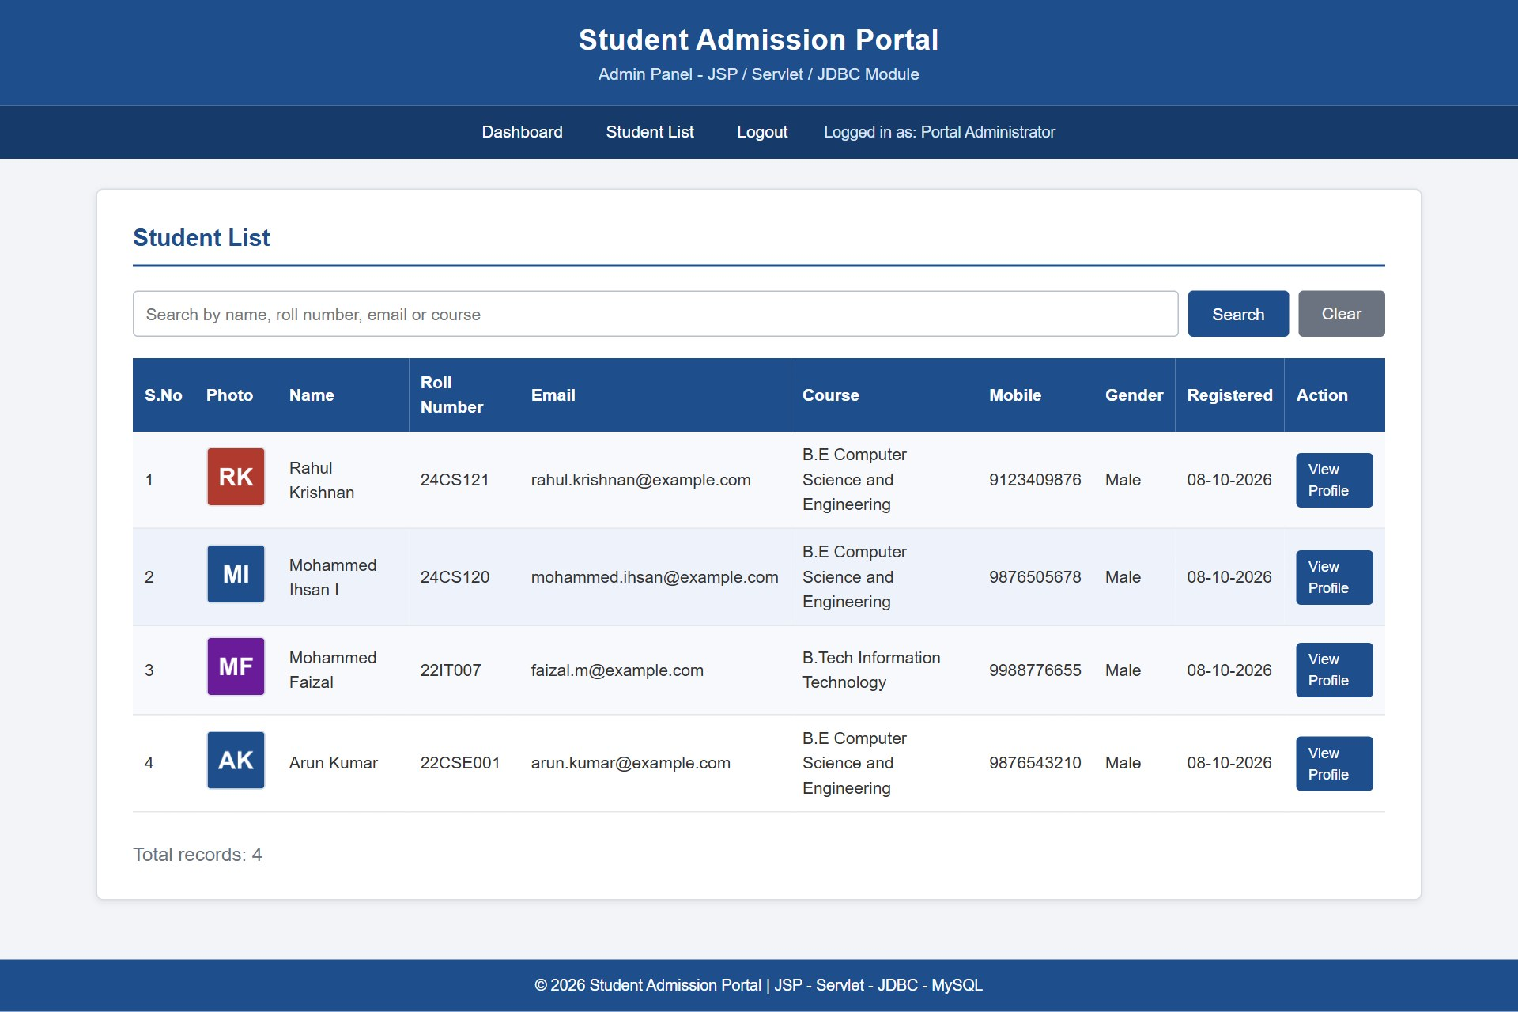
Figure 3.4 – Student List Rendered by JSP
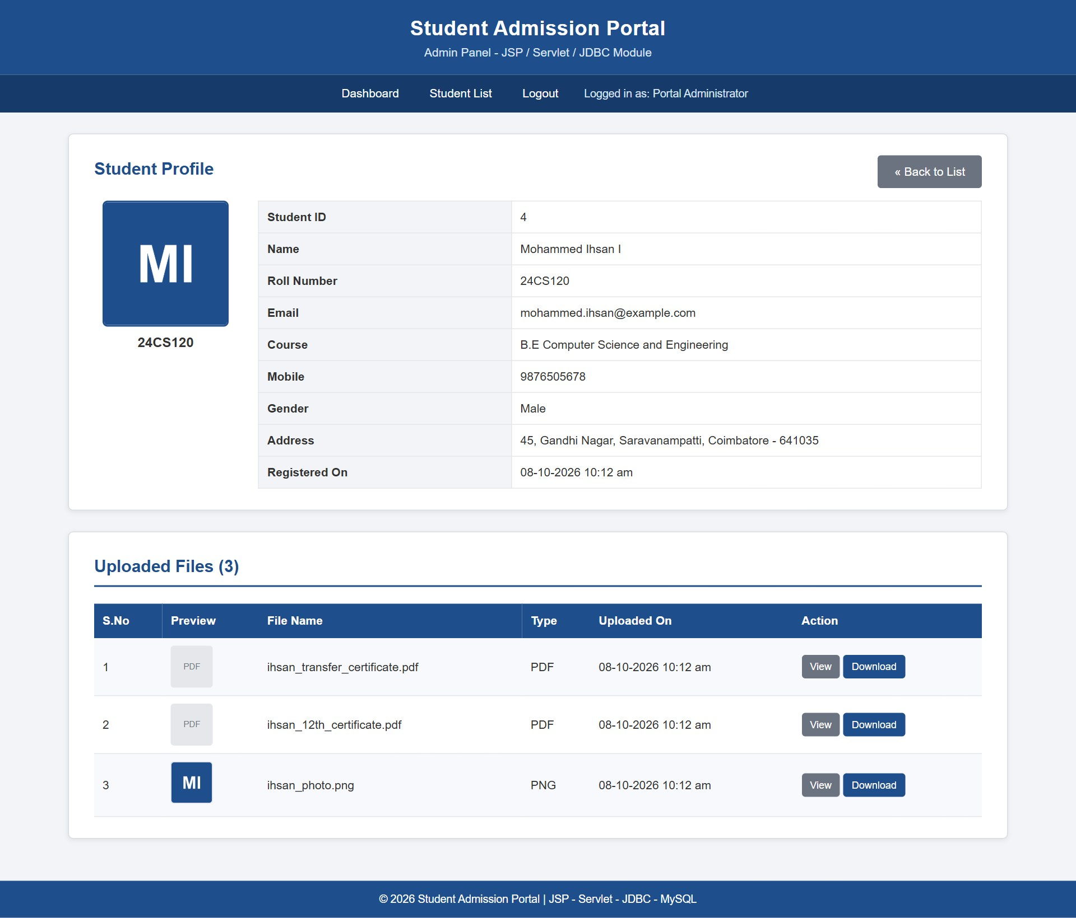
Figure 3.5 – Dynamic Student Profile Rendering

Figure 3.6 – Document Streaming Output

8. CONCLUSION
The Student Admission Portal with Registration, Student Management and Student Profile Viewing System was designed, implemented and tested successfully as part of Assignment II of the course U21CS501 – Web Technology. The project fulfils every requirement stated in the three questions and demonstrates how client-side technologies, a PHP server-side application and a Java web application can be combined to form a complete information system that operates on a single relational database.
Question 1 provided a practical understanding of how a well-structured user interface is built with HTML5 and CSS3. The use of semantic form controls, labels and grouped fields made the form clear and accessible, while the card layout, consistent colour scheme and media queries ensured that the page remains usable on screens of every size. Writing the validation logic in JavaScript strengthened the understanding of regular expressions, the Document Object Model and event handling, and showed the value of giving immediate and specific feedback to the user before any data is sent to the server.
Question 2 offered experience in server-side programming and relational database design. Designing the students and student_files tables reinforced the concepts of primary keys, unique constraints, foreign keys and referential actions such as ON DELETE CASCADE. Implementing the CRUD operations with prepared statements highlighted the importance of preventing SQL injection, and the use of transactions demonstrated how consistency can be maintained when several related operations must succeed or fail together. The file upload module provided insight into multipart form submission, server-side verification of file type and size, MIME type inspection and the generation of unique file names to prevent overwriting.
Question 3 introduced the architecture of Java web applications. Organising the code into Model, DAO, Servlet and JSP layers illustrated the Model-View-Controller pattern and the advantages of separating business logic from presentation. Working with JDBC clarified how connections, prepared statements and result sets are managed, and the use of try-with-resources ensured that database resources are released correctly. Implementing login, session creation, page restriction and logout gave a clear understanding of how state is maintained over the stateless HTTP protocol, while the development of FileServlet showed how binary content can be streamed securely with appropriate response headers.
Throughout the project, attention was given to security and reliability. Input was validated on both the client and the server, passwords were stored only as hashes, all output was escaped to prevent cross-site scripting, uploaded files were restricted and isolated, and administrative pages were protected by sessions. Errors arising from the database or from invalid input were handled gracefully and reported through clear messages instead of technical failures.
In conclusion, the assignment has strengthened both the theoretical understanding and the practical skills required for full-stack web development. The resulting portal is functional, secure, responsive and easy to maintain, and its modular structure allows further enhancements such as student self-service login, role-based access, pagination, e-mail notifications and deployment on a public server with HTTPS to be incorporated in the future.

9. GITHUB REPOSITORY
The complete source code of the project, including the database script, the README file and this documentation, is maintained in the following GitHub repository.
GitHub Repository Link | https://github.com/shankhannilgiris-ai/StudentAdmissionPortal
Repository Name | StudentAdmissionPortal
Maintained by | Mohammed Ihsan I (24CS120)

