WEB TECHNOLOGIES
Mini Project
SPORTS GROUND BOOKING SYSTEM
Name | Mohammed Ihsan I
Roll No | 24CS120
Class | III CSE B
Subject | Web Technologies
Technologies: HTML, CSS, JavaScript

1. index.html
<!DOCTYPE html>
<html lang="en">
<head>
<meta charset="UTF-8">
<meta name="viewport" content="width=device-width, initial-scale=1.0">
<title>Sports Ground Booking System</title>
<link rel="stylesheet" href="style.css">
</head>
<body>

<header>
<h1>🏟️ Sports Ground Booking System</h1>
</header>

<section class="grounds">

<div class="card">
<h2>🏏 Cricket Ground</h2>
<p class="location">📍 Main Sports Block</p>
<p class="capacity">👥 Capacity: 22 Players</p>
<p id="cricketStatus" class="available">🟢 Available</p>
</div>

<div class="card">
<h2>⚽ Football Ground</h2>
<p class="location">📍 Outdoor Arena</p>
<p class="capacity">👥 Capacity: 20 Players</p>
<p id="footballStatus" class="booked">🔴 Booked</p>
</div>

<div class="card">
<h2>🏀 Basketball Court</h2>
<p class="location">📍 Indoor Stadium</p>
<p class="capacity">👥 Capacity: 10 Players</p>
<p id="basketballStatus" class="available">🟢 Available</p>
</div>

</section>

<section class="form-section">

<h2>Book a Ground</h2>

<form id="bookingForm">

<input
type="text"
id="name"
placeholder="Student Name"
>

<select id="ground">
<option value="">Select Ground</option>
<option>Cricket Ground</option>
<option>Football Ground</option>
<option>Basketball Court</option>
</select>

<input
type="date"
id="date"
>

<button type="submit">
Submit Booking
</button>

</form>

<p id="message"></p>

</section>

<script src="index.js"></script>

</body>
</html>

2. style.css
*{
margin:0;
padding:0;
box-sizing:border-box;
font-family:'Segoe UI',sans-serif;
}

body{
min-height:100vh;
background:linear-gradient(135deg,#0f172a,#1e293b);
padding-bottom:40px;
}

header{
background:rgba(255,255,255,0.08);
backdrop-filter:blur(10px);
color:white;
text-align:center;
padding:25px;
box-shadow:0 4px 15px rgba(0,0,0,0.2);
}

header h1{
font-size:2.2rem;
}

.grounds{
display:flex;
justify-content:center;
gap:25px;
flex-wrap:wrap;
padding:40px 20px;
}

.card{
width:280px;
background:white;
border-radius:20px;
padding:25px;
text-align:center;
box-shadow:0 10px 25px rgba(0,0,0,0.15);
transition:0.3s;
}

.card:hover{
transform:translateY(-10px);
box-shadow:0 20px 35px rgba(0,0,0,0.2);
}

.card h2{
margin-bottom:10px;
color:#0f172a;
}

.location,
.capacity{
color:#64748b;
margin:6px 0;
font-size:14px;
}

.available{
color:#16a34a;
font-weight:bold;
margin-top:10px;
font-size:18px;
}

.booked{
color:#dc2626;
font-weight:bold;
margin-top:10px;
font-size:18px;
}

.form-section{
width:90%;
max-width:500px;
margin:auto;
background:white;
padding:35px;
border-radius:20px;
box-shadow:0 15px 35px rgba(0,0,0,0.2);
}

.form-section h2{
text-align:center;
margin-bottom:25px;
}

input,
select{
width:100%;
padding:14px;
margin-bottom:15px;
border:2px solid #e2e8f0;
border-radius:10px;
font-size:15px;
}

input:focus,
select:focus{
outline:none;
border-color:#16a34a;
}

button{
width:100%;
padding:14px;
border:none;
border-radius:10px;
background:linear-gradient(135deg,#16a34a,#22c55e);
color:white;
font-size:16px;
font-weight:bold;
cursor:pointer;
transition:0.3s;
}

button:hover{
transform:scale(1.03);
}

#message{
margin-top:15px;
text-align:center;
font-weight:bold;
font-size:16px;
}

@media(max-width:768px){

.grounds{
flex-direction:column;
align-items:center;
}

.card{
width:90%;
}

.form-section{
width:95%;
}
}

3. index.js
const grounds = {
"Cricket Ground": "Available",
"Football Ground": "Booked",
"Basketball Court": "Available"
};

const statusIds = {
"Cricket Ground": "cricketStatus",
"Football Ground": "footballStatus",
"Basketball Court": "basketballStatus"
};

const form = document.getElementById("bookingForm");
const message = document.getElementById("message");
const dateInput = document.getElementById("date");

const today = new Date().toISOString().split("T")[0];
dateInput.min = today;

form.addEventListener("submit", function(event){

event.preventDefault();

const name = document.getElementById("name").value.trim();
const ground = document.getElementById("ground").value;
const date = document.getElementById("date").value;

if(name === "" || ground === "" || date === ""){
message.style.color = "red";
message.innerText = "Please fill all fields.";
return;
}

const selectedDate = new Date(date);
const currentDate = new Date();

currentDate.setHours(0,0,0,0);

if(selectedDate < currentDate){
message.style.color = "red";
message.innerText = "Past dates cannot be booked.";
return;
}

if(grounds[ground] === "Booked"){
message.style.color = "red";
message.innerText =
ground + " is already booked. No slots available.";
return;
}

grounds[ground] = "Booked";

const statusElement =
document.getElementById(statusIds[ground]);

statusElement.className = "booked";
statusElement.innerHTML = "🔴 Booked";

message.style.color = "#16a34a";
message.innerText =
"Booking Request Submitted Successfully!";

form.reset();
});

4. Output
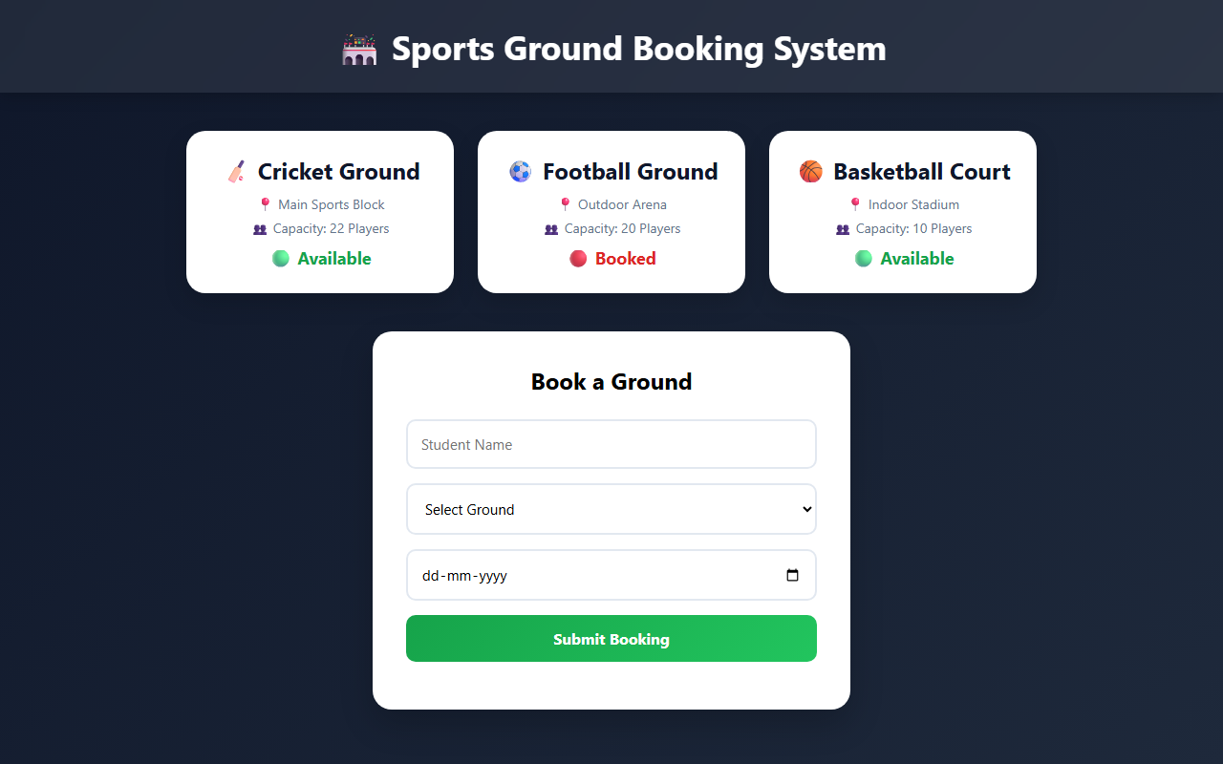
Figure 1: Home page showing grounds and their availability
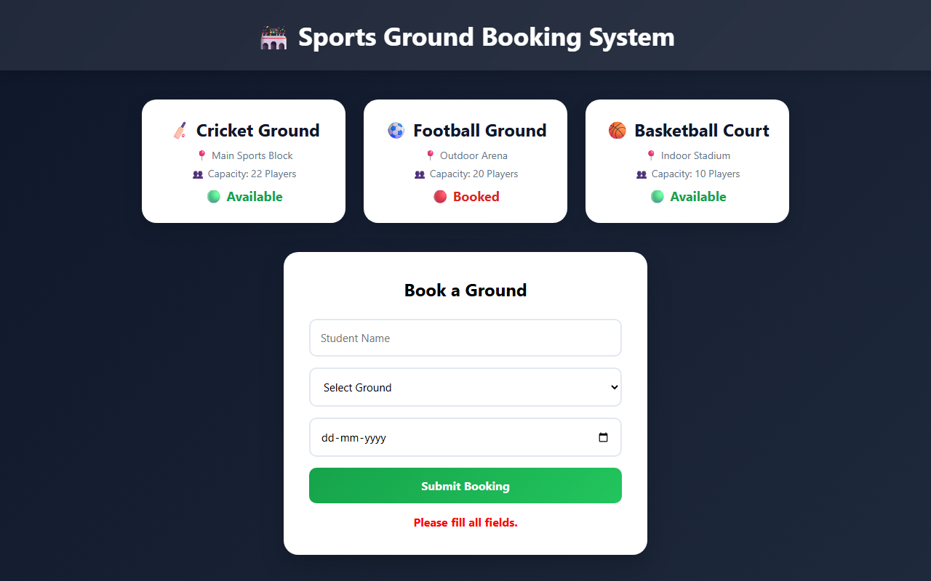
Figure 2: Validation message when fields are left empty

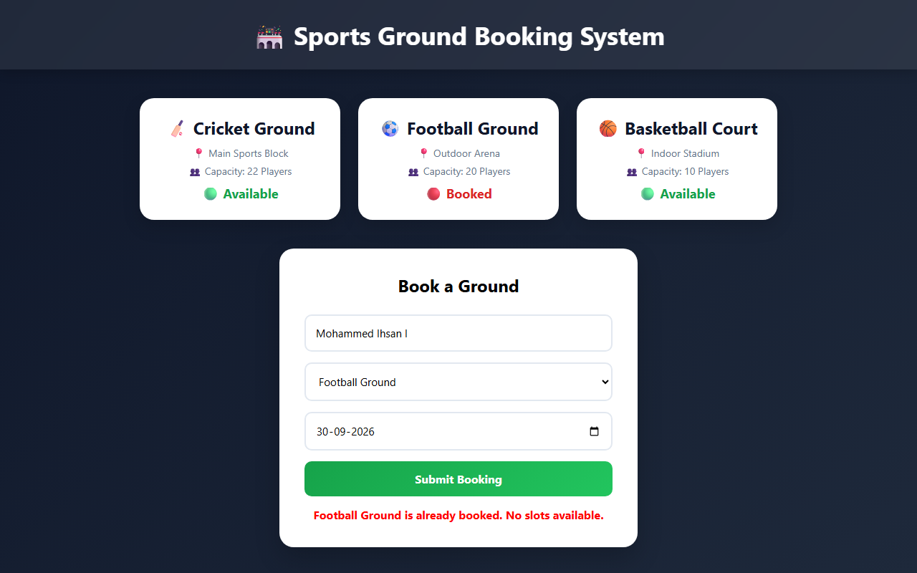
Figure 3: Trying to book a ground that is already booked
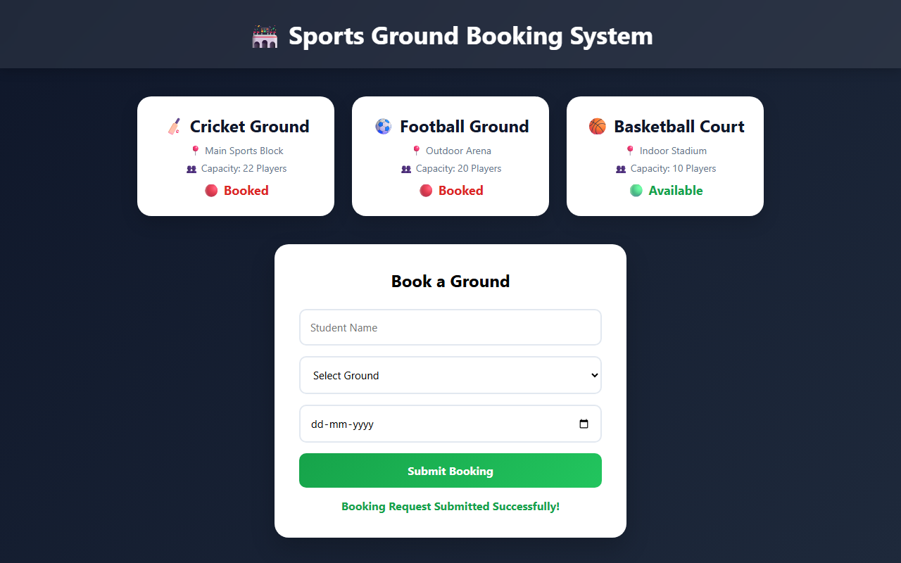
Figure 4: Successful booking – Cricket Ground status changes to Booked

