Assignment : With vibe coding implement the below
1)Connect to jira via api
2)Fetch the user storie from jira to generate testcases

Step 1 : JIRA Integration
Prompt : Analyze the existing code base and need to to implements the JIRA integration.. Provide step by step instructions to establish the JIRA connection
Reponse :
CURRENT CODEBASE ANALYSIS
Architecture:
- Backend: Express.js + Groq LLM integration
- Frontend: React + Vite
- Current Flow: Manual input → LLM generates test cases
To Add: Jira integration with dynamic project/story selection

🔧 STEP-BY-STEP IMPLEMENTATION PLAN
PHASE 1: BACKEND - JIRA CONNECTIVITY & CONFIGURATION
Step 1a: Install Jira Client Library
Step 1b: Create Jira Configuration Schema (backend/src/schemas.ts)
Add these new types:
Step 1c: Update Environment Variables (root .env)
Step 1d: Create Jira Client (backend/src/llm/jiraClient.ts)
- Initialize Jira client with auth (email + API key)
- Methods needed:
  - getProjects() - Fetch all projects
  - getStories(projectKey) - Fetch user stories by project
  - getStoryDetails(storyKey) - Fetch full story with acceptance criteria
Would you like me to proceed with this Phase 1 backend setup? ✓/✗

PHASE 2: BACKEND - NEW API ENDPOINTS
Create routes (backend/src/routes/jira.ts):
- POST /api/jira/config - Save/validate Jira credentials
- GET /api/jira/projects - List projects
- GET /api/jira/stories?projectKey=XXX - List stories by project
- POST /api/generate-tests - Modified to accept storyKey instead of manual input
Should I proceed with Phase 2? ✓/✗

PHASE 3: FRONTEND - TYPES & API SETUP
Update types.ts:
Update api.ts:
- saveJiraConfig(config) - Send credentials to backend
- fetchProjects() - Get projects list
- fetchStories(projectKey) - Get user stories
- generateTestsFromStory(storyKey) - Submit story for test generation
Proceed with Phase 3? ✓/✗

PHASE 4: FRONTEND - UI COMPONENTS
Modify App.tsx:
- Add Jira credentials form (email, API key, host)
- Replace manual story input with:
  - Dropdown 1: Select Project (with auto-populate)
  - Dropdown 2: Select User Story (with auto-populate after project selection)
  - Button: Generate Tests (calls backend with story key)
Create frontend/src/components/JiraConfig.tsx:
- Form for Jira credentials with save/validate
Should I implement Phase 4 UI components? ✓/✗

📌 BEFORE YOU APPROVE
Do you have:
- A Postman collection reference I should look at? (you mentioned referring to it)
- Jira instance URL?
- API authentication method preference (API token vs OAuth)?
- Default project/stories you want to test with?
Please confirm:
- Should I start with Phase 1 (Backend Jira Client)?
- Proceed sequentially through all phases?
Awaiting your approval to begin implementation! 🚀
Step 2 :
GO STEP BY STEP implmentatin up on my approval proceed with next step
[MAN]DATORY] : Start with KIRA Integration, Backend and proceed with Frontend
[CRITICAL] : Implement JIRA connectivity. Email and api key should be configurable.
Postman Collection : https://www.postman.com/prathibaviswanathan-1745800/workspace/prathiba/collection/53396437-4bc93c68-d748-48bb-898e-f10cbb266461?action=share&source=copy-link&creator=53396437
Jira instance URL & Fefault Project : : https://prathibaviswanathan-genai.atlassian.net/jira/software/projects/GT/boards/2/backlog
API authentication method preference : API Tokens
[CRITICAL] : Get the project details from JIRA and should be auto populated as drop down.
[CRITICAL] : Get the user story details from Project and should be auto populated as drop down.

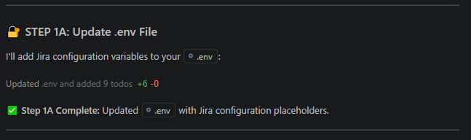
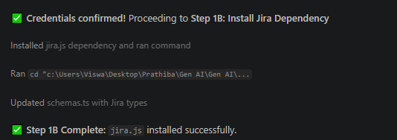

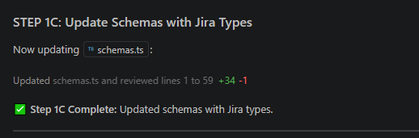
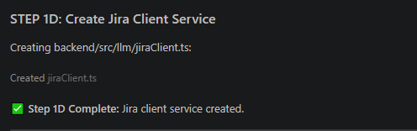
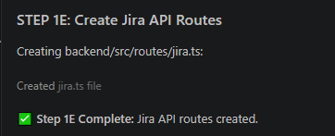

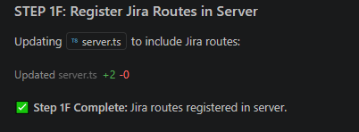

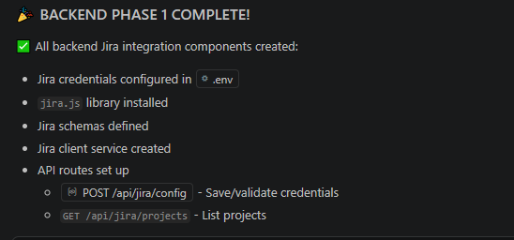
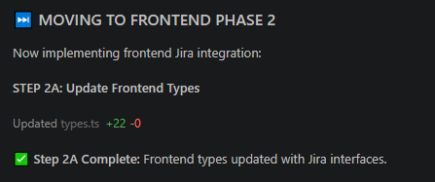
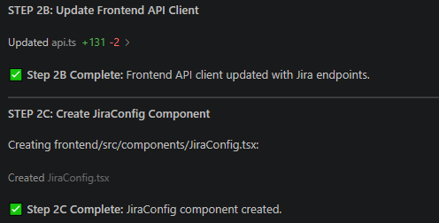

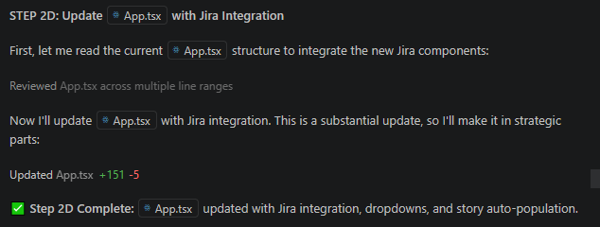
Completion
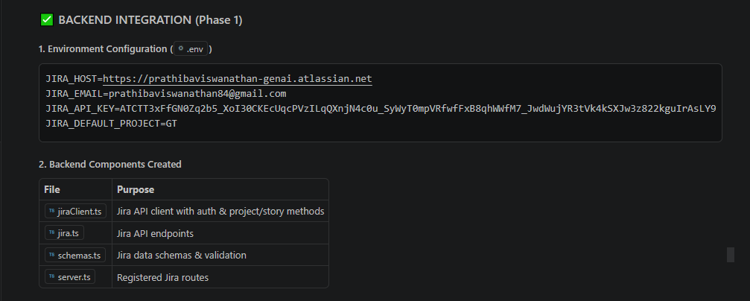
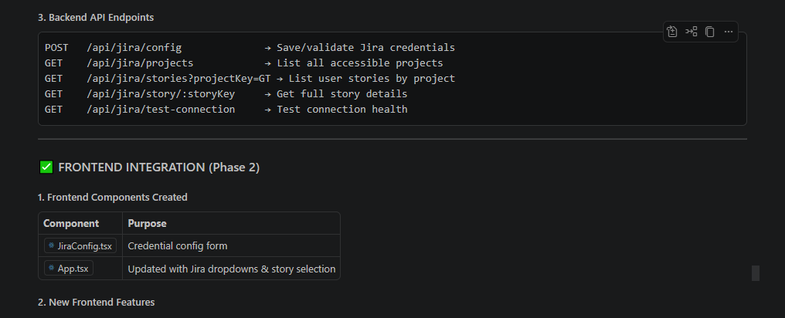
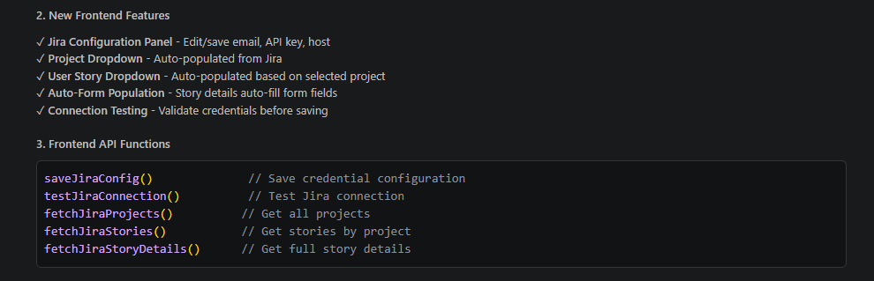
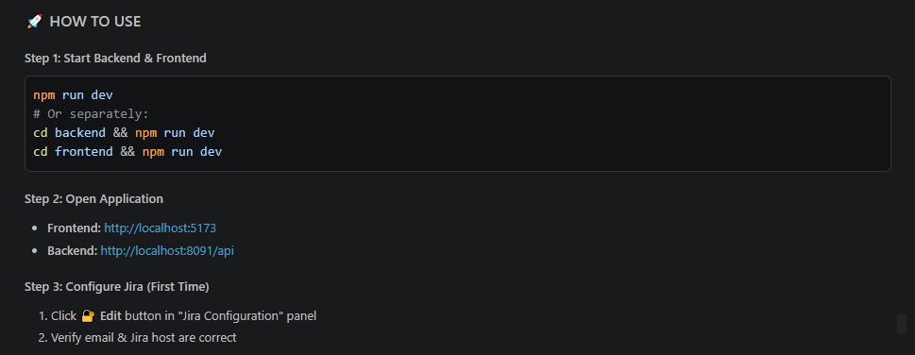
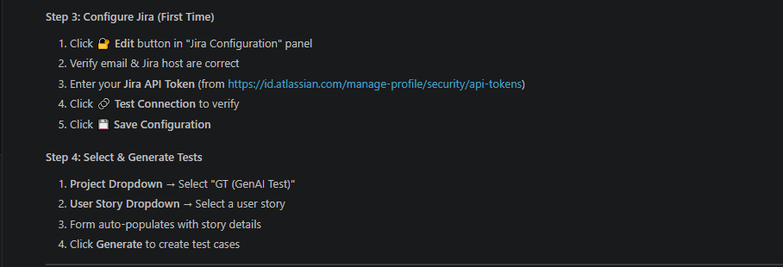
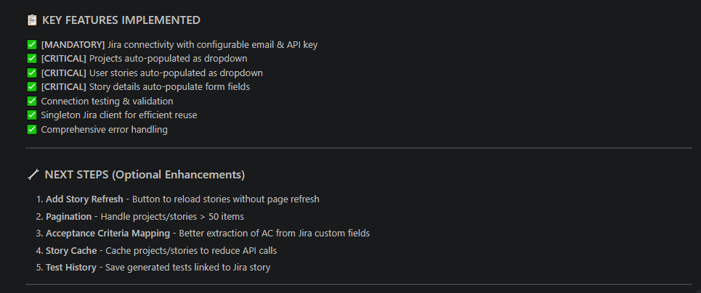
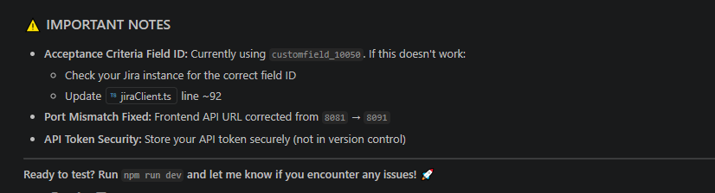

Application Post JIRA Integration :
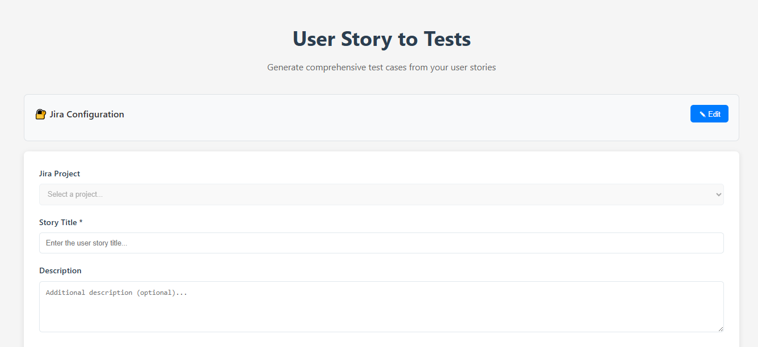
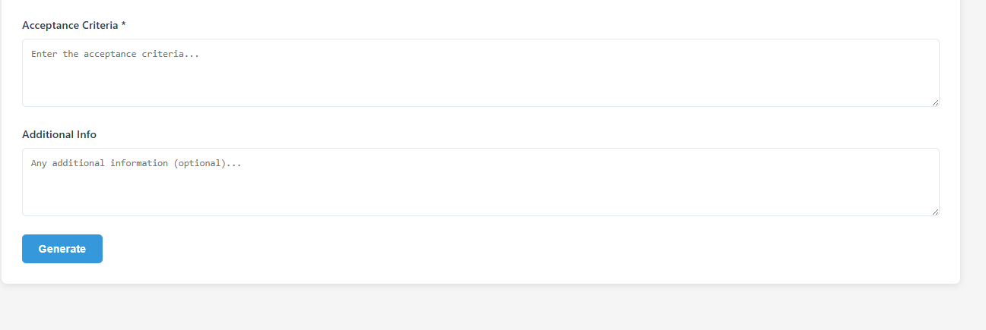
JIRA Connection Established
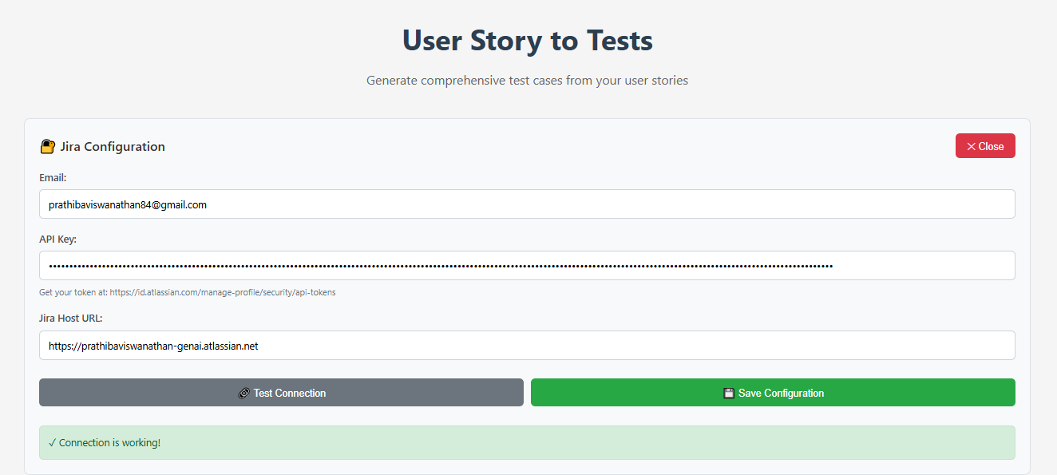
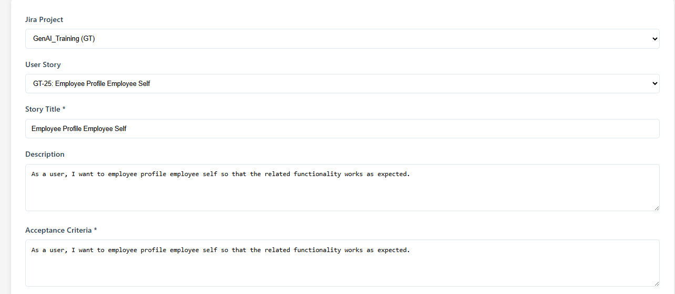
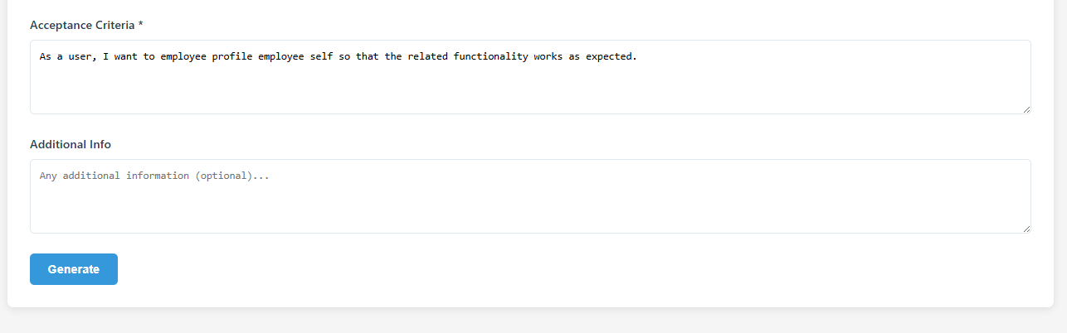

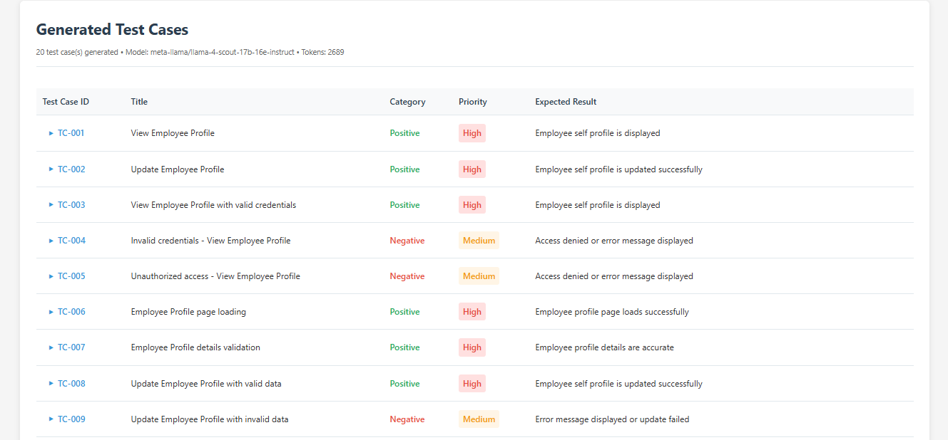

Detailed Test Cases :

