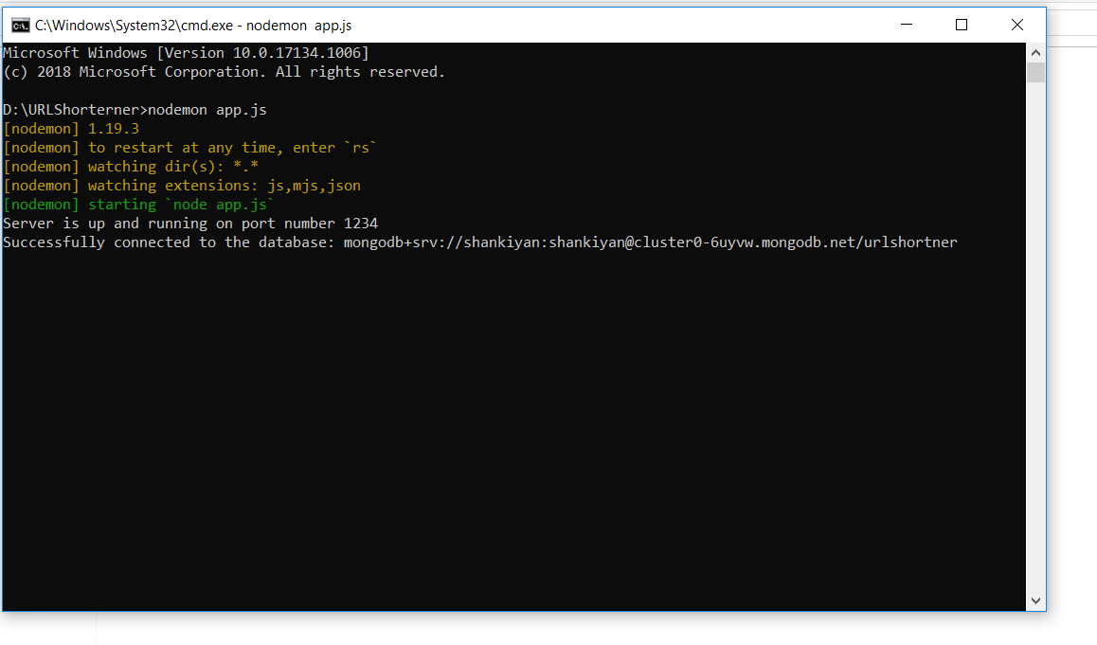

**Fig1 :** API is UP and Running and it its connected to my cloud MongoDB Service Atlas

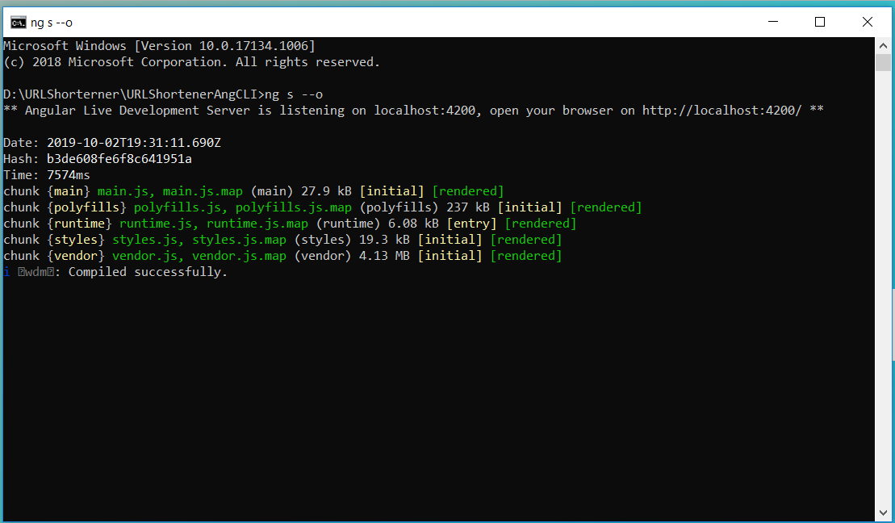

**Fig 2:**  UI is up and running

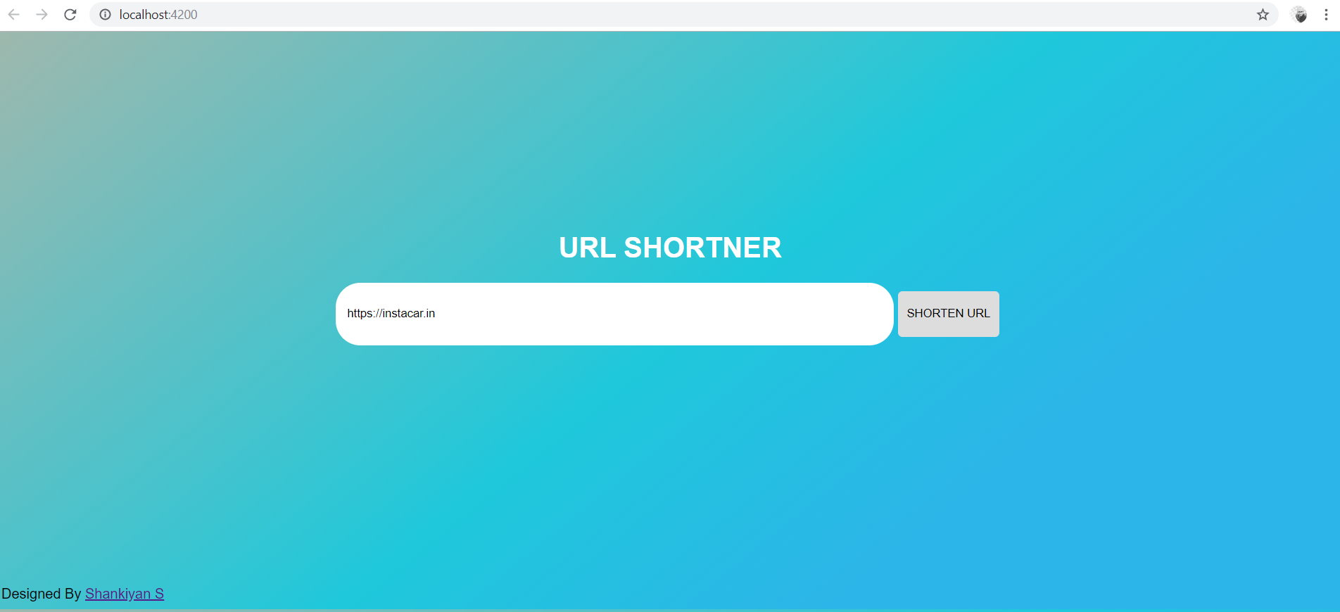

**Fig 3 :**  Angular App Rendered with its homepage and I gave URL as Input

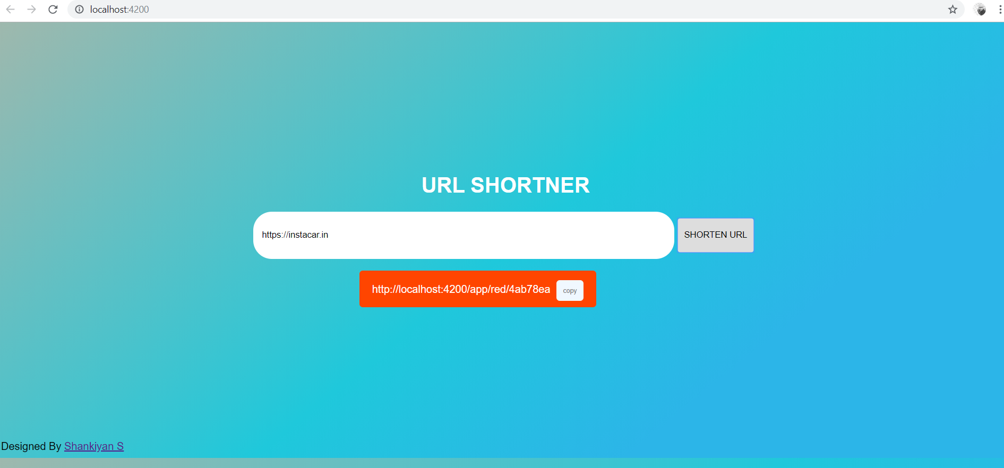

**Fig 4:**  Url has been shortened with the copy section

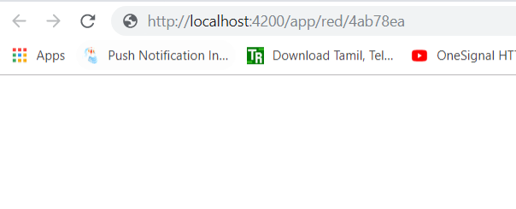

**Fig 5:**  Accessing the Shortened URL in another tab

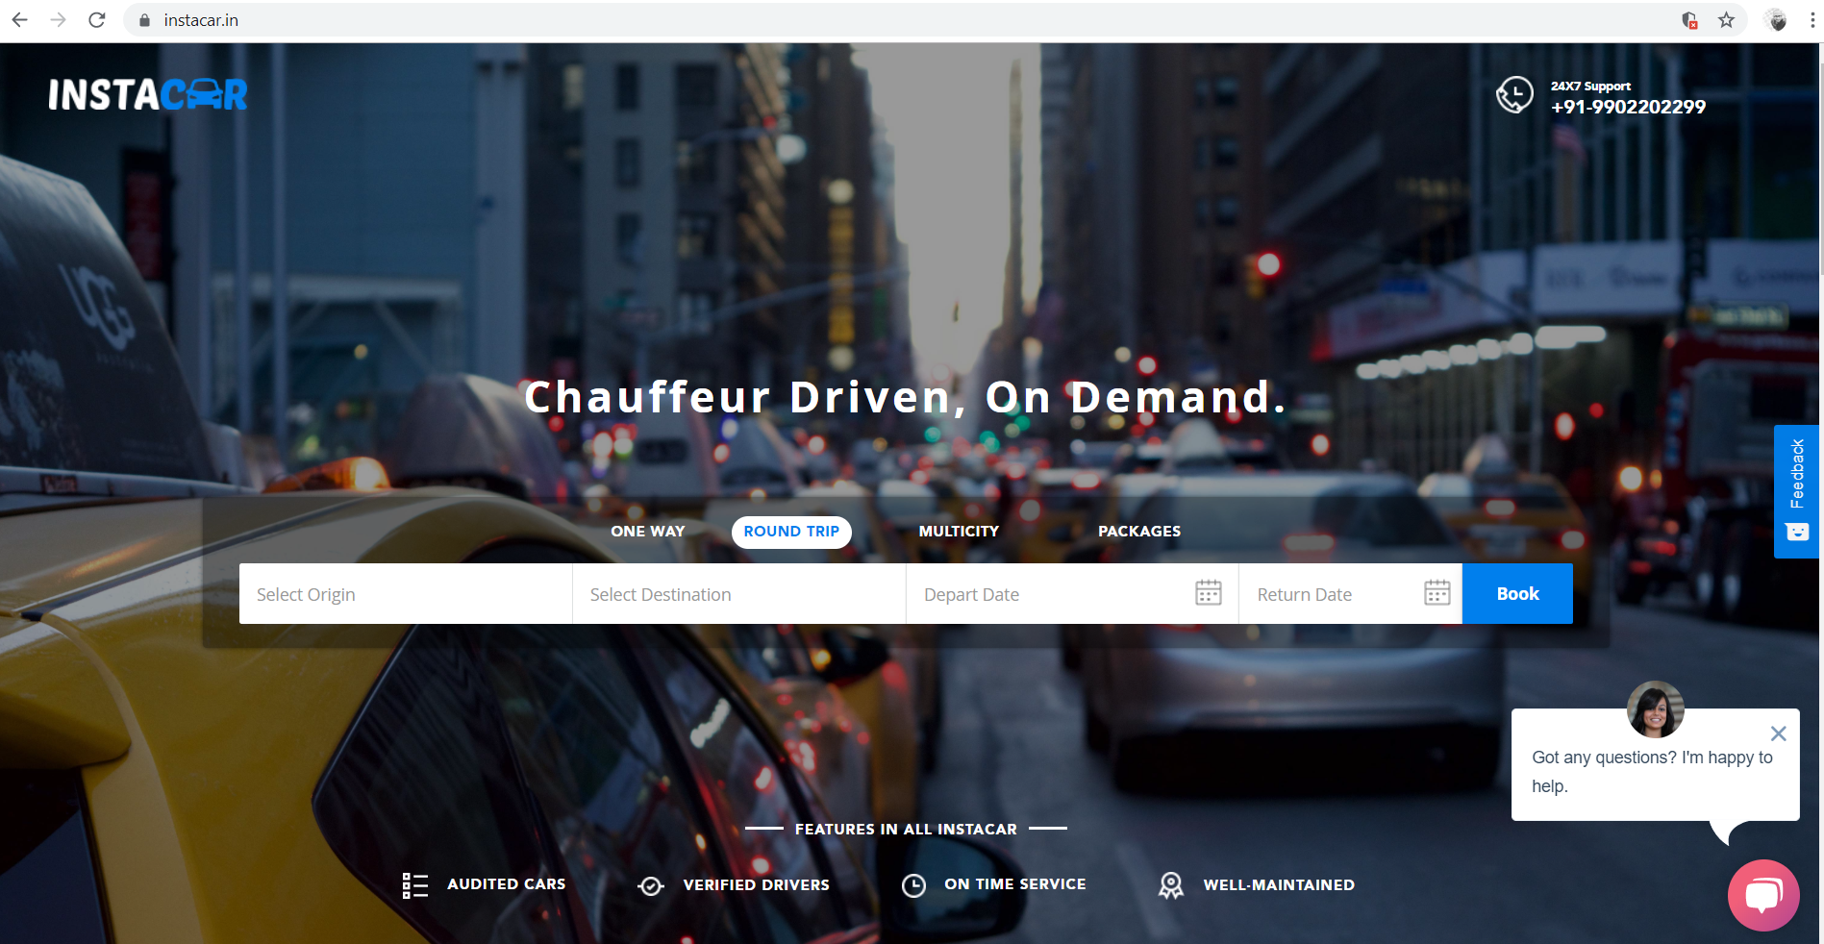

**Fig 6:**  It gets redirected to the original website

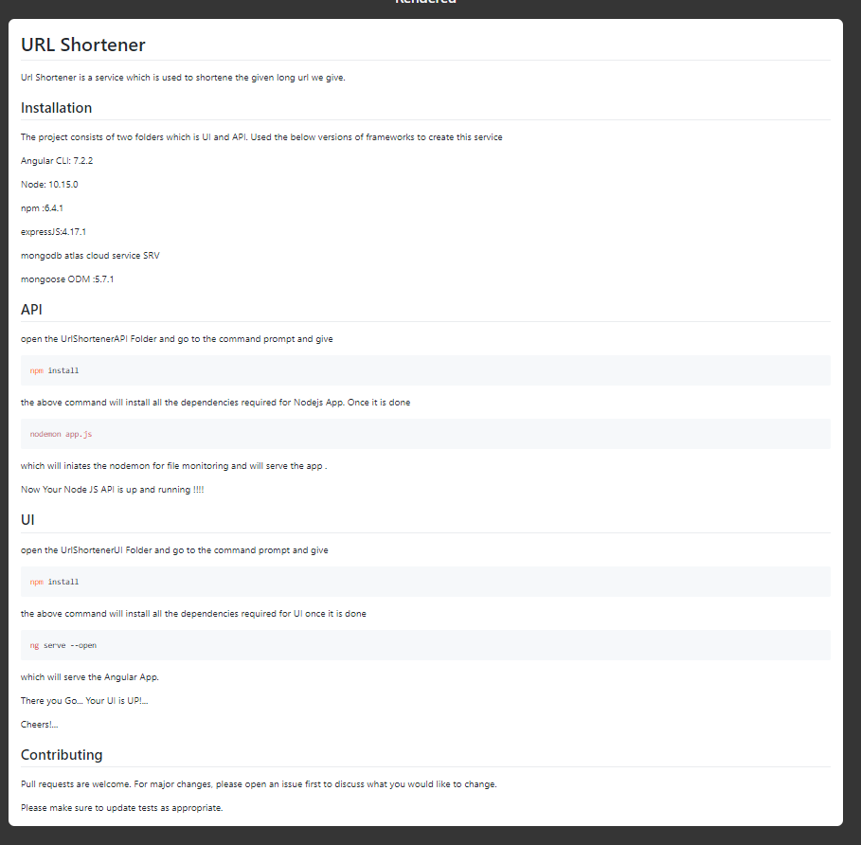

**Fig 7 :** Read me file