<!DOCTYPE html>

<html lang="en">

<head>

    <meta charset="UTF-8">

    <meta name="viewport" content="width=device-width, initial-scale=1.0">

    <title>Document</title>

</head>

<body>

    <input type="text" id="username">

</body>

</html>

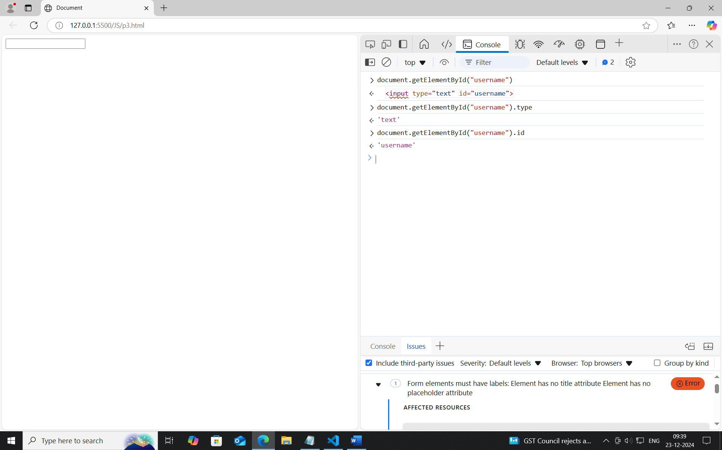

**Adding and changing the value.**

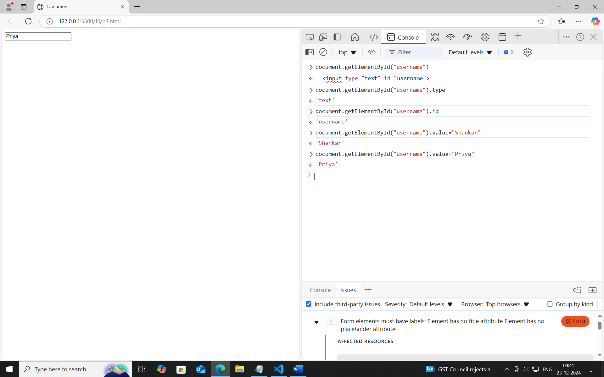

**Adding and changing the classname and type.**

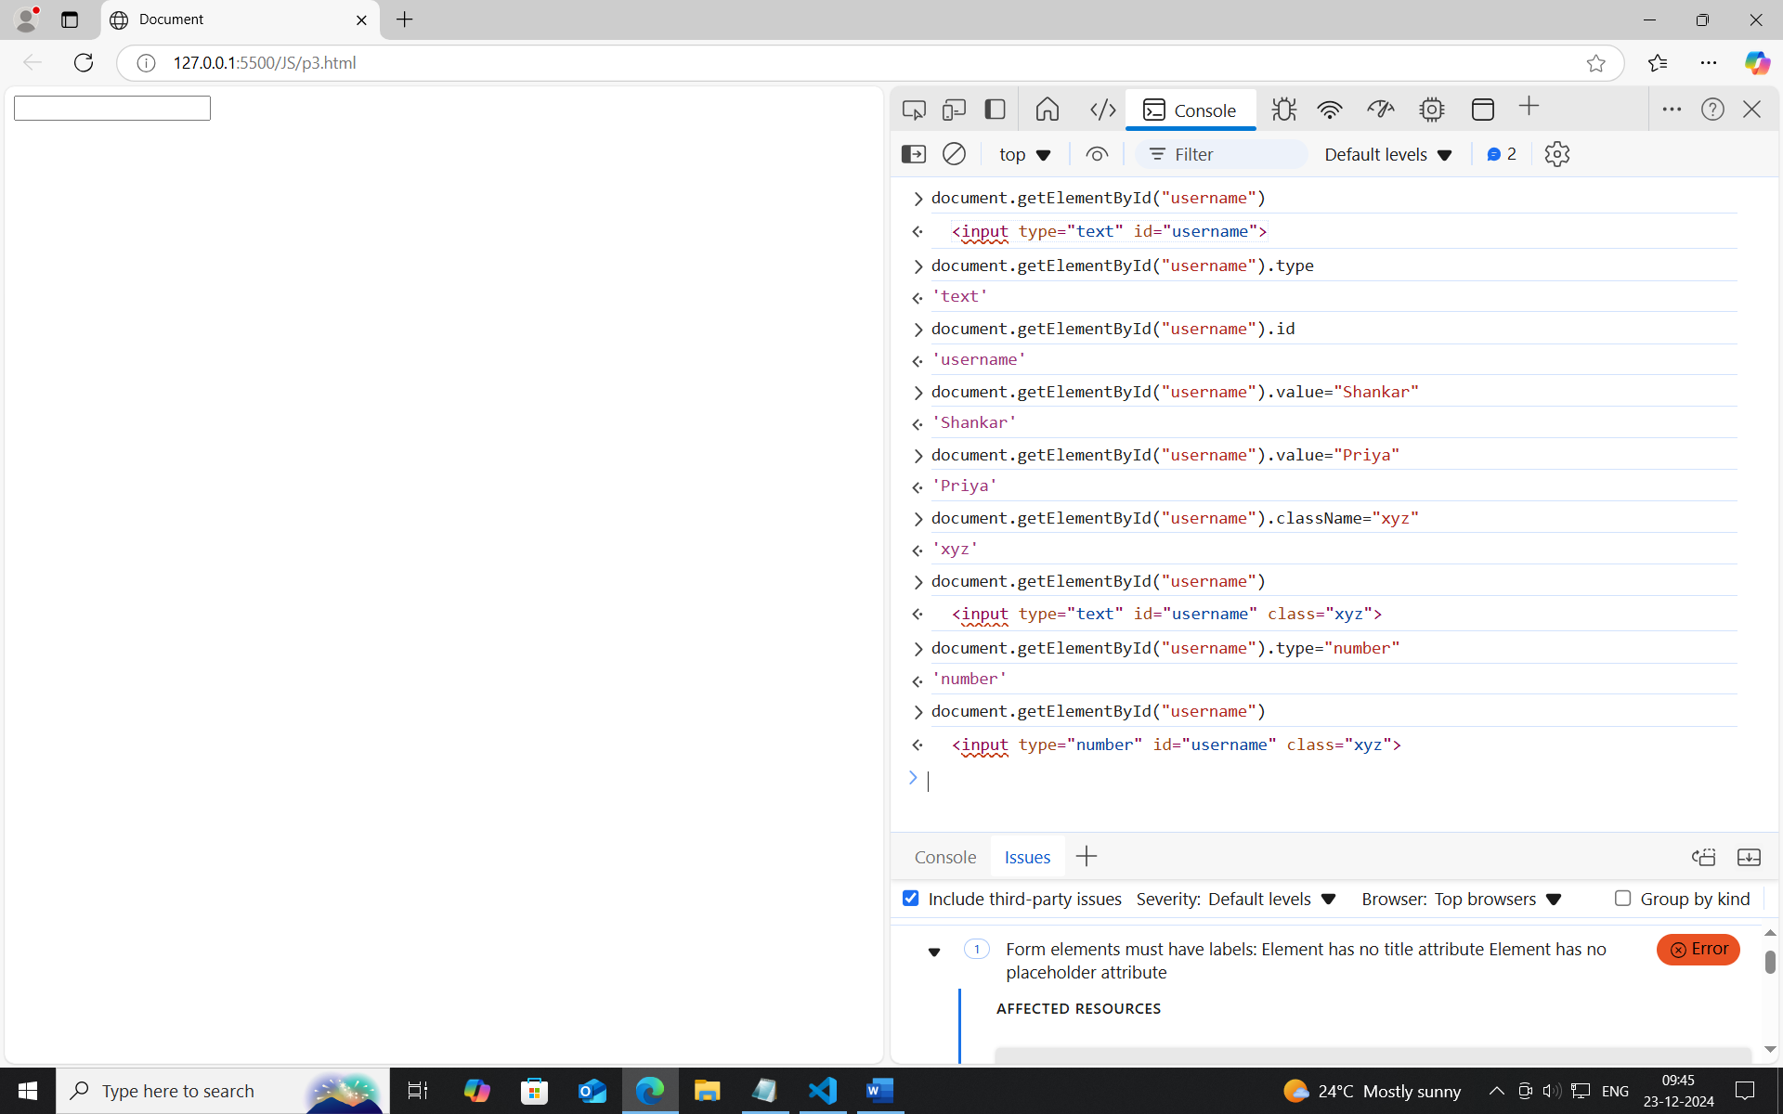

<body>

    <input type="text" id="username">

    <button id="usernamebtn">Click here</button>

    <!-- eventlistener("click",() =>{}) -->

    <script>

        document.getElementById("usernamebtn").addEventListener("click",()=>{

            alert("Hello")

        })

    </script>

</body>

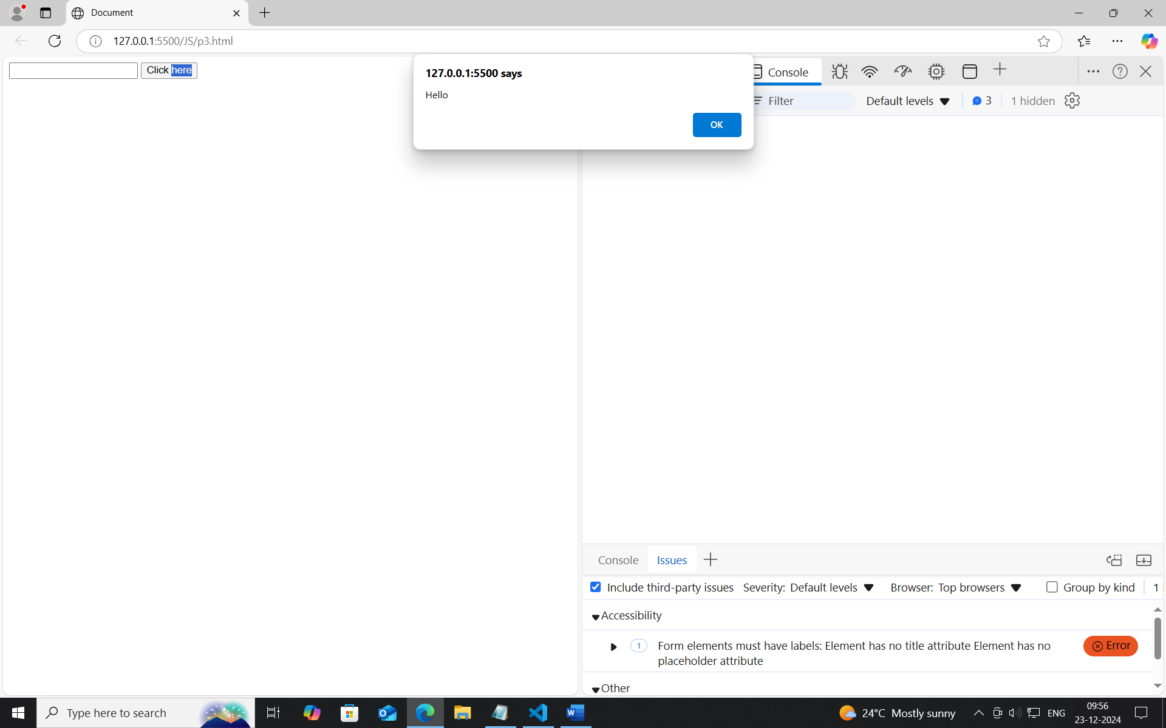

<!DOCTYPE html>

<html lang="en">

<head>

    <meta charset="UTF-8">

    <meta name="viewport" content="width=device-width, initial-scale=1.0">

    <title>Document</title>

</head>

<body>

    <input type="text" id="username">

    <button id="usernamebtn">Click here</button>

    <!-- eventlistener("click",() =>{}) -->

    <script>

        document.getElementById("usernamebtn").addEventListener("click",()=>{

            // alert("Hello")

            let username = document.getElementById("username").value;

            document.write("<h1>Welcome "+username+" </h1>");

        })

    </script>

</body>

</html>

