ELEC 3300 Project Summary Sheet
This is a ONE Page Summary Sheet, Content more than 1 page will be deleted.
All the fonts used in this Sheet should be in Times New Roman at 12 points

Group Number | 11
Project Title | Digital Storage Oscilloscope
Name of Student 1 | Ka Wai Au
Name of Student 2 | Stephen Shanko

Please attach ONE photo of your project here
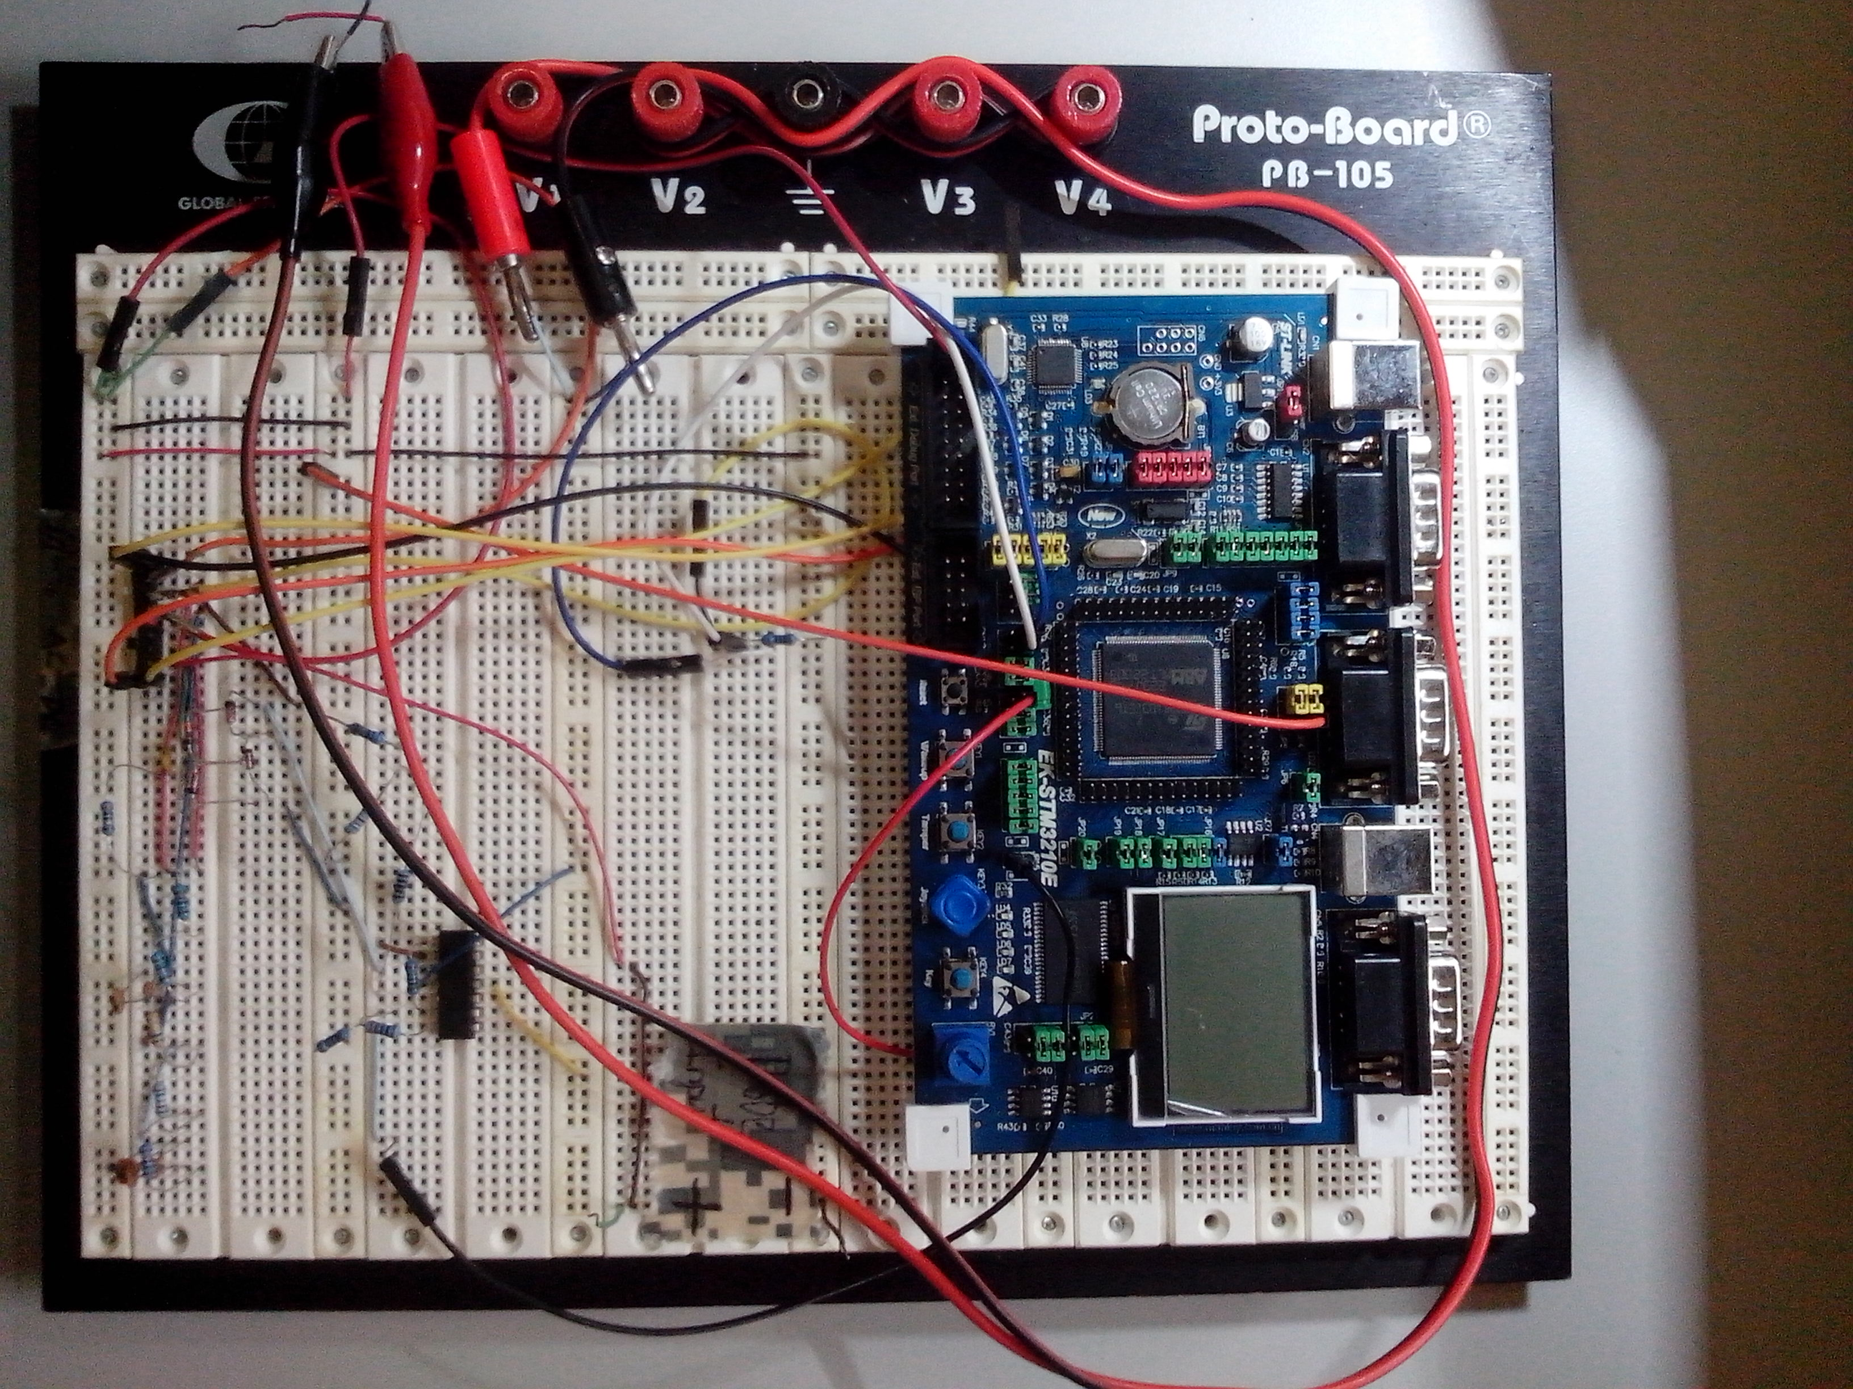

Please list the functions of your project in point form

- 300kS/s sampling rate
- 4MHz bandwidth
- Selectable 4x attenuation for an input voltage range up to +- 6.6V
- DC and AC coupling with input impedance of 30Ω 47nF
- Automatic triggering, frequency, period, and RMS calculations for periodic waveforms
- Maximum, minimum, mean, and peak to peak voltage calculations
- Voltage scale from 20mV to 3V per division
- Time scale from 50uS to .5S per division

