**Front End Engineering II**

Project Report

Semester-IV (Batch-2022)

Template 32

**Supervised By: Submitted By:**

Raveesh Samkaria Sukoon, 2210990870

**Department of Computer Science and Engineering**

## Chitkara University Institute of Engineering & Technology,

## Chitkara University, Punjab

**TABLE OF CONTENTS**

|  |  |  |
| --- | --- | --- |
|  | **TITLE** |  |
|  | **ABSTRACT** | **iii** |
| **1.0** | **INTRODUCTION** |  |
| **2.0** | **FOLDER STRUCTURE** | - |
| **3.0** | **CODE SCREENSHOTS** | - |
| **4.0** | **RESULT SCREENSHOTS** | - |

ABSTRACT

INTRODUCTION

FILE STRUCTURE

Main files: -

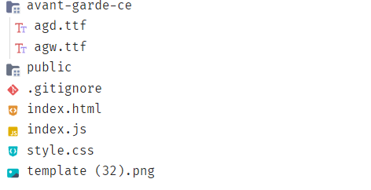

Public Directory: -

CODE SCREENSHOTS

Code can also be found at <https://github.com/sukoon870/fee-project-sem4/>

1. index.html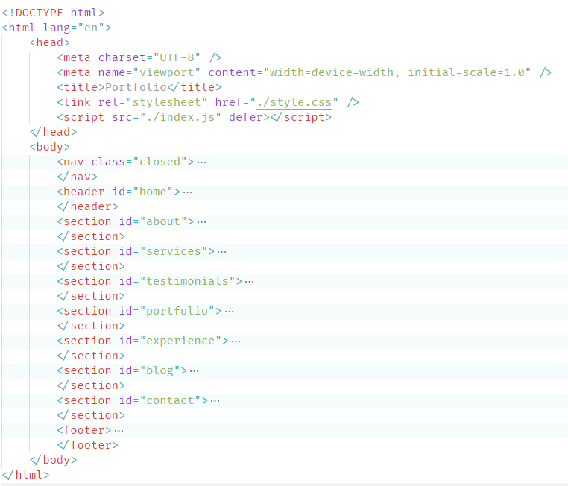A computer screen shot of a program

   Description automatically generatedA screen shot of a computer code

   Description automatically generatedA screenshot of a computer

   Description automatically generatedA screen shot of a computer program

   Description automatically generatedA screen shot of a computer code

   Description automatically generatedA screenshot of a computer program

   Description automatically generatedA screen shot of a computer program

   Description automatically generatedA screen shot of a computer program

   Description automatically generatedA screen shot of a computer program

   Description automatically generatedA screen shot of a computer program

   Description automatically generatedA screen shot of a computer code

   Description automatically generated
2. index.js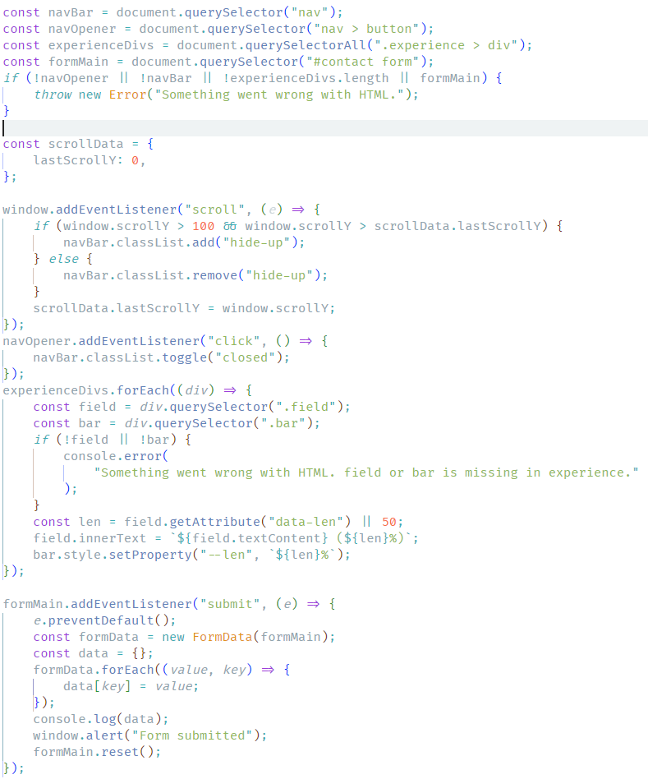
3. style.css  
   A screenshot of a computer code

   Description automatically generatedA screen shot of a computer code

   Description automatically generated

RESULT SCREENSHOTS

Website can be found at <https://sukoon870.github.io/fee-project-sem4/>

1. Desktop   
   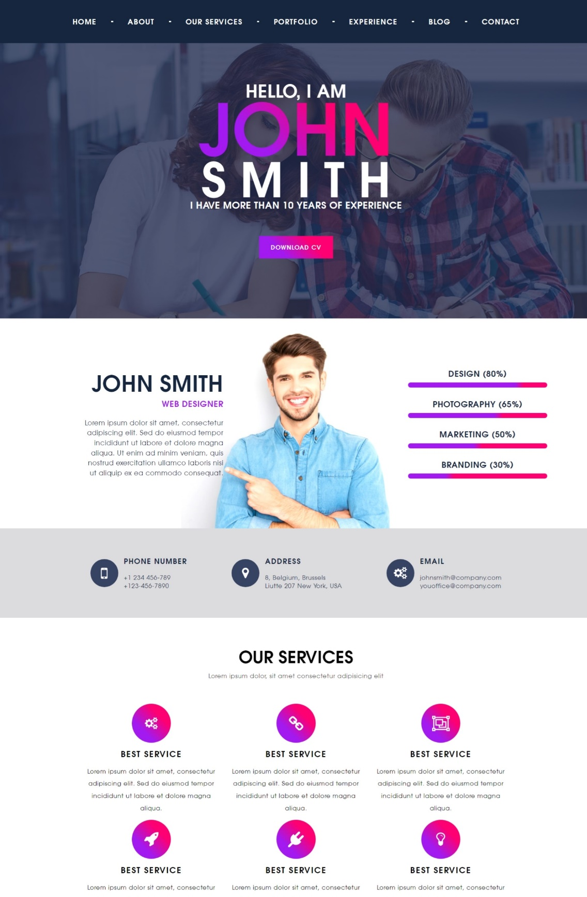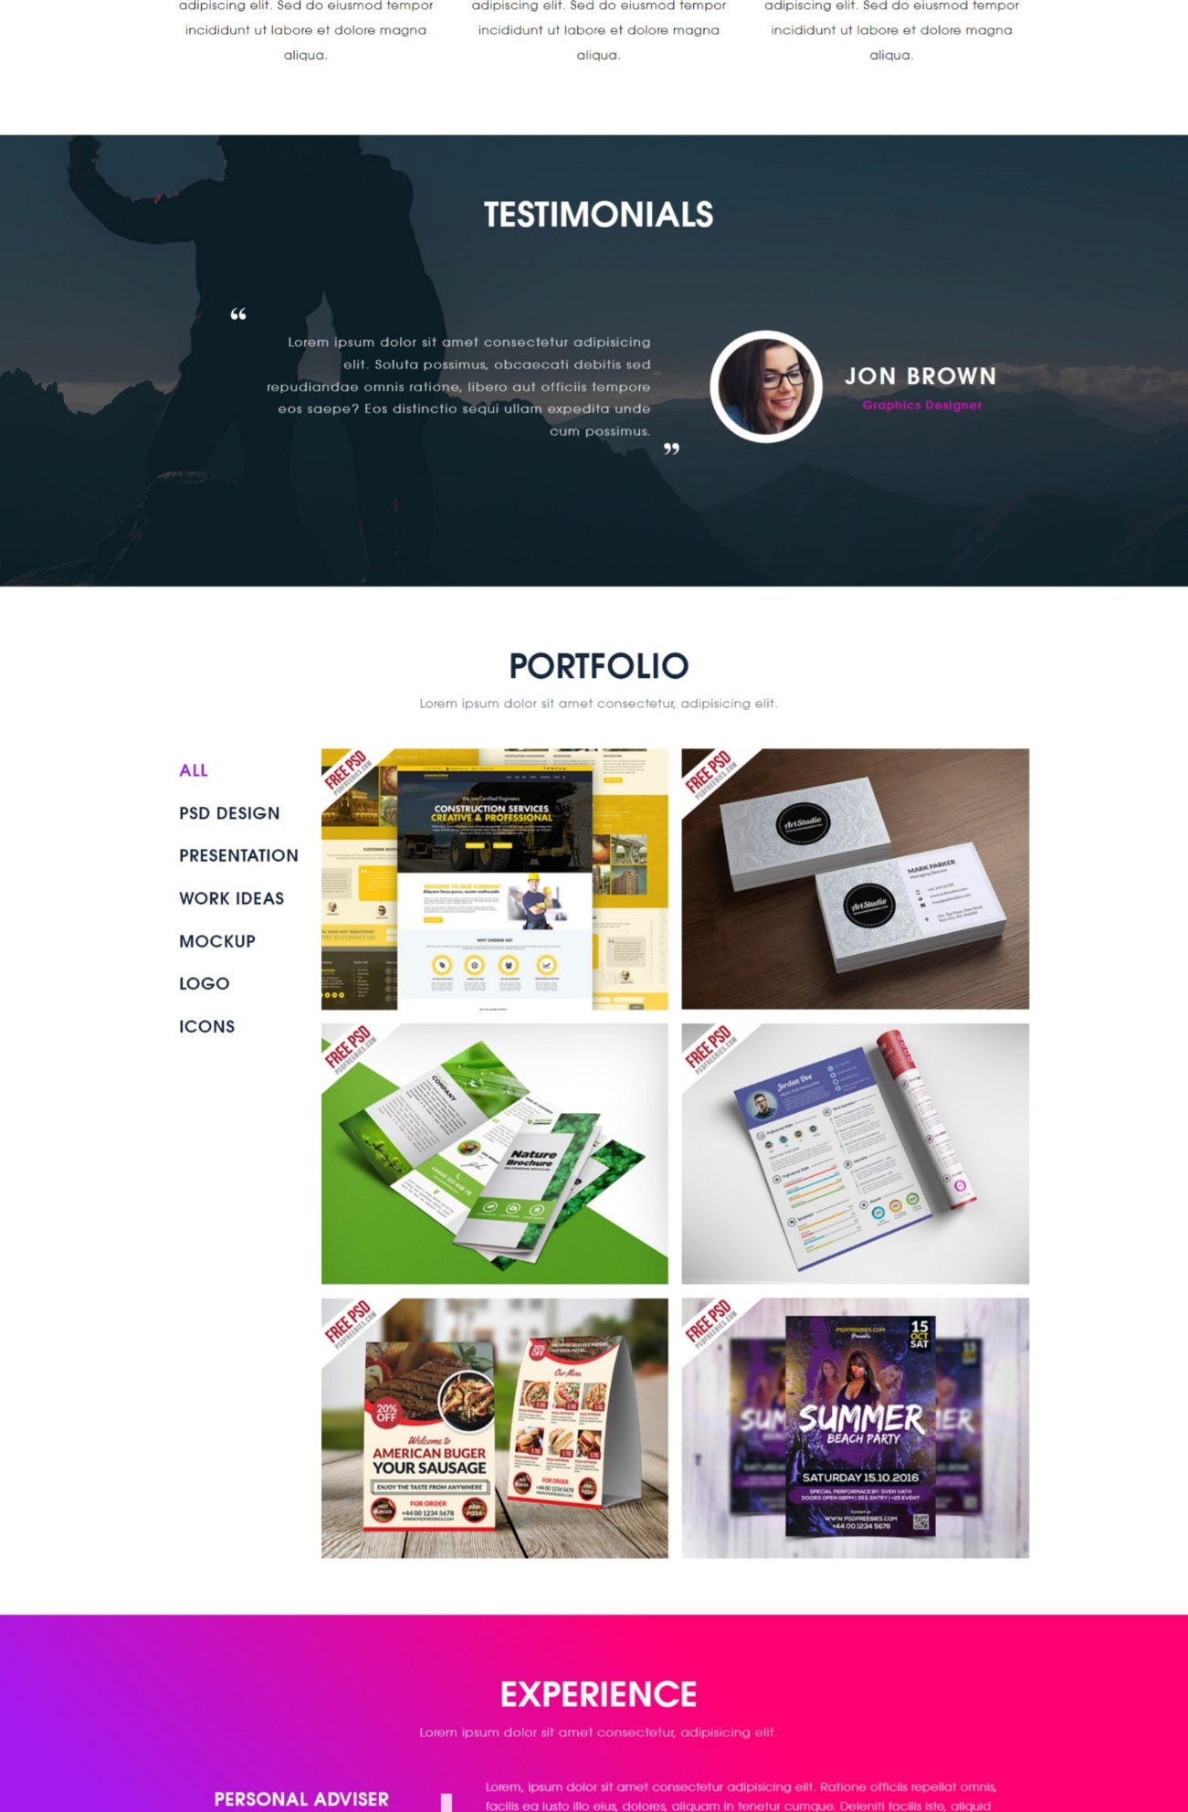A website with a contact page

   Description automatically generated with medium confidence
2. Mobile  
     
   A person with a purple and black text

   Description automatically generated with medium confidence A screenshot of a phone

   Description automatically generated  
   A screenshot of a phone

   Description automatically generated A screenshot of a phone

   Description automatically generated A collage of a calendar

   Description automatically generated A pink and purple cover

   Description automatically generated