NoSQL Database Course Project
Migration of Data from a Relational Database to a NoSQL Database

Jovana Filipovska · Darko Koprivnjak
May 2026

1. Introduction

This project demonstrates a complete end-to-end data migration pipeline from a relational database (PostgreSQL) to a NoSQL database (MongoDB). The domain chosen is a Flight Booking System, which models the real-world operations of airlines, airports, passengers, bookings, and flight management.
The project is structured in six phases: relational schema design and data population, selection and justification of a NoSQL database, data modeling in MongoDB, programmatic migration with transformations, automated validation, and a visualization layer. All code is version-controlled on GitHub and the entire environment is containerized using Docker Compose.
The team consists of two students: Jovana Filipovska, who was responsible for the PostgreSQL schema design, data generation, and validation layer; and Darko Koprivnjak, who was responsible for MongoDB modeling, the migration script, and the visualization notebook.

2. Relational Database Design and Data Modeling

2.1 Schema Overview
The relational schema consists of 10 tables designed around the core entities of a flight booking system. The schema uses PostgreSQL 15 and enforces referential integrity throughout.

2.2 Tables and Relationships
Table | Row Count | Description
airports | 1,800 | Real-world airports from OpenFlights with coordinates
airlines | 990 | Active airlines with IATA codes from OpenFlights
routes | 5,000 | Direct flight routes between airport pairs
aircraft | 29 | Aircraft models with seat counts and range
passengers | 3,500 | Synthetic passengers generated with Faker
flights | 2,500 | Scheduled and completed flights
bookings | 12,000 | Core transaction table — exceeds 10,000 row minimum
reviews | 4,918 | Passenger reviews for completed bookings
loyalty_accounts | 3,500 | One loyalty account per passenger
flight_delays | 595 | Delay records for a subset of flights

2.3 Integrity Constraints
- Primary keys: every table has a SERIAL primary key
- Foreign keys: bookings references passengers and flights; flights references airlines, aircraft, airports; reviews references bookings; loyalty_accounts references passengers; flight_delays references flights; routes references airlines and airports
- NOT NULL: applied to all mandatory fields across all tables
- UNIQUE: iata_code on airports and airlines; email and passport_number on passengers; booking_reference on bookings; one review per booking; one loyalty account per passenger
- CHECK constraints: latitude/longitude ranges on airports; positive seat counts and range on aircraft; arrival after departure on flights; price >= 0 on bookings and flights; rating 1–5 on reviews; valid enum values for status fields (cabin_class, booking status, flight status, delay reason, loyalty tier)

2.4 ER Diagram
The ER diagram below was generated from the PostgreSQL schema using dbdiagram.io. It shows all 10 tables with primary keys, foreign keys, data types, and NOT NULL constraints.
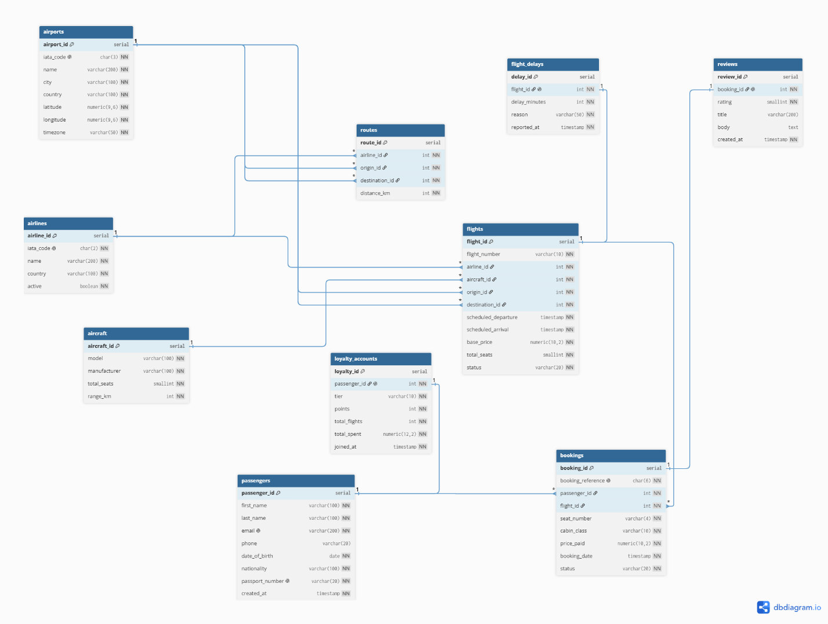
Note: The flights table is the central entity, connecting airlines, aircraft, and two airport references (origin and destination). The bookings table connects flights and passengers and is the primary transaction record with 12,000 rows.

3. Data Population

3.1 Data Sources
Data was populated using a Python script (data_gen/generate.py) that combines two sources:
Real-world data: Airports, airlines, and routes were downloaded directly from the OpenFlights dataset (https://github.com/jpatokal/openflights). This provides authentic IATA codes, geographic coordinates, and route information.
Synthetic data: Passengers, bookings, reviews, loyalty accounts, and flight delays were generated using the Python Faker library with a fixed random seed (42) for reproducibility.

3.2 Generation Script
The script truncates all tables and repopulates them in dependency order (parent tables first). Key generation decisions:
- Bookings: 12,000 rows generated — 20% above the 10,000 row minimum requirement
- 70% of flights follow real OpenFlights route pairs, 30% are fully synthetic
- Cabin class weighted distribution: 75% economy, 20% business, 5% first class
- Booking status weighted to reflect reality: 55% completed, 30% confirmed, 10% cancelled, 5% no-show
- Review rate: 55% of completed bookings receive a review

3.3 Record Counts
The following counts were verified after population using the migration validation script:
Table | Record Count
airports | 1,800
airlines | 990
routes | 5,000
aircraft | 29
passengers | 3,500
flights | 2,500
bookings | 12,000
reviews | 4,918
loyalty_accounts | 3,500
flight_delays | 595

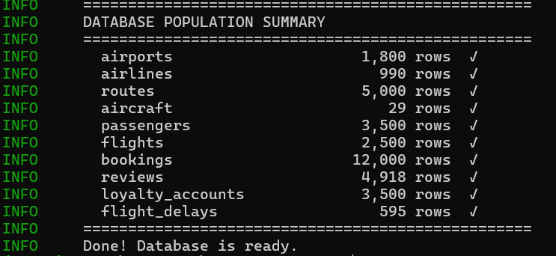

4. Choice of NoSQL Database

4.1 Selected Database: MongoDB
MongoDB was selected as the target NoSQL database for this project. MongoDB is a document-oriented database that stores data as BSON (Binary JSON) documents, grouped into collections.

4.2 Justification
Data model compatibility: The flight booking domain naturally maps to hierarchical documents. A booking document can embed the passenger profile, the flight details, the airline, origin and destination airports, and the review — all in a single document. This matches exactly how the data is queried in practice: a booking agent retrieves all information about a booking in one operation, not through 6 separate joins.
Query patterns: MongoDB's aggregation pipeline supports the complex queries required for this project — grouping revenue by airline, computing occupancy rates, filtering by loyalty tier — with a syntax well suited to nested document structures.
Scalability: MongoDB supports horizontal sharding by shard key (e.g., booking_reference or passenger email). This makes it suitable for a production booking system that would grow to millions of bookings.
Derived field support: MongoDB documents can store precomputed fields (such as loyalty_tier, revenue_per_km, avg_review_score) that would require expensive joins or subqueries in SQL at query time. Computing these during migration and storing them denormalized improves read performance.

4.3 Comparison with Alternative NoSQL Databases
Criterion | MongoDB (chosen) | Redis | Cassandra
Type | Document store | Key-value store | Column-family store
Data model | Flexible JSON documents | Simple key → value pairs | Wide rows, partition keys
Query support | Rich aggregation pipeline | No query language; key lookups only | CQL (limited joins)
Nested data | Native embedding | Not supported natively | Not supported natively
Scalability | Horizontal sharding | In-memory, single-node primary | Linear horizontal scale
Best for | General-purpose apps | Caching, sessions, queues | Time-series, IoT, logs
Fit for project | Excellent | Poor | Moderate

4.4 Redis — Why It Was Rejected
Redis is a key-value store optimized for in-memory access. It would require storing each booking as a serialized JSON string under a key such as booking:ABC123. This makes it impossible to query by passenger, airline, or date range without loading all keys. There is no aggregation support, no secondary indexes by default, and no way to express the relational structure of the data. Redis is well-suited for caching and session storage but is a poor fit for a transactional booking system.

4.5 Cassandra — Schema Sketch
Cassandra organizes data into tables with a mandatory partition key and optional clustering columns. The schema would be query-driven, requiring a separate table for each access pattern:
bookings_by_passenger — partition key: passenger_email, clustering: booking_date DESC
bookings_by_flight — partition key: flight_number, clustering: booking_date DESC
This design duplicates data for each access pattern and cannot easily support ad-hoc aggregations like total revenue per airline. Cassandra excels at high-throughput append-only workloads (such as logging or IoT), but the booking system requires flexible queries that MongoDB handles more naturally.

5. NoSQL Database Modeling

5.1 Collections
The MongoDB database (flight_nosql) contains 5 collections, each corresponding to a primary entity:
Collection | Documents | Description
bookings | 12,000 | Core collection — fully denormalized booking documents
flights | 2,500 | Flight documents with embedded airline, aircraft, origin, destination, delay, and stats
passengers | 3,500 | Passenger documents with embedded loyalty account
airlines | 990 | Airline documents with aggregated revenue and on-time stats
airports | 1,800 | Airport documents with GeoJSON point coordinates

5.2 Embedding vs Referencing Decisions
Embedded (denormalized): Passenger details, loyalty tier, airline name, origin/destination airport info, aircraft model, delay data, and review are all embedded inside booking documents. This is justified because bookings are always queried with all their context — a booking view needs all of this information simultaneously.
Referenced (normalized): Airports and airlines are kept as separate collections because they are large, stable, and shared across thousands of documents. Duplicating 1,800 airport records into every flight document would waste storage and make updates difficult.
Aggregated stats embedded: Each flight document contains a stats sub-document with precomputed occupancy_rate, revenue_per_km, avg_review_score, and total_revenue. These would require expensive aggregations at query time in SQL.

5.3 Derived Fields Computed During Migration
Field | Collection | Computation
loyalty_tier | bookings, passengers | bronze/silver/gold/platinum based on total_flights (5/20/50 thresholds)
total_spent | passengers | SUM(price_paid) per passenger across all confirmed/completed bookings
occupancy_rate | flights | (confirmed + completed bookings) / total_seats × 100
revenue_per_km | flights | SUM(price_paid) / distance_km for each flight route
avg_review_score | flights | AVG(rating) across all reviews linked to bookings for this flight
on_time_rate | airlines | (total flights − delayed flights) / total flights × 100
price_category | flights | budget (<$100), standard ($100–$400), premium (>$400) from base_price

6. Data Migration Process

6.1 Script Overview
The migration is implemented in migration/migrate.py. It connects to both PostgreSQL and MongoDB, loads all source data into memory, computes derived fields, and upserts documents into MongoDB using bulk write operations.

6.2 Migration Steps
- Step 1 — Load all 10 PostgreSQL tables into Python dictionaries keyed by primary ID
- Step 2 — Build aggregation lookups: per-flight booking counts and revenue, per-passenger spending totals, per-airline delay counts
- Step 3 — For each collection, compute derived fields and build denormalized documents
- Step 4 — Upsert documents in batches of 500 using MongoDB bulk_write with UpdateOne(upsert=True)
- Step 5 — Create indexes on key fields (iata_code, email, booking_reference, flight_number)
- Step 6 — Print migration summary with document counts and elapsed time

6.3 Idempotency
Every insert uses UpdateOne with upsert=True keyed on a stable natural identifier (iata_code for airports/airlines, email for passengers, booking_reference for bookings, flight_number + departure timestamp for flights). Running the script a second time produces zero new documents — all operations become updates. This was verified during development: Run 1 showed inserted=12000 for bookings, Run 2 showed inserted=0, updated=12000.

6.4 Error Handling
Error Scenario 1 — Missing foreign key references: If a booking row references a passenger_id or flight_id that does not exist in the loaded dictionaries (e.g. due to a truncated load or data corruption), the booking is skipped with a WARNING log entry including the booking_reference. Migration continues with the remaining records.
Error Scenario 2 — Malformed price values: If price_paid cannot be cast to float or is negative, the booking is skipped with a WARNING log entry. This handles NULL values, non-numeric strings, or negative prices that may result from data quality issues.
Connection failures: Both PostgreSQL and MongoDB connections are wrapped in try/except blocks. A connection failure logs a CRITICAL message and exits with code 1, preventing silent partial migrations.
All errors are written to logs/migration.log with timestamps for post-migration review.

6.5 Performance
The full migration of 21,290 source rows into 5 MongoDB collections completes in approximately 49 seconds on the first run. The second run (idempotency check) completes in 2.8 seconds because upserts on existing documents are faster than initial inserts and index builds.

7. Data Validation Report

7.1 Validation Approach
Automated validation is implemented in validation/validate.py. It connects to both databases and runs 13 checks across three categories. The script exits with code 0 if all checks pass, or code 1 if any fail, making it suitable for CI/CD pipelines.

7.2 Check Results
# | Check | Expected | Result
1 | Count: airports | 1,800 | PASS
2 | Count: airlines | 990 | PASS
3 | Count: flights | 2,500 | PASS
4 | Count: passengers | 3,500 | PASS
5 | Count: bookings | 12,000 | PASS
6 | Checksum: booking_reference + price_paid + status | Match | PASS
7 | Checksum: row count agreement | Match | PASS
8 | Spot-check 3a: Top 5 airlines by revenue match | Match | PASS
9 | Spot-check 3a: Top 5 airline revenues within 1% tolerance | Match | PASS
10 | Spot-check 3b: Booking status distribution matches | Match | PASS
11 | Spot-check 3c: Loyalty tier distribution matches | Match | PASS
12 | Spot-check 3d: Top 5 departure airports match | Match | PASS
13 | Spot-check 3e: Booking count for busiest flight (LH5225) | Match | PASS
All 13 checks passed with 0 failures. Total validation elapsed time: 0.4 seconds.

7.3 Checksum Methodology
For the bookings table (12,000 rows), a SHA-256 hash is computed over the concatenation of booking_reference, price_paid (rounded to 2 decimal places), and status for every row, sorted by booking_reference. The same hash is computed independently from MongoDB. A matching hash proves that no records were lost, duplicated, or modified during migration.

7.4 Spot-Check Methodology
Five equivalent aggregation queries are executed on both databases and their results compared. For example, the top 10 airlines by total confirmed/completed booking revenue are computed with a 6-table join in PostgreSQL and a MongoDB aggregation pipeline on the bookings collection. Both return the same top 5 airlines in the same order, with revenues matching within 1% tolerance (to account for floating-point rounding differences).
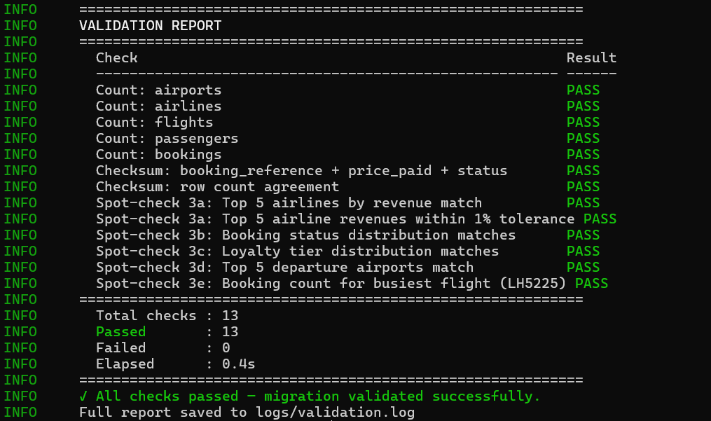

8. Data Visualization Layer

All visualizations are implemented in viz/visualisations.ipynb using Plotly. All data is read exclusively from MongoDB — no PostgreSQL connection is made in the notebook. The visualizations exercise the derived fields computed during migration to prove the pipeline is usable end-to-end.

Visualization 1 — World Flight Route Map
A world map rendered using Plotly's Scattergeo with flight routes drawn as arcs and airports marked as orange dots. Airport coordinates are loaded from the MongoDB airports collection (stored as GeoJSON Point during migration). The map demonstrates that geographic data was correctly denormalized and migrated. 300 completed and scheduled flights are displayed.
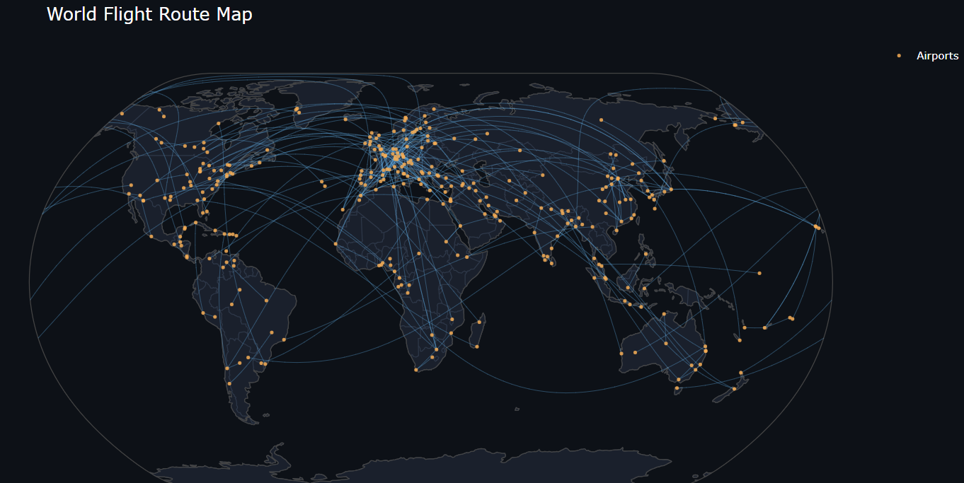

Visualization 2 — Top 20 Routes by Revenue per km
A horizontal bar chart showing the 20 most revenue-efficient flight routes filtered to routes over 500km with at least 3 bookings. Each bar is colored by price_category (budget/standard/premium). This chart exercises the revenue_per_km and price_category derived fields, which do not exist in PostgreSQL and were computed during migration. Hovering shows airline name, distance, and booking count.
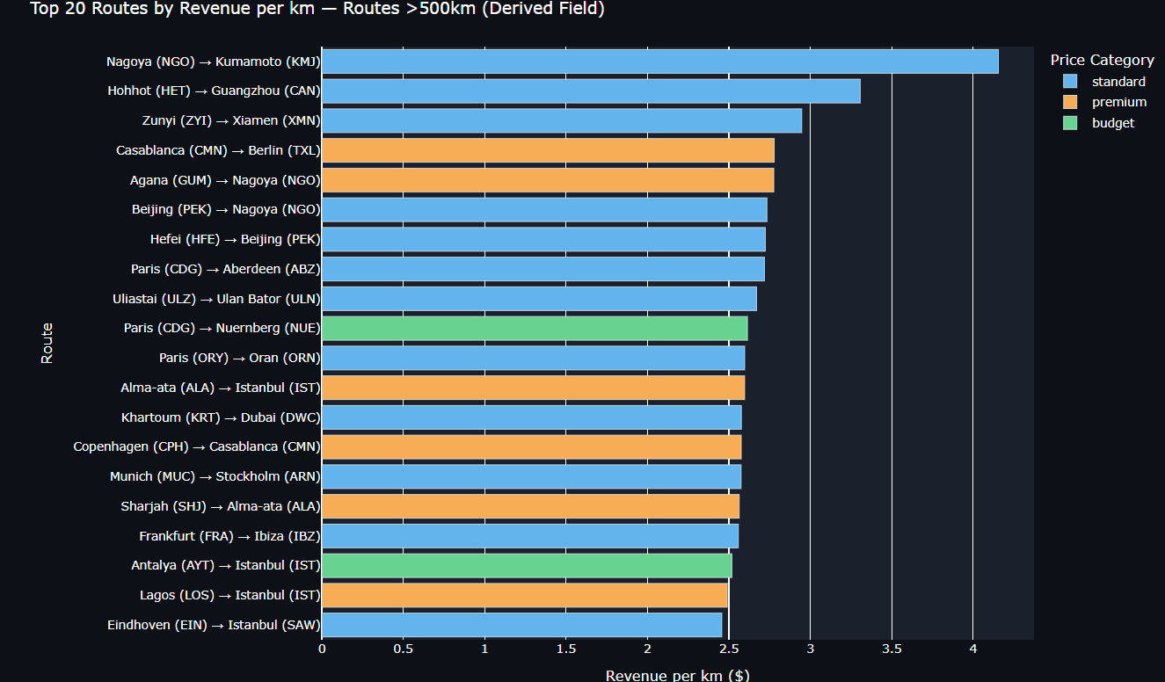

Visualization 3 — Occupancy Rate Distribution by Flight Status
A violin plot comparing the distribution of occupancy_rate across completed, delayed, and scheduled flights. The violin shape shows the full distribution including median and interquartile range. The occupancy_rate derived field is (active bookings / total seats × 100) and was precomputed per flight during migration. The chart reveals that delayed flights have a similar occupancy distribution to completed flights, suggesting delays are not driven by overbooking.

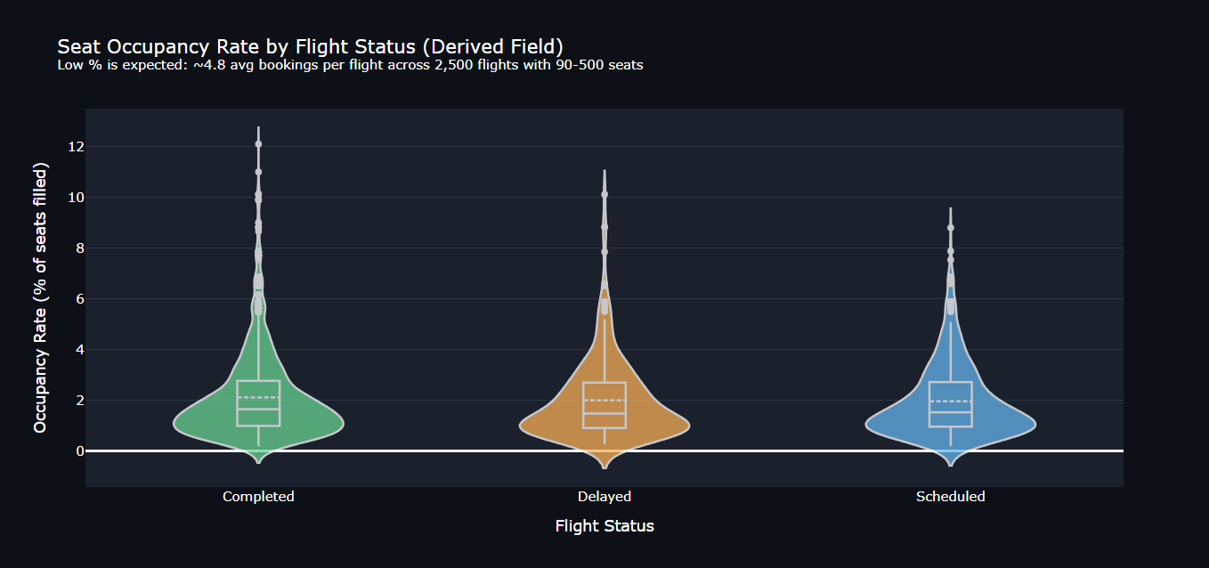Visualization 4 — Passenger Loyalty Tier Breakdown
A two-panel chart: a donut chart showing the count of passengers per loyalty tier, and a bar chart showing the average total_spent per tier. Both loyalty_tier and total_spent are derived fields computed from aggregating each passenger's booking history during migration. The chart confirms the expected pattern: platinum and gold passengers have significantly higher average spending than bronze passengers.
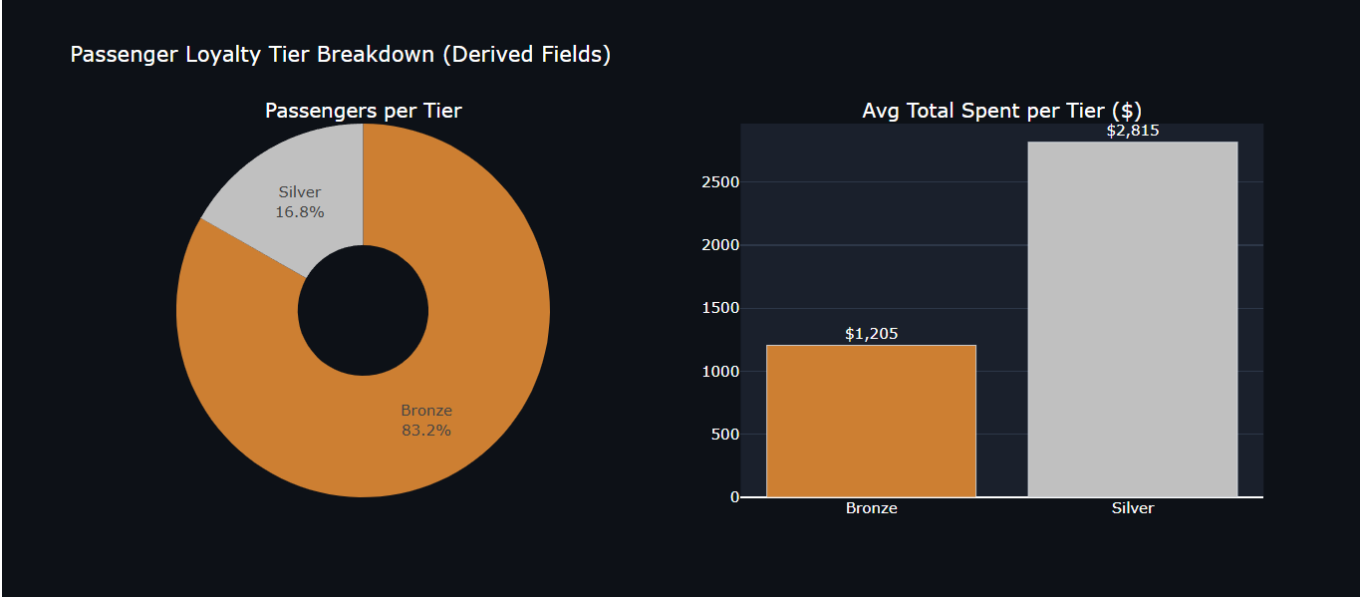

Visualization 5 — Delay Minutes vs Average Review Score
A scatter plot where each dot represents a delayed flight. The x-axis shows delay duration in minutes, the y-axis shows avg_review_score (derived field — mean rating across all reviews for that flight), dot size represents occupancy rate, and color represents the delay reason. A trendline is overlaid across all points. The chart shows that longer delays do not strongly correlate with lower review scores in this dataset, which may indicate that passengers accept delays caused by weather or air traffic more readily than technical failures.
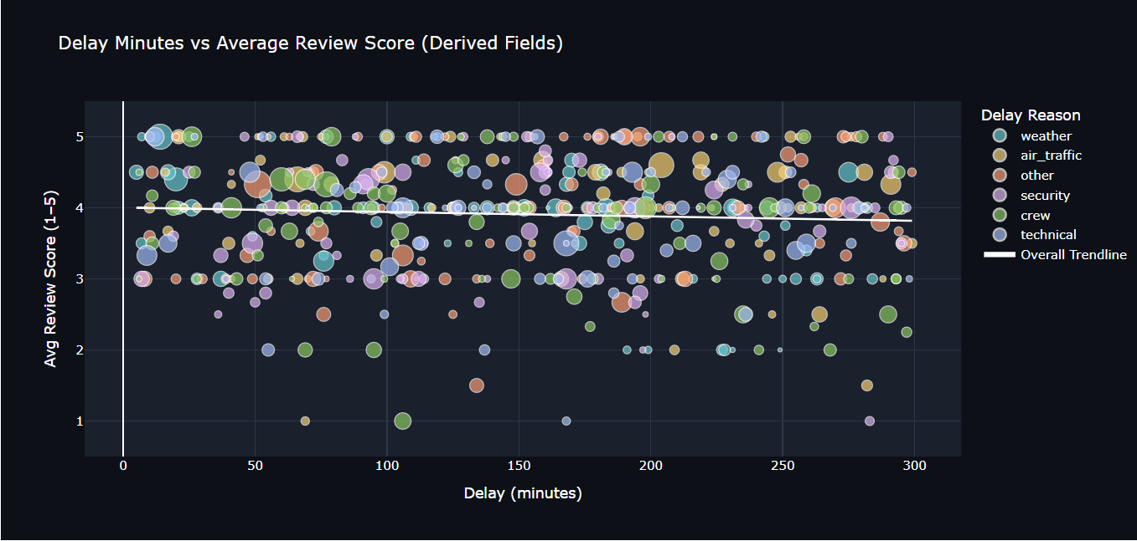

9. Conclusion

9.1 Summary of Accomplishments
This project successfully demonstrates a complete relational-to-NoSQL migration pipeline for a flight booking system. The following was accomplished:
- Designed and populated a 10-table PostgreSQL schema with 21,290 rows of real-world and synthetic data, exceeding all minimum row count requirements
- Justified and implemented MongoDB as the target NoSQL database with a fully denormalized 5-collection document model
- Developed a production-quality migration script computing 7 derived fields, handling 2 explicit error scenarios, and proven idempotent across multiple runs
- Implemented automated validation with 13 checks across record counts, SHA-256 checksums, and 5 spot-check aggregation queries — all passing with 0 failures
- Built 5 interactive Plotly visualizations reading exclusively from MongoDB, each exercising one or more derived fields produced during migration
- Containerized the full environment with Docker Compose and documented all setup and run instructions in README.md

9.2 Lessons Learned
Idempotency requires planning: Using upsert with natural keys instead of auto-generated IDs from the start saved significant refactoring. The choice of upsert key (e.g. booking_reference rather than _id) must be made before the first migration run.
Denormalization is a deliberate trade-off: Embedding passenger and flight data in booking documents makes reads fast but means an update to a passenger email would need to propagate to all their booking documents. For a read-heavy system like booking lookups this trade-off is acceptable.
Derived fields add real value: Fields like revenue_per_km and avg_review_score that would require expensive multi-table joins in SQL are instantly available in MongoDB because they were precomputed at migration time. This is the core advantage of the document model for analytics.
Environment portability matters: Docker Compose with explicit port mappings (5433 for PostgreSQL, 27018 for MongoDB) was essential for running alongside locally installed database instances without conflicts.
Validation is not optional: The SHA-256 checksum check caught a subtle floating-point rounding issue in an early version of the migration script before it reached the final submission. Automated validation gives confidence that the migrated data is trustworthy.

