VIT Time-table and Attendance calculator

CSE2003- DSA PROJECT REPORT

(J Component)

submitted by

**Shashank Shukla (18BME0107)**

*in partial fulfilment for the award of the degree of*

**B. Tech**

in

**School of Mechanical Engineering**



Vellore-632014, Tamil Nadu, India

**School of Computer Science and Engineering**

**March, 2019**

**ABSTRACT**

This program can be used by VIT students to maintain their attendance above 75%. In VIT attendance above 75% is mandatory to sit in each and every exam. Most of the students gets debar and fail to pass the subject. This program will keep them safe from getting debar. They can anytime modify their time-table by checking the attendance and could leave classes which are not required. They can easily check their attendance and also effect on attendance if they will not go to next class. They will be not debar frequently and can give exams happily. Students can easily check how much their attendance will become if they skipped next class. They can also make their time-table to look simple, it will only show information of classes they want to go.

**1-INTRODUCTION**

In this program data is stored in queue, stack and various structures. Personal information of a student is stored in a structure under various variables like name, registration no., block etc. Academic information i.e., subject name, room no. and time etc. is stored in a structure which forms a queue. It is stored under a different queue which shows time-table. Attendance of each subject is stored in different stacks in a separate array. In that array each block denotes a subject in which structure is stored. Subject name, its initial attendance and a stack of attendance is stored in that structure under array.

In individual stack, attendance of 7 days is stored for individual subjects. In time-table section, when student modifies time-table, subjects stored in front can only be dequeued. So, first in first out (FIFO) concept is used to enqueue and dequeue data from a queue. This queue of subjects is stored in a separate queue called time-table, whose each block denotes a day of a weak. In this queue also, FIFO is used and hence after selecting moving to next day option from menu, it dequeues present day data from queue which was stored in front location. In stack of attendance LIFO concept is used i.e., last in first out.

**OVERVIEW OF THE PROPOSED SYSTEM**

* 1. **SYSTEM ARCHITECTURE**

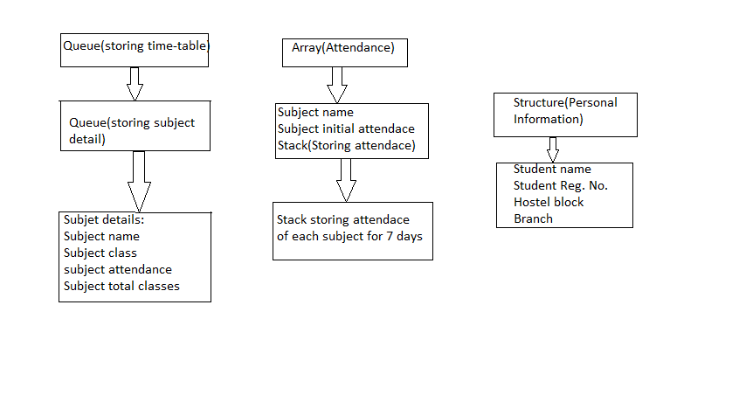

**2.2 MODULE DECSCRPTION**

Module 1- To check attendance of a particular subject.

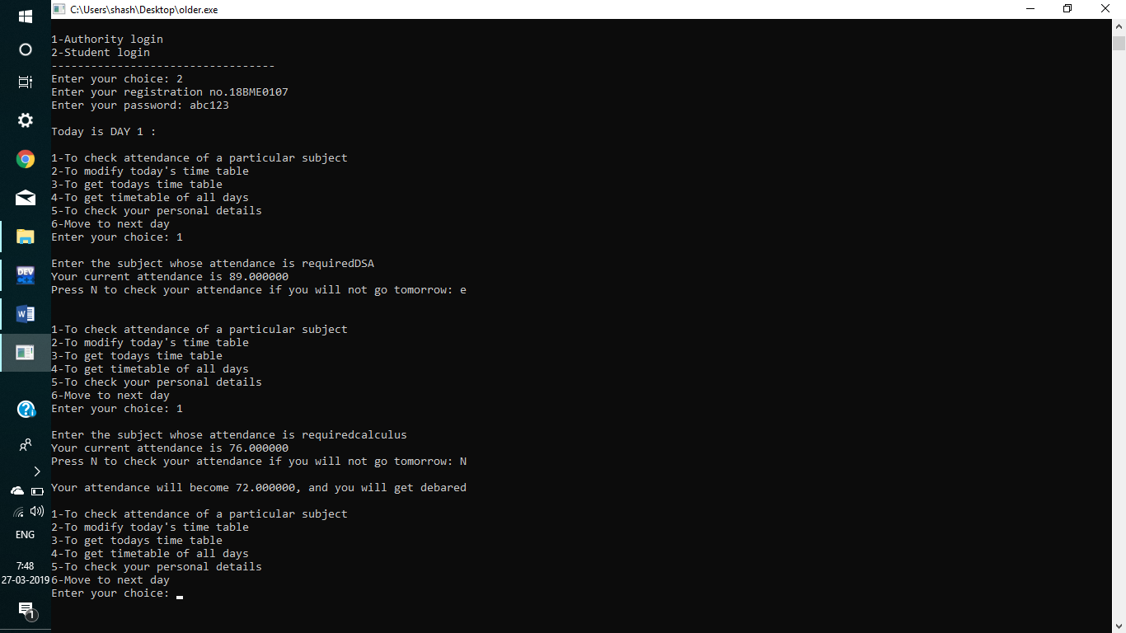

In this module, a function **search** is called under which program asks for name of subject whose attendance is required. After giving name of subjects, it runs a loop in attendance array and compares stored name with this name. After it found out, current attendance which is already stored is shown. Now, program to asks whether you will go tomorrow or not. If you press N i.e., not to go, the it calculates attendance after not going to tomorrow’s class. Then it shows reduced attendance after not going next day’s class. If that attendance is less than 75%, it also shows a debar message along with attendance.

**For e.g**., in the above code execution I gave Calculus subject whose attendance is to be required, it showed attendance as 76%. I typed N to not go to class, immediately message popped up stating my attendance will become 72% and I will get debar

Module 2- To modify today’s time-table

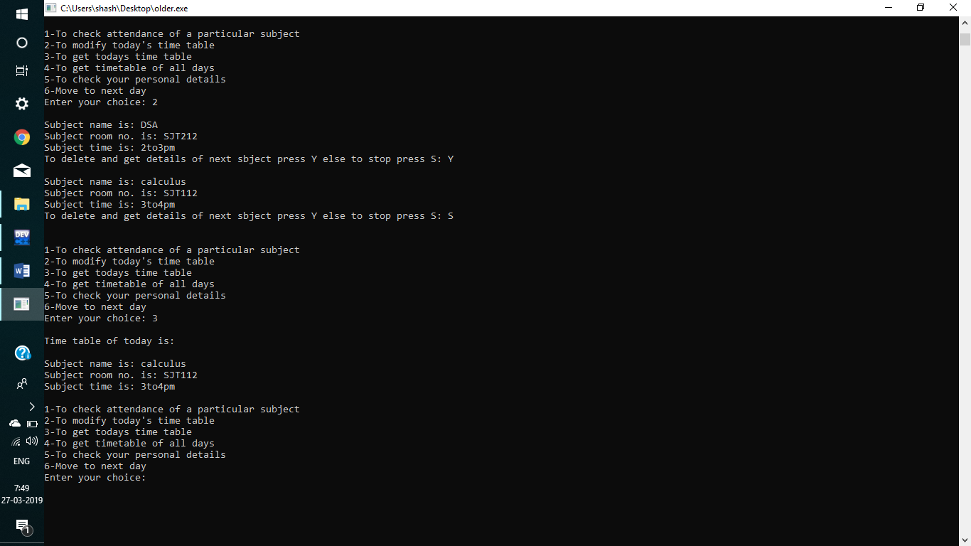

In this module named **modify**, user can modify time-table of the current day. It can delete slots of subjects whose classes they want to go. Since this data is stored in a queue, only limitation is that data can be deleted or dequeued only from the front which is the property of the queue. So, user can’t remove any slot, it can only remove that slot which is at front of queue. To remove slots which are inside, it has to dequeue all the slots coming before that. Program displays details of subject currently at front of queue and asks to press Y to delete it and move to next. It asks to press S to stop deletion.

**For e.g.,** In the above code execution first slot it showed was of subject DSA. I typed Y i.e., to delete it. Next subject’s Information popped up which was Calculus, I typed S to stop. So DSA removed from my time-table and Calculus with all its information in structure came at front of queue.

Module 3- To get today’s time-table.

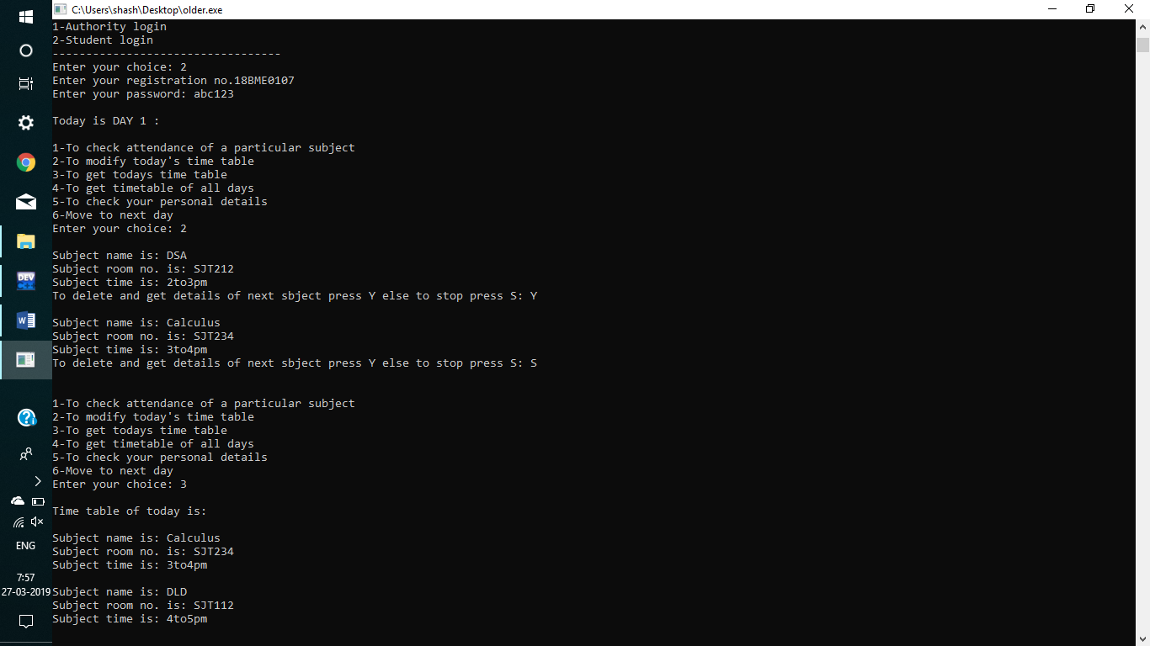

In this module named **todisplay**, time-table of present day is displayed. In this loop runs from front to rear of sub queue storing information of subjects inside time-table queue. It shows time-table of subjects which are stored at front of queue named time-table(tt). At day 1, it shows time-table of subjects stored at front. While moving to next day it dequeues this information and front assigns subject details of Day 2 and rear gets decremented by 1. This iteration continues till Day 7.

**For e.g**., In the above code execution, I selected option to display today’s time-table after modifying it. So, subject details of all subjects of today time-table got displayed. It didn’t show DSA and its information as I already removed it in modify time-table module.

Module 4-To get time-table of all days.

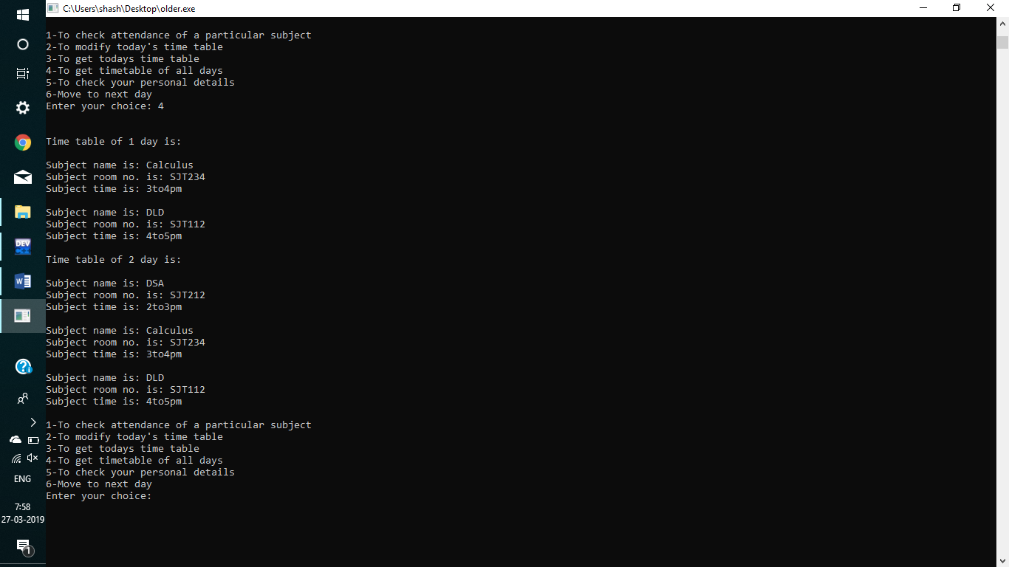

In this module named **ttdisplay**, time-table of all days is displayed. In this, loop runs from front to rear of main queue named as time-table(tt). It shows information of ith day. Another loop inside the previous loop runs from front to rear of sub queue storing information of subjects. It shows information of ith day and jth subject. Time-table of all days with their subject’s information is displayed by this module.

**For e.g**., In the above code execution I selected ttdisplay module. Time-table of 2 days showed up (since at beginning, I gave only 2 days) with a heading stating time-table of which day and other information of subjects.

Module 5- To check your personal details.

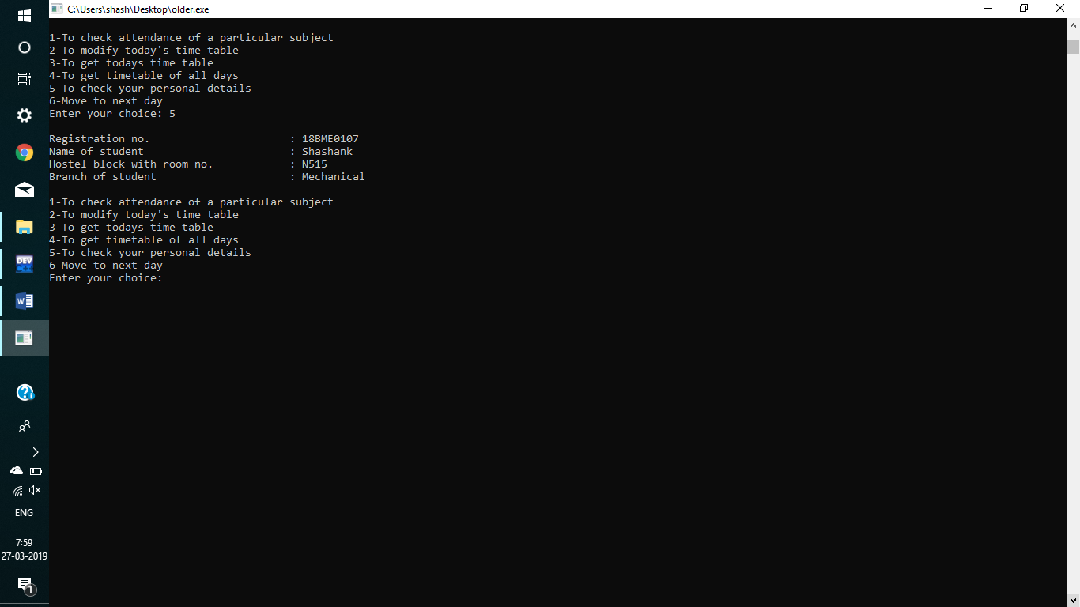

In this module named **studisplay**, personal information of students are displayed. While adding data in authority menu, some personal data was entered regarding to student. On selecting this option personal data like name, reg.no. and hostel block etc. is displayed on the screen. This data is stored in various character arrays named rg, nm etc.

**For e.g**., In the above code execution, On selecting studisplay, personal data i.e., name-shashank, reg. no.-18BME0107 etc. was displayed.

Module 6- Move to next day.

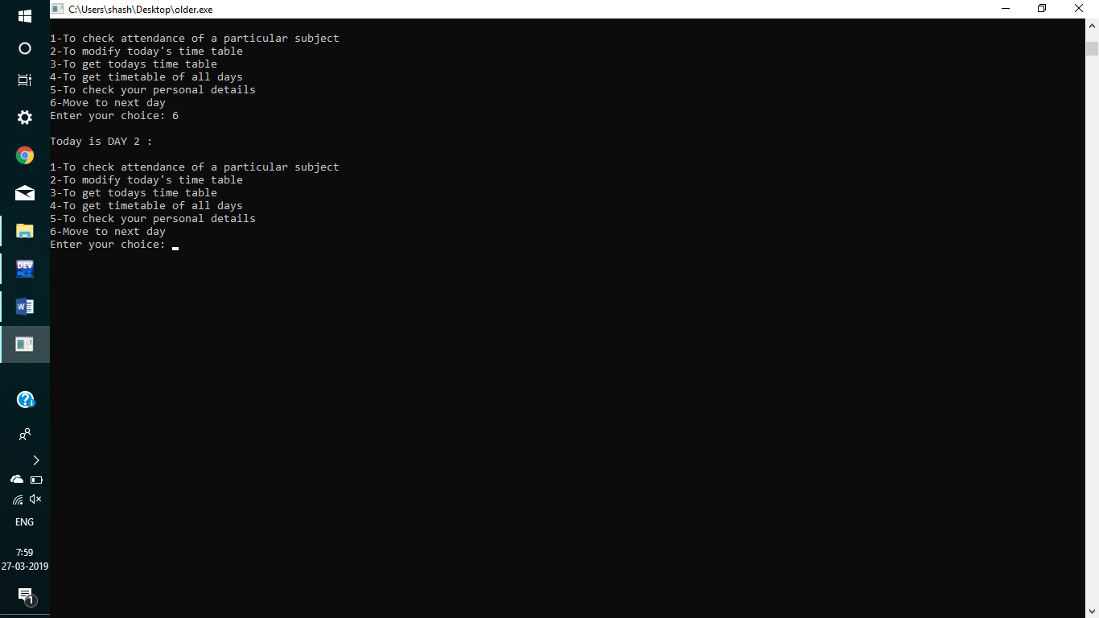

In this module named **dequeue**, it removes current day’s data or time-table from queue. Subject information for current day is dequeued from queue at front. Next day’s information moves to front and rear gets decremented by 1. This iterates till it reaches to last day or 7th day.

Selecting option 6 i.e., move to next day means current day is finished and attendance of all subject can be pushed in stack. So attendance of subjects of whom you went today is calculated and is pushed in stack of respective subjects.

**RESULTS AND CONCLUSION**

It allows student or user to modify their time table for a weak. It also allows student to check current attendance of any particular subject. An additional feature is added which allows user to check attendance if they will not go to next class. It shows current attendance and attendance if you will not go to next class. It also shows a message if your attendance becomes less than 75%. A message pops up stating that user will get debar and shows current attendance.

One more feature is added related to time-table. It allows user to edit time-table but in a specified way. User can remove slots of subjects which they don’t want to go. It shows modified time-table for the current day. It also displays time-table of the whole weak. These various options can be selected under menu.

It works on C or C++ software like Dev c++, codeblocks, geany etc. This program is written in C language.

**REFERENCES**

Wikipedia

Geeksforgeeks

Tutorial’s point

Murali Sir Notes