**POSTGRESQL**

**Exercise-1**

Shashank Shukla

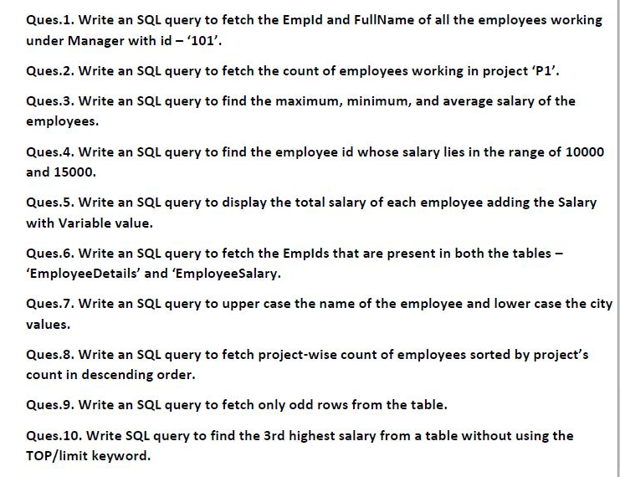

SOLUTION-

**Table Creation-**

-- Employee Table

create table employee1 (empid int not null primary key,

fname text,

mid int not null,

project text,

city text

);

insert into employee1 (empid, fname, mid, project, city) values (1, 'Shashank', 100, 'P1', 'Etawah');

insert into employee1 (empid, fname, mid, project, city) values (2, 'Mihir', 101, 'P2', 'Delhi');

insert into employee1 (empid, fname, mid, project, city) values (3, 'Pranav', 102, 'P1', 'Agra');

insert into employee1 (empid, fname, mid, project, city) values (4, 'Gaurav', 103, 'P1', 'Lucknow');

select * from employee1;

drop table employee1;

-- Salary Table

create table salary (sid int not null primary key,

sal real,

empid int,

constraint fk_emp foreign key (empid) references employee1(empid)

);

insert into salary (sid, sal, empid) values (100, 11000, 1);

insert into salary (sid, sal, empid) values (101, 18000, 2);

insert into salary (sid, sal, empid) values (102, 14000, 3);

insert into salary (sid, sal, empid) values (103, 20000, 4);

select * from salary;

drop table salary;

**-- Questions-**

-- Ques-1

select empid, fname from employee1 where mid=101;

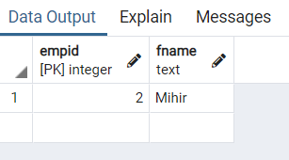

-- Ques-2

select count(*) from employee1 group by project having project='P1';

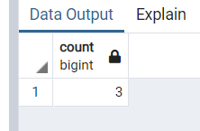

-- Ques-3

select max(sal) from salary;

select min(sal) from salary;

select avg(sal) from salary;

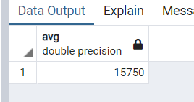 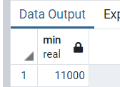 

-- Ques-4

select empid from salary where sal>10000 and sal<15000;

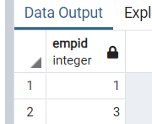

-- Ques-5

alter table salary add column variable real;

update salary set variable=sal*0.45;

select empid, sal+variable as Total_Salary from salary;

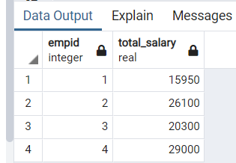

-- Ques-6

select empid from employee1 where empid in (select empid from salary);

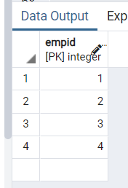

-- Ques-7

select upper(fname), lower(city) from employee1;

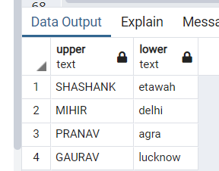

-- Ques-8

select project, count(*) as pcount from employee1 group by project order by pcount desc;

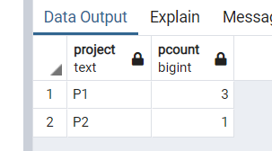

-- Ques-9

select * from

( select *,

Row_Number() over(order by empid) as rn

from employee1

)as newtable

where newtable.rn%2!=0;

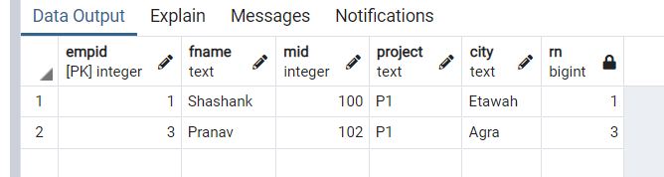

-- Ques-10

select sal from salary s1 where 2=(select count(distinct(sal)) from salary s2 where s2.sal>s1.sal);

