**PROJECT**

**REVIEW-1**

SHASHANK SHUKLA

18BCE2522

DBMS

PROF. MURALI SIR

ABSTRACT-

Topic of my project is **‘NCC DATABASE MANAGEMENT SYSTEM’**. The National Cadet Corps (NCC) is a voluntary organization which recruits cadets from universities all over India. A faculty with rank as ANO is the main admin of NCC in college and serves as a link between higher authority and cadets. The NCC database management is a system required for management and visualization of cadet’s attendance, issues and leave approvals. It is designed to connect ANO (admin) with respective in charge cadet, senior cadets and other fellow cadets. The goal of this system is to allow visualisation of attendance and to build a flow of responsibilities among cadets.

CQMS (Company Quarter Master Sergeant) is a post given to a cadet who is in its third year of NCC and he becomes in charge of all cadets. SGT(Sergeant) is a senior cadet who delivers all necessary information to cadets. LCPL (Lance Corporal) is a senior in NCC who is responsible for approval of leaves applied by cadets. CPL (Corporal) is also a senior cadet who is responsible to solve any kind of issues raised by cadets.

In website, there will be separate logins for Admin (ANO), CQMS, LCPL, CPL and other cadets. In case of respective login there will be separate modules of tasks which can be performed by the respective user. The tasks will vary according to the ranks of cadets. In case of other cadet login there will be a separate module to apply for leave, to check attendance and to apply for any grievance.

ER DIAGRAM-

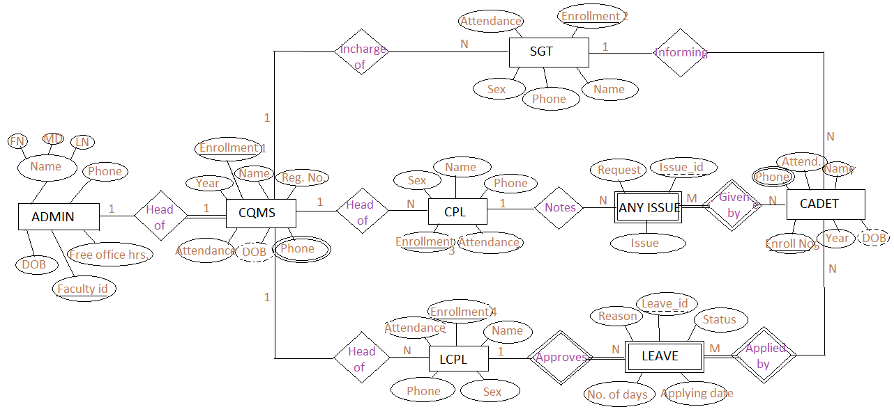

RELATIONAL SCHEMA-

ADMIN

|  |  |
| --- | --- |
| Faculty id | Primary key |
| FN | Not null |
| MN |  |
| LN | Not null |
| DOB | Not null |
| Phone | Not null |
| Free office hrs. | Not null |

CQMS

|  |  |
| --- | --- |
| Enrollment1 | Primary Key |
| Name | Not null |
| Reg. No. | Not null |
| Year | Not null |
| Attendance | Not null |
| Faculty id | Foreign Key(ADMIN) |

LCPL

|  |  |
| --- | --- |
| Enrollment4 | Primary Key |
| Name | Not null |
| Attendance | Not null |
| Sex | Not null |
| Phone |  |
| Enrollment1 | Foreign Key (CQMS) |

CPL

|  |  |
| --- | --- |
| Enrollment3 | Primary key |
| Name | Not null |
| Attendance | Not null |
| Sex | Not null |
| Phone |  |
| Enrollment1 | Foreign Key (CQMS) |

SGT

|  |  |
| --- | --- |
| Enrollment2 | Primary key |
| Name | Not null |
| Attendance | Not null |
| Sex | Not null |
| Phone |  |
| Enrollment1 | Foreign Key (CQMS) |

ANY ISSUE

|  |  |
| --- | --- |
| Issue_id | Primary key |
| Issue | Not null |
| Request |  |
| Enrollment3 | Foreign Key (CPL) |

LEAVE

|  |  |
| --- | --- |
| Leave_id | Primary key |
| Reason | Not null |
| No. of days | Not null |
| Applying date | Not null |
| Status | Not null |
| Enrollment4 | Foreign key (LCPL) |

CADET

|  |  |
| --- | --- |
| Enrollment5 | Primary key |
| Name | Not null |
| Year | Not null |
| Attendance | Not null |
| Enrollment2 | Foreign key (SGT) |

GIVEN BY

|  |  |
| --- | --- |
| Issue_id | Foreign key (ANY ISSUE) |
| Enrollment5 | Foreign key (CADET) |

APPLIED BY

|  |  |
| --- | --- |
| Leave_id | Foreign key (LEAVE) |
| Enrollment5 | Foreign key (CADET) |

CQMS_PHONE

|  |  |
| --- | --- |
| Phone no1 | Not null |
| Phone no2 |  |
| Phone no3 |  |
| Enrollment1 | Foreign key (CQMS) |

CADET_PHONE

|  |  |
| --- | --- |
| Phone no1 | Not null |
| Phone no2 |  |
| Phone no3 |  |
| Enrollment5 | Foreign key (CADET) |

TOOLS-

HTML, CSS, PHP for front end, Mysql for database and phpMyAdmin and other DBMS tools.