# 小组1

**成员：唐钰斌 苟明开 胡桂飞 任务：完成get_opt文件夹下所有文件**

函数接口：

// 获取参数个数，不包含./a.out命令本身

int get_opt_size(int argc);

// 获取路径

char* get_path(int argc, char const *argv[]);

// 判断是否有-l参数

int is_l(int argc,char const *argv[]);

代码编写：

## get_opt_size.c:

#include <stdio.h>

#include "get_opt_size.h"

int get_opt_size(int argc){

// 返回除ls命令本身参数个数

return argc - 1;

}

int main(int argc, char const *argv[])

{

printf("%d\n", get_opt_size(argc));

return 0;

}

get_path.c:

#include <stdio.h>

#include "get_path.h"

char* get_path(int argc, char const *argv[]){

return argv[argc - 1];

}

int main(int argc, char const *argv[])

{

printf("the input path is %s\n", get_path(argc, argv));

return 0;

}

is_l.c:

#include <stdio.h>

#include <string.h>

#include "is_l.h"

#include "get_opt_size.h"

// 判断是否有-l 参数 有返回1 无返回0

int is_l(int argc, char const *argv[]){

if(get_opt_size(argc) >= 1){

if(!strcmp("-l", argv[1])){

return 1;

}

}

return 0;

}

int main(int argc, char const *argv[])

{

if(is_l(argc, argv)){

printf("have -l parameter\n");

}else{

printf("no -l parameter\n");

}

return 0;

}

### 单元测试结果：

get_opt_size: 

get_path:

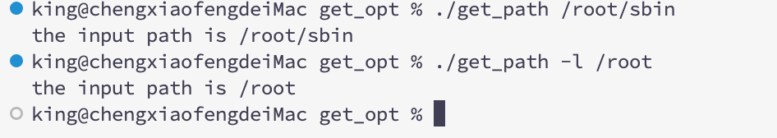

is_l:

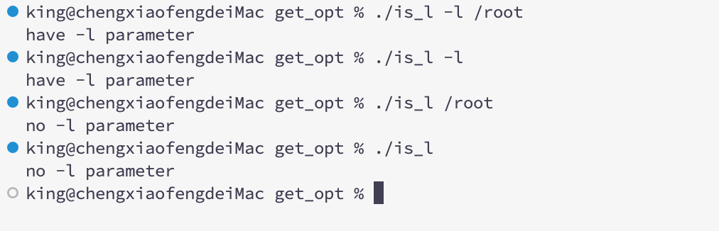

# 小组2

**成员：罗淞 颜志豪 李思衡 任务：完成Main.c**

## Main.c

代码编写：#include<stdio.h>

#include<stdlib.h>

#include<get_opt_size.h>

#include<get_path.h>

#include<is_l.h>

#include<show_file_all_info.h>

#include<show_file_names.h>

main(int argc, char*argv[]){

char str = '.';

int rt = -1;

if(argc>3)

{

printf("閿欒");

exit(1);

}

if(argc == 1)

lsdir(&str);

else if(argc == 2)

{

if(strcmp(argv[1],"-1") == 0 )

lsdir(&str);

else

{

checkfiletype(argv[1]);

if(typeflag == 2)

lsdir(argv[1]);

else if(typeflag == 1)

printf("%s\n",argv[1]);

}

}

else if(argc == 3)

{

if(strcmp(argv[1],"-1") == 0)

{

checkfiletype(argv[2]);

if(typeflag == 2)

lsdir(argv[2]);

else if(typeflag == 1)

printlong(argv[2]);

}

}

}

### 单元测试结果：

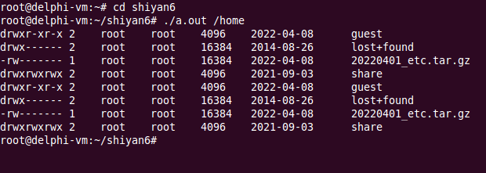

# 小组3

**成员：李时进 施婷 申黄琪 董静 任务： 完成show_file_names.c**

函数接口：

// 显示路径path下所有文件的文件名

## void show_file_names(char* path);

代码编写：

#include<stdio.h>

#include<sys/types.h>

#include<dirent.h>

#include<stdlib.h>

void show_file_names(char[]);

int main(int argc, char** argv)

{

if (argc == 1) {//查看当前目录

show_file_names(".");

}

else {

while (--argc) {//查看指定的一个或多个目录

printf("%s : \n", *++argv);//打印当前所查看的目录路径

show_file_names(*argv);//print环节

}

}

}

void show_file_names(char dirname[])

{

DIR* dir_ptr;//文件夹指针

struct dirent* direntp;//存放文件夹目录内容

if ((dir_ptr = opendir(dirname)) == NULL) {

fprintf(stderr, "ls1: open error %s\n", dirname);//打开失败

}

else {

while ((direntp = readdir(dir_ptr)) != NULL) {//while（readdir）

printf("%s\n", direntp->d_name);//d_name:

}

int flag;

if ((flag = closedir(dir_ptr)) == -1) {

perror("ls1: close dir error");//关闭失败

exit(0);

}

}

}

### 单元测试结果：

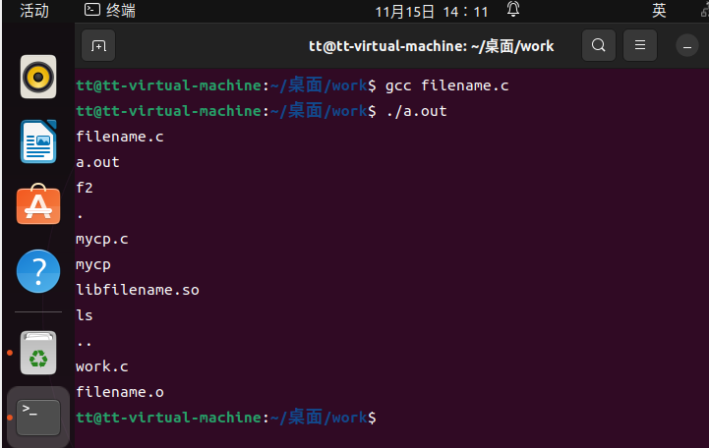

# 小组4

**成员：龙月 刘维 曾春琳 彭喆 任务：完成show_file_all_info.c**

函数接口：

// 显示路径path下所有文件的长格式

void show_file_all_info(char* path)

代码编写：

## show_file_all_info.c

void gettype(char *name)//判断文件类型

{

struct stat buf;

lstat(name,&buf);

switch(buf.st_mode&S_IFMT)

{

case S_IFREG:

typeflag=1;

break;

case S_IFDIR:

typeflag=2;

break;

case S_IFLNK:

typeflag=3;

break;

case S_IFCHR:

typeflag=4;

break;

case S_IFBLK:

typeflag=5;

break;

case S_IFSOCK:

typeflag=6;

break;

case S_IFIFO:

typeflag=7;

break;

default:

typeflag=0;

}

if(typeflag==1)

{

print_long(name);

}

else if(typeflag==2)

{

lsdir(name);

}

else

printf("cannot print this type");

}

void lsdir(char *name)//显示所有文件的文件名

{

DIR *d1;

struct dirent *dent1;

char namebuf[128];

char workdir[50];

d1=opendir(name);

if(d1==NULL)

{

perror("opendir");

exit(1);

}

getcwd(workdir,50);

chdir(name);

errno=0;

dent1=readdir(d1);

while(dent1!=NULL)

{

if(dent1->d_name[0]!='.')

{

print_long(dent1->d_name);

}

dent1=readdir(d1);

}

if(errno!=0)

perror("readdir");

closedir(d1);

chdir(workdir);

}

void print_size(struct stat *statp)//打印文件大小

{

switch(statp->st_mode & S_IFMT)

{

case S_IFCHR:

case S_IFBLK:

printf("%u,%u",(unsigned)(statp->st_rdev>>8),(unsigned)(statp->st_rdev&0xFF));

break;

default:

printf("%lu",(unsigned long)(statp->st_size));

}

}

void print_long(char *name)//得到长格式

{

struct stat buf;

struct passwd *user;

struct group *grp;

char linkname[64];

char dirfilename[64];

int rt;

rt=lstat(name,&buf);

if(-1==rt)

{

perror("in print_long:lstat");

return;

}

switch(buf.st_mode&S_IFMT)

{

case S_IFDIR:

printf("d");

break;

case S_IFLNK:

printf("l");

break;

case S_IFREG:

printf("-");

break;

case S_IFBLK:

printf("b");

break;

case S_IFCHR:

printf("c");

break;

case S_IFSOCK:

printf("s");

break;

case S_IFIFO:

printf("p");

break;

default:

printf("?");

break;

}

putchar((buf.st_mode&S_IRUSR)?'r':'-');

putchar((buf.st_mode&S_IWUSR)?'w':'-');

if(buf.st_mode&S_ISUID)

{

putchar((buf.st_mode&S_IXUSR)?'s':'S');

}

else

{

putchar((buf.st_mode&S_IXUSR)?'x':'-');

}

putchar((buf.st_mode&S_IRGRP)?'r':'-');

putchar((buf.st_mode&S_IWGRP)?'w':'-');

if(buf.st_mode&S_ISGID)

{

putchar((buf.st_mode&S_IXGRP)?'s':'S');

}

else

{

putchar((buf.st_mode&S_IXGRP)?'x':'-');

}

putchar((buf.st_mode&S_IROTH)?'r':'-');

putchar((buf.st_mode&S_IWOTH)?'w':'-');

if(buf.st_mode&S_ISVTX)

{

putchar((buf.st_mode&S_IXOTH)?'t':'T');

}

else

{

putchar((buf.st_mode&S_IXOTH)?'x':'-');

}

printf("%2u",buf.st_nlink);

user=getpwuid(buf.st_uid);

printf("\t%s",user->pw_name);

grp=getgrgid(buf.st_gid);

printf("\t%s\t",grp->gr_name);

print_size(&buf);

print_date(&buf);

if(typeflag==3)

{

rt=readlink(name,linkname,sizeof(linkname));

linkname[rt]=0;

printf("\t%s->%s",name,linkname);

}

else

{

printf("\t%s",name);

}

printf("\n");

}

void print_date(struct stat *statp)//得到文件的时间

{

time_t now;

double diff;

char buf[100],*fmt;

if(time(&now)==-1)

{

printf("????????????");

return;

}

diff=difftime(now,statp->st_mtime);

if(diff<0||diff>60*60*24*128.5)

fmt="%Y-%m-%d";

else

fmt="%Y-%m-%d %H:%M";

strftime(buf,sizeof(buf),fmt,localtime(&statp->st_mtime));

printf("\t%s",buf);

}

void show_file_all_info(char* path){

gettype(path);

}

### 单元测试结果：

