分组情况：

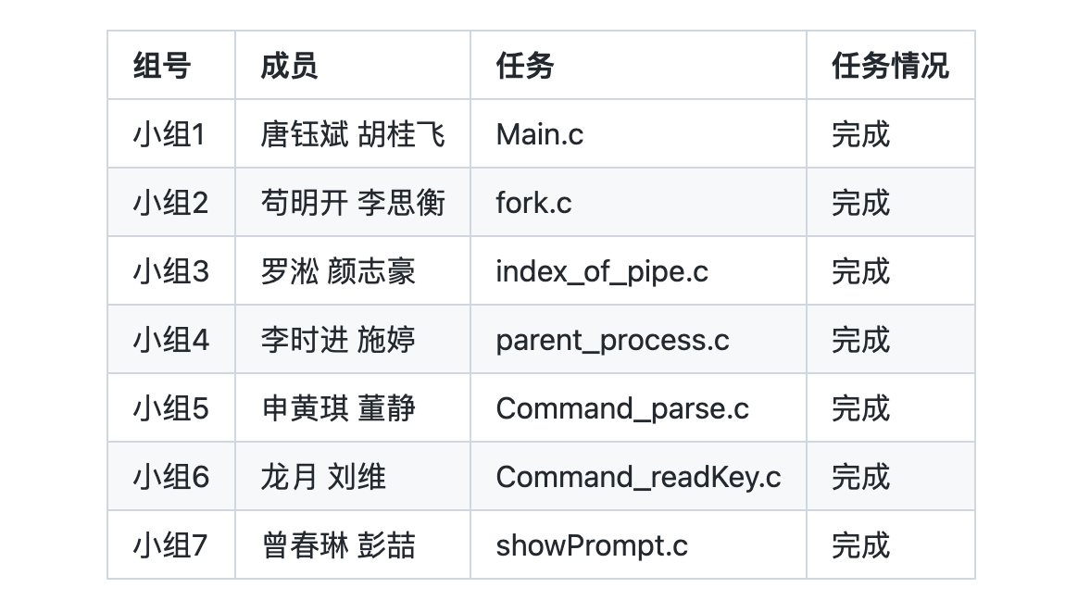

**小组1**

核心代码：

#include <stdio.h>

#include <string.h>

#include <stdlib.h>

#include <unistd.h>

#include "show/getCommand_parse.h"

#include "show/getCommand_readKey.h"

#include "show/showPrompt.h"

#include "process/fork.h"

#include "process/index_of_pipe.h"

#include "process/parent_process.h"

#define MAXSIZE 4096

int main(int argc, char const *argv[], char *env[])

{

int ppipe[2];

int pid1, pid2;

char buff[MAXSIZE];

char *buff_2;

char *args_1[64];

char *args_2[64];

int arg_nums = 0;

int pipe_flag = 0;

printf("**\n\n\t** Welcom to Google Future Leaders very Power Shell System!**\n\n**");

while(1){

showPrompt();

readKey(buff);

if(!strcmp(buff, "**\n**")){

continue;

}

if((pipe_flag = index_of_pipe(buff)) != -1){

pipe(ppipe);

buff[pipe_flag] = 0; // instead '|' whit '\0'

buff_2 = &buff[pipe_flag + 1];

parse(buff_2, args_2);

}

parse(buff, args_1);

if(!strcmp(args_1[0],"exit")){

exit(0);

}

if((pid1 = fork()) == 0){

fork_1(args_1[0], args_1, pipe_flag, ppipe);

}

if(pipe_flag != -1){

if((pid2 = fork()) == 0){

fork_2(args_2[0], args_2, ppipe);

}

}

parent_process(pid1, pid2, pipe_flag, ppipe);

}

return 0;

}

编译过程：

cd show

gcc -fPIC -c getCommand_parse.c

gcc -fPIC -c getCommand_readKey.c

gcc -fPIC -c showPrompt.c

gcc -shared -o libshow.so getCommand_parse.o getCommand_readKey.o showPrompt.o

cp libshow.so ../

cd ../process

gcc -fPIC -c fork.c

gcc -fPIC -c index_of_pipe.c

gcc -fPIC -c parent_process.c

gcc -shared -o libprocess.so fork.o parent_process.o index_of_pipe.o

cp libprocess.so ../

cd ../

export LD_LIBRARY_PATH=.

gcc Main.c -o google_future_shell -L. -lprocess -lshow

测试：

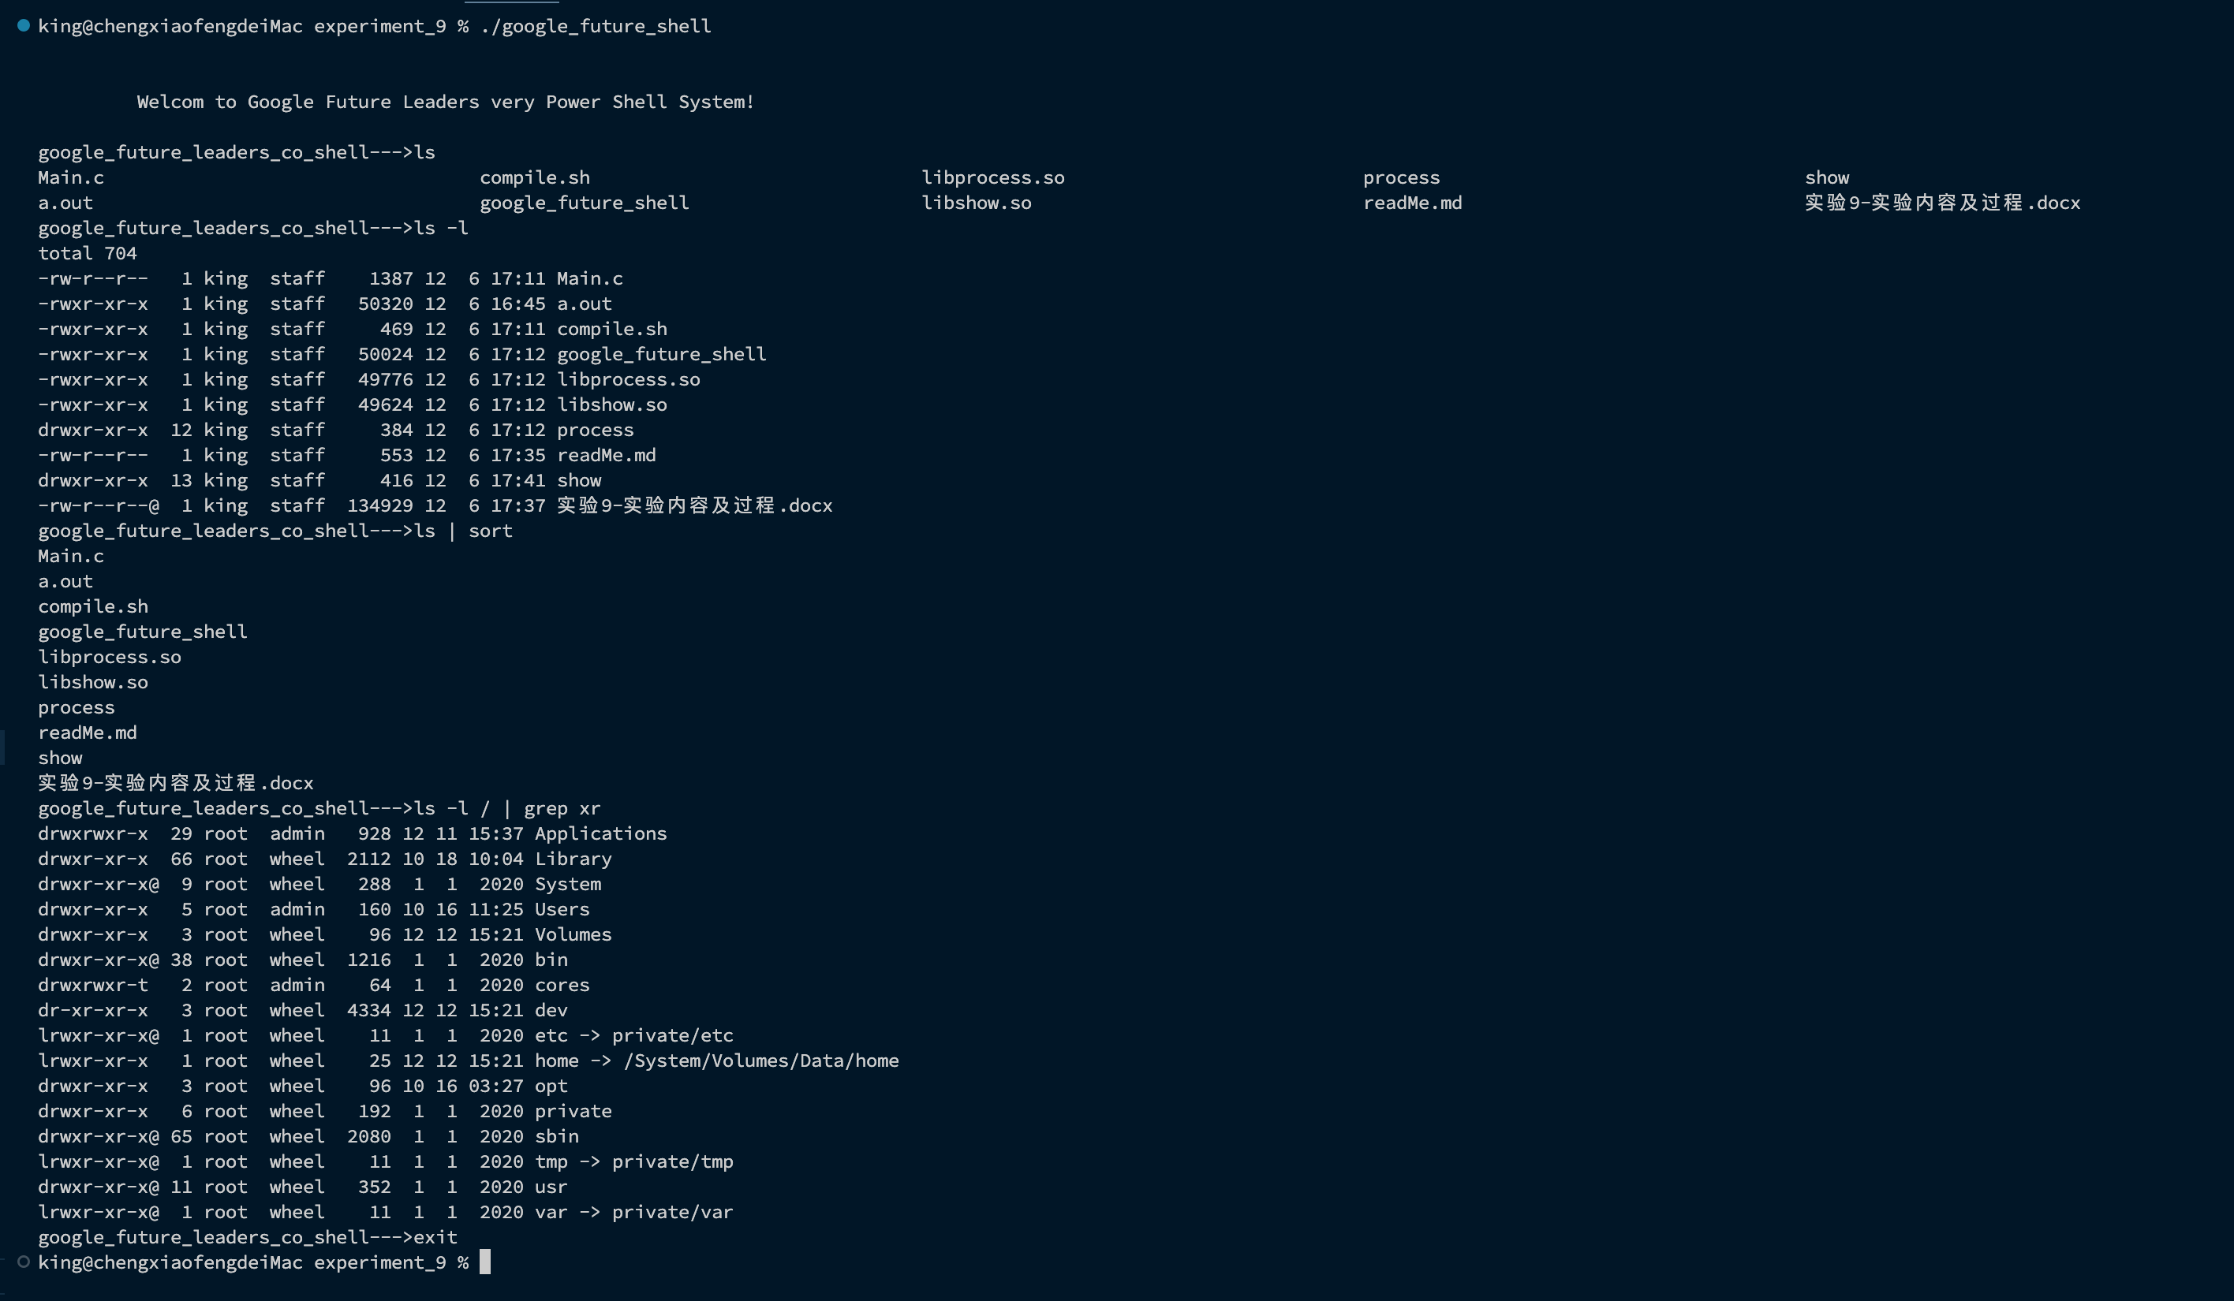

**小组2**

接口：

void fork_1(char* command, char** args, int pipe_flag, int ppipe[]);

void fork_2(char* command, char** args, int ppipe[]);

核心代码：

#include <stdio.h>

#include <unistd.h>

#include <stdlib.h>

#include "fork.h"

void fork_1(char* command, char** args, int pipe_flag, int ppipe[]){

if(pipe_flag != -1){

dup2(ppipe[1], 1);

close(ppipe[0]);

close(ppipe[1]);

}

execvp(command, args);

printf("could not execute %s\n", command);

exit(127);

}

void fork_2(char* command, char** args, int ppipe[]){

dup2(ppipe[0], 0);

close(ppipe[0]);

close(ppipe[1]);

execvp(command, args);

printf("could not execute %s\n", command);

exit(127);

}

// int main(int argc, char const *argv[])

// {

// char *args[3] = {"ps"};

// fork_1(*args, args, -1);

// return 0;

// }

单元测试：

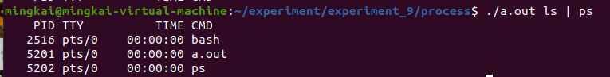

**小组3**

接口：

int index_of_pipe(char *buff);

核心代码：

index_of_pipe.h

#ifndef _INDEX_PIPE_

#define _INDEX_PIPE_

int index_of_pipe(char *buff);

#endif

index_of_pipe.c

#include "index_of_pipe.h"

int index_of_pipe(char *buff){

int count = 0;

while(*buff != '\0' && *buff != '|'){

buff++;

count++;

}

if(*buff == '\0'){

return -1;

}

return count;

}

**小组4**

接口：

void parent_process(int pid1, int pid2, int pipe_flag, int ppipe[]);

核心代码：

parent_process.h

#ifndef _PARENT_PROCESS_

#define _PARENT_PROCESS_

void parent_process(int pid1, int pid2, int pipe_flag, int ppipe[]);

#endif

parent_process.c

#include <stdio.h>

#include <unistd.h>

#include <sys/types.h>

#include <sys/wait.h>

#include "parent_process.h"

void wait_child(int pid){

    if (pid = waitpid(pid, NULL, 0) < 0)

        printf(" pid error!");

}

void parent_process(int pid1, int pid2, int pipe_flag, int ppipe[]){

    if(pipe_flag != -1){

        close(ppipe[0]);

        close(ppipe[1]);

    }

    wait_child(pid1);

    if(pipe_flag != -1){

        wait_child(pid2);

    }

}

**小组5**

接口：

int parse(char *buff, char** args);

核心代码：

#include <stdio.h>

#include "getCommand_parse.h"

int parse(char *buff, char** args){

int num = 0;

while(*buff!='\0')

{

while((*buff==' ')||(*buff=='\t'||(*buff=='\n')))

*buff++='\0';

*args++=buff;

++num;

while((*buff!='\0')&&(*buff!=' ')&&(*buff!='\t')&&(*buff!='\n'))

buff++;

}

*(--args)='\0';

return num - 1;

}

// int main(int argc, char const *argv[])

// {

// char buff[] = "ls -l /root/home/";

// char *args[64];

// int argsnum = parse(buff, args);

// printf("the args num is %d\n", argsnum);

// for(int i = 0; i < argsnum; i++){

// printf("%s\n", args[i]);

// }

// return 0;

// }

单元测试：

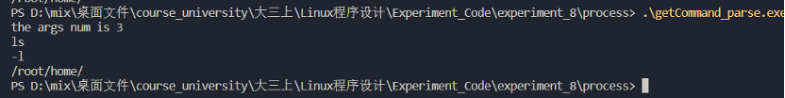

**小组6**

接口：

void readKey(char* buff);

核心代码：

#include <stdio.h>

#include <unistd.h>

#include <stdlib.h>

#include <string.h>

#include "getCommand_readKey.h"

#define MAXSIZE 4096

void readKey(char* buff){

char* ret;

ret = fgets(buff, MAXSIZE, stdin);

if(ret == NULL){

printf("error occurs!\n");

exit(1);

}

if(buff[strlen(buff) - 1] == "\n"){

buff[strlen(buff) - 1] = 0;

}

}

// int main(int argc, char const *argv[])

// {

// char buff[MAXSIZE];

// readKey(buff);

// printf("the buff is %s\n", buff);

// return 0;

// }

单元测试：

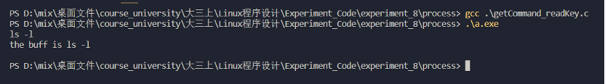

**小组7**

接口：

void showPrompt();

核心代码：

#include <stdio.h>

#include "showPrompt.h"

void showPrompt(){

printf("google_future_leaders_co_shell--->");

}

// int main(int argc, char const *argv[])

// {

// showPrompt();

// return 0;

// }

单元测试：

