**Week6_React_HandsOn**

**HandsOn1:**

Create a new React Application with the name “myfirstreact”, Run the application to print “welcome to the first session of React” as heading of that page.

**App.js**

import './App.css';

function App() {

  return (

     <div>

      <h1>Welcome to the first session of React</h1>

    </div>

  );

}

export default App;

**OUTPUT :**

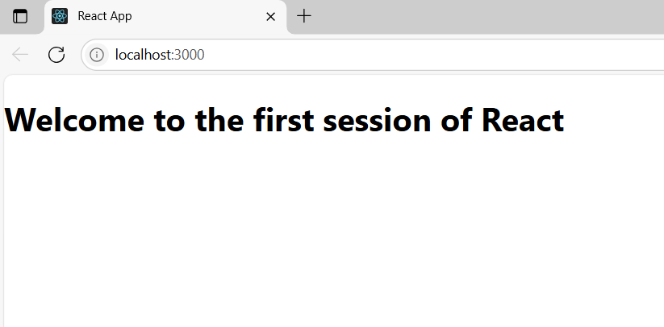

**HandsOn2 :**

Create a react app for Student Management Portal named StudentApp and create a component named Home which will display the Message “Welcome to the Home page of Student Management Portal”. Create another component named About and display the Message “Welcome to the About page of the Student Management Portal”. Create a third component named Contact and display the Message “Welcome to the Contact page of the Student Management Portal”. Call all the three components

**App.js**

import React from "react";

import './App.css';

import Home from "./Components/Home";

import About from "./Components/About";

import Contact from "./Components/Contact";

function App() {

  return (

    <div>

      <h1>Student Management System</h1>

      <Home/>

      <About/>

      <Contact/>

    </div>

  );

}

export default App;

**Home.js**

import React from "react";

class Home extends React.Component {

  render() {

    return (

      <div>

        <h2>Welcome to the Home page of Student Management Portal</h2>

      </div>

    );

  }

}

export default Home;

**About.js**

import React from "react";

class About extends React.Component {

  render() {

    return (

      <div>

        <h2>Welcome to the About page of the Student Management Portal</h2>

      </div>

    );

  }

}

export default About;

**Contact.js**

import React from "react";

class Contact extends React.Component {

  render() {

    return (

      <div>

        <h2>Welcome to the Contact page of the Student Management Portal</h2>

      </div>

    );

  }

}

export default Contact;

**OUTPUT :**

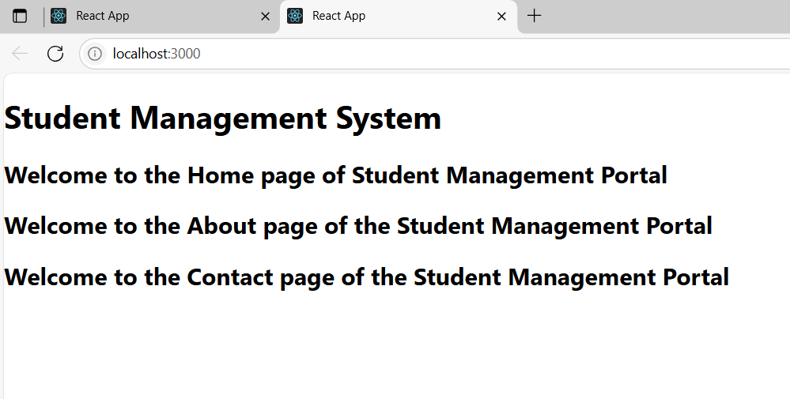

**HandsOn3 :**

**App.js**

import './App.css';

import CalculateScore from "./Components/CalculateScore";

function App() {

  return (

    <div className="App">

      <h1>Student Management Portal</h1>

      <CalculateScore name="shanmathi" school="XYZ school" total={450} goal={5} />

    </div>

  );

}

export default App;

**CalculateScore.js**

import React from "react";

import "../Stylesheets/mystyle.css";

function CalculateScore(props) {

  const { name, school, total, goal } = props;

  const average = total / goal;

  return (

    <div className="score-container">

      <h2>Student Score Calculator</h2>

      <p><b>Name:</b> {name}</p>

      <p><b>School:</b> {school}</p>

      <p><b>Total Score:</b> {total}</p>

      <p><b>Goal:</b> {goal}</p>

      <h3>Average Score: {average}</h3>

    </div>

  );

}

export default CalculateScore;

**mystyle.css**

.score-container {

  border: 2px solid #4CAF50;

  border-radius: 8px;

  padding: 20px;

  margin: 20px auto;

  width: 50%;

  text-align: center;

  background-color: #f9f9f9;

  font-family: Arial, sans-serif;

}

h2 {

  color: #4CAF50;

}

h3 {

  color: #333;

}

**OUTPUT :**

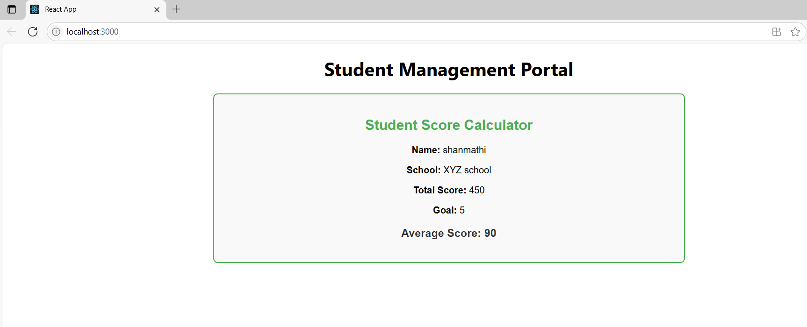

**HandsOn4:**

**App.js**

import React from "react";

import "./App.css";

import Posts from "./Posts";

function App() {

  return (

    <div className="App">

      <Posts />

    </div>

  );

}

export default App;

**Post.js**

class Post {

  constructor(id, title, body) {

    this.id = id;

    this.title = title;

    this.body = body;

  }

}

export default Post;

**Posts.js**

import React from "react";

import Post from "./Post";

class Posts extends React.Component {

  constructor(props) {

    super(props);

    this.state = {

      posts: [],

      hasError: false

    };

  }

  // Fetch API call

  loadPosts() {

    fetch("https://jsonplaceholder.typicode.com/posts")

      .then(response => response.json())

      .then(data => {

        const postList = data.map(item => new Post(item.id, item.title, item.body));

        this.setState({ posts: postList });

      })

      .catch(error => {

        console.error("Error fetching posts:", error);

      });

  }

  // Lifecycle hook

  componentDidMount() {

    this.loadPosts();

  }

  // Error handling hook

  componentDidCatch(error, info) {

    this.setState({ hasError: true });

    alert("Something went wrong in Posts component!");

    console.error(error, info);

  }

  render() {

    if (this.state.hasError) {

      return <h2>Something went wrong.</h2>;

    }

    return (

      <div>

        <h1>Blog Posts</h1>

        {this.state.posts.map(post => (

          <div key={post.id}>

            <h3>{post.title}</h3>

            <p>{post.body}</p>

            <hr />

          </div>

        ))}

      </div>

    );

  }

}

export default Posts;

**OUTPUT :**

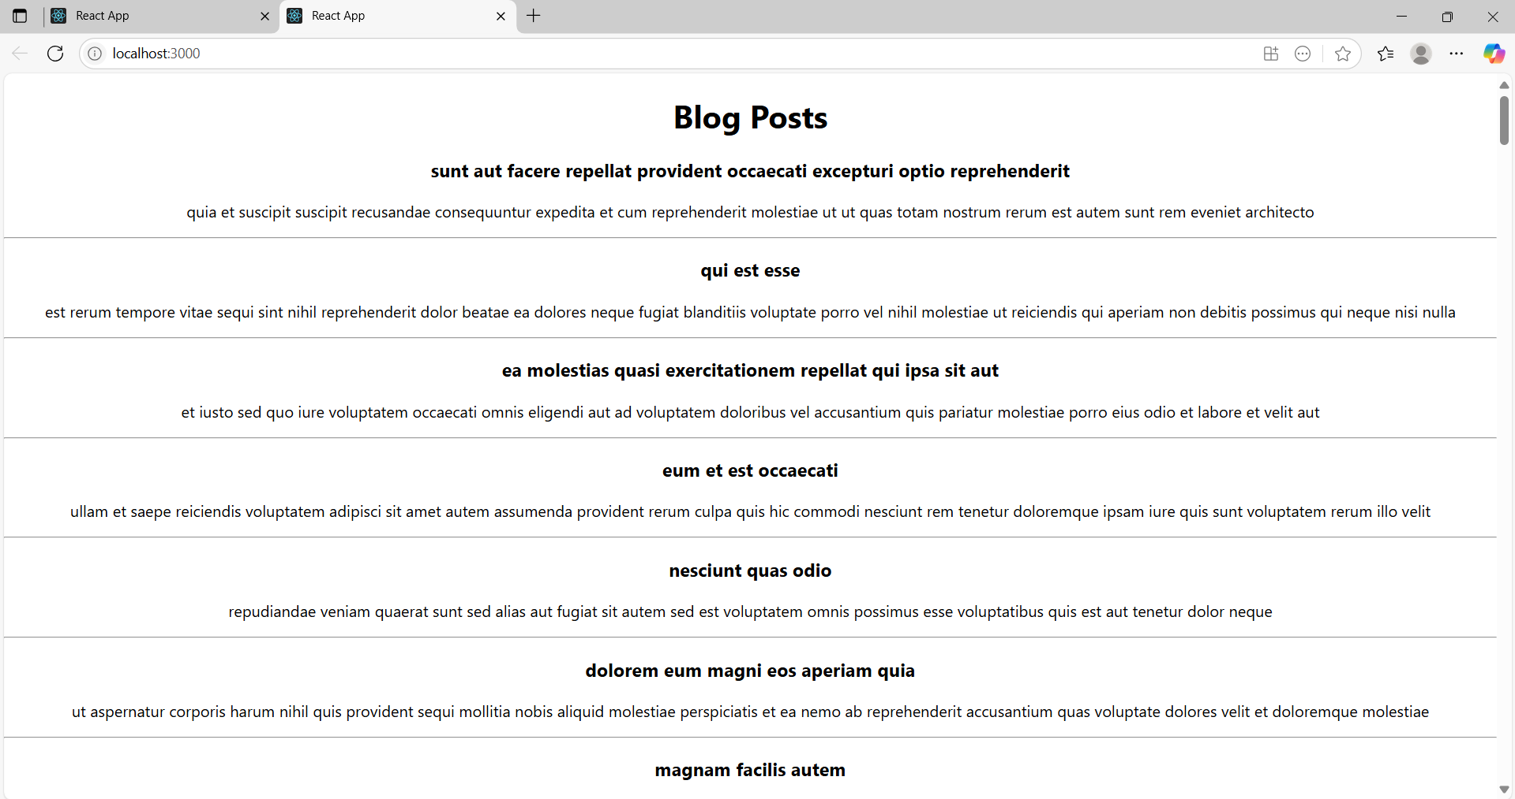

**HandsOn5 :**

**App.js**

import logo from './logo.svg';

import './App.css';

import { CohortsData} from './Cohort'

import CohortDetails from './CohortDetails';

function App() {

  return (

  <div>

    <h1>Cohorts Details</h1>

    {CohortsData.map(cohort => <CohortDetails cohort={cohort}/>)}

  </div>

  );

}

export default App;

**CohortDetails.module.css**

.box {

  width: 300px;

  display: inline-block;

  margin: 10px;

  padding: 10px 20px;

  border: 1px solid black;

  border-radius: 10px;

}

dt {

  font-weight: 500;

}

**CohortDetails.js**

import styles from './CohortDetails.module.css';

function CohortDetails(props) {

    return (

        <div className={styles.box}>

            <h3 style={{ color: props.cohort.currentStatus === "ongoing" ? "green" : "blue" }}>

             {props.cohort.cohortCode} - <span>{props.cohort.technology}</span>

            </h3>

            <dl>

                <dt>Started On</dt>

                <dd>{props.cohort.startDate}</dd>

                <dt>Current Status</dt>

                <dd>{props.cohort.currentStatus}</dd>

                <dt>Coach</dt>

                <dd>{props.cohort.coachName}</dd>

                <dt>Trainer</dt>

                <dd>{props.cohort.trainerName}</dd>

            </dl>

        </div>

    );

}

export default CohortDetails;

**OUTPUT :**

